

IN 02

Royal Splendours of India
Mumbai (A)- Aurangabad (B) – Udaipur (C) – Jaipur (D) – Agra (E) – Delhi (F)
12 Days / 11 Nights
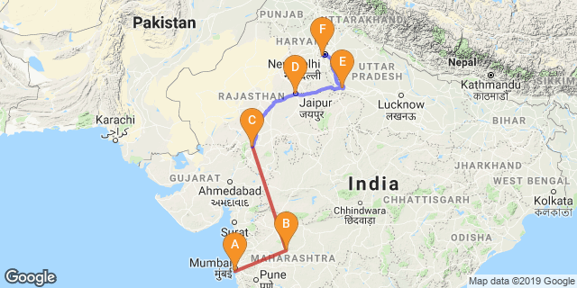

Overview : The tour begins from Mumbai - the Commercial capital of India along with the UNESCO world heritage sites of 1st and 2nd century BC Buddhist cave temples at Ajanta and Ellora, the majestic palaces and forts for Rajasthan, Taj – the monument of love and Agra and Delhi – the capital of India.
Highlights : Cultural, architecture, family, cuisine
- Explore the highlights of Mumbai – the commercial capital
- Visit to the unique cave temples at Ajanta and Ellora
- Visit to the magnificent city Palace at Udaipur
- Boat ride on Lake Pichola
- Explore the forts, palaces and the bustling bazaars of the Pink City of Jaipur
- Visit to world famous Taj Mahal

Day 1: Arrive Mumbai

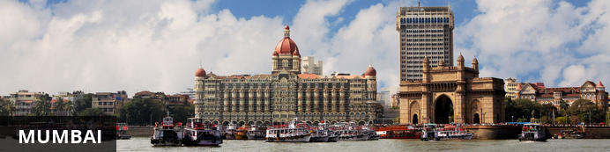
The thriving metropolis of Mumbai is a go-to destination for travellers curious to experience a modern Indian city. Lapped by the Arabian Sea, this urban seaside peninsula is a melting pot of old and new India. Towering office blocks and shiny apartment buildings shoulder crumbling grand dames of architecture. Men play cricket in the leafy central parks, taxis navigate the jam-packed streets and families stroll along the seaside promenades of Mumbai, while kilometres away children beg on the peripheries of Asia’s biggest slum. In the wide avenue of Colaba’s high street, western culture overshadows the brightly lit storefronts, where Levi’s, Adidas and McDonalds vie for retail space.

On arrival in Mumbai: Having cleared immigration, collected your luggage and passed through customs, please make your way towards the exit of the terminal building where you will see a bank of people waiting for you. Amongst them will be Travel Counsellor Representative who will be waiting to greet you with a paging board with your name on.
You are then transferred to your hotel and assisted with check in (Standard check in time is 1400 Hrs)
Rest of the day is at leisure to get over jet lag.

Day 2: Mumbai

After breakfast take a half day sightseeing tour of Mumbai covering Gateway of India, Malabar hills, Victoria Terminus and Mani Bhawan .
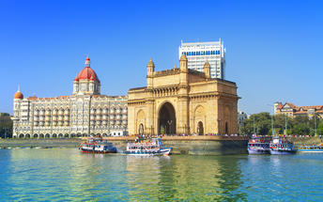
Gateway of India – Located on the waterfront in Apollo Bunder, the Gateway is a basalt arch 26 metres (85 ft) high. It was a crude jetty used by fisher folks and was later renovated and used as a landing place for British governors and other distinguished personages.

Malabar Hills. The colonial bungalows that peppered the hillside in the 18th century have now been replaced by the apartment blocks of Mumbai. You would visit Victoria Terminus, and Mani Bhavan - the old Mumbai residence of Mahatma Gandhi. It is a pretty, two-storied structure that now houses a reference library with over 2000 books, a photo exhibition of the Mahatma's life, and well preserved memorabilia, including an old charkha or spinning wheel that Gandhi ji used to use.

Day 3: Mumbai – Aurangabad


Known for its myriad cultural and historical monuments, Aurangabad is a popular tourist city set on the Kaum River in a hilly upland region of India's Maharashtra state. The city is best known for the impressive marble Bibi Ka Maqbara, which bears a striking resemblance to the Taj Mahal and was commissioned by the sixth Mughal Emperor Aurangzeb in the late 17th century. Other notable sights include: the Shivaji Maharaj Museum, dedicated to the Maratha king Shivaji; the Aurangabad Caves featuring ancient, rock-cut Buddhist shrines; and the impressive 12th-century medieval Daulatabad Fort. Aurangabad serves as a gateway to the ancient caves of Ajanta and Ellora.

After breakfast, your Travel Counsellor Representative will assist & transfer you to Mumbai airport to board the flight for Aurangabad.
Upon your arrival in Aurangabad, you will be assisted and transferred to the hotel.

Day 4: Aurangabad

Breakfast is at the hotel. Later leave for an excursion with your private chauffeur driven vehicle to Ajanta Caves (Closed on Mondays) [Approx.100 kms/ 3 Hrs one way]

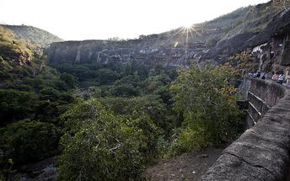
Ajanta Caves
Ajanta is world's greatest historical monument recognised by UNESCO. There are 30 caves in Ajanta of which 9, 10, 19, 26 and 29 are chaitya-grihas and the rest are monasteries. These caves were discovered in AD 1819 and were built up in the earlier 2nd century BC-AD. Most of the paintings in Ajanta are right from 2nd century BC-AD and some of them about the fifth century AD and continued for the next two centuries. All paintings shows heavy religious influence and center around Buddha, Bodhisattvas, and incidents from the life of Buddha and the Jatakas. The paintings are executed on a ground of mud-plaster in the tempera technique.

Day 5: Aurangabad

Breakfast is at the hotel. Later leave with your private chauffeur driven vehicle to Ellora followed by a tour of the city covering Bibi Ka Makbara.

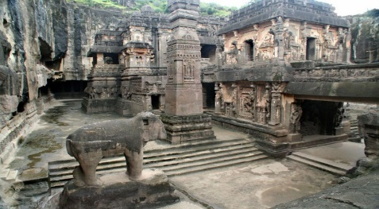
Ellora Caves
These 34 monasteries and temples, extending over more than 2 km, were dug side by side in the wall of a high basalt cliff. Ellora, with its uninterrupted sequence of monuments dating from A.D. 600 to 1000, brings the civilization of ancient India to life. Not only is the Ellora complex a unique artistic creation and a technological exploit but, with its sanctuaries devoted to Buddhism, Hinduism and Jainism, it illustrates the spirit of tolerance that was characteristic of ancient India.

Bibi Ka Maqbara
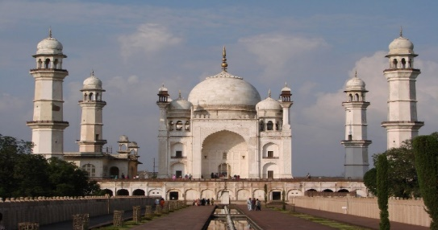
Known as the "poor man's Taj Mahal" or the "mini Taj", like the original it is a monument built in memory of love lost. In this case, it was a mother's love, rather than a wife's, that inspired Prince Azam Shah to build the structure between 1651 and 1661. The mini Taj was erected less than 30 years after the original composed of slightly more modest building materials, with limestone and plaster as well as marble under the all-marble onion dome. Marble was abundant in northern India, near Jaipur where the Taj Mahal was built. In order to build the Bibi Ka Maqbara, the marble had to haul on carts to the new capital of the Mughal empire. The construction took only 6 years, compared to the 22 years for the Taj Mahal. The grounds cover 458 x 275 meters of gardens. At the center of the building is the lone tomb of Rabia-ul-Daurani, third wife of the emperor, and mother of the architect.

Day 6: Aurangabad – Mumbai – Udaipur

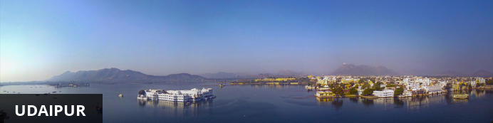
Dubbed the ‘Venice of the East’, the city of Udaipur is built around three interconnected lakes – Lake Pichhola, Fateh Sagar Lake and the smaller Swaroop Sagar Lake – and encircled by the hills of the Aravalli mountain range. It is home to an array of ancient temples and fairy-tale palaces (several of the latter have been converted into luxury heritage hotels) and is known as one of Rajasthan’s most beautiful and romantic cities. Must-see attractions include the City Palace, the Lake Palace (set on a small island in the middle of Lake Pichola) and the Udaipur Solar Observatory – Asia’s premier solar-gazing site.

Day Itinerary
After breakfast, your Travel Counsellors representative will assist you and then transfer to Aurangabad airport for the flight to Uaipur.
Arrive Udaipur where you will be assisted and taken to the hotel.

Day 7: Udaipur

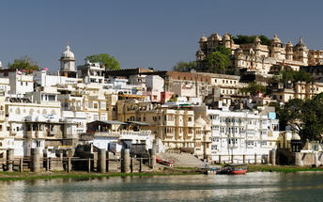
After breakfast, do a tour city tour of Udaipur covering City Palace, Jagdish temple and Saheliyon ki Bari and later in the evening enjoy shared boat ride at lake pichola. (Subject to water level)

Udaipur City Palace
Situated above Lake Pichola, Udaipur City Palace has housed many royals over four centuries who have each added their own unique preferences to the establishment. The palace is a one of a kind in Rajasthan. Constructed entirely out of marble and granite, which makes it highly luxurious. The inside is even more so with its inlays of coloured glass, engravings, towers, and balconies.

Jagdish Temple
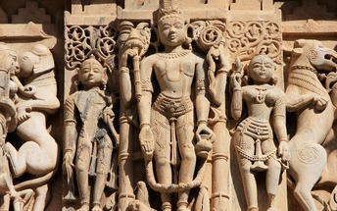
Completed in 1651, Jagdish Temple is situated just outside the royal palace. The temple can be seen as soon as visitors enter the city. Puja’s and prayer time are the best time to visit when melodious chants from devotees float through the small interior. Visitors should make a point of climbing the temple's many steps which invite them on a journey of discovery of the rich and vibrant history of Udaipur.

Saheliyon ki Bari
Built by Maharana Sangram Singh II as a garden for women, Saheliyon-ki-Bari or the Garden of the Maidens is a popular tourist destination. Along with a small museum, it has several attractions such as marble elephants, fountains, kiosks and a lotus pool.

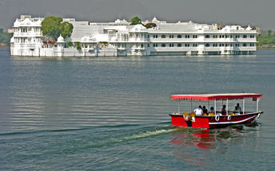
Boat ride at Lake Pichola
Pichola Lake is one of the most beautiful lakes in Rajasthan. Located in the heart of Udaipur, Pichola is the oldest and one of the largest lakes in all of Udaipur. In 1362 AD Pichola Lake was built by Banjara. Later, Maharana Udai Singh, affected by the charm of this lake and extended the lake when he founded the city of Udaipur and also built a dam made of stone that is in the Badipol region on the shore of the lake. Lofty Palaces, temples, bathing ghats and elevated hills on all its sides, envelop Pichola Lake.

Day 8: Udaipur – Jaipur

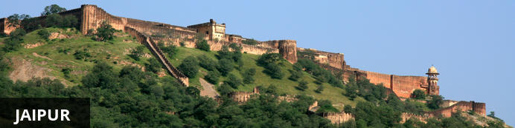
Fringed by the rugged Aravali Hills, Jaipur is the capital and largest city in India’s northern state of Rajasthan. This city is famed for being India’s first planned city featuring a multitude of pink terracotta buildings within the walled historic centre, earning it the nickname, ‘The Pink City’. Jaipur falls within the Golden Triangle, a popular tourist circuit, which includes Delhi, Jaipur and Agra, and serves as a gateway to the neighbouring desert cities of Jaisalmer and Jodhpur. This colourful city is a combination of tradition and modernity and offers visitors vibrant bazaars, lavish palaces and ancient temples. The salmon-hued old city is home to the opulent City Palace, encompassing an impressive assortment of palatial structures, sprawling gardens, courtyards and buildings. Do not miss the fairy-tale splendour of the Amber Fort, set against the backdrop of the arid landscape.

Day Itinerary
After breakfast, your Travel Counsellor representative will assist and transfer you to Udaipur airport for the flight to Jaipur.
Arrive Jaipur wherein you will be met and transferred to the hotel. Rest of the day is at leisure.

Day 9: Jaipur

After breakfast, enjoy Full day sightseeing tour of Jaipur covering Amer Fort, City Palace and the Observatory and a photo stop at Hawa Mahal “Palace of Winds”. Take a shared Jeep ride to reach Amer Fort.

Amer Fort
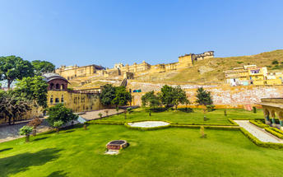
Amer Fort, officially known as the ‘Amer Palace’, is one of the most famous forts of Rajasthan attracting around 4000 to 5000 visitors a day during peak tourist season. The palace was named after the small town of Amer, where it is situated - only eleven kilometres from Jaipur. Perfectly picturesque, this 16th century hillside residence is well preserved, boasting grand pavilions and mirrored halls that open onto flourishing gardens and courtyards. Although the palace’s main construction started in 1592 by Maharaja Man Singh, it was added to over the years by successive rulers and continued to be occupied by them until Jaipur was built.

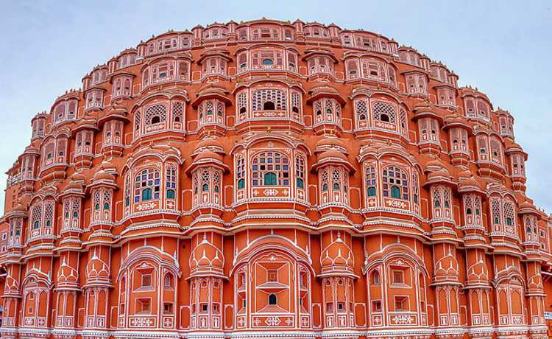
Hawa Mahal (Palace of Winds)
One of Jaipur’s most recognised buildings, the Hawa Mahal (Palace of Winds) is known for its iconic façade. Small windows, decorated with intricate latticework create a honeycomb-like appearance. The original intention of the lattice was to allow the royal women to observe everyday life in the street below without being seen. The cooling effect, provided by the breeze passing through the small windows, gave the palace its name. Built in 1799 by Maharaja Sawai Pratap Singh, the unique construction was originally designed to look like the crown of Krishna
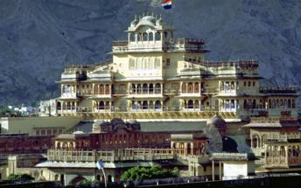

Jaipur City Palace
City Palace forms one of the most famous tourist attractions and a major landmark in Jaipur. The beautiful palace was built by Maharaja Sawai Jai Singh during his reign. Among the various forts and palaces of Jaipur, City Palace stands apart, with its outstanding art and architecture.

Jantar Mantar Jaipur
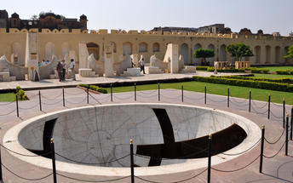
In 1734, the year of its completion, the Jai Singh Observatory was the last outpost of medieval science. From the outside, the eighteen fixed observational instruments look more like playground apparatus than sighting devices, but they were used to measure the position of the sun, stars and planets. Built by Jai Singh, the first Maharaja of Jaipur who founded the city in 1727, the observatory is one of a handful. Jai Singh, fulfilling a lifelong interest in mathematics and astronomy, built observatories in Delhi, Jaipur, Ujjain, Mathura and Benares. The Jaipur observatory is the largest and best preserved of these.

Day 10: Jaipur – Agra

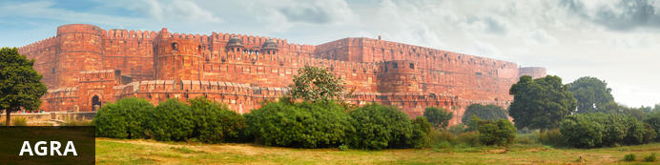
Home of the world-famous Taj Mahal, Agra is one of India’s prime tourist destinations for specifically this reason, though its attractions also extend to an array of other impressive historical sights. These include the red-hued Agra Fort, the sacred Jama Masjid mosque and Itmad-ud-Daulah’s tomb, with its white marble facade embellished with intricate inlaid designs and semi-precious gems. The Taj, however, is in a league of its own and is a must-see for any visitor to the city. Commissioned by the Mughal emperor Shah Jahan in the 15th century as a memorial to his beloved wife Mumtaz Mahal, it is an architectural masterpiece of exquisite artisanship and perfect proportions.

Day Itinerary
After breakfast, leave with your private chauffeur driven vehicle to Agra. [Approx. 260 Kms/ 06 Hrs] with a stop enroute at Fatehpur SIkri.

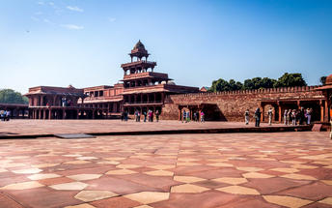
Fatehpur Sikri
This world heritage site is rated as one of the best-preserved collections of Mughal architecture in India. Surrounded by a six kilometre wall, with the fourth being a lake at the time, a day can be spent exploring the elaborate structures within. Marvel at the impressive Jama Masjid mosque, the detailed palaces built for Emperor Akbar’s wives, the public and private discussion halls and vast ornamental pool; all of which took over 15 years to conceptualise and build.
Arrive Agra and check-in at the hotel. Later in the day visit Agra Fort.

Agra Fort
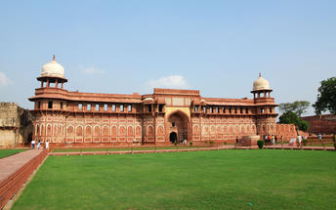
Known as the Red Fort of Agra, this walled imperial city was founded in 1565 by the Emperor Akbar (1556-1605) and is a well-deserving UNESCO World Heritage site, located just 2.5 kilometres from the famous Taj Mahal. Its palaces, grand mosques and elaborate public hall are crafted from pink-red sandstone and are testament to an era when Indo-Muslim art, strongly marked by influences from Persia, was at its height. Emperor Shah Jahan, who built the Taj Mahal for his deceased wife, was imprisoned by his son Aurangzeb in Agra Fort. He is said to have died in the Musamman Burj, a marble tower he himself built, with one of the most alluring views of the Taj Mahal.

Day 11: Agra – Delhi

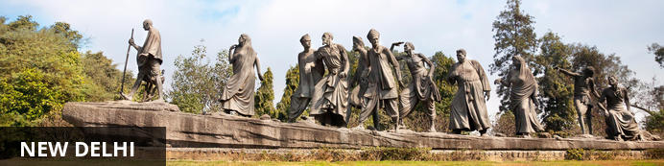
India’s largest city, Delhi, has been one of the country’s commercial and economic hubs for centuries and, as a result, is incredibly rich in culture and history. Made up of the ancient walled city of Old Delhi and the more modern sector, New Delhi, the city encompasses a staggering array of beautiful architecture, notable monuments and age-old temples, including three UNESCO World Heritage Sites – the Red Fort, Qutab Minar and Humayun's Tomb. Other key attractions include the 17th century Chandni Chowk marketplace – still one of the cities most popular retail centres today, particularly for jewellery and traditional Indian saris; and the Jama Masjid, India’s largest mosque.

Sunrise visit to Taj and then return to hotel for breakfast.
Please note, the monument is closed to public on Fridays.

Taj Mahal
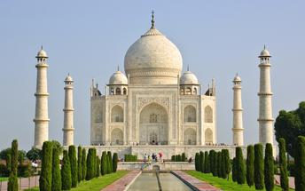
The iconic Taj Mahal is not only an architectural masterpiece, a UNESCO World Heritage Site and one of the new Seven Wonders of the World – it is also the enduring legacy of a royal love story. It was commissioned in the 15th century by the Mughal Emperor Shah Jahan after the death of his third and favourite wife, Mumtaz Mahal, to serve as her final resting place and a symbol of his eternal affection for her. Combining Islamic, Persian, Ottoman Turkish and Indian design elements, it’s an awe-inspiring structure of elegant domes and white marble, which changes colour along with the light – pink at sunrise, pearly white in the afternoon and silver-gold in the full moon.
After breakfast, leave with the your private cheauffeur driven vehicle to Delhi [Approx. 210 Kms / 05 Hrs]. Arrive Delhi and proceed to a tour of New Delhi.
The tour of New Delhi covers the UNESCO world Heritage sites of Humyauns tomb, Qutab Minar along with a photo stop at India Gate – the war memorial and drive past the Govt. Secretariat building and the President Palace.

Humayun's Tomb:
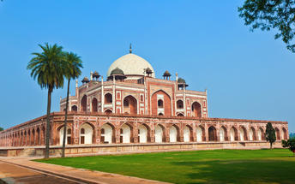
The mausoleum complex of Humayun, India’s second Mughal Emperor, was commissioned by his widow in 1565 and was the first garden tomb to be built in India, taking seven years to complete. Humayun had travelled widely in Persia and Central Asia during his lifetime, and many of the architectural principles he brought back from these journeys were incorporated into the building at his wife’s instructions. With its double domes, decorative inlaid marble and vast garden with pools connected by channels, this 16th Century building set the stage for the style that culminated in the Taj Mahal almost 100 years later.

Qutub Minar
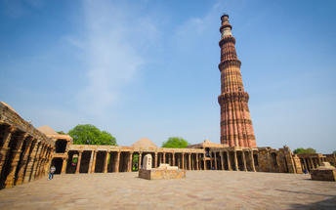
Standing tall at 73-metres, the tower consists of 5 storeys with a flight of spiral stairs leading to its top. The walls are adorned with decorative motifs and Quranic inscriptions. At the foot of the tower lie other monuments of historical significance, such as the Quwwat-ul-Islam Mosque and the Iron Pillar of Delhi. The Amazing race Australia used this site as a pit stop in the second series. Visitors can take advantage of stunning photo opportunities.

Day 12: Depart Delhi

At an appropriate time, your Travel Counsellor Representative will provide the necessary transfer to the airport for your onward flight back home.

