

IN: 06

Highlights of Rajasthan
New Delhi (A)- Agra (B) – Ranthambore (C) - Jaipur (D)- Jodhpur (E) – Nimaj (F) - Udaipur (G)- Mumbai (H)
17 Days / 16 Nights
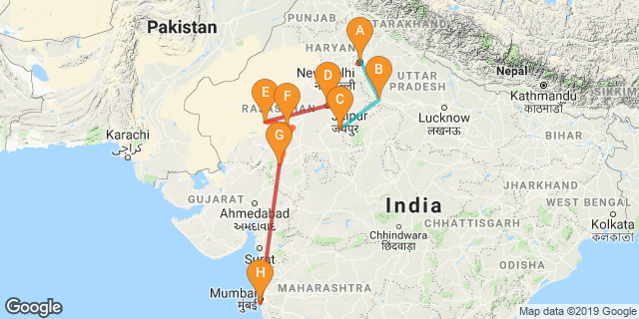

Overview: The journey covers the highlights of Rajasthan along with Golden Triangle – Delhi, Agra, Jaipur and Ranthambore National Park and Mumbai – the commercial capital of India.

Highlights: Culture, cuisine, Wildlife, Indian railways
- Explore the historic layers of the Old and New Delhi with its UNESCO world heritage sites.
- A heritage walk along with rickshaw ride through the fabled markets of “Chandni Chowk”
- Experience a journey on Indian Railways.
- Visit to “Taj Mahal” - the universally admired masterpiece of the world's heritage.
- Explore the deserted city of Fatehpur Sikri.
- Game drive into Ranthambore National Park in search of the elusive Bengal Tiger
- A cooking demonstration followed by a meal with a local family
- Explore the bustling bazaars of the Pink City of Jaipur.
- Cover the forts at Jaipur, Jodhpur and Udaipur

Day 1: Arrive Delhi

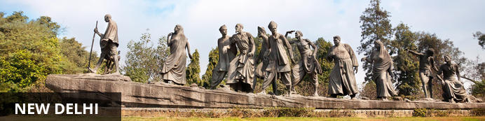
India’s largest city, Delhi, has been one of the country’s commercial and economic hubs for centuries and, as a result, is incredibly rich in culture and history. Made up of the ancient walled city of Old Delhi and the more modern sector, New Delhi, the city encompasses a staggering array of beautiful architecture, notable monuments and age-old temples, including three UNESCO World Heritage Sites – the Red Fort, Qutab Minar and Humayun's Tomb. Other key attractions include the 17th century Chandni Chowk marketplace – still one of the cities most popular retail centres today, particularly for jewellery and traditional Indian saris; and the Jama Masjid, India’s largest mosque.

On arrival in Delhi: Having cleared immigration, collected your luggage and passed through customs, please make your way towards the exit of the terminal building where you will see a bank of people waiting for you. Amongst them will be Travel Counsellors Representative who will be waiting to greet you with a paging board with your name on.
You will be transferred to your hotel and assisted with check in. Standard check in time is 1400 hrs.

Day 2: In Delhi

The day is scheduled for a heritage walk of Old Delhi in the morning followed by a tour of New Delhi in the afternoon.

Old Delhi Heritage Walk
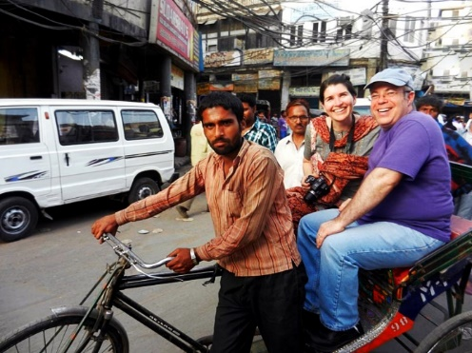
Delhi is one of very few places where the ancient and modern co-exist side-by-side complementing each other perfectly. Our heritage walks of Delhi are a perfect way of exploring this amalgam of old traditions, modern development and the unique heritage which makes it so interesting. It is the perfect way to explore some of the lesser visited places and gain a new insight about the history, people and sights of Delhi city.
The tour of New Delhi covers the UNESCO world Heritage sites of Humyauns tomb, Qutab Minar along with a photo stop at India Gate – the war memorial and drive past the Govt. Secretariat building and the President Palace.

Humayun's Tomb:
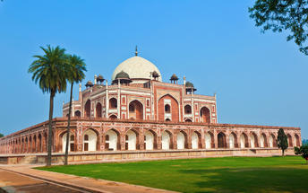
The mausoleum complex of Humayun, India’s second Mughal Emperor, was commissioned by his widow in 1565 and was the first garden tomb to be built in India, taking seven years to complete. Humayun had travelled widely in Persia and Central Asia during his lifetime, and many of the architectural principles he brought back from these journeys were incorporated into the building at his wife’s instructions. With its double domes, decorative inlaid marble and vast garden with pools connected by channels, this 16th Century building set the stage for the style that culminated in the Taj Mahal almost 100 years later.

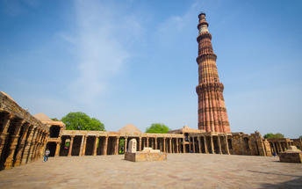
Qutub Minar
Standing tall at 73-metres, the tower consists of 5 storeys with a flight of spiral stairs leading to its top. The walls are adorned with decorative motifs and Quranic inscriptions. At the foot of the tower lie other monuments of historical significance, such as the Quwwat-ul-Islam Mosque and the Iron Pillar of Delhi. The Amazing race Australia used this site as a pit stop in the second series. Visitors can take advantage of stunning photo opportunities.

Day 3: Delhi- Agra

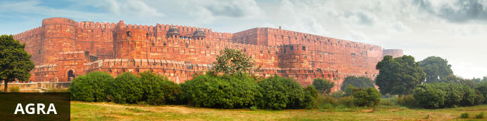
Home of the world-famous Taj Mahal, Agra is one of India’s prime tourist destinations for specifically this reason, though its attractions also extend to an array of other impressive historical sights. These include the red-hued Agra Fort, the sacred Jama Masjid mosque and Itmad-ud-Daulah’s tomb, with its white marble facade embellished with intricate inlaid designs and semi-precious gems. The Taj, however, is in a league of its own and is a must-see for any visitor to the city. Commissioned by the Mughal emperor Shah Jahan in the 15th century as a memorial to his beloved wife Mumtaz Mahal, it is an architectural masterpiece of exquisite artisanship and perfect proportions.

Day Itinerary
After breakfast, you will be transferred to railway station to board the train to Agra.
Train Gatimaan Express (daily except on Fridays)
Departs Delhi 0810 Hrs
Arrives Agra 0950 Hrs

Upon arrival at Agra, you will be assisted & transferred and taken directly to Agra Fort for the visit followed by check-in at the hotel. (Standard check in time at the hotel is 1400 Hrs).
Later in the evening, visit Taj Mahal at sunset.

Agra Fort
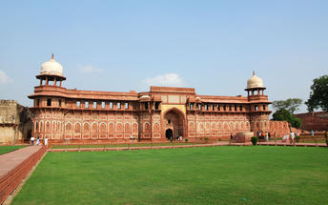
Known as the Red Fort of Agra, this walled imperial city was founded in 1565 by the Emperor Akbar (1556-1605) and is a well-deserving UNESCO World Heritage site, located just 2.5 kilometres from the famous Taj Mahal. Its palaces, grand mosques and elaborate public hall are crafted from pink-red sandstone and are testament to an era when Indo-Muslim art, strongly marked by influences from Persia, was at its height. Emperor Shah Jahan, who built the Taj Mahal for his deceased wife, was imprisoned by his son Aurangzeb in Agra Fort. He is said to have died in the Musamman Burj, a marble tower he himself built, with one of the most alluring views of the Taj Mahal.

Taj Mahal
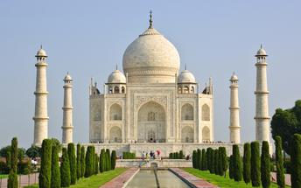
The iconic Taj Mahal is not only an architectural masterpiece, a UNESCO World Heritage Site and one of the new Seven Wonders of the World – it is also the enduring legacy of a royal love story. It was commissioned in the 15th century by the Mughal Emperor Shah Jahan after the death of his third and favourite wife, Mumtaz Mahal, to serve as her final resting place and a symbol of his eternal affection for her. Combining Islamic, Persian, Ottoman Turkish and Indian design elements, it’s an awe-inspiring structure of elegant domes and white marble, which changes colour along with the light – pink at sunrise, pearly white in the afternoon and silver-gold in the full moon.

Day 5: Agra- Ranthambore


Ranthambore National Park, in the western state of Rajasthan, is one of the most visited wildlife parks in India. Spanning over an impressive 1300-square-kilometer stretch of wilderness, the park’s outstanding natural beauty is characterized by its dense jungle, golden savanna, dramatic cliffs and lotus-filled lakes. Considered the best spot to catch a glimpse of tigers in the wild, the park offers visitors a spellbounding combination of mystical temples, wild beauty and crumbling ruins. While the main attraction is undoubtedly the elusive Bengal tiger, the park provides a sanctuary for other wildlife including, among others: sambar, gazelle, caracal, black buck, crocodile, chital, wild boars and a wide array of birds. Don’t miss the ancient Ranthambore Fort, perched high on the cliffs overlooking the vast expanse of this spectacular park.

After breakfast check out from the hotel and leave with your private chauffeur driven vehicle to Fathepur Sikri. After the visit, proceed to Bhararput train station for the train ride to Sawai Madhopur.

Fatehpur Sikri
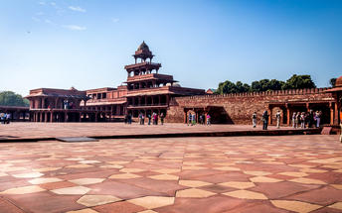
A highlight in the province of Uttar Pradesh, Fatehpur Sikri served briefly as the capital of the Mughal Empire from 1571 to 1585. This world heritage site is rated as one of the best-preserved collections of Mughal architecture in India. Surrounded by a six-kilometre wall, with the fourth being a lake at the time, a day can be spent exploring the elaborate structures within. Marvel at the impressive Jama Masjid mosque, the detailed palaces built for Emperor Akbar’s wives, the public and private discussion halls and vast ornamental pool; all of which took over 15 years to conceptualise and build.
After the visit, your Travel Counsellor Representative will transfer you to Bharatpur railway station (approx 25 kms/ 40 minutes) to board the train to Sawai Madhopur
Train Kota Jn Shatabdi
Departs Bharatpur 1550 Hrs
Arrive Sawai Madhopur 1802 Hrs

Upon arrival at Sawai Madhopur, you will be met and taken to the hotel for check in.

Day 6: In Ranthambore

Enjoy morning and afternoon game drive in to the park. The game drive is either by shared jeep (max. 6 persons in a jeep) or by open bus (canter – max 20 person). The schedule of the game drive is :
Morning : 0600 – 0930 hrs
Afternoon : 1500 – 1800 hrs

Day 7: Ranthambore - Jaipur

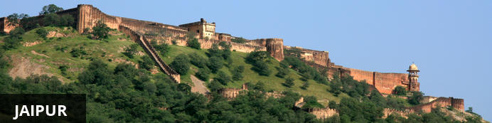
Fringed by the rugged Aravali Hills, Jaipur is the capital and largest city in India’s northern state of Rajasthan. This city is famed for being India’s first planned city featuring a multitude of pink terracotta buildings within the walled historic centre, earning it the nickname, ‘The Pink City’. Jaipur falls within the Golden Triangle, a popular tourist circuit, which includes Delhi, Jaipur and Agra, and serves as a gateway to the neighbouring desert cities of Jaisalmer and Jodhpur. This colourful city is a combination of tradition and modernity and offers visitors vibrant bazaars, lavish palaces and ancient temples. The salmon-hued old city is home to the opulent City Palace, encompassing an impressive assortment of palatial structures, sprawling gardens, courtyards and buildings. Do not miss the fairy-tale splendour of the Amber Fort, set against the backdrop of the arid landscape.

Early morning game drive into the Park.
After breajast, check-out and leave with your private chauffeur driven vehicle to Jaipur (approx 145 kms./ 04 hours drive). Arrive Jaipur and check-in at the hotel.
Rest of the day is at leisure.

Day 8: In Jaipur
After breakfast, enjoy Full day sightseeing tour of Jaipur covering Amer Fort, City Palace and the Observatory and a photo stop at Hawa Mahal “Palace of Winds”. Take a shared Jeep ride to reach Amer Fort.

Amer Fort
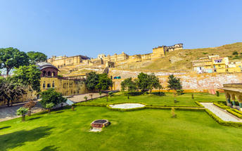
Amer Fort, officially known as the ‘Amer Palace’, is one of the most famous forts of Rajasthan attracting around 4000 to 5000 visitors a day during peak tourist season. The palace was named after the small town of Amer, where it is situated - only eleven kilometres from Jaipur. Perfectly picturesque, this 16th century hillside residence is well preserved, boasting grand pavilions and mirrored halls that open onto flourishing gardens and courtyards. Although the palace’s main construction started in 1592 by Maharaja Man Singh, it was added to over the years by successive rulers and continued to be occupied by them until Jaipur was built.

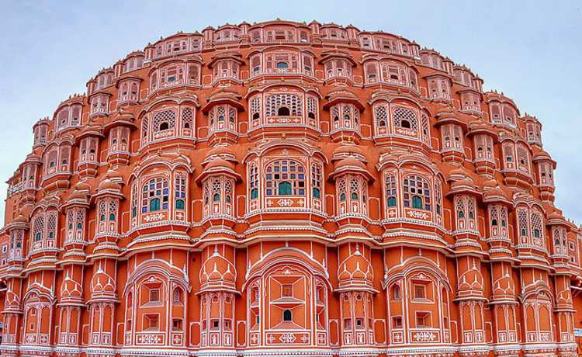
Hawa Mahal (Palace of Winds)
One of Jaipur’s most recognised buildings, the Hawa Mahal (Palace of Winds) is known for its iconic façade. Small windows, decorated with intricate latticework create a honeycomb-like appearance. The original intention of the lattice was to allow the royal women to observe everyday life in the street below without being seen. The cooling effect, provided by the breeze passing through the small windows, gave the palace its name. Built in 1799 by Maharaja Sawai Pratap Singh, the unique construction was originally designed to look like the crown of Krishna
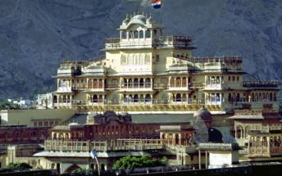

Jaipur City Palace
City Palace forms one of the most famous tourist attractions and a major landmark in Jaipur. The beautiful palace was built by Maharaja Sawai Jai Singh during his reign. Among the various forts and palaces of Jaipur, City Palace stands apart, with its outstanding art and architecture.

Jantar Mantar Jaipur
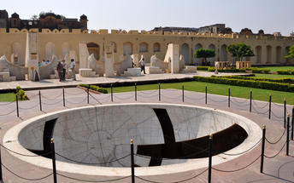
In 1734, the year of its completion, the Jai Singh Observatory was the last outpost of medieval science. From the outside, the eighteen fixed observational instruments look more like playground apparatus than sighting devices, but they were used to measure the position of the sun, stars and planets. Built by Jai Singh, the first Maharaja of Jaipur who founded the city in 1727, the observatory is one of a handful. Jai Singh, fulfilling a lifelong interest in mathematics and astronomy, built observatories in Delhi, Jaipur, Ujjain, Mathura and Benares. The Jaipur observatory is the largest and best preserved of these.

Day 9: Jaipur- Jodhpur

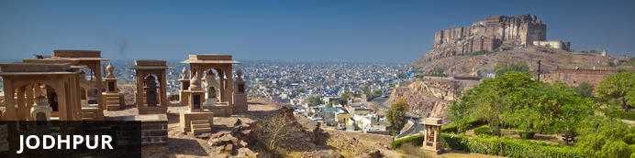
Known as the gateway to the Thar Desert, Jodhpur is the second largest city in the state of Rajasthan, India. It is a popular tourist destination featuring a variety of ornate palaces, age-old forts and sacred temples. Dubbed “The Blue City", most houses in the old city are painted a beautiful shade of indigo. While Jodhpur is largely a sprawling modern metropolis, enclosed within its old city walls is a labyrinth of winding, narrow medieval streets and bazaars. Jodhpur is home to one of the largest forts in India, the massive 15th-century Mehrangarh Fort, which towers over the city from its sandstone plinth. Other must-see attractions include the Umaid Bhawan Palace, one of the world's largest private residences; and the Jaswant Thada, an intricately carved white marble mausoleum.

After breakfast, leave with your private chauffeur driven vehicle to Jodhpur. (Approx. 295 kms / 6 hours’ drive)
Arrive Jodhpur and check in at the hotel. Rest of the day is at leisure.

Day 10: In Jodhpur

After breakfast do the tour of the city covering the majestic Mehrangarh Fort and Jaswant Thada.

Mehrangarh Fort
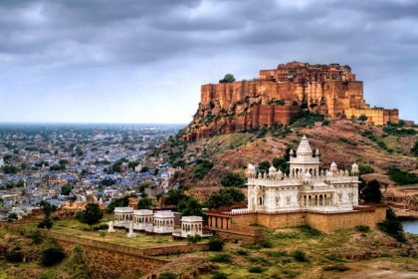
Mehrangarh Fort rises four hundred feet above the skyline of Jodhpur from its rock precipice on Bhaurcheeria hill. The foundation of Mehrangarh Fort was laid on May 12, 1459 by Rao Jodha, the fifteenth Rathore ruler who wanted to shift the capital from nearby Mandore to Jodhpur. In all its history, Mehrangarh Fort has never been taken in a siege. Mammoth and imposing from the outside, the interiors of the fort are light and detailed in contrast. Several palaces can be found inside the complex, boasting intricate carvings and sprawling courtyards.

Jaswant Thada
If you are looking for a quiet place in Jodphur head to Jaswant Thada, popularly known as the ‘Taj Mahal of Marwar’. This architectural landmark was built in 1899 by Maharaja Sardar Singh of Jodhpur State, in memory of his father, Maharaja Jaswant Singh I. Built from intricately carved marble sheets and boasting some beautiful carved marble lattice work, the impeccable design and architecture is symbolic of the fine craftsmanship of a bygone era. Beautiful sculptures, carved gazebos and frescos characterise the cenotaph, with the tiered garden offering superb views across to the fort and over the city.

Day 11: Jodhpur- Chhatrasagar

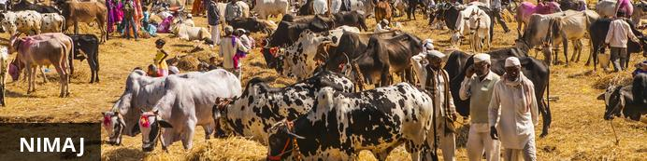
Nimaj is a tranquil farming hideaway on the edge of the Aravalli Hills. Roughly half way between Jaipur and Jodhpur, it is a great destination for a rural break as part of a tour of Rajasthan. The lakes in the area a renowned for their birdlife with flocks of migratory birds: waders and wildfowl which visit during the winter months. One of the highlights of the village is the Nimaj Palace Heritage Hotel, an exquisite palace occupied by royalty since Medieval times. Other buildings of the same era include the Magarmandi Mata Temple. For a unique accommodation experience, visitors to the area can stay at the Chhatra Sagar Camp, a collection of five-star luxurious tents overlooking the lake and featuring private outside areas.

After breakfast, leave with your private cheauffeur driven vehicle to Nimaj (approx 120 kms/ 03 hours drive)
Arrive Nimaj and check in at the luxury tent.

Day 12: In Chhatrasagar

During your stay at Chhatra Sagar, Nimaj you may choose to take a village tour or simply watch birds that flock close to the water body.

Day 13: Chhatrasagar- Udaipur

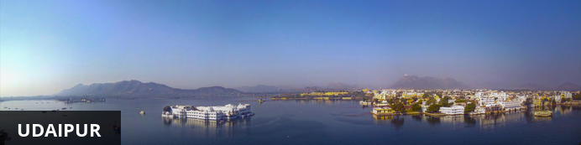
Dubbed the ‘Venice of the East’, the city of Udaipur is built around three interconnected lakes – Lake Pichhola, Fateh Sagar Lake and the smaller Swaroop Sagar Lake – and encircled by the hills of the Aravalli mountain range. It is home to an array of ancient temples and fairy-tale palaces (several of the latter have been converted into luxury heritage hotels) and is known as one of Rajasthan’s most beautiful and romantic cities. Must-see attractions include the City Palace, the Lake Palace (set on a small island in the middle of Lake Pichola) and the Udaipur Solar Observatory – Asia’s premier solar-gazing site.

After breakfast, leave with your private chauffeur driven vehicle to Udaipur (approx 295 Kms/ 7 hours drive) with a stop at the magnificent 15th century Jain temples at Ranakpur.
Arrive Udaipur and check in at the hotel.

Ranakpur
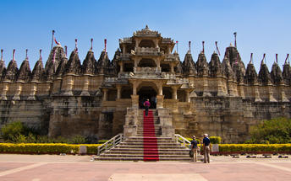
The small town of Ranakpur is home to what is arguably the most spectacular of all India’s Jain temples. The complex rests on a lush mountain slope and encompasses a series of temples dating to the 15th century, all constructed from white marble and featuring exquisite decorative detail. The main temple, Chamukha, is a multi -tiered structure with no less than 80 domes and over 1400 pillars, all of which are intricately carved with unique designs – no two are alike. As the light changes during the day, so does the colour of the temple interior, shifting from golden to cream and then pale blue at dusk.

Day 14: In Udaipur

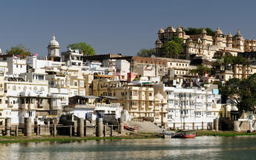
After breakfast, do a tour city tour of Udaipur covering City Palace, Jagdish temple and Saheliyon ki Bari and later in the evening enjoy shared boat ride at lake pichola. (Subject to water level)

Udaipur City Palace
Situated above Lake Pichola, Udaipur City Palace has housed many royals over four centuries who have each added their own unique preferences to the establishment. The palace is a one of a kind in Rajasthan. Constructed entirely out of marble and granite which makes it highly luxurious. The inside is even more so with its inlays of coloured glass, engravings, towers, and balconies.

Jagdish Temple
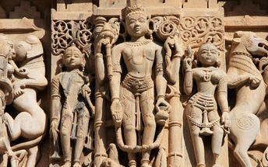
Completed in 1651, Jagdish Temple is situated just outside the royal palace. The temple can be seen as soon as visitors enter the city. Puja’s and prayer time are the best time to visit when melodious chants from devotees float through the small interior. Visitors should make a point of climbing the temple's many steps which invite them on a journey of discovery of the rich and vibrant history of Udaipur.

Saheliyon ki Bari
Built by Maharana Sangram Singh II as a garden for women, Saheliyon-ki-Bari or the Garden of the Maidens is a popular tourist destination. Along with a small museum, it has several attractions such as marble elephants, fountains, kiosks and a lotus pool.

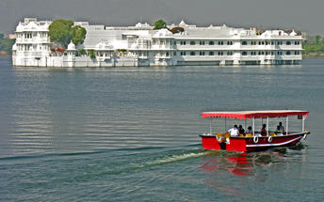
Boat ride at Lake Pichola
Pichola Lake is one of the most beautiful lakes in Rajasthan. Located in the heart of Udaipur, Pichola is the oldest and one of the largest lakes in all of Udaipur. In 1362 AD Pichola Lake was built by Banjara. Later, Maharana Udai Singh, affected by the charm of this lake and extended the lake when he founded the city of Udaipur and also built a dam made of stone that is in the Badipol region on the shore of the lake. Pichola Lake is enveloped by lofty Palaces, temples, bathing ghats and elevated hills on all its sides.

Day 15: Udaipur- Mumbai

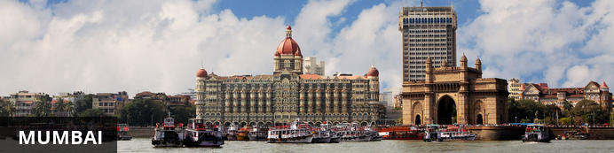
The thriving metropolis of Mumbai is a go-to destination for travellers curious to experience a modern Indian city. Lapped by the Arabian Sea, this urban seaside peninsula is a melting pot of old and new India. Towering office blocks and shiny apartment buildings shoulder crumbling grand dames of architecture. Men play cricket in the leafy central parks, taxis navigate the jam-packed streets and families stroll along the seaside promenades of Mumbai, while kilometres away children beg on the peripheries of Asia’s biggest slum. In the wide avenue of Colaba’s high street, western culture overshadows the brightly lit storefronts, where Levi’s, Adidas and McDonalds vie for retail space.

Breakfast at the hotel. Later at an appropriate time, your Travel Counsellors representative will provide you the necessary transfer to the airport to board the flight to Mumbai
Upon arrival at Mumbai airport, you will be assisted & transferred to the hotel for check in. Rest of the day is at leisure.

Day 16: In Mumbai

After breakfast, take a full day tour our Mumbai, beginning with an excursion to Elephanta Caves [Closed on Monday]

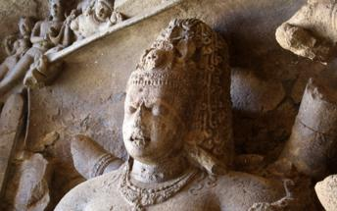
Elephanta Caves
Elephanta Caves is UNESCO World Heritage site is a fine specimen of rock cut architecture and art of medieval India. To state the trivial, there are no elephants in Elephanta! The name was given by the Portuguese as there was a large elephant sculpture in the island, when it was held by them. Otherwise this island was known as Gharapuri. The island is known for the 7th century caves with boldly executed mythical themes.
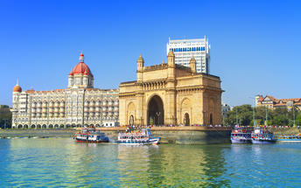
Gateway of India – Located on the waterfront in Apollo Bunder, the Gateway is a basalt arch 26 metres (85 ft) high. It was a crude jetty used by fisher folks and was later renovated and used as a landing place for British governors and other distinguished personages.

Malabar Hills. The colonial bungalows that peppered the hillside in the 18th century have now been replaced by the apartment blocks of Mumbai. You would visit Victoria Terminus, and Mani Bhavan - the old Mumbai residence of Mahatma Gandhi. It is a pretty, two-storied structure that now houses a reference library with over 2000 books, a photo exhibition of the Mahatma's life, and well preserved memorabilia, including an old charkha or spinning wheel that Gandhi ji used to use.

Dhobhi Ghat
A unique feature of Mumbai, the dhobi is a traditional laundryman, who collects dirty linen, washes it, and return it neatly pressed. The most famous of these Dhobi Ghats Mahalaxmi dhobi ghat, the world's largest washerman colony is at Saat Rasta near Mahalaxmi Station where almost 731 dhobis and their families work together in what has always been a hereditary occupation. This area is strangely popular with foreign tourists looking for a piece of quintessential Indianness

Marine Drive
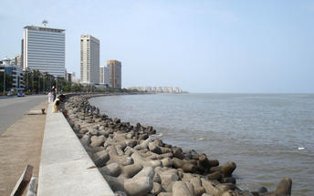
Marine Drive (officially, "Netaji Subhash Chandra Bose Road") is a 3km long, six lane concrete road in southern Mumbai which stretches north along the coastline, forming a natural bay. This C-shaped road links Nariman Point to Babulnath, and is situated at the foot of Malabar Hill. Known world over as Marine Drive, this tourist spot has also been called Sonapur by the locals of the city. Large crowds of people come to this place to stride along the beautiful walkway and to view the stunning sight of the setting sun at dusk. The scenic beauty of the perfectly lined palm trees offers its visitors an enthralling experience. Marine Drive is also referred to as 'Queen's necklace', because the street lights make the road look like a string of pearls and create an illusion of a necklace, when viewed at night from any elevated point along the pathway of the drive.

Day 17: Mumbai Departure

At an appropriate time, your Travel Counselldor representative will provide you the necessary transfers to the airport.

