

IN: 06

Homestays of Kerala- the Gods own country
Kochi (A) - Dewalokam (B) – Thekkady (C) – Alappuzha (D) – Kovalam (E)
11 Days / 10 Nights
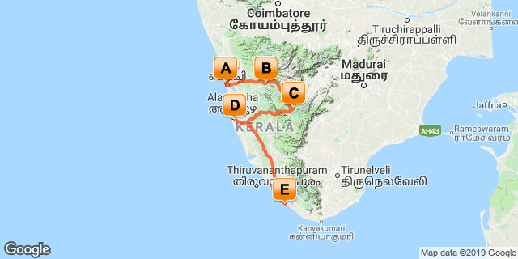

Overview: A journey through Kerala – widely known as Gods Own Country with its
Highlights: Family, Culture, Nature, Backwater, Beach, Spa, Ayurveda and Wellness
- Explore Fort Kochi with its churches, Chinese fishing net, Jewish synagogue and Dutch palace
- Try your luck on Chinese fishing net with the locals for the fresh catch of the day
- Witness Kathakali dance performance at a local theatre
- Experience the rural life at Dewalokam
- Learn out spices
- Nature walk through the National Park
- Cruise on the backwaters of Kerala
- Wellness, yoga/meditation
- Beach life

Day 1: Arrive Cochin

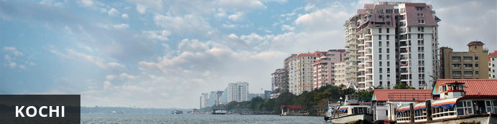
Also known as Cochin, Kochi is a city in southwest India's coastal Kerala state. This attractive city has served as a popular port for over 600 years and is known for its eclectic architecture and its array of religious monuments, museums, galleries, cafes and antique shops. The city stretches across a number of peninsulas and islands, which can be reached by a network of water taxis and bridges. The majority of Kochi’s visitor highlights can be found on the peninsula of Fort Kochi. These highlights include the St Francis Church, the oldest European-built church in India; and Mattancherry Palace, which dates back to 1557 and contains some exceptional Kerala murals and temple art. Other must-see attractions include the Kerala Folklore Museum, displaying more than 4,000 cultural and ethnic artifacts; the 16th-century Jewish Synagogue; and the local market, where the air is filled with the aroma of exotic spices.

Fly in to Kochi where you will be received by a Travel Counsellor Representative and he will transfer you to your hotel for check in. (Standard check in time – 1400 Hrs)

Day 2: In Cochin

A day to explore the city visiting Fort Kochi, Chinese fishing nets, the Jewish Synagogue, Dutch Palace and witness a Kathakli dance performance at a local theatre.

Fort Kochi
Fort Kochi takes its name from a long-gone fort which was built during its occupation by the Portuguese. The Portuguese were followed by the Dutch, who left their own legacy, and hot on their heels came the British with their own unique ways. Independent now for many years, Fort Kochi remains a colourful melting pot of diversity, retaining its colourful history in its architecture and culture.

Jewish Synagogue (Closed on Friday afternoon and Saturdays)
This synagogue was built in 1568 by the Malabar Yehudans or Cochin Jewish community. It was built close to the Mattancherry Palace Temple on the land gifted by King Rama Varma, a former ruler of Kochi. The Mattancherry Palace Temple and the Mattancherry synagogue share a common wall. This synagogue is the oldest one in the Commonwealth of Nations.
As one approaches the synagogue on Jew Street, its white facade begins to appear very prominently. A clock tower can also be seen, towering over and close to the facade. This was built in 1760 by Ezekiel Rahabi an affluent Jewish businessman. Of the four faces of the clock, the one facing the maharaja's palace showed the time in Malayalam. And among the other three, the face with etchings in Roman numerals was meant for the traders. Of the remaining two faces of the clock, one had writings in Hebrew while the other remains blank.
Stepping inside the Synagogue, one's eyes would easily go to the glass chandeliers and blue willow-patterned Chinese floor tiles. The chandeliers are of Belgian origin. Also of interest are the Scrolls of the Law housed here and the several gold crowns received as gifts and the brass-railed pulpit. And for some exclusive pieces from history, the synagogue also houses the copper plates of privileges given to Joseph Rabban, the earliest known Cochin Jew, dating from the 10th century, written in Tamil, by the ruler of the Malabar Coast.

Kathakali
Kathakali is a highly stylized classical kerala dance performance noted for its attractive make-up of characters, their elaborate costumes, detailed gestures and well-defined body movements presented in tune with the anchor playback music and complementary percussion.
Kathakali is said to have evolved from other performing arts like Kootiyattam (a classical Sanskrit drama existing in Kerala), Krishnanattam and Kalarippayattu. Kathakali explicates ideas and stories from the Indian epics and Puranas.
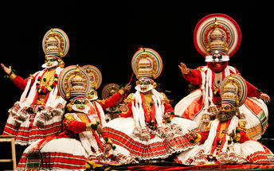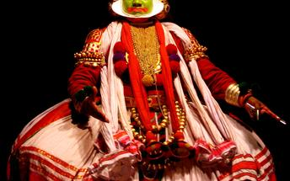

Day 3: Cochin- Dewalokam
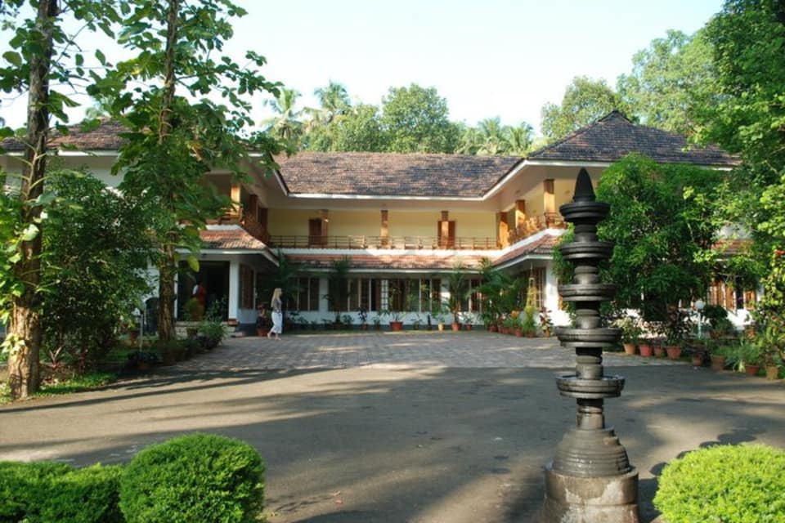
After breakfast, leave with your private chauffeur driven vehicle to Dewalokam [approx. 75 kms/ 2 hours drive]. Arrive Dewalokam and check in at the homestay.
Dewalokam is the ancestral farm of the Alilakuzhy family, an ancient Syrian Christian family of Kerala. A stay at Dewalokam is a truly unique way to relax and unwind in a secluded, unspoilt environment. The homestay offers freshly cooked home grown produce and gourmet traditional Keralan food. Guests can join professional chefs in the state of the art kitchen for informal cooking lessons. The farm is run on organic and eco principles as the water is heated with solar power, vegetables grown with home-made compost, chickens and goats fed on vegetable waste and methane from the cow manure is recovered, to provide gas for cooking. Dewalokam is family-run lodge and the staff are all local villagers, thus directly supporting sixteen local families and educating the children. The natural beauty includes a safe, clean river, which forms a natural boundary; beyond which is a nature reserve, and the Nilgiri mountains, which is a haven for wildlife. Dewalokam offers Authentic Yoga and Ayurveda packages at the retreat.

Day 4-5: In Dewalokam
-
Stay at the homestay with all meals. During the stay, the guests have the option to do the following activities : the day participate the activities offered by the hosts.
- Spice walk [Guided walk in the organic farm]
- Bamboo rafting,
- Cooking demo
- visit to Thommankuthu waterfall
- visit to School
- Village walk.

Day 6: Dewalokam- Thekkady

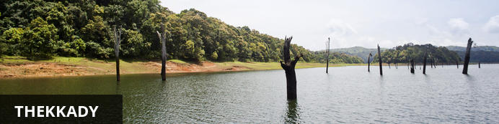
Thekkady comprises evergreen forests and savanna grasslands, and is known for its natural spices such as black pepper, cardamom, cinnamon, nutmeg, ginger and clove. Elephants, tigers, sambar and many other species inhabit the park. Top attractions include the exquisite ancient Mangla Devi Temple, the aromatic Abraham’s spice garden, and the massive waterfall at the sleepy, picturesque village of Chellarkovil. Take in panoramic views of the extraordinary landscape from the Chellarkovil viewpoint, and picnic on the rolling, lush green lawns at Pandikuzhi. Don’t miss the opportunity to visit the Kadathanadan Kalari Centre, to see demonstrations of the best traditional martial arts. Thekaddy is home to India’s sole Tiger Reserve, and has a rich living tribal culture.

After breakfast, leave with your private chauffeur driven vehicle to Periyar. (approx. 98 Kms / 3 Hrs drive). Arrive Periyar and check in at the hotel. Later take a nature walk at Periyar National park followed by a visit to a spice plantation.

Nature Walk
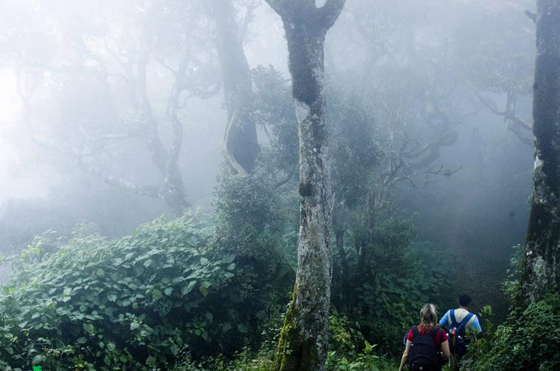
Different nature trails traversing diverse habitats form the trekking routes, generally 4 to 5 km. in length. This is an interpretive program offering excellent opportunity to watch birds, butterflies and other wildlife. The trails often pass through evergreen and moist deciduous forests interspersed with marshy grasslands. The program is offered between 7.00 am and 10.30 am and between 2.00 pm. and 3.00 pm. and lasts for about 3 hours. A maximum of 5 persons can go for trekking at a time along each nature trail, accompanied by a trained tribal guide. The Nature walk is the right program to feel nature, hear her whispers and smell her flowers.

Spice Plantation
The visit take you to the plantation where one can see, learn about the spices such as cardamom, pepper, vanilla, clove, cinnamon, nutmeg, ayurvedic herbs etc.

Day 7: Thekkady- Alleppey

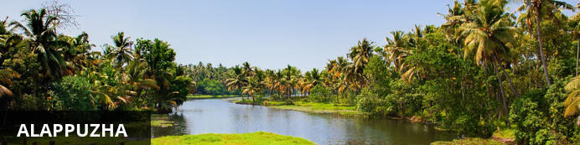
Dubbed the ‘Venice of the East’, it is renowned for its houseboat cruises which float along the tranquil backwater canals of Kerala. It is said to be one of the most popular tourist centres in the state. While cruising the palm-shaded canals is the main attraction, visitors can also enjoy visiting Alappuzha’s beautiful beaches, exploring the little riverside villages dotting the lush countryside and discovering an array of resplendent temples. Do not miss the annual Nehru Trophy Boat Race held at Punnamada Lake.

After breakfast, leave with your private chauffeur driven vehicle to Alleppey [Approx. 130 Kms / 4 Hours’]. On arrival, board the Houseboat for a cruise over the backwaters of Kerala.
The houseboats or Kettuvallam as they are traditionally called were at one time the mode of transportation for man and goods. Today, these are made to cater to the discerning guests who can lay back and enjoy the gentle cruise. Cruise the backwaters from the main Vembanad Lake through the small estuaries that link small villages to the mainland. Today, these are refurbished and all modern conveniences have been added for tourists who visit this beautiful water locked region of the country.

The houseboat cruise takes you through the intricate maze of backwaters, mesmerizing and surprising you at every turn with its serene beauty & simple charm. Enjoy the countryside of Kerala at its best. Soak your eyes & soul with array of coconut trees & endless paddy fields. You will also get chance to take a small stroll through the villages & interact with the locals.

Day 8: Alleppey- Kovalam

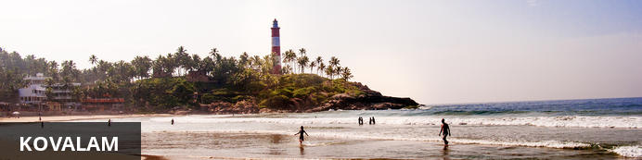
Conveniently located only 16 km from the city of Thiruvananthapuram, Kovalam is a small but well-developed tourist village on the coast of the southern Indian state of Kerala. This busy little beach town is renowned for its exquisite palm-lined surf beaches including the well-known Lighthouse Beach, which is lined with an array of excellent hotels, restaurants and shops, and features a striped lighthouse at its southern end. The village attracts countless surfers with its thriving surf culture, excellent waves, and popular surf club. Other activities on offer include enjoying wonderfully relaxing Ayurvedic massages, sampling the delicious local seafood, sightseeing in the surrounding area, and indulging in a range of exhilarating water sports.

After breakfast, disembark the houseboat and then leave with your private chauffeur driven vehicle to Kovalam [approx. 180 kms/ 05 hours].
Arrive Kovalam and check in at the hotel.

Day 9-10: In Kovalam

Day is at leisure at the Resort with option to do the beach activities or rejuvenate with some Ayurveda / spa massages or do some yoga/meditation sessions..

Day 11: Kovalam- Trivandrum departure

At an appropriate time, your Travel Counsellor Representative will assist and transfer you to the international airport [approx. 40 minutes’ drive]

