

IN-07

Karnataka with Beach
Bangalore (A) – Mysore (B) – Hassan (C) – Hampi (D) – Badami(E) – Goa(F)
16 Days / 15 Nights
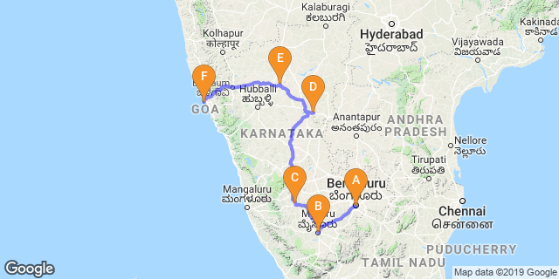

Overview: This journey covers travel in western coast of India including Karnataka and Goa. Karnataka is famous for its natural, cultural and architectural heritage and Goa is is famous for its Beautiful beaches, nightlife party, and hospitality, carnival and water sports.

Highlights: Culture, Heritage, Beach, Family Holiday.

- Explore Bangalore – the silicon valley
- Visit the historic city of Mysore.
- Visit the rich culture, ancient monuments and temples of Hassan, Hampi and Badami.
- Enjoy the lively culture of Goa and of course the pristine beaches

Day 1: Arrive Bangalore

Known as the ‘garden city’, Bangalore offers a leafy backdrop from which to explore the bustling streets of India’s third largest city. Cosmopolitan restaurants line wide avenues where foodies can delight in a smorgasbord of south Indian flavours. Tea lovers can indulge in fragrant cups of Chai and a spell of people-watching from any of the tea stalls dotted around the city. A booming IT industry coupled with a city that seeks to preserve its green and colonial heritage has created a modern and sophisticated metropolis. Recently voted the most liveable city in India, Bangalore makes a great base for travelling southern India.

On arrival in Bangalore: Having cleared immigration, collected your luggage and passed through customs, please make your way towards the exit of the terminal building where you will greeted by your Travel Counsellors Representative who will then be taken you to your hotel of stay. Normal check in time at the Hotel is 1400 Hrs.

Day 2: Bangalore

After breakfast, enjoy half day Bangalore city tour covering the Bull Temple followed by Tipu Palace. Drive past the local markets (Vegetables & Fruits), Vidhan Sowdha (State Parliament), the botanical gardens at Lalbagh. Rest of the day is at leisure to explore the city on your own.

Bull Temple

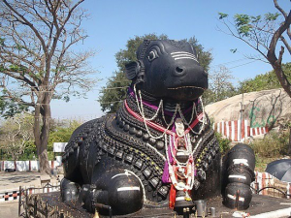
Bull Temple is among the oldest temples in the city, which is dedicated to Nandi, the wagon of Lord Shiva. Associated with mythological and religious significance, the shrine is a renowned worship place. Situated atop a mountain, the temple was built in the 16th Century, during the Vijayanagara Rule. The temple is relatively small in size, but houses one of the largest Nandi sculptures in the world. It boasts a monolithic stat ue of deity Nandi, which is 4.5 meters tall and 6 meters long. Carved from a granite rock, the sculpture reflects Dravidian artwork.

Tipu Sultan's Summer Palace

Tipu Sultan Summer Palace was initially built by Kempe Gowda, the founder of Bengaluru, the palace was later extended by Tipu Sultan, the Emperor of Mysore. Located near the City Market, the fort dates back to the year 1537. This majestic fort stands as a witness to the struggle of the Mysore Emperor against the British domination. The arches are intricately carved and have been built as per Islamic architectural style. One of the major attractions of the fort is the well-preserved Ganapati temple, which is situated inside the fort. Within the fort there is Tipu Sultan Palace, which dates back to year 1790.

Drive past the local markets (Vegetables & Fruits) and later proceed to Lalbagh Botanical Garden, Lal Bagh is one of the most famous gardens of Bangalore. Hyder Ali laid out this famous botanical garden and his son added horticultural wealth to it by importing trees and plants from several countries. The garden today houses over 1000 species of flora, which include rare and enchanting collection of tropical plants, trees and herbs. The Glass House, modelled along London's Crystal Palace, is the center of attraction in this 2400-acre park. Bi-annual flower shows attracting participants from all over India is held in the Glass House.

Day 3: Bangalore – Mysore

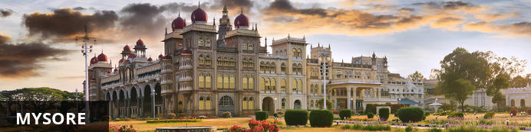
Serving as the capital of the Kingdom of Mysore from 1399 until 1947, the city of Mysore is a rich cultural and historical centre renowned for its beautiful Hindu palaces. Arguably the most captivating of these is the opulent Mysore Palace or Amba Vilas, particularly during the annual Dasara Festival, when every day after sunset it turns incandescent with the light of nearly 100 000 bulbs. In the modern context, Mysore is considered one of India’s cleanest and most efficiently planned cities, and has earned a reputation for its high quality sandalwood and silk.

After breakfast you will be driven to Mysore in your private chauffeur driven vehicle [Approx. 160 kms / 4 hrs] with a stop at Srirangapatnam.

Srirangapatna
Srirangapatnam, renowned for its seemingly impregnable fort, associated with the great ruler Tipu Sultan, is situated at the western end of an oval shaped island formed by the two branches of the Cauvery. It is the island fortress of Tipu Sultan, the legendary Tiger of Mysore who put up a valiant fight against British domination. General Harris stormed the fort in 1799, confirming British supremacy in South India. The high stonewalls and moats enclose palaces, with its beautiful frescoes, Wellesley Bridge and the celebrated. Sri Ranganatha Temple are other monuments from its chequered past.

Day 4: Mysore

Morning enjoy walking tour Mysore with your guide. The tour starts with K.R circle & Small clock tower, followed with Devaraj Market, It is about more than a hundred year old market which has lot to be explore in and around. Coffee break at Hotel Dasaprakash, to experience the local people & food. Sayyaji Rao Road It is the local shopping street of the city with ongoing local trade.

Day 5: Mysore – Hassan

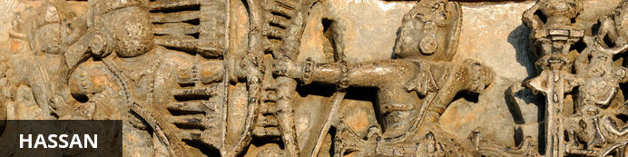
As one of the oldest towns in India’s Karnataka State, Hassan has a long and rich history. The town was founded by Channa Krishnappa Naik in the 11th century and remained under the rule of the Hoysala dynasty until the 13th century. It is the unique Hoysala architecture of this time that has made Hassan a popular tourist attraction as, during this period, numerous architectural marvels including a number of exquisite temples were constructed, many of which remain well-preserved today. However, it is not only the diverse variety of temples and unique architecture that draws visitors to Hassan, but also the town’s lovely markets, delicious local cuisine and remarkable natural beauty of the town itself and its extraordinarily scenic surrounding areas.

After breakfast you will be driven to Hassan [Approx. 140 kms / 4 hrs]. The breezy, cool and pleasant picturesque town of Hassan is located in the heart of the Malanad region which was made famous by the Hoysala Dynasty with its unique style of architecture. The town’s outskirts are dominated mainly by farmlands, at patches of forest and lakes.
On arrival at Hassan, check into your hotel. Rest of the day is at leisure.

Day 6: Hassan

Breakfast is at the hotel. In the morning take a tour of Belur and Halebid.

Belur
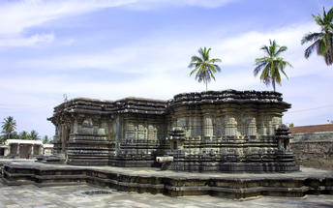
Set on the banks of Yagachi River in the Hassan District in the state of Karnataka, Belooru, or more commonly known as Belur is set amidst lush surrounds. It boasts a rich cultural heritage, historical significance and a variety of sacred temples. Belur is a popular tourist destination in the state of Karnataka. It features the Chennakeshava Temple Complex, is a 12th-century Hindu temple displaying some of the best of Hoysala architecture in the country. Other highlights include: Panduranga Temple, Shankaralingeshwara Temple, and Hoysaleshwara Temple and the spectacular Jain temples in Halebidu.

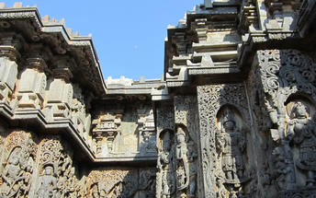
Halebidu
A city in the Karnataka state of India, Halebid features Hoysala structures. Halebid's temple complex contains the Hoysaleswara, Kedareswara and Jain temples.

Day 7: Hassan – Hampi

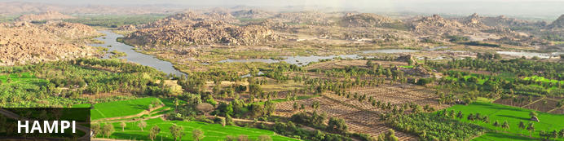
An enchanting ancient city and hippy backpacker destination, Hampi offers the perfect heady mix of Indian charms that make it hard for visitors to leave. Here history and modernity meet: impressive ancient remnants of Vijayanagara, the former capital of the Vijayanagara Empire, are dotted around the congested buildings of Hampi town. Cross the river and you will find laid back restaurants and rooms bordered by banana plantations and paddy fields, with a view over the river and ruins. Sightseeing can take up most of your time but do not neglect to visit the Monkey Temple, a 572-stair climb, to catch the sunset.

After breakfast you will be driven to Hampi [Approx. 340 kms / 8 hrs]. Upon arrival in Hampi, check in at the hotel.

Day 8: Hampi

After breakfast, explore the Hampi Ruins.
Hampi, the World Heritage Center, is the most beautiful and evocative of all the ruins of Karnataka. Capital of Vijayanagar kingdom is full of delightful surprises, viz., Kings Balance where kings were weighed against grain, gold or money which was then distributed to the poor, other attractions are Queen's Bath with its arched corridors, projecting balconies, Lotus Mahal Vittala Temple, Virupaksha Temple, Ugra Narasimha are not to be missed. The best way to experience this World Heritage Site is to take a leisurely stroll through the eloquent ruins. Most of the important structure and ruins are located in tow areas, which are generally referred to as the Royal Centre and the Sacred Centre. The Royal Centre contains structures that seem to have been palaces, baths, pavilions, royal stables, and temples for ceremonial use. The sacred center is situated on the banks of the holy Tungabhadra River. Visit Vittthala temple and Virupaksha temple.

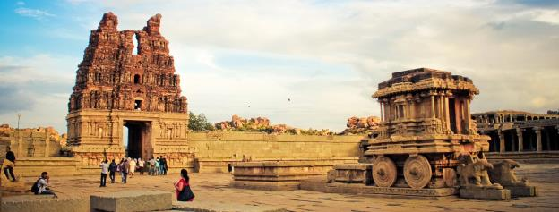
Hampi
The best way to experience this World Heritage Site is to take a leisurely stroll through the eloquent ruins. Most of the important structure and ruins are located in tow areas, which are generally referred to as the Royal Centre and the Sacred Centre. The Royal Centre contains structures that seem to have been palaces, baths, pavilions, royal stables, and temples for ceremonial use. The sacred center is situated on the banks of the holy Tungabhadra River. Visit Vittthala temple and Virupaksha temple.

Day 9: Hampi – Badami

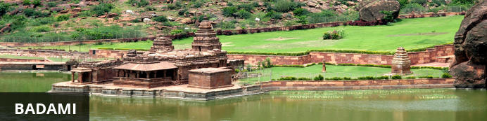
Situated in northern Karnataka, the quiet village of Badami is home to a series of ancient cave temples. Between the 6th and 7th centuries Badami was the capital of the Early Chalukyas, who ruled much of Karnataka and Andhra Pradesh. They carved out sacred spaces into the rust-coloured cliffs above Agstya Lake, and decorated the walls of these holy caves with bold, detailed reliefs of their deities. Out of the shimmering waters below rise the steps of the Bhutanatha temple complex, a cluster of sandstone shrines devoted to this god.

After breakfast, you will be driven to Badami [Approx. 150 kms / 3 hrs]

Day 10: Badami

Breakfast at the hotel. Do a visit to Badami.
Later visit Aihole and Pattadakal. Aihole - is famous as the Cradle of Indian Temple Architecture has over 125 temples all intricately carved and rich in detail famous ones are Lad Khan Temple, Drug (fort) Temple, Ravalphadi Cave Temple, Konti Temple Complex, Jain Meguthi Temple are few not to be Missed. Pattadaka l-a World Heritage center has 10 major temples representing early Chalukyan architecture. Temples to visit are Virupaksha, Mallikarjuna and Panatha.

Badami
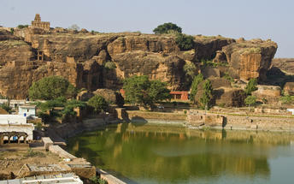
Situated in northern Karnataka, the quiet village of Badami is home to a series of ancient cave temples. Between the 6th and 7th centuries Badami was the capital of the Early Chalukyas, who ruled much of Karnataka and Andhra Pradesh. They carved out sacred spaces into the rust-coloured cliffs above Agstya Lake, and decorated the walls of these holy caves with bold, detailed reliefs of their deities. Out of the shimmering waters below rise the steps of the Bhutanatha temple complex, a cluster of sandstone shrines devoted to this god.

Aihole
The ancient walled city Aihole, which dates back to the 6th century in Karnakata served as the former capital of the region during the early Chalukyas period. Visitors can enjoy exploring the historic fortified complex comprised of over a hundred stone temples featuring a blend of fascinating architectural styles, Jain monuments, and ancient caves displaying unique traditional art depicting Hindu deities and legends.

Pattadakal
Declared a world heritage site in 1987, Pattadakal, situated on the banks of the Malaprabha river in the Bagalkot district of Karnataka, represents the high point of temple architecture under the Chalukya dynasty in the 7th and 8th centuries. Earlier called Kisuvolal or Pattada Kisuvolal, that literally translates to City of Crown Rubies, Pattadakal along with Aihole and Badami provide an incredible concentration of religious monuments that reveal a beautiful fusion of north (Nagara, Indo-Aryan) and south (Dravidian) Indian architectural forms.

Day 11: Badami – Goa

Breakfast at the hotel. Today you will be driven to Goa [Approx. 260 kms / 5 hrs] in your private chauffeur driven vehicle.

Day 12 – 15: Goa

Day at leisure at Goa

Day 16: Goa Depart

After breakfast, Travel Counsellor Representative will assist and transfer to Airport on time to board flight for onwards flight back home.

