

IN - 12

Central India with Wildlife
Mumbai (A) – Bhopal (B) – Satpura (C) – Pench (D) – Kanha (E)
12 Days / 11 Nights
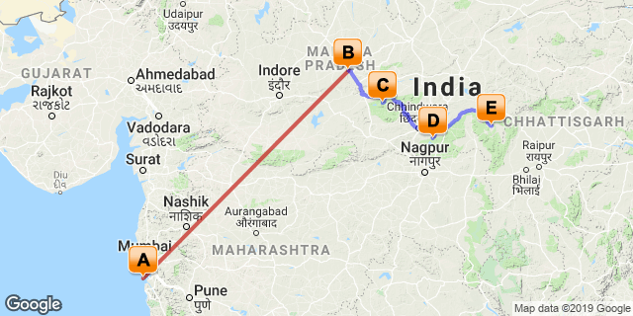

Overview: This journey covers Mumbai, Bhopal and the wild life parks of central India.

Highlights: Wildlife, Culture
- Explore Mumbai city for its Modernity & architecture.
- Visit ancient palaces, Mosques and bustling bazaars of Bhopal.
- Game drives in National Parks in search of the elusive Bengal Tiger

Day 1: Arrive Mumbai

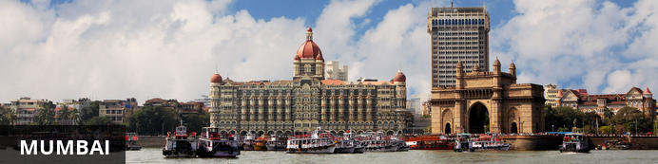
The thriving metropolis of Mumbai is a go-to destination for travellers curious to experience a modern Indian city. Lapped by the Arabian Sea, this urban seaside peninsula is a melting pot of old and new India. Towering office blocks and shiny apartment buildings shoulder crumbling grand dames of architecture. Men play cricket in the leafy central parks, taxis navigate the jam packed streets and families stroll along the seaside promenades of Mumbai, while kilometres away children beg on the peripheries of Asia’s biggest slum. In the wide avenue of Colaba’s high street, western culture overshadows the brightly lit storefronts, where Levi’s, Adidas and McDonalds vie for retail space.

Fly into Mumbai where you will be met by your Travel Counsellors Representative who will take you to your hotel for check in. Standard check in time is 1400 hrs.

Day 2: Mumbai

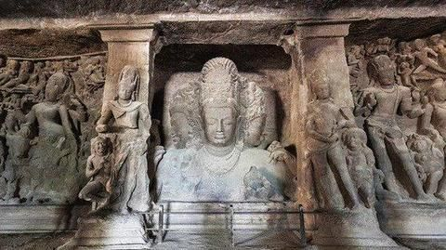
This day proceed for half day excursion to Elephanta Caves [Closed on Mondays]. This morning you’ll head off on an excursion to the UNESCO World Heritage Site of Elephanta Caves. Situated 9km north east of Mumbai Harbour, a short ferry ride takes you across to the labyrinth of cave temples carved into the island’s basalt rock. The caves cover an area of over 5,000 m2 and contain some of India’s most impressive temple carvings.

Afternoon continue your sightseeing tour of Mumbai with your guide.

Enjoy a half day sightseeing tour of Mumbai, starting with the Gateway of India – the grand ceremonial arch built to commemorate the visit of King George V in 1911, followed by the Mani Bhavan Museum located in the building where Mahatma Gandhi used to stay during his visits to Mumbai from 1917 to 1934. The museum now movingly documents his life through press cuttings, photographs and various artefacts including two of his famous spinning wheels.

Continue to Marine Drive, one of Mumbai’s most popular promenades and then on to Chhatrapati Shivaji Maharaj Vastu Sangrahalaya (the Prince of Wales Museum – Closed on Monday). Adorned with a beautiful white Mughal dome and surrounded by neat gardens, this splendid building is home to what many consider the best museum in the country. Afterwards climb up Malabar Hill to the Hanging Gardens, renowned for their views over the Arabian Sea and numerous animal shaped hedges before finishing with a visit to Chhatrapati Shivaji station (Victoria Terminus), one of the city’s largest and most magnificent colonial era buildings.

Day 3: Mumbai – Bhopal

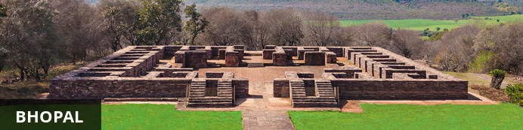
Bhopal is the capital city of the central Indian state of Madhya Pradesh. The city known for its exquisite landcapes characterised by lush forests, green hills and a number of natural and manmade lakes. While the old part of the city features a maze of narrow winding alleyways lined with grand old mosques, ancient palaces and bustling bazaars, the newer part is better planned and contains some excellent museums and galleries, manicured parks and gardens, and upmarket hotels and restaurants. Bhopal serves as a gateway to the nearby a UNESCO World Heritage Site of Sanchi, one of the most impressive Buddhist monuments in Asia. Other must-see attractions in the area include the Van Vihar National Park, home to tigers, lions and leopards; and the State Museum, displaying fossils, paintings and rare Jain sculptures

Fly to Bhopal and then check-in at your hotel.

Day 4: Bhopal

Breakfast at the hotel and do a tour of the city.

Taj-ul-Masjid, named as the ‘The Crown of Mosques’, is an old mosque that was also used as a madrasah. Sultan Shah Jehan Begum of Bhopal (1868-1901) started the construction of this mosque. However, it was completely built only after 1971 by the great efforts of Allama Mohammad Imran Khan Nadwi Azhari of Bhopal.

Tribal Museum - Built over seven acres of land next to the Archaeological Museum, it is housed in a striking building designed by Revathi Kamath. The museum stands out from all others in the country because of the way its exhibits are put up. It does not conform to the old, sedate style of showing individual artworks as distinct masterpieces, with little contextual information. Instead, it celebrates the ways of life practised by the seven major tribes in the state – the Gond, Bheel, Korku, Baiga, Sahariya, Kol and Bhariya – through their crafts. In a series of riotously colourful galleries whose roofs soar as high as three-storey buildings, the dramatically-lit artefacts project tribal living, aesthetics, and spiritual beliefs.

The Shaukat Mahal is one of the architectural curiosities of Bhopal. Situated right at the entrance of the Chowk area, the Mahal is a blend of both oriental and occidental styles of architecture. The Shaukat Mahal was another important building constructed during Sikander Begum's tenure. It is a strange mixture of Indo-Islamic and European styles of architecture. It was designed by a Frenchman, a descendant of the Bourbon Kings of France. Post Renaissance and Gothic styles have been combined in an enchanting manner in the building.
Rest of the day is at leisure to relax or pursue independent activities.

Day 5: Bhopal – Satpura

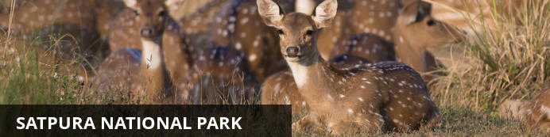
Tucked away in the spectacularly scenic Satpura hills, the Satpura National Park is comprised of 524 square-kilometers of pristine wilderness. The area is known for its towering sandstone peaks and rugged hills, which are cloaked in dense forests and intersected by glistening streams. The park also features a number of narrow gorges and ravines which provide an ideal secluded environment for a diverse array of wildlife including tiger, leopard, four-horned antelope, sambar, nilgai, chital, wild dog, chinkara, wild boar and bison. In addition to the usual game drives by jeep, visitors can look forward to exploring the park on guided safari walks, elephant back safaris, or by canoe or kayak.

Leave for Satpura National Park. Satpura National Park is located in Hoshangabad district of Madhya Pradesh in Central India. It is spread over Satpura Hills on highlands of Central India. Its name Satpura is a sanskrit word, which simply means Seven-hills. It is part of Pachmarhi Biosphere Reserve and covers an area of 524 sq.kms. Satpura national park, along with its surrounding buffer-zone area have a much better population of wildlife which are rarely seen in other national parks of state. Here we can find 50 species of mammals, 254 species of birds, 30 species of reptiles, 50 species of butterflies and much more. Attractive birds species includes , Malabar whistling Thrush, Paradise Fly-catcher, Honey Buzzard, Malabar pied Hornbill etc. Presence of various flower species, moist conditions offers ideal conditions for various butterfly species to flourish like Oakleaf, Black Rajah, Great Eggfly, Blue Pancy etc. Here we can find about 14 species of endangered mammals and reptiles.

Day 6: At Satpura National Park

Enjoy morning & evening shared jeep safaris in the National Park.

Day 7: Satpura – Pench

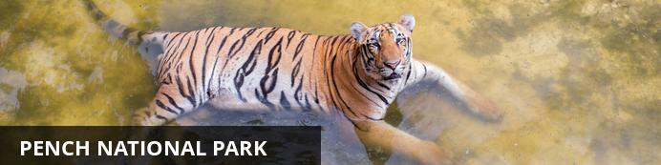
Resting in the lower southern reaches of the Satpuda Hills, in the central Indian state of Madhya Pradesh, Pench National Park is renowned for having the highest concentration of prey of any park in India, increasing the chances of seeing predatory cats such as leopard and tiger. This impressive expanse of wilderness features typical central Indian teak jungle and is bisected by the spectacularly scenic Pench River. Aside from the river, the park also contains a number of bamboo-lined jungle streams providing a valuable water source for the local wildlife which includes, among others: wild dog, sloth bear, wolf, jungle cat, hyena, jackal, gaur, sambar, and chital. Pench is also a bird lover's paradise with over 250 species of bird inhabiting the area, including: parakeets, hornbills, kingfishers, orioles and wagtails, as well as a large selection of birds of prey.

Leave today for Pench National Park by your private chauffeur driven car [approx. 260 Kms /6 Hrs.]
Upon arrival, check into your Resort

Day 8: At Pench National Park

Enjoy morning & evening shared jeep safaris in the National Park. [On Wednesdays the park remains closed in the evening]

Pench National Park is very rich in fauna and it’s an abode to a large number of endangered species. The most dominant predator is Tiger and there are around 25 of them in these prey-rich woodlands. There are some other predators like dhol (Indian Wild Dog), leopard, hyena, wolf, jackal and jungle cat. Some prey species observed in the park are sambhar, chital, gaur, muntjac, langur, wild boar, and rhesus macaques. Commonly seen species are herd of deer.There are more than 170 species of birds comprising various migratory ones like peafowl, crow pheasant, junglefowl, red-vented bulbul, crimson-breasted barbet, magpie robin, lesser whistling teal, racket-tailed drongo, egret, pintail, shoveler, herons to name a few.

Day 9: Pench – Kanha

Also known as the Kanha Tiger Reserve, the Kanha National Park is widely considered to be the greatest of India’s wildlife reserves and the inspiration for Rudyard Kipling’s classic, 'The Jungle Book'. This impressive expanse of wilderness is set in the central Indian state of Madhya Pradesh, encompassing about 950 square kilometres of lush rolling hills, peaceful rivers, saal and bamboo forest, and endless stretches of savanna grassland. This spectacularly scenic environment provides a diverse range of habitats for an extraordinary array of wildlife including tigers, leopards, jackals, swamp deer, foxes, porcupines, sloth bears, pythons, hare, chitals, gaur monkeys, mongooses, and hundreds of species of bird.

Leave for Kanha National Park by your private chauffeur driven car [approx. 200 Kms /4-5 Hrs.]

Day 10 – 11: At Kanha National Park

Enjoy morning & evening shared jeep safaris in the National Park

Day 12: Kanha – Jabalpur Depart

At an appropriate time, your Travel Counsellor Representative will assist and provide you the necessary transfer to Jabalpur airport for the onward flight

