

IN - 15

Taj and Tiger
Delhi (D)- Agra (B)–Ranthambore - Jaipur (C)
9 Days / 8 Nights
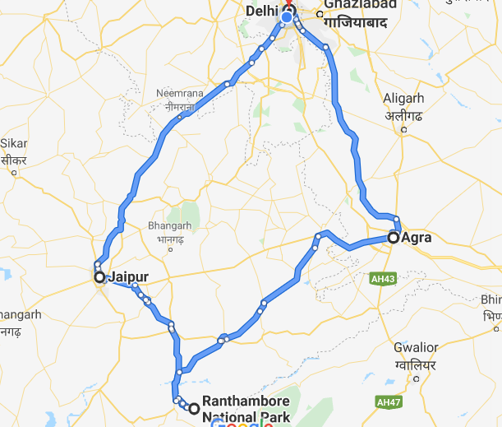

Overview: This journey is the beginning of an exciting Indian trail – the Golden Triangle that the seekers of India begin their voyage of discoverwith. Within this is cradled the essence of India – Delhi, a rich tapestry of contrasts, Agra the zenith of art and an enshrined romance (Taj Mahal), Ranthmabore for the elusive Tiger and Jaipur exuberance of colours.

Highlights: Culture, cuisine, Indian railways, Family, Wildlife
- Explore the historic layers of the Old and New Delhi with its UNESCO world heritage sites.
- A heritage walk along with rickshaw ride through the fabled markets of “ChandniChowk”
- Experience a journey on Indian Railways.
- Visit to “Taj Mahal” - the universally admired masterpiece of the world's heritage.
- Explore the deserted city of FatehpurSikri.
- A cooking demonstration followed by a meal with a local family
- Explore the bustling bazaars of the Pink City of Jaipur.

Day 1: Arrive Delhi
India’s largest city, Delhi, has been one of the country’s commercial and economic hubs for centuries and, as a result, is incredibly rich in culture and history. Made up of the ancient walled city of Old Delhi and the more modern sector, New Delhi, the city encompasses a staggering array of beautiful architecture, notable monuments and age-old temples, including three UNESCO World Heritage Sites – the Red Fort, QutabMinar and Humayun's Tomb. Other key attractions include the 17th century ChandniChowk marketplace – still one of the cities most popular retail centres today, particularly for jewellery and traditional Indian saris; and the Jama Masjid, India’s largest mosque.
On arrival in Delhi: Having cleared immigration, collected your luggage and passed through customs, please make your way towards the exit of the terminal building where you will see a bank of people waiting for you. Amongst them will be Travel Counsellors Representative who will be waiting to greet you with a paging board with your name on.
You will be transferred to your hotel and assisted with check in. Standard check in time is 1400 hrs.

Day 2: In Delhi
The day is scheduled for a heritage walk of Old Delhi in the morning followed by a tour of New Delhi in the afternoon.
Delhi is one of very few places where the ancient and modern co-exist side by side complementing each other perfectly. Our heritage walks of Delhi are a perfect way of exploring this amalgam of old traditions, modern development and the unique heritage which makes it so interesting. It is the perfect way to explore some of the lesser visited places and gain a new insight about the history, people and sights of Delhi city.
The tour of New Delhi covers the UNESCO world Heritage sites of Humyauns tomb, QutabMinar along with a photo stop at India Gate – the war memorial and drive past the Govt. Secretariat building and the President Palace.

Day 3: Delhi- Agra
Home of the world-famous Taj Mahal, Agra is one of India’s prime tourist destinations for specifically this reason, though its attractions also extend to an array of other impressive historical sights. These include the red-hued Agra Fort, the sacred Jama Masjid mosque and Itmad-ud-Daulah’s tomb, with its white marble facade embellished with intricate inlaid designs and semi-precious gems. The Taj, however, is in a league of its own and is a must-see for any visitor to the city. Commissioned by the Mughal emperor Shah Jahan in the 15th century as a memorial to his beloved wife Mumtaz Mahal, it is an architectural masterpiece of exquisite artisanship and perfect proportions.
After breakfast, you will be transferred to railway station to board the train to Agra.
Train Gatimaan Express (daily except on Fridays)
Departs Delhi 0810 Hrs
Arrives Agra 0950 Hrs

Upon arrival at Agra, you will be assisted & transferred and taken directly to Agra Fort for the visit followed by check-in at the hotel. (Standard check in time at the hotel is 1400 Hrs).
Later in the evening, visit Taj Mahal at sunset.
Known as the Red Fort of Agra, this walled imperial city was founded in 1565 by the Emperor Akbar (1556-1605) and is a well-deserving UNESCO World Heritage site, located just 2.5 kilometres from the famous Taj Mahal. Its palaces, grand mosques and elaborate public hall are crafted from pink-red sandstone and are testament to an era when Indo-Muslim art, strongly marked by influences from Persia, was at its height. Emperor Shah Jahan, who built the Taj Mahal for his deceased wife, was imprisoned by his son Aurangzeb in Agra Fort. He is said to have died in the MusammanBurj, a marble tower he himself built, with one of the most alluring views of the Taj Mahal.
The iconic Taj Mahal is not only an architectural masterpiece, a UNESCO World Heritage Site and one of the new Seven Wonders of the World – it is also the enduring legacy of a royal love story. It was commissioned in the 15th century by the Mughal Emperor Shah Jahan after the death of his third and favourite wife, Mumtaz Mahal, to serve as her final resting place and a symbol of his eternal affection for her. Combining Islamic, Persian, Ottoman Turkish and Indian design elements, it’s an awe-inspiring structure of elegant domes and white marble, which changes colour along with the light – pink at sunrise, pearly white in the afternoon and silver-gold in the full moon.

Day 4: Agra- Bharartpur – Ranthmabore
Youwill be driven to Bharatpur railway station to board your train for Ranthambore with a stop en-route at FatehpurSikri

FatehpurSikri- Once the seat of Mughal legacy and the other, an abandoned city glowing red under the sun, FatehpurSikri - the deserted red sandstone city was built by the Great Mughal Emperor, Akbar, as his capital and palace in the late 16th century is just 37kms from Agra. It was abandoned soon after it was built when the local wells went dry and it remains today in much the same condition that it was over 300 years ago. It is complete with palaces and mosques and used to be a town larger than London when it was originally constructed. Now it is an extraordinary place to wander around with its buildings in near perfect condition

After sightseeing tour, continue drive to Bharatpur Railway Station.

TRAIN Kota Jan Shatabdi
Departs Bharatpur 15:45 Hrs
Arrive SawaiMadhopur 18:02 Hrs

On arrival, met our representative at the railway station and then you will be transferred to your lodge
Near the township of SawaiMadhopur, in the state of Rajasthan, Ranthambore National Park is an outstanding example of Project Tiger’s efforts at conservation in the country. The forests around the Ranthambore Fort was once, the private grounds of the Maharajas of Jaipur. As a result of the stringent efforts in conservation, tigers, the prime assets of the Park, have become more and more active during the day. More than in any other park or sanctuary in India, tigers are easily spotted here in daylight. It is very easy to chance upon a tiger lollingaround lazily in the sun, or feverishly hunting down sambhar around the lakes. Apart from tigers, you will come across a few panthers too. The other permanent residents of the park include marsh crocodiles, hyenas, jungle cats and sloth bears. Sambars are found in abundance all over the area, the prime target of all predators. Chital, Nilgai and chinkara are the other inhabitants of the region.The avian population comprises of black storks, quails, Bonelli’s eagles, spur fowls, crestedserpent eagles and painted storks.

Day 5: Ranthmabore
Morning and afternoon game drive in to the park.

Day 6: Ranthmabore - Jaipur
Leave with the private chauffeur driven vehicle for Jaipur (approx. 145 kms/ 04 hours’ drive) Arrive Jaipur in the afternoon and check-in at the hotel.

Day 7: In Jaipur
After breakfast, enjoy full day sightseeing tour of Jaipur covering Amer Fort, City Palace and the Observatory along with a photo stop at Hawa Mahal “Palace of Winds”. Take a shared Jeep ride to reach Amer Fort.
Amer Fort, officially known as the ‘Amer Palace’, is one of the most famous forts of Rajasthan attracting around 4000 to 5000 visitors a day during peak tourist season. The palace was named after the small town of Amer, where it is situated - only eleven kilometres from Jaipur. Perfectly picturesque, this 16th century hillside residence is well preserved, boasting grand pavilions and mirrored halls that open onto flourishing gardens and courtyards. Although the palace’s main construction started in 1592 by Maharaja Man Singh, it was added to over the years by successive rulers and continued to be occupied by them until Jaipur was built.
City Palace forms one of the most famous tourist attractions and a major landmark in Jaipur. The beautiful palace was built by Maharaja Sawai Jai Singh during his reign. Among the various forts and palaces of Jaipur, City Palace stands apart, with its outstanding art and architecture.
In 1734, the year of its completion, the Jai Singh Observatory was the last outpost of medieval science. From the outside, the eighteen fixed observational instruments look more like playground apparatus than sighting devices, but they were used to measure the position of the sun, stars and planets. Built by Jai Singh, the first Maharaja of Jaipur who founded the city in 1727, the observatory is one of a handful. Jai Singh, fulfilling a lifelong interest in mathematics and astronomy, built observatories in Delhi, Jaipur, Ujjain, Mathura and Benares. The Jaipur observatory is the largest and best preserved of these.

Day 8: Jaipur – Delhi
After breakfast, leave with your private chauffeur driven vehicle to Delhi [Approx. 260 kms / 6 hrs]. On arrival, check in at an airport hotel. Rest of day is at leisure.

Day 9: Delhi - Departure
Your Travel Counsellor Representative will provide you the necessary assistance and provide the transfer to the international airport.

