

IN - 18

Tamil Nadu & Kerala
Chennai (A) – Mahabalipuram (B) – Puducherry (C) – Thanjavur (D) - Chettinad (E)- Madurai (F) – Thekkady (G) – Alappuzha (H) – Cochin (I)
14 Days / 13 Nights
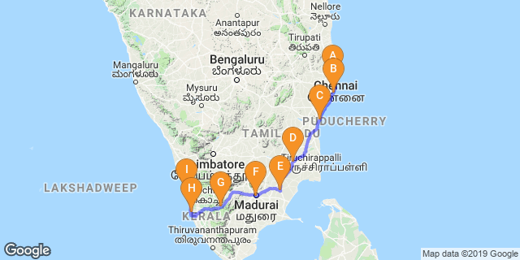

Overview: Enjoy diverse cultures as the journey takes you through the Southern States of Tamil Nadu, Pondicherry and Kerala. Each with distinctive traditions, exquisite architectural jewels, and exceptional cuisine. Your stay have been selected at each place on the basis of their special charm, comfort and the locations. This exceptional and exclusive 14-day tour will give you an opportunity to understand the elegance and traditions of a by-gone opulent colonial lifestyle, mingling with the people at traditional rural villages, experiencing the hospitality of special families and their marvelous culinary heritage !

Highlights: Religion, Culture, Cusinie, Spice Plantations, Tea Plantations, Nature, Backwaters.

Day 1: Arrive Chennai

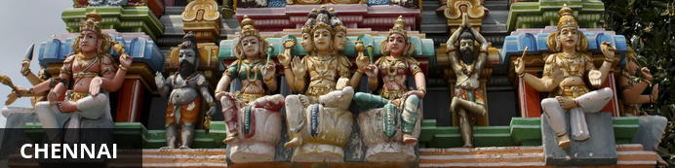
Chennai is Tamil Nadu’s coastal capital and one of India’s financial, cultural and tourism hubs. Attractions include the city’s beaches, museums, shopping areas and historical sites, particularly the centrally located Kapaleeshwar Temple – a historical shrine to the goddess Shiva, featuring gaudily decorative gopurams (towers) covered with colourful carvings – and the group of ancient rock-carved temples at Mahabalipuram, a UNESCO World Heritage Site located roughly 60 kilometres from the city centre. Also of interest is the Guindy National Park, which occupies nearly three square kilometres of greenery in the city centre and is home to an array of birds, reptiles and (mainly smallish) mammals.

Fly into Chennai where you will be met with your Travel Counsellors Representative who will transfer you to your hotel. Rest of the day is at leisure

Day 2: Chennai – Mahabalipuram

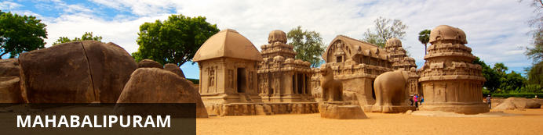
The ancient port town of Mammallapuram is a charming tourist hub which has been attracting travellers for centuries. It was known already in Marco Polo’s day as the “Seven Pagodas" alluding to the seven tiered towers that once stood on the shore, of which one - the Shore Temple, still stands. The port is famous for its stone carvings, which have World Heritage Site status. Impressive cave temples, monolithic rathas (chariots) and sculpted reliefs built by the Pallavas in the 7th and 8th centuries form this group of monuments. After sightseeing, enjoy an Indian thali meal or chai tea at one of the bustling diners in town.

After breakfast drive to Mahabalipuram. [Approx 3 Hrs Kms] with stop enroute at Kanchipuram, one of the seven sacred cities of India.

Kanchipuram
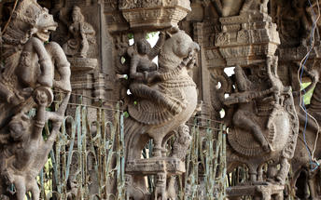
Kanchipuram is located in the state of Tamil Nadu in southern India. This ancient town - the capital of the Pallava Kingdom from the 4th to the 10th centuries - is full of spectacular architectural treasures, and is most easily accessed from the hub of Chennai (which is about two hours away). The highlight is the Ekambareswarar Temple, an enormous stone edifice featuring intricate carvings, and with a mango tree in its inner sanctuary said to be 3,500 years old. Other key sights include Vaikunta Perumal Temple, which has stunning pillars; Kailasanatha Temple, which has been meticulously restored to give visitors a sense of its original stonework; and the steeply-tiered Kamakshi Amman Temple. Kanchi (as it is popularly known) is also a major silk-weaving centre, which makes it a great place to shop for souvenirs.

Day 3: Mahabalipuram

Full day tour of Mahabalipuram

Mahabalipuram
The Shore Temple is the icon of the ancient monuments of Mahabalipuram. The temple gets its name from its location on the Coromandel shore overseeing the Bay of Bengal. The sculptural excellence symbolizes the heights of Pallava architecture. The Dravidian style of architecture dates back to the 7-8th century. It was built under the rule of King Narsimha Varma. The visual delight of finest architecture, the sculptures and intricate and full of vivacity. The granite rock cut carvings are proof of the sheer brilliance of the artisans who have created this magnificent structure. The structural designs can be only called ‘poetry in stone’. It has been an UNESCO World Heritage Site since 1984.
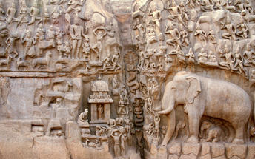
Arjuna’s Penance - Located in Mahabalipuram, India, Arjuna’s Penance is a magnificent monument to Mahabalipuram. This monument stems back to the seventeenth century and stands at the height of approximately 43 feet. It is said that this structure cannot be fully enjoyed if it is seen in photographs and that standing before it is an experience of its own.
Pancha Rathas - Located in Mahabalipuram, India, Pancha Rathas is a monument complex situated approximately 56 kilometres from Chennai. The five monuments found in the complex each resemble a chariot and are carved over a long stone of granite which is placed in a north-south direction at a small incline.

Day 4: Mahabalipuram – Puducherry

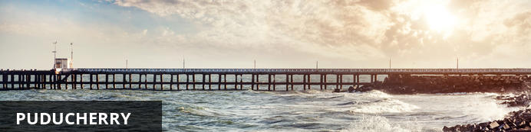
Puducherry – previously known as Pondicherry – is made up of four entirely separate enclaves along the Indian coast, all of which were colonised by the French in the 18th century. Named after the largest of these enclaves, this union territory has retained a strong European culture that makes it unlike any other place in India. Nowhere is this more evident than in Puducherry district, dubbed the ‘French Riviera of the East’, where antiquated colonial buildings line the quiet cobbled streets and tree-lined avenues of the old town, and many people still speak French as their first language.

This day drive to Pondicherry [Approx 3 Hrs / 138 Kms]

Day 5: Puducherry

Breakfast at the hotel. After your breakfast, enjoy the walking tour and rickshaw ride of Pondicherry. The walk starts from the Sri Aurobindo Ashram, the white town and the old town.
The world renowned Sri Aurobindo Ashram was founded in the year 1926, by Sri Aurobindo, a revolutionary turned Yogi from Bengal along with The Mother (Mira Alfassa) a French painter as well as a sculptor. It is indeed the best known landmark of Pondicherry and the ashram attracts people from all over the world. One can find peace prevailing in this memorial place. People come and meditate in this ashram. Sri Aurobindo elaborated a system of Internal Yoga in order to practice Yoga and Modern Science. Aurobindo Ashram since its establishment almost a century back has played a significant role in the socio-economic-spiritual fabric of Pondicherry.

Day 6: Puducherry – Tanjore

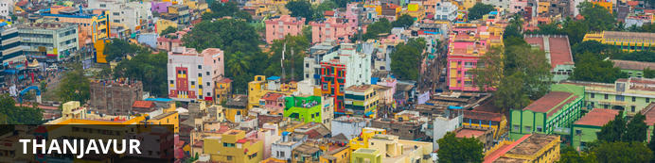
Situated between Trichy and the coast of Tamil Nadu, Thanjavur is an important centre of South Indian religion, art, and architecture. It is also an agricultural hub, fondly known as the ‘rice bowl of Tamil Nadu’. It’s most visited monument, the Brihadeeswara Temple, is located at the centre of the city and a style of painting, called Tanjore, which is unique to the region, can be seen here. The temple forms part of the Great Living Chola Temples, which are UNESCO World Heritage Sites located in and around Thanjavur. Thousands of people still worship at the Cholas' grand Brihadishwara Temple every day.

This day drive to Tanjore en-route visiting Darasuram temples. [Approx 5 Hrs]

Darasuram
Darasuram is 4 Kms from Kumbakonam. This temple built by Raja Raja Chola dedicated to Lord Siva, is either called as Drasuram temple or Airavateswara Temple. This is well preserved temple of the 12th century Chola Kingdom. The columns of the temple have unique and excellent miniature sculptures. This is termed as one of the Great Living Chola Temples along with Big Temple and the Gangaikondan Cholapuram temple. During the 14th century the large stone statues surrounding the temple was replaced with brick and mortar statues similar to that of Big Temple at Thanjavur. Achaeological Survey of India has restored the temple. UNESCO declared it as World Heritage Monument in its 2004 list.
After visit continue your drive to Tanjore, upon arrival check-in at hotel.
Afternoon proceed to visit Tanjore - Thanjavur or Tanjore as it is known, is the ancient capital of the Chola kings and represents all that they have to put in the fields of architecture, art and government. We visit the city and the beautiful Brihadeshwara temple, believed to be the largest temple ever built in India. Visit the Palace and bronze ideal making units.

Brihadeeswarar Temple
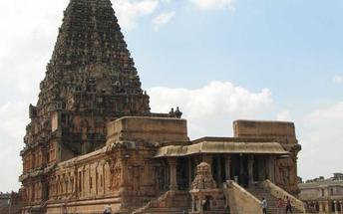
Peruvudaiyar Kovil, which is also famous as Brihadeeswarar Temple, Rajarajeswaram and RajaRajeshwara Temple, is located at Thanjavur in Tamil Nadu state of India. It is one Hindu temple, which they dedicate towards Lord Shiva. It is one luminous example of major heights, which Cholas achieves within Tamil architecture. This temple is one tribute and one reflection of power of its supporter Raja Raja Chola I. this temple remains as India’s largest and Indian architecture’s one of greatest glories. It is also a part of UNESCO World Heritage Site as “Great Living Chola Temples”. This great temple is India’s one of most prized site for its architecture. It stands in middle of fortified walls added probably in sixteenth century. There is one temple tower, which people call as Vimana. It is 216 feet or 66 meters high. It is also one among tallest tower in whole world in its kind. Kumbam, Chikharam or Kalasha, which is bulbous, or apex structure on top of temple, people believe that it is made out of a single stone carving.

Day 7: Thanjavur

This day proceed to visit Trichy Temples.

Rock Fort Temple
The spectacular Rock Fort Temple, the landmark of the city, is on the shores of the Kaveri. It is perched on a massive rocky outcrop at an altitude of 83 m above sea level. The Thayumanaswamy Temple, dedicated to Lord Shiva (the destroyer in the Hindu trinity), is situated halfway to the top. It has a 100-pillar hall and a Vimana covered with gold. On the southern face of the rock are several beautifully carved rock-cut cave temples of the Pallava period.

Srirangam
The Sri Ranganathaswamy Temple (Srirangam), situated 6 km north of the city, is among the most revered shrines dedicated to Lord Vishnu in South India, and one of the largest temple complexes in India. Shrouded in a haze of coconut palms away to the north, the temple is built on an island in the middle of the Kaveri and covers an area of 2.5 sq km. Enclosed by seven rectangular walled courtyards, this 13th-century temple has 21 gopurams, the largest of which was built in 1987 and measures 73 m in height. The temple is connected to the mainland by a bridge. The temple is replete with excellent carvings and numerous shrines dedicated to various gods.

Day 8: Thanjavur – Chettinad

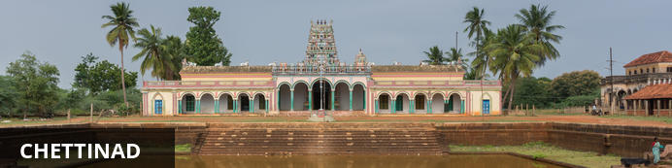
Situated in the heart of the state of Tamil Nadu in India, the region of Chettinad is well-known for its agriculture, architecture and unique cuisine. This region holds important cultural and historical treasures including French Art-Deco style palatial mansions peppered across the region, the magnificent Raja’s palace in Kanadukathan, and the 17th-century hilltop Thirumayam Fort. Visitors can also enjoy some wonderful activities including: browsing antique markets in Karaikudi, sampling the region’s flavourful and fiery cuisine featuring the famous Chettinad chicken and spending a night in one of Chettinad’s restored historical mansions, which have been transformed into elegant heritage hotels featuring Burmese teak, European crystal, and Italian marble. Don’t miss a visit to one of the impressively ornate temples, as well as discovering the locally made beautifully hand-printed cotton fabric and traditional bright-coloured handmade Athangudi tiles.

This day drive to Chettinad. [Approx 3 Hrs]
En-route located in the Sivaganga district of Tamil Nadu, Chettinad showcases the rich art and cultural heritage of Tamil Nadu. A Tour to Chettinad will be an extremely enriching experience for the tourist as the place is full with rich cultural heritage, exotic food and remarkable specimens of Dravidian architecture. Chettinad is well known for its mansions, temples and culinary delicacies.
On arrival check in at the hotel, spend rest of the day at leisure.

Day 9: Chettinad – Madurai

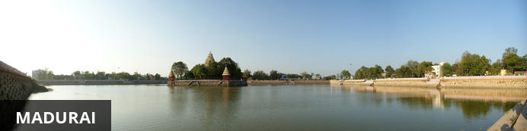
Located in the southern state of Tamil Nadu, Madurai is the oldest existing city on the Indian peninsula, and one of the oldest continuously inhabited cities in the world, with a recorded history spanning more than 2500 years. It is known as ‘the city of temples’ due to its countless ancient Hindu shrines, including the great Meenakshi-Sundareswar Temple, spread over 6 hectares and featuring a series of 50-metre-high gateway towers that can be seen from afar. The best time to visit Madurai is between October and March, when temperatures are between 20-35 degrees.

This day drive to Madurai. [Approx 3 Hrs]. Afternoon visit Sree Meenakshi Amman Temple.

Meenakshi Temple
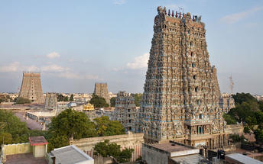
Afternoon visit Sree Meenakshi Amman Temple is one of the most famous temples in South India. The huge temple that extends beyond 6 hectares of land is dedicated to god Shiva and it is named after goddess Parvati. The temple was constructed by Kulasekara Pandya. The temple has been mentioned in the songs sung by ancient saint as early as the 7th century. Invasion of Malik Kapur in 1310 resulted in the ancient temple being destroyed. When Hindu kings returned to power, the temple was restored and the present form is a contribution by Nayaks who ruled Madurai between 16th and 18th centuries. The thousand pillar hall is one of the amazing works in the temple that is famous for architectural brilliance. It is the temple’s museum and the statues here are exquisite.
Evening visit to the Sri Meenakshi Temple and experience the night ceremony “Going to Bed Ceremony”
With lots of noise and commotion, the fish-eyed goddess and her husband are carried from their separate day time places to the inner sanctum, and placed together, for a night of love.

Day 10: Madurai – Thekkady

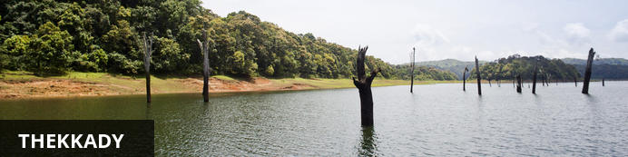
Thekkady comprises evergreen forests and savanna grasslands, and is known for its natural spices such as black pepper, cardamom, cinnamon, nutmeg, ginger and clove. Elephants, tigers, sambar and many other species inhabit the park. Top attractions include the exquisite ancient Mangla Devi Temple, the aromatic Abraham’s spice garden, and the massive waterfall at the sleepy, picturesque village of Chellarkovil. Take in panoramic views of the extraordinary landscape from the Chellarkovil viewpoint, and picnic on the rolling, lush green lawns at Pandikuzhi. Don’t miss the opportunity to visit the Kadathanadan Kalari Centre, to see demonstrations of the best traditional martial arts. Thekaddy is home to India’s sole Tiger Reserve, and has a rich living tribal culture.

Leave for Periyar. [Approx. 04 Hrs] Rest of the day is at leisure

Day 11: Thekkady – Alappuzha

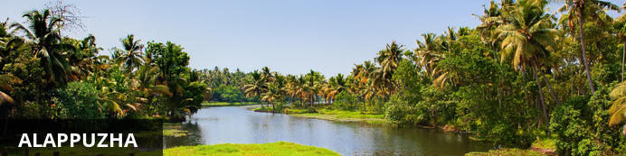
Located in the Indian state of Kerala, the bustling city of Alappuzha, also known as Alleppey, is set along the coast of the Laccadive Sea. Dubbed the ‘Venice of the East’, it is renowned for its houseboat cruises which float along the tranquil backwater canals of Kerala. It is said to be one of the most popular tourist centres in the state. While cruising the palm-shaded canals is the main attraction, visitors can also enjoy visiting Alappuzha’s beautiful beaches, exploring the little riverside villages dotting the lush countryside and discovering an array of resplendent temples. Don’t miss the annual Nehru Trophy Boat Race held at Punnamada Lake.

Nature walk at Periyar National park. Different nature trails traversing diverse habitats form the trekking routes, generally 4 to 5 km. in length. This is an interpretive program offering excellent opportunity to watch birds, butterflies and other wildlife. The trails often pass through evergreen and moist deciduous forests interspersed with marshy grasslands. The program is offered between 7.00 am and 10.30 am and between 2.00 pm. and 3.00 pm. and lasts for about 3 hours. A maximum of 5 persons can go for trekking at a time along each nature trail, accompanied by a trained tribal guide. The Nature walk is the right program to feel nature, hear her whispers and smell her flowers.
After breakfast drive to Alleppey. [Approx 4 Hrs] and board House Boat These houseboats or Kettuvallam as they are traditionally called were at one time the mode of transportation for man and goods. Today, these are made to cater to the discerning guests who can lay back and enjoy the gentle cruise. Cruise the backwaters from the main Vembanad Lake through the small estuaries that link small villages to the mainland. Today, these are refurbished and all modern conveniences have been added for tourists who visit this beautiful water locked region of the country

Day 12: Alleppey – Cochin

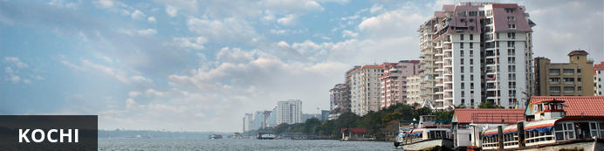
Also known as Cochin, Kochi is a city in southwest India's coastal Kerala state. This attractive city has served as a popular port for over 600 years and is known for its eclectic architecture and its array of religious monuments, museums, galleries, cafes and antique shops. The city stretches across a number of peninsulas and islands, which can be reached by a network of water taxis and bridges. The majority of Kochi’s visitor highlights can be found on the peninsula of Fort Kochi. These highlights include the St Francis Church, the oldest European-built church in India; and Mattancherry Palace, which dates back to 1557 and contains some exceptional Kerala murals and temple art. Other must-see attractions include the Kerala Folklore Museum, displaying more than 4,000 cultural and ethnic artifacts; the 16th-century Jewish Synagogue; and the local market, where the air is filled with the aroma of exotic spices.

This day disembark the houseboat and drive to Cochin (Approx 2 hours). Arrive Cochin and you will be transferred to your hotel.

Day 13: Cochin

Breakfast at the hotel. Tour of Cochin. The tour allows you to explore the charming fort Cochin, Jewish Synagogue (Closed on Fridays & Saturdays), and Dutch Palace (Closed on Thursdays and Fridays), Jew Town, and St Francis church.
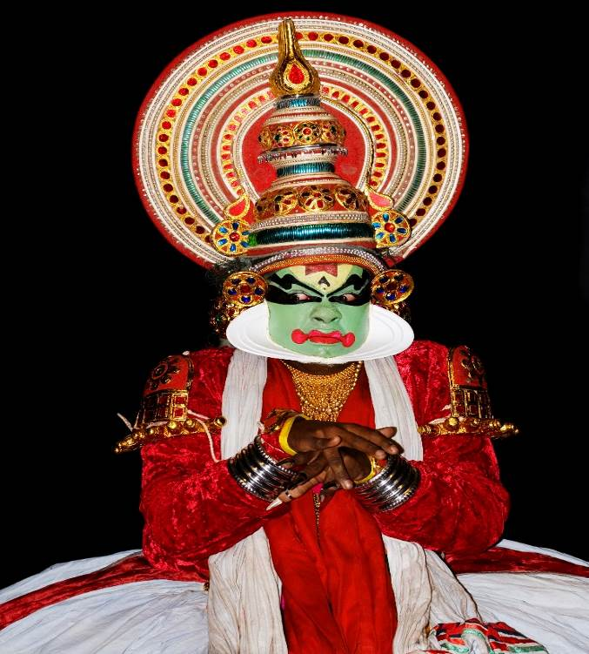
The Dutch Palace is a beautiful palace that was originally built by the Portuguese. It was only during the 17th century that the Dutch took it over, modified it and then presented it to the Raja of Kochi. The main attractions here are the outstanding collection of mural paintings found inside. These murals beautifully depict scenes from the Hindu epics of Mahabharatha and Ramayana.
The St. Francis Church [close on Sunday] is the oldest church in India to have been built by the Europeans. The famous Portuguese trader Vasco da Gamais well known for reaching India from Europe by sea instead of by the usual overland route. The church is famous for being the initial burial place for Vasco Da Gama.
Later in the evening enjoy Kathakali – the traditional dance drama of Kerala, it dates from the 17th century and is rooted in Hindu mythology. Kathakali is one of the most complicated, highly stylized Indian art form that is basically a Dance Drama noted for its heavy and attractive larger than life make up, elaborate costumes, detailed body movements, synchronized eye-hands movements and thematic presentation of stories with rhythmic steps.

Day 14: Kochi Departure

At an appropriate time, your Travel Counsellor Representative will assist and provide you the necessary transfer to the international airport.

