

IN- 19

Best of Karnataka
Bangalore (A)- Mysore (B)- Kabini (C)- Coorg (D)- Chikmagalur (E) – Hampi (F) - Badami (G)- Goa (H)
18 Days / 17 Nights

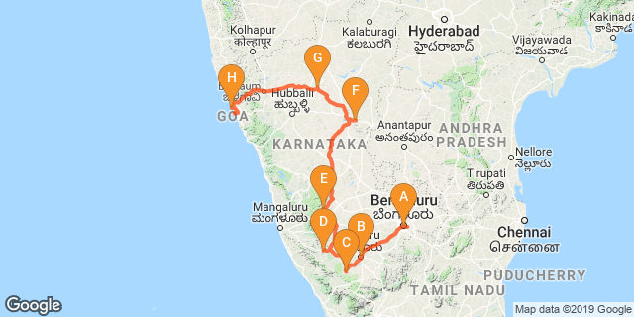
Overview: This journey covers the much sought after “Karnataka with its beautiful temples, UNESCO world heritage sites and the beautiful baches and churches of Goa.

Highlights: Culture, Achitecture, Heritage, Nature, Wildlife, Beach,

Day 1: Arrive Bangalore

Fly into Bangalore where you will be met by your Travel Counsellors Representative who will assist and transfer you to the hotel

Day 2: Bangalore- Mysore

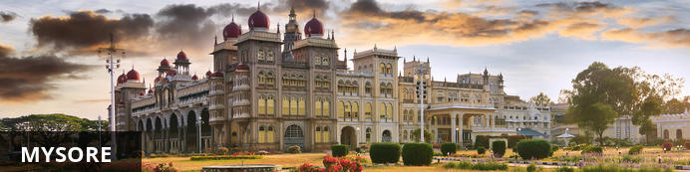
Serving as the capital of the Kingdom of Mysore from 1399 until 1947, the city of Mysore is a rich cultural and historical centre renowned for its beautiful Hindu palaces. Arguably the most captivating of these is the opulent Mysore Palace or Amba Vilas, particularly during the annual Dasara Festival, when every day after sunset it turns incandescent with the light of nearly 100 000 bulbs. In the modern context, Mysore is considered one of India’s cleanest and most efficiently planned cities, and has earned a reputation for its high quality sandalwood and silk.

After breakfast, you will be driven to Mysore (approx 160 kms/ 04 hours drive) with a stop enroute at Srirangapatnam

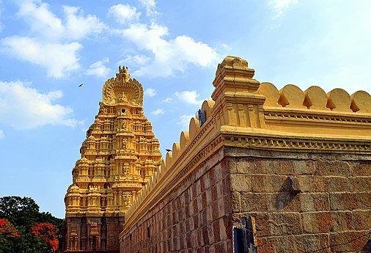
Srirangapatna
Located in Karnataka, India, Srirangapatna alternatively known as Shrirangapattinam is a religious, cultural and historically significant town. This river island town's name is sourced from the famous Ranganathaswamy Temple which dominates the town, and this temple resembles Hoysala and Vijayanagar architecture as it was restrengthened and modified after its initial construction in the 9th century.

Day 3: In Mysore

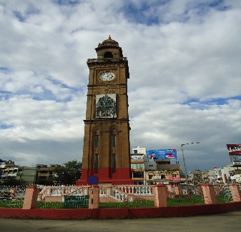
Morning enjoy walking tour Mysore with your guide. The tour starts with K.R circle & Small clock tower, followed with Devaraj Market, It is about more than a hundred year old market which has lot to be explore in and around.Coffee break at Hotel Dasaprakash, to experience the local people & food. Sayyaji Rao Road It is the local shopping street of the city with ongoing local trade. The tour ends at the clock tower.

Day 4: Mysore- Kabini

After breakfast you will be driven to Kabini (approx 100 kms/ 03 hours drive). Upon arrival you will check in at the hotel.

Day 5: In Kabini

Day Itinerary
Breakfast at the hotel. Morning and evening enjoy safaris [Subject to availability].Following are the activities you could considered while in Kabini.

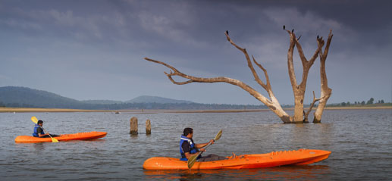
Cycling
Recapture the thrill of childhood adventures with all-terrain cycling – across trails with breath-taking mountain views, and acquaint yourself with the local flora. Man against machine for an unforgettable 3-hour trip.

Kayaking on the Kabini
When was the last time you pitted your spirit against Nature? Feel the power in your hands as you move the oar against the swirling waters of the Kabini, and guide your kayak to wherever you want to. No traffic, no signals – just 45 minutes of the river and you.

Day 6: Kabni- Coorg

Resting in the spectacularly scenic Western Ghats of south-western Karnataka, Coorg is a historically significant hillstation and a well-loved tourist destination. Coorg is one of mother nature’s darlings with its remarkably scenic landscape comprised of undulating hills, waterfalls, valleys, streams, forests, and endless spice farms. This enchanting natural environment provides plenty of opportunities for outdoor activities including: some interesting treks up to Pushpagiri, Tadiandamol and Brahmagiri Peaks; angling in the Kaveri River; and golfing at one of the area's world-class golf courses.

After breakfast you will be driven to Coorg (approx 142 kms. 03 hours drive). En-route discover Bylekuppe [subject to permission], the second largest Tibetan settlement outside Tibet, complete with a Tibetan monastery with 7,000 monks, a Golden temple, a Tibetan village and a flea market.

Bylekuppe [subject to permission]
Set on a 162-hectare coffee and spice estate, this luxury resort is 19 km from Dubare Elephant Camp by the Kaveri River and 46 km from Nagarhole National Park. Featuring colonial-style decor, tile floors and hardwood furniture, the posh villas and 1- and 2-bedroom suites offer living rooms with cable TV, minifridges, and tea and coffee making equipment. Some units have private courtyards with plunge pools. Rooms service is available. There's no Wi-Fi. There are 3 upscale restaurants, a bar, and a cafe/lounge on stilts by a paddy field, plus an outdoor pool, an infinity pool and a spa with Ayurvedic treatments.

Day 7: In Coorg

Day Itinerary
Day at your leisure to enjoy the different activities offer by the resort

Day 8: Coorg- Chikmagalur

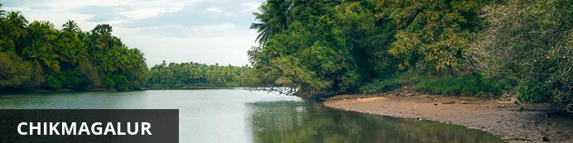
Situated in the state of Karnataka in southwest India, the hill station of Chikmagalur is remarkable for its stunning natural scenery, extraordinary temples, and delicious coffee. Boasting bright green hills and mountains jutting into the sky at extreme angles, Chikmagalur’s terrain is one which inspires near disbelief. A wealth of waterfalls, accessed by picturesque trails through dense forests on the slopes and coffee plantations in the valleys, provide wonderful spots for refreshing dips. Several ancient and exquisitely decorated temples adorn the landscape. The area is known for its abundance of coffee plantations and delicious varietals. Don’t miss the opportunity to visit the Bhadra Wildlife Sanctuary, home to elephants, tigers and leopards; the three holy caves in the Baba Budangiri Mountain Range; and the pretty Mahatama Gandhi Park.

After breakfast you will be transferred to Chikmagalur [Approx. 190 kms / 5 hrs]. En-route visit ruin of Belur and Halebeedu. On arrival check in your hotel. Spend rest of the day will be at your leisure.

Belur
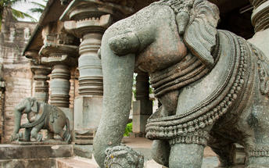
Set on the banks of Yagachi River in the Hassan District in the state of Karnataka, Belooru, or more commonly known as Belur is set amidst lush surrounds. It boasts a rich cultural heritage, historical significance and a variety of sacred temples. Belur is a popular tourist destination in the state of Karnataka. It features the Chennakeshava Temple Complex, is a 12th-century Hindu temple displaying some of the best of Hoysala architecture in the country. Other highlights include: Panduranga Temple, Shankaralingeshwara Temple, and Hoysaleshwara Temple and the spectacular Jain temples in Halebidu.

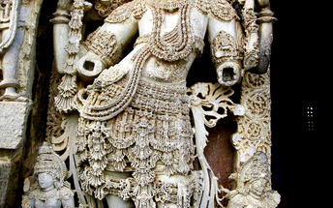
Halebidu
A city in the Karnataka state of India, Halebid features Hoysala structures. Halebid's temple complex contains the Hoysaleswara, Kedareswara and Jain temples.

Day 9: Chikmagalur- Hampi

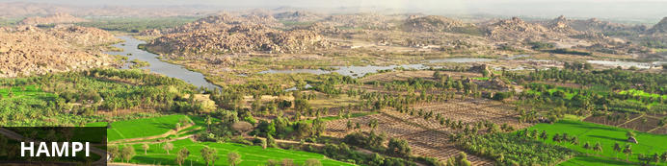
An enchanting ancient city and hippy backpacker destination, Hampi offers the perfect heady mix of Indian charms that make it hard for visitors to leave. Here history and modernity meet: impressive ancient remnants of Vijayanagara, the former capital of the Vijayanagara Empire, are dotted around the congested buildings of Hampi town. Cross the river and you’ll find laid back restaurants and rooms bordered by banana plantations and paddy fields, with a view over the river and ruins. Sightseeing can take up most of your time but don’t neglect to visit the Monkey Temple, a 572-stair climb, to catch the sunset.

After breakfast you will be transferred to Hampi [Approx. 320 kms / 6-7 hrs].

Day 10: In Hampi

After breakfast explore Hampi ruins.

Hampi Ruins
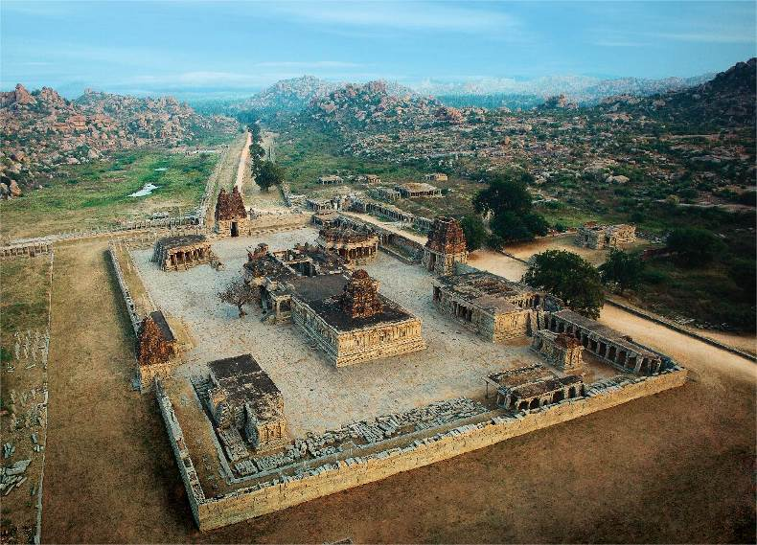
Hampi, the World Heritage Center, is the most beautiful and evocative of all the ruins of Karnataka. Capital of Vijayanagar kingdom is full of delightful surprises, viz., Kings Balance where kings were weighed against grain, gold or money which was then distributed to the poor, other attractions are Queen's Bath with its arched corridors, projecting balconies, Lotus Mahal Vittala Temple, Virupaksha Temple, Ugra Narasimha are not to be missed. The best way to experience this World Heritage Site is to take a leisurely stroll through the eloquent ruins. Most of the important structure and ruins are located in tow areas, which are generally referred to as the Royal Centre and the Sacred Centre. The Royal Centre contains structures that seem to have been palaces, baths, pavilions, royal stables, and temples for ceremonial use. The sacred center is situated on the banks of the holy Tungabhadra River. Visit Vittthala temple and Virupaksha temple.

Day 11: Hampi- Badami

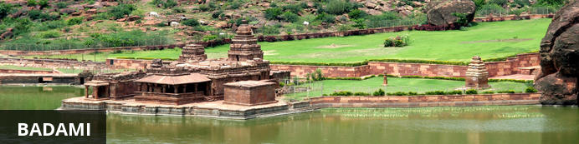
Situated in northern Karnataka, the quiet village of Badami is home to a series of ancient cave temples. Between the 6th and 7th centuries Badami was the capital of the Early Chalukyas, who ruled much of Karnataka and Andhra Pradesh. They carved out sacred spaces into the rust-coloured cliffs above Agstya Lake, and decorated the walls of these holy caves with bold, detailed reliefs of their deities. Out of the shimmering waters below rise the steps of the Bhutanatha temple complex, a cluster of sandstone shrines devoted to this god.

After breakfast, you will be driven to Badami [Approx. 150 kms / 3 hrs].

Day 12: In Badami

Breakfast at the hotel. Today you will be taken for sightseeing tour of Badami.

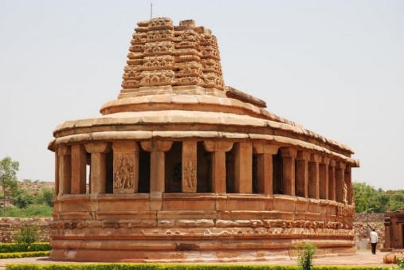
Aihole
The ancient walled city Aihole, which dates back to the 6th century in Karnakata served as the former capital of the region during the early Chalukyas period. Visitors can enjoy exploring the historic fortified complex comprised of over a hundred stone temples featuring a blend of fascinating architectural styles, Jain monuments, and ancient caves displaying unique traditional art depicting Hindu deities and legends.

Pattadakal
Declared a world heritage site in 1987, Pattadakal, situated on the banks of the Malaprabha river in the Bagalkot district of Karnataka, represents the high point of temple architecture under the Chalukya dynasty in the 7th and 8th centuries. Earlier called Kisuvolal or Pattada Kisuvolal, that literally translates to City of Crown Rubies, Pattadakal along with Aihole and Badami provide an incredible concentration of religious monuments that reveal a beautiful fusion of north (Nagara, Indo-Aryan) and south (Dravidian) Indian architectural forms.

Day 13: Badami- Goa

Breakfast at the hotel. Today you will be driven to Goa [Approx. 260 kms / 5 hrs] in your private chauffeur driven vehicle.

Day 14-17: In Goa

Breakfast at the hotel. Spend rest of these days at leisure. No vehicle will be provided on disposal basis.

Day 18: Goa – Departure

At an appropriate time, you will be assisted & transferred to airport to board the flight for onward journey.

