

IN- 20

Jewels of South India Tour
Bangalore - Mysore - Wayanad - Kerala - Kochi – Allepey- Kochi
12 Days / 11 Nights

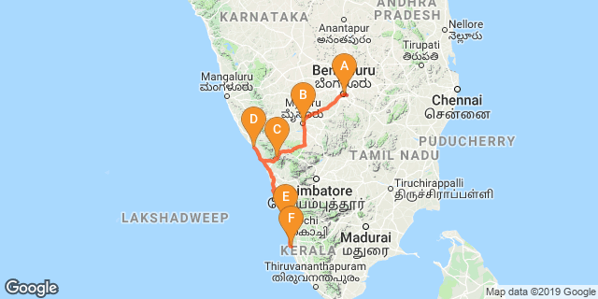

Overview: This journey covers the highlights of Karnataka, i.e.. Bangalore, Mysore along with Wayanad and Kochi from Kerala – the Gods Own country.

Highlights: Culture, Nature, Cuisine, Backwaters

Day 1: Arrive Bangalore

Fly into Bangalore where you will met by your Travel Counsellors Representative, who will meet and assist for your transfer to hotel for check in.

Day 2: Bangalore- Mysore

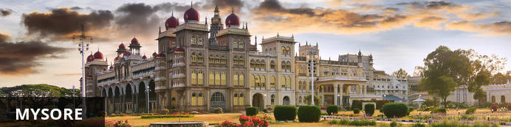
Serving as the capital of the Kingdom of Mysore from 1399 until 1947, the city of Mysore is a rich cultural and historical centre renowned for its beautiful Hindu palaces. Arguably the most captivating of these is the opulent Mysore Palace or Amba Vilas, particularly during the annual Dasara Festival, when every day after sunset it turns incandescent with the light of nearly 100 000 bulbs. In the modern context, Mysore is considered one of India’s cleanest and most efficiently planned cities, and has earned a reputation for its high quality sandalwood and silk.

After breakfast, take an orientation tour of Bangalore and then proceed to Maysore (Approx. 150 kms / 04 hours drive). Arrive Mysore and check in at the hotel.

Bull Temple
Located in Bangalore, India, Bull Temple, also known as Nandi Temple is a religious shrine famous for its colossal image of a bull. Built in 1537 by Kempe Gowda, Bull Temple is primarily used for the worship of the sacred bull or Basava in Hinduism, Lord Shiva's vahana.

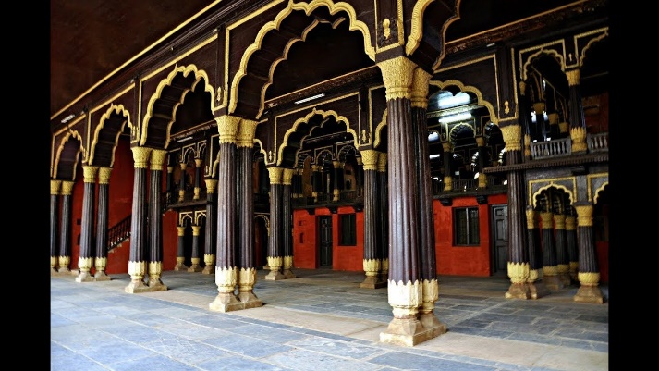
Tipu Sultan's Summer Palace
The intricately carved arches of the Tipu Sultan Fort have been built as per the Islamic style. Another major attraction of the fort is the well-preserved Ganapati temple situated inside it. Within the fort lies Tipu Sultan palace, which dates back to year 1790. Built entirely of teakwood, the palace was constructed as the summer residence of Tipu Sultan. The two-storied palace stands adorned with pillars, arches and balconies.

Day 3: In Mysore

After breakfast enjoy half day sightseeing tour of Mysore.

Chamundeshwari Temple
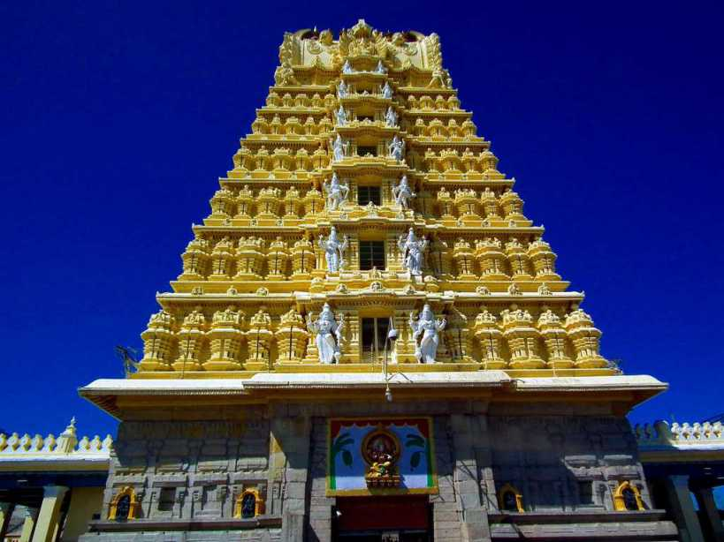
The temple was named after Chamundeshwari or Durga, the fierce form of Shakti, a tutelary deity held in reverence for centuries by Mysore Maharajas. Chamundi Hill is named after Goddess Chamundi who is believed to be the incarnation of Parvati, the consort of Lord Shiva. A large number of devotees from all over the country and even abroad visit the temple every year. Pilgrims strongly believe that the Goddess helps them to fulfill their needs. Standing as the crown jewel of Mysore, Chamundi Hills is the abode of all powerful Goddess, Chamundi or Chamundeswari.

Day 4: Mysore- Wayanad

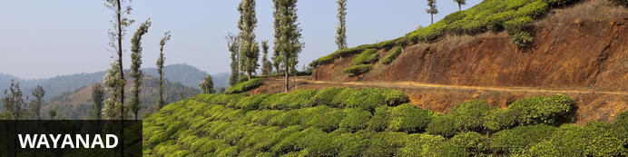
Resting on the lush green slopes of the Western Ghats, Wayanad is the most sparsely populated region of India’s Kerala state. This spectacularly scenic area is ideal for trekking and is characterised by towering, mist-cloaked mountains, serene fresh water lakes, dense emerald green forests, breathtaking waterfalls, and paddy fields as far as the eye can see. Wayanad features a number of luxury resorts and elegant eco-hideaways where visitors can base themselves while exploring the many attractions on offer. Chief among these is the Wayanad Wildlife Sanctuary which was established in 1973 and is now an integral part of the Nilgiri Biosphere Reserve. This sanctuary is one of the best place in India to spot Elephant in the wild as well as a number of other large mammals such as Indian bison, deer and tiger.

After breakfast at the hotel, you will be driven to Wayanad (Approx. 131 kms / 03 hours drive). Arrive Wayanad and check in at the hotel.

Day 5: In Wayanad

After breakfast, you will proceed for your Shared Jeep ride at Wildlife Sanctuary [Subject to availability] Muthanga. Later visit Edakkal Caves.

Edakkal Caves
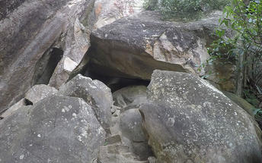
Located at about 1200 ft above the sea level, the Edakkal Caves are among the oldest human settlements ever discovered. Inside the caves are pictorial drawings and engravings that indicate the presence of ancient human settlements in the region. Despite their name, the Edakkal Caves are not actually caves. They are part of a prehistoric rock shelter, formed naturally when one huge boulder got wedged between two bigger ones. The name Edakkal itself means “a stone in between”. The Edakkal cave paintings are remarkable in their sheer scale and complexity, but their origins are shrouded in mystery. Ever since their discovery in 1895, they have been a source of awe and wonder for tourists and historians alike.

Day 6: In Wayanad

Breakfast at the hotel. And opportunity to do the visits / activiites offered by the resort.

Day 7: Wayanad- Thalassery

After breakfast you will be driven to Thalassery. [Approx. 100 kms / 03 hours drive). Arrive Thalassery and check in at the hotel.

Day 8: In Thalassery

Morning after breakfast, leave with the host to the local market. Visit the spice, vegetable, Fish market, buy the fresh produce and return to the home for a hand on experience with the host to make your choice of meal for lunch.
Become a Malabar Cuisine expert before you leave! At Ayisha Manzil, the guests may eat and try to prepare the real authentic tastes of Muslim Malabar Food.
Mrs. Faiza Moosa, the hostess conducts cooking classes to add up the entertainment to the guests. As a part of the baggage, there is always the booklet of recipes given to the guests by this master cook. No Kerala meal is complete without the spicy Biryani accompanied by Chutneys and Pickles. It is made of rice, chicken or beef and spices, which is a popular dish in Kerala. The other recipes at this place which are sure to leave your taste buds longing for more, are, pathiri, neypathil, petipathiri, muttamala, alisas, unnakai, erachipathil and of course, the yummy taste of fresh seafood recipes. The mussels, fishes and prawns are marinated and fried to give a whole new taste to the seafood.

Day 9: Thalassery- Cochin

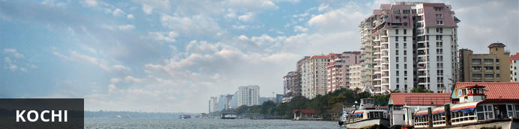
Also known as Cochin, Kochi is a city in southwest India's coastal Kerala state. This attractive city has served as a popular port for over 600 years and is known for its eclectic architecture and its array of religious monuments, museums, galleries, cafes and antique shops. The city stretches across a number of peninsulas and islands, which can be reached by a network of water taxis and bridges. The majority of Kochi’s visitor highlights can be found on the peninsula of Fort Kochi. These highlights include the St Francis Church, the oldest European-built church in India; and Mattancherry Palace, which dates back to 1557 and contains some exceptional Kerala murals and temple art. Other must-see attractions include the Kerala Folklore Museum, displaying more than 4,000 cultural and ethnic artifacts; the 16th-century Jewish Synagogue; and the local market, where the air is filled with the aroma of exotic spices.

Leave Thalaseery to Ernakulam by train on arrival check-in at the hotel.

Day 10: In Cochin

After breakfast enjoy Full day sightseeing tour of Cochin. Evening enjoy Kathakali Dance show

Jewish Synagogue
Visitors to Fort Kochi would invariably be treated to many a cultural representation. They all have left their marks in the form of traders, asylum seekers, rulers and those who came to spread their religious faiths. What we are going to unravel is a landmark in a place called Mattancherry in Fort Kochi; a monumental one that rose from the cultural traits and religious beliefs of a community that came to Kochi seeking asylum. The Jews of Fort Kochi, who fled their homeland - Israel during the Diaspora embraced Fort Kochi as their second home.

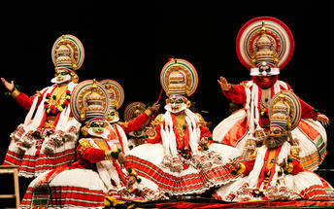
Kathakali
Kathakali is a highly stylized classical kerala dance performance noted for its attractive make-up of characters, their elaborate costumes, detailed gestures and well-defined body movements presented in tune with the anchor playback music and complementary percussion. Kathakali is nearly a 300 year old classical dance form, said to have evolved from other performing arts like Kootiyattam (a classical Sanskrit drama existing in Kerala), Krishnanattam and Kalarippayattu. Kathakali explicates ideas and stories from the Indian epics and Puranas.

Day 11: Cochin- Alleppey

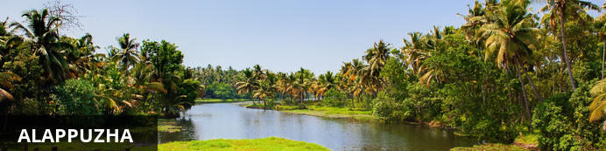
Located in the Indian state of Kerala, the bustling city of Alappuzha, also known as Alleppey, is set along the coast of the Laccadive Sea. Dubbed the ‘Venice of the East’, it is renowned for its houseboat cruises which float along the tranquil backwater canals of Kerala. It is said to be one of the most popular tourist centres in the state. While cruising the palm-shaded canals is the main attraction, visitors can also enjoy visiting Alappuzha’s beautiful beaches, exploring the little riverside villages dotting the lush countryside and discovering an array of resplendent temples. Don’t miss the annual Nehru Trophy Boat Race held at Punnamada Lake.

After breakfast you will be driven to Allepey. (approx 70 kms/ 02 hours drive). On arrival board the Houseboat by 12:30 Hrs. for a cruise over the backwaters of Kerala.
The houseboats or Kettuvallam as they are traditionally called were at one time the mode of transportation for man and goods. Today, these are made to cater to the discerning guests who can lay back and enjoy the gentle cruise. Cruise the backwaters from the main Vembanad Lake through the small estuaries that link small villages to the mainland. Today, these are refurbished and all modern conveniences have been added for tourists who visit this beautiful water locked region of the country.

The houseboat cruise takes you through the intricate maze of backwaters, mesmerizing and surprising you at every turn with its serene beauty & simple charm. Enjoy the countryside of Kerala at its best. Soak your eyes & soul with array of coconut trees & endless paddy fields. You will also get chance to take a small stroll through the villages & interact with the locals.

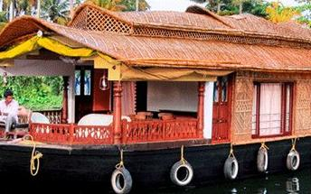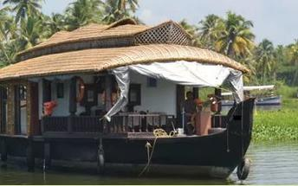

Day 12: Alleppey – Kochi – Departure

Dis-embark the house and leave for Kochi airport for your onward flight back home

