

IN- 21

North India Tour
Delhi (A)- Jaipur (B) - Agra (C)- Khajuraho (D)– Varanasi (E)- Delhi (F)
11 Days / 10 Nights

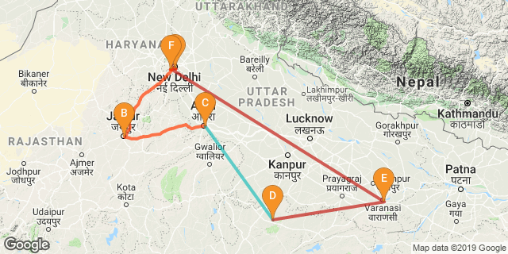

Overview: This journey covers the much sought after “Golden Triangle” i.e. Delhi, Jaipur, Agra, along with the Khajuraho for the magnificent temples and Varanasi – one of the oldest living cities of the world.

Highlights: Culture, History, Temples, Family, Indian Railways, Cuisine
- Explore the historic layers of the Old and New Delhi with its UNESCO world heritage sites.
- A heritage walk along with rickshaw ride through the fabled markets of “Chandni Chowk”
- Experience a journey on Indian Railways.
- Visit to “Taj Mahal” - the universally admired masterpiece of the world's heritage.
- Explore the deserted city of Fatehpur Sikri.
- Explore the bustling bazaars of the Pink City of Jaipur.
- Cover the forts and palace at Jaipur and Agra
- Visit the beautiful havelis at Jaisalmer
- Experience the temples in Orchha, Khajuraho and Varanasi;
- Experience Ganga aarti and boat ride in Varanasi;

Day 1: Arrive Delhi

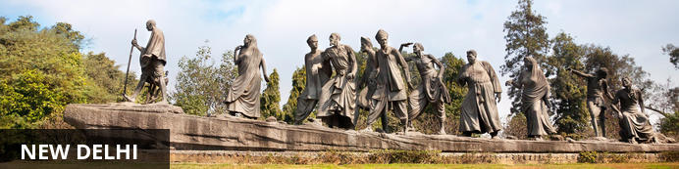
India’s largest city, Delhi, has been one of the country’s commercial and economic hubs for centuries and, as a result, is incredibly rich in culture and history. Made up of the ancient walled city of Old Delhi and the more modern sector, New Delhi, the city encompasses a staggering array of beautiful architecture, notable monuments and age-old temples, including three UNESCO World Heritage Sites – the Red Fort, Qutab Minar and Humayun's Tomb. Other key attractions include the 17th century Chandni Chowk marketplace – still one of the city’s most popular retail centres today, particularly for jewellery and traditional Indian saris; the iconic Bahà’i Lotus Temple – an award-winning architectural gem; and the Jama Masjid, India’s largest mosque.

Fly into Delhi where you will be met by your Travel Counsellors Representative who will assist and transfer you to your hotel

Day 2: In Delhi

After an early breakfast, you will proceed for Heritage walk in Old Delhi. In the afternoon New Delhi sightseeing tour followed by drive past to India Gate, the Parliament building and the Rashtrapati Bhawan, the President’s residence.

Old Delhi Heritage Walk
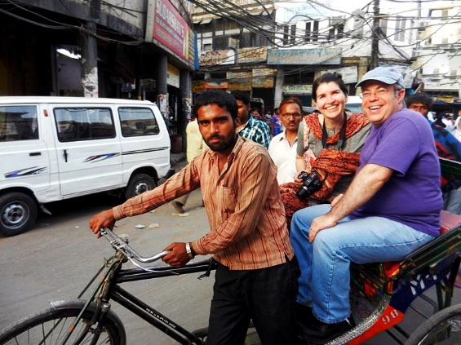
Delhi is an ancient city with history going back to 3000 BC. It has been mentioned extensively in numerous Indian epics like Mahabharat. But the Delhi we see and know about from written records starts from 736 AD. The city has been built, destroyed and rebuilt numerous times. According to popular folklore, Delhi was site of seven different cities between 3000 BC and 17th century AD. But when we count the smaller settlements around the area, there are atleast fifteen. delhi heritage walk. This ancient history and influx of people from all over the world has given Delhi a culture and heritage matched by only a handful of places. Delhi is one of very few places where the ancient and modern co-exist side by side complementing each other perfectly.

Humayun's Tomb
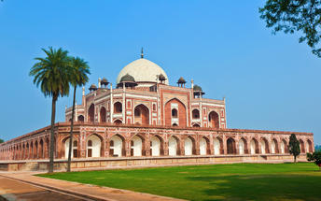
The mausoleum complex of Humayun, India’s second Mughal Emperor, was commissioned by his widow in 1565 and was the first garden tomb to be built in India, taking seven years to complete. Humayun had travelled widely in Persia and Central Asia during his lifetime, and many of the architectural principles he brought back from these journeys were incorporated into the building at his wife’s instructions. With its double domes, decorative inlaid marble and vast garden with pools connected by channels, this 16th Century building set the stage for the style that culminated in the Taj Mahal almost 100 years later.

Qutub Minar
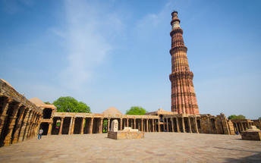
The majestic Qutub Minar is a heritage building located in downtown Mehrauli in India. Standing tall at 73-metres, the tower consists of 5 storeys with a flight of spiral stairs leading to its top. The walls are adorned with decorative motifs and Quranic inscriptions. At the foot of the tower lie other monuments of historical significance, such as the Quwwat-ul-Islam Mosque and the Iron Pillar of Delhi. The Amazing race Australia used this site as a pitstop in the second series. Visitors can take advantage of stunning photo opportunities.

Day 3: Delhi- Jaipur

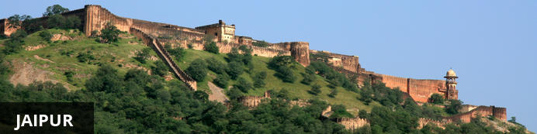
Fringed by the rugged Aravali Hills, Jaipur is the capital and largest city in India’s northern state of Rajasthan. This city is famed for being India’s first planned city featuring a multitude of pink terracotta buildings within the walled historic centre, earning it the nickname,’The Pink City’. Jaipur falls within the Golden Triangle, a popular tourist circuit, which includes Delhi, Jaipur and Agra, and serves as a gateway to the neighbouring desert cities of Jaisalmer and Jodhpur. This colourful city is a combination of tradition and modernity and offers visitors vibrant bazaars, lavish palaces and ancient temples. The salmon-hued old city is home to the opulent City Palace, encompassing an impressive assortment of palatial structures, sprawling gardens, courtyards and buildings. Don’t miss the fairy-tale splendour of the Amber Fort, set against the backdrop of the arid landscape.

After breakfast, you will be driven to Jaipur. (approx 260 kms/ 5-6 hours drive). Arrive Jaipur and check in at the hotel.

Day 4: In Jaipur

After breakfast enjoy Full day sightseeing tour of Jaipur. Enjoy Shared Jeep ride towards upward climb at Amer Fort.

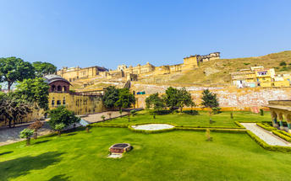
Amer Fort
Amer Fort, officially known as the ‘Amer Palace’, is one of the most famous forts of Rajasthan attracting around 4000 to 5000 visitors a day during peak tourist season. The palace was named after the small town of Amer, where it is situated - only eleven kilometres from Jaipur. Perfectly picturesque, this 16th century hillside residence is well preserved, boasting grand pavilions and mirrored halls that open onto flourishing gardens and courtyards. Although the palace’s main construction started in 1592 by Maharaja Man Singh, it was added to over the years by successive rulers and continued to be occupied by them until Jaipur was built.

Hawa Mahal (Palace of Winds)
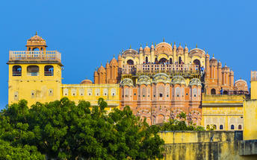
One of Jaipur’s most recognised buildings, the Hawa Mahal (Palace of Winds) is known for its iconic façade. Small windows, decorated with intricate latticework create a honeycomb-like appearance. The original intention of the lattice was to allow the royal ladies to observe everyday life in the street below without being seen. The cooling effect, provided by the breeze passing through the small windows, gave the palace its name. Built in 1799 by Maharaja Sawai Pratap Singh, the unique construction was originally designed to look like the crown of Krishna. A panoramic view of Jaipur can be had from the top of the building.

Jaipur City Palace
City Palace forms one of the most famous tourist attractions and a major landmark in Jaipur. The beautiful palace was built by Maharaja Sawai Jai Singh during his reign. Among the various forts and palaces of Jaipur, City Palace stands apart, with its outstanding art and architecture.

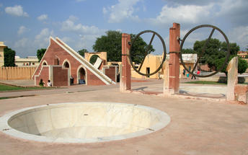
Jantar Mantar Jaipur
In 1734, the year of its completion, the Jai Singh Observatory was the last outpost of medieval science. From the outside, the eighteen fixed observational instruments look more like playground apparatus than sighting devices, but they were used to measure the position of the sun, stars and planets. Built by Jai Singh, the first Maharaja of Jaipur who founded the city in 1727, the observatory is one of a handful. Jai Singh, fulfilling a lifelong interest in mathematics and astronomy, built observatories in Delhi, Jaipur, Ujjain, Mathura and Benares. The Jaipur observatory is the largest and best preserved of these.

Day 5: Jaipur- Agra

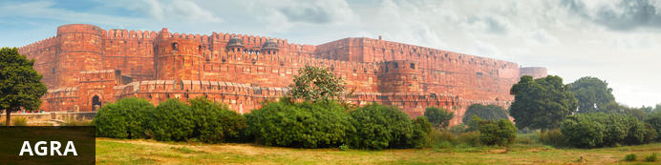
Home of the world-famous Taj Mahal, Agra is one of India’s prime tourist destinations for specifically this reason, though its attractions also extend to an array of other impressive historical sights. These include the red-hued Agra Fort, the sacred Jama Masjid mosque and Itmad-ud-Daulah’s tomb, with its white marble facade embellished with intricate inlaid designs and semi-precious gems. The Taj, however, is in a league of its own and needless to say is a must-see for any visitor to the city. Commissioned by the Mughal emperor Shah Jahan in the 15th century as a memorial to his beloved wife Mumtaz Mahal, it is an architectural masterpiece of exquisite craftsmanship and perfect proportions.

After breakfast check out from the hotel and you will be driven to Agra. (approx 250 kms/ 5 hours drive). En route visit Fatehpur Sikri. Arrive Agra and check in at the hotel.

Fatehpur Sikri
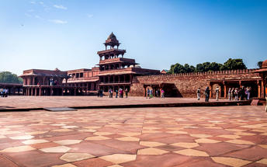
A highlight in the province of Uttar Pradesh, Fatehpur Sikri served briefly as the capital of the Mughal Empire from 1571 to 1585. This world heritage site is rated as one of the best preserved collections of Mughal architecture in India. Surrounded by a six kilometre wall, with the fourth being a lake at the time, a day can be spent exploring the elaborate structures within. Marvel at the impressive Jama Masjid mosque, the detailed palaces built for Emperor Akbar’s wives, the public and private discussion halls and vast ornamental pool; all of which took over 15 years to conceptualise and build.

Day 6: In Agra

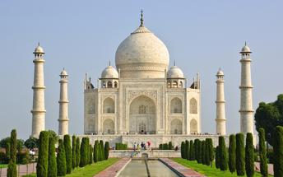
Early morning visit sunrise Taj Mahal (closed on every Friday). Return to the hotel for breakfast. Later visit Agra Fort.

Taj Mahal
The iconic Taj Mahal is not only an architectural masterpiece, a UNESCO World Heritage Site and one of the new Seven Wonders of the World – it’s also the enduring legacy of a royal love story. It was commissioned in the 15th century by the Mughal Emperor Shah Jahan after the death of his third and favourite wife, Mumtaz Mahal, to serve as her final resting place and a symbol of his eternal affection for her. Combining Islamic, Persian, Ottoman Turkish and Indian design elements, it’s an awe-inspiring structure of elegant domes and white marble, which changes colour along with the light – pink at sunrise, pearly white in the afternoon and silver-gold in the full moon.

Agra Fort
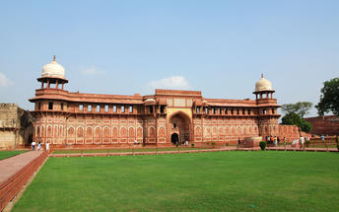
Known as the Red Fort of Agra, this walled imperial city was founded in 1565 by the Emperor Akbar (1556-1605) and is a well-deserving UNESCO World Heritage site, located just 2.5 kilometres from the famous Taj Mahal. Its palaces, grand mosques and elaborate public hall are crafted from pink-red sandstone and are testament to an era when Indo-Muslim art, strongly marked by influences from Persia, was at its height. Emperor Shah Jahan, who built the Taj Mahal for his deceased wife, was imprisoned by his son Aurangzeb in Agra Fort. He is said to have died in the Musamman Burj, a marble tower he himself built, with one of the most alluring views of the Taj Mahal.

Day 7: Agra- Jhansi- Khajuraho

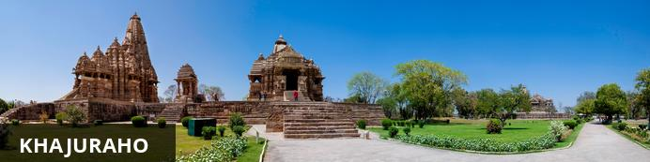
Khajuraho is considered one of India’s seven wonders and listed as a UNESCO world heritage site. The city encompasses the nation’s largest array of medieval Hindu and Jain temples, decorated with intricately detailed erotic sculptures and reliefs. The site incorporates close to 100 sacred structures, some of them exquisitely preserved, and each evening, a light and sound show is staged here, covering the history, philosophy and craftsmanship encapsulated in this archaeological goldmine.

After early breakfast, you will be transferred to Agra railway station to board the train to Jhansi. On arrival, you will be met and transfer to Khajuraho with a en-route at Orchha temples (Approx. 210 kms / 4 hours drive).

Orchha Temples
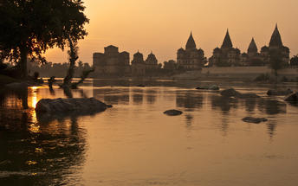
Situated on the banks of Betwa River, laid back Orchha is often overshadowed by its neighbour, Khajuraho, famous for its erotic sculptures. But Orchha has charms of its own: this sleepy and timeless destination resembles a medieval Indian town, dominated by impressive ochre coloured palaces, forts and temples. Most of these date to between the 15th and 18th century – when the city was the thriving seat of government for the Bundela kings – and make for a sensory day of sightseeing, with main attractions including the intricate palace of Jahangir Mahal, the 14 Cenotaphs and the white-washed Ram Raja Temple.

Day 8: Khajuraho- Varanasi

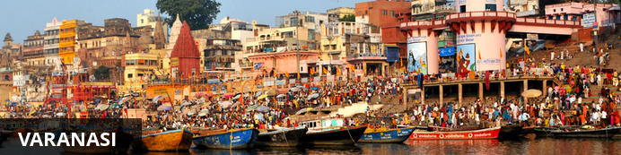
An ancient and deeply sacred city, Varanasi rests along the banks of the holy River Ganges and encompasses a wealth of beautiful riverside temples, stately old forts and vibrant markets. It’s considered the spiritual capital of Hinduism, and it’s widely believed that dying here will bring salvation. As a result, the city is home to a multitude of ghats – stone steps leading to the river –some of which are used for bathing rituals and others as cremation sites. An early morning boat ride along the Ganges offers an excellent way to take in the ghats and the bustling activity centred on them.

After breakfast, you will be taken for the tour of the temples at Khajuraho.
Later take the flight to Varanasi.

Khajuraho Temples
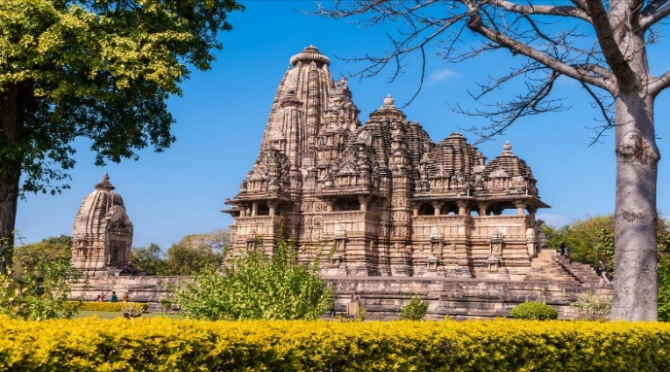
The architectural style of the Khajuraho temples is very different from the temple prototype of that period. Each stands, instead of within the customary enclosure, on a high masonry platform. Combined with the upward direction of the structure, which is further accentuated by vertical projections, the total effect is one of grace and lightness, reminiscent of the Himalayan peaks. Each of the chief compartments has its own roof, grouped in such a way that the highest is in the centre, the lowest over the portico, a triumph of skill and imagination in recreating the rising peaks of a range. The temples of Khajuraho are divided into three geographical groups: Western, Eastern and Southern.

Day 9: In Varanasi

Early morning enjoy a boat ride on the river Ganges. Return to the hotel for breakfast. In the afternoon, enjoy visit to Sarnath. Evening attend the “aarti ceremony” at the Ghats.

Boat ride on the River Ganges
Sunrise boat ride on Gangas is a spiritual experience in itself. It gives a glimpse of morning life along the ghats. If you are lucky you can see stunning views of sun rising in the eastern horizon. For locals it is the lifeline. For devout pilgrims she is “Ganga Mayya – the mother who will wash away all the sins”.

Sarnath
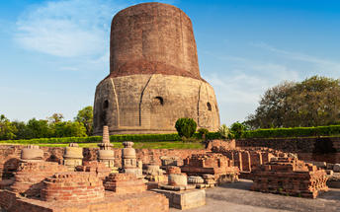
Sarnath is one of the most important Buddhist pilgrimage centres in India. It is here that Buddha came after reaching enlightenment at Bodh Gaya (present-day Bihar), and where he first began his teachings of Dharma and the four noble truths to his five disciples. It is also an important place for the followers of Jainism. While many of the ancient buildings and structures at Sarnath were damaged or destroyed by the Turks, relics remain in the form of ruins that can be visited, or artefacts held in the Sarnath Archaeological Museum, which also houses some of the greatest treasures of Indian Buddhist art, including almost 300 images. The Deer Park, which is the site of Buddha’s first teachings, is maintained as an animal park and still home to resident deer.

Evening Aarti at Ghat
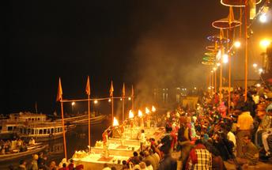
Ganges Aarti is performed daily in the evening by a group of priests at the Dashashwamedh Ghat near famous Kashi Vishwanath Temple as a dedication to Shiva, Gange, Surya (Sun), Agni (Fire), and the entire universe. The whole ritual of the Ganges Aarti is performed by the seven students of the Vedas and Upanishads lead by the head priest of the Gangotri Seva Samiti in a well choreographed manner with a great synchronization. The whole event takes around 45 minutes. An announcement at 7.00 pm indicates the beginning of the Aarti.

Day 10: Varanasi- Delhi

Breakfast at the hotel. At an appropriate time, you will be assisted & transferred to airport to board the flight for Delhi. Upon arrival at New Delhi, you will be assisted & transferred to the hotel check in.

Day 11: Delhi departure

At appropriate time, your Travel Counsellor representative will provide you the necessary transfer to the airport

