

IN-22

Golden Triangle with Himalayas
New Delhi - Agra - Jaipur - Chandigarh - Shimla
12 Days / 11 Nights
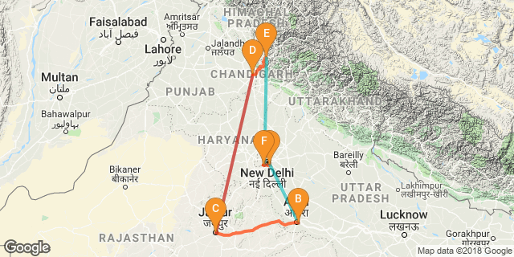

The journey will take you through an exciting Indian trail – the Golden Triangle – Delhi, Agra, Jaipur along with the Shimla –the erstwhile summer capital of the British.

Highlight Culture, cuisine, nature, Indian railways, mountains

Day 1: Arrive Delhi

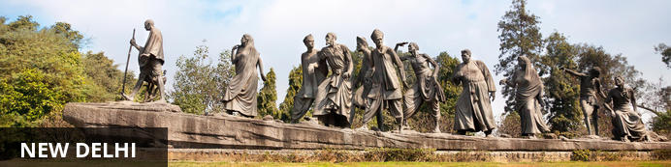
India’s largest city, Delhi, has been one of the country’s commercial and economic hubs for centuries and, as a result, is incredibly rich in culture and history. Made up of the ancient walled city of Old Delhi and the more modern sector, New Delhi, the city encompasses a staggering array of beautiful architecture, notable monuments and age-old temples, including three UNESCO World Heritage Sites – the Red Fort, Qutab Minar and Humayun's Tomb. Other key attractions include the 17th century Chandni Chowk marketplace – still one of the cities most popular retail centres today, particularly for jewellery and traditional Indian saris; and the Jama Masjid, India’s largest mosque.

On arrival in Delhi: Having cleared immigration, collected your luggage and passed through customs, please make your way towards the exit of the terminal building where you will see a bank of people waiting for you. Amongst them will be Travel Counsellors Representative who will be waiting to greet you with a paging board with your name on.
You will be transferred to your hotel and assisted with check in. Standard check in time is 1400 hrs.

Day 2: In Delhi

The day is scheduled for a heritage walk of Old Delhi in the morning followed by a tour of New Delhi in the afternoon.

Old Delhi Heritage Walk
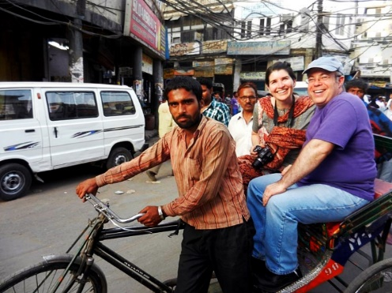
Delhi is one of very few places where the ancient and modern co-exist side by side complementing each other perfectly. Our heritage walks of Delhi are a perfect way of exploring this amalgam of old traditions, modern development and the unique heritage which makes it so interesting. It is the perfect way to explore some of the lesser visited places and gain a new insight about the history, people and sights of Delhi city.
The tour of New Delhi covers the UNESCO world Heritage sites of Humyauns tomb, Qutab Minar along with a photo stop at India Gate – the war memorial and drive past the Govt. Secretariat building and the President Palace.

Humayun's Tomb:
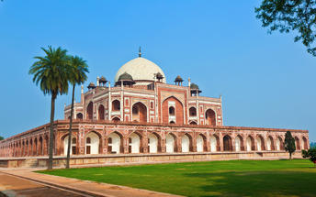
The mausoleum complex of Humayun, India’s second Mughal Emperor, was commissioned by his widow in 1565 and was the first garden tomb to be built in India, taking seven years to complete. Humayun had travelled widely in Persia and Central Asia during his lifetime, and many of the architectural principles he brought back from these journeys were incorporated into the building at his wife’s instructions. With its double domes, decorative inlaid marble and vast garden with pools connected by channels, this 16th Century building set the stage for the style that culminated in the Taj Mahal almost 100 years later.

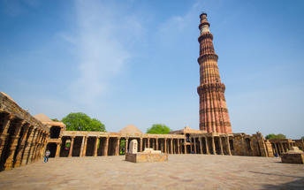
Qutub Minar
Standing tall at 73-metres, the tower consists of 5 storeys with a flight of spiral stairs leading to its top. The walls are adorned with decorative motifs and Quranic inscriptions. At the foot of the tower lie other monuments of historical significance, such as the Quwwat-ul-Islam Mosque and the Iron Pillar of Delhi. The Amazing race Australia used this site as a pit stop in the second series. Visitors can take advantage of stunning photo opportunities.

Day 3: Delhi- Agra

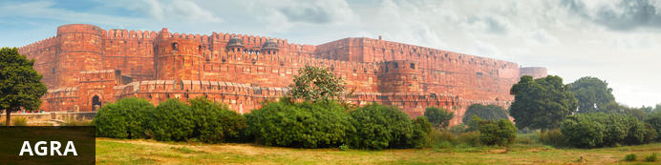
Home of the world-famous Taj Mahal, Agra is one of India’s prime tourist destinations for specifically this reason, though its attractions also extend to an array of other impressive historical sights. These include the red-hued Agra Fort, the sacred Jama Masjid mosque and Itmad-ud-Daulah’s tomb, with its white marble facade embellished with intricate inlaid designs and semi-precious gems. The Taj, however, is in a league of its own and is a must-see for any visitor to the city. Commissioned by the Mughal emperor Shah Jahan in the 15th century as a memorial to his beloved wife Mumtaz Mahal, it is an architectural masterpiece of exquisite artisanship and perfect proportions.

After breakfast, you will be transferred to railway station to board the train to Agra.
Upon arrival at Agra, you will be assisted & transferred and taken directly to Agra Fort for the visit followed by check-in at the hotel. (Standard check in time at the hotel is 1400 Hrs).
Later in the evening, visit Taj Mahal at sunset.

Agra Fort
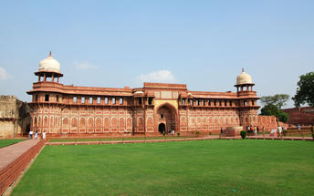
Known as the Red Fort of Agra, this walled imperial city was founded in 1565 by the Emperor Akbar (1556-1605) and is a well-deserving UNESCO World Heritage site, located just 2.5 kilometres from the famous Taj Mahal. Its palaces, grand mosques and elaborate public hall are crafted from pink-red sandstone and are testament to an era when Indo-Muslim art, strongly marked by influences from Persia, was at its height. Emperor Shah Jahan, who built the Taj Mahal for his deceased wife, was imprisoned by his son Aurangzeb in Agra Fort. He is said to have died in the Musamman Burj, a marble tower he himself built, with one of the most alluring views of the Taj Mahal.

Taj Mahal
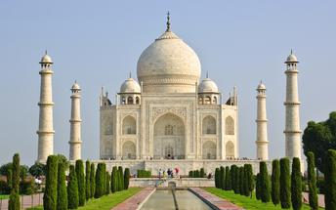
The iconic Taj Mahal is not only an architectural masterpiece, a UNESCO World Heritage Site and one of the new Seven Wonders of the World – it is also the enduring legacy of a royal love story. It was commissioned in the 15th century by the Mughal Emperor Shah Jahan after the death of his third and favourite wife, Mumtaz Mahal, to serve as her final resting place and a symbol of his eternal affection for her. Combining Islamic, Persian, Ottoman Turkish and Indian design elements, it’s an awe-inspiring structure of elegant domes and white marble, which changes colour along with the light – pink at sunrise, pearly white in the afternoon and silver-gold in the full moon.

Day 4: Agra- Jaipur

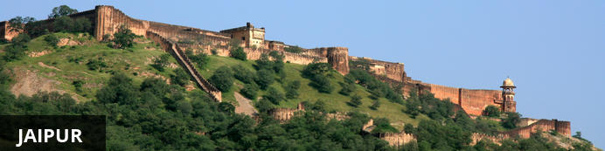
Fringed by the rugged Aravali Hills, Jaipur is the capital and largest city in India’s northern state of Rajasthan. This city is famed for being India’s first planned city featuring a multitude of pink terracotta buildings within the walled historic centre, earning it the nickname, ‘The Pink City’. Jaipur falls within the Golden Triangle, a popular tourist circuit, which includes Delhi, Jaipur and Agra, and serves as a gateway to the neighbouring desert cities of Jaisalmer and Jodhpur. This colourful city is a combination of tradition and modernity and offers visitors vibrant bazaars, lavish palaces and ancient temples. The salmon-hued old city is home to the opulent City Palace, encompassing an impressive assortment of palatial structures, sprawling gardens, courtyards and buildings. Do not miss the fairy-tale splendour of the Amber Fort, set against the backdrop of the arid landscape.
After breakfast, leave with the private chauffeur driven vehicle Jaipur (approx. 235 kms/ 06 hours’ drive) with a stop at Fatehpur Sikri.
Arrive Jaipur in the afternoon and check-in at the hotel.

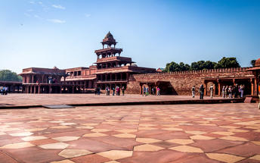
Fatehpur Sikri
This world heritage site is rated as one of the best-preserved collections of Mughal architecture in India. Surrounded by a six kilometre wall, with the fourth being a lake at the time, a day can be spent exploring the elaborate structures within. Marvel at the impressive Jama Masjid mosque, the detailed palaces built for Emperor Akbar’s wives, the public and private discussion halls and vast ornamental pool; all of which took over 15 years to conceptualise and build.

Day 5: In Jaipur

After breakfast, enjoy Full day sightseeing tour of Jaipur covering Amer Fort, City Palace and the Observatory and a photo stop at Hawa Mahal “Palace of Winds”. Take a shared Jeep ride to reach Amer Fort.

Amer Fort
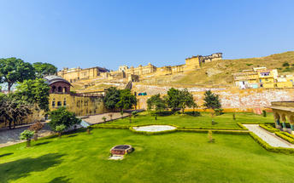
Amer Fort, officially known as the ‘Amer Palace’, is one of the most famous forts of Rajasthan attracting around 4000 to 5000 visitors a day during peak tourist season. The palace was named after the small town of Amer, where it is situated - only eleven kilometres from Jaipur. Perfectly picturesque, this 16th century hillside residence is well preserved, boasting grand pavilions and mirrored halls that open onto flourishing gardens and courtyards. Although the palace’s main construction started in 1592 by Maharaja Man Singh, it was added to over the years by successive rulers and continued to be occupied by them until Jaipur was built.

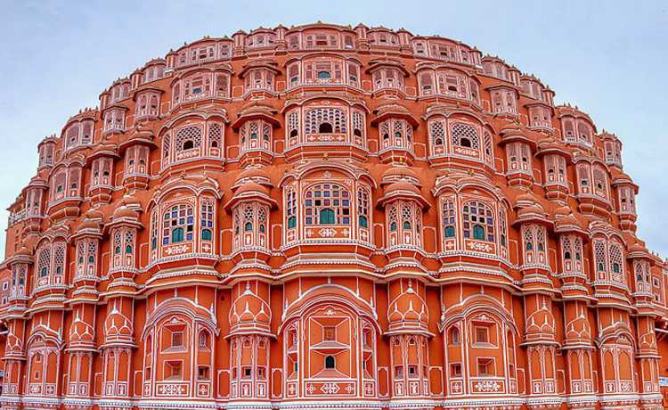
Hawa Mahal (Palace of Winds)
One of Jaipur’s most recognised buildings, the Hawa Mahal (Palace of Winds) is known for its iconic façade. Small windows, decorated with intricate latticework create a honeycomb-like appearance. The original intention of the lattice was to allow the royal women to observe everyday life in the street below without being seen. The cooling effect, provided by the breeze passing through the small windows, gave the palace its name. Built in 1799 by Maharaja Sawai Pratap Singh, the unique construction was originally designed to look like the crown of Krishna
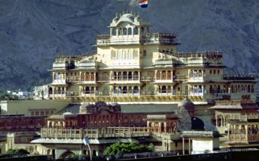

Jaipur City Palace
City Palace forms one of the most famous tourist attractions and a major landmark in Jaipur. The beautiful palace was built by Maharaja Sawai Jai Singh during his reign. Among the various forts and palaces of Jaipur, City Palace stands apart, with its outstanding art and architecture.

Jantar Mantar Jaipur
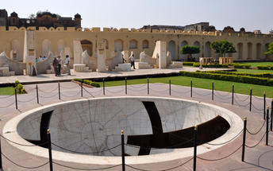
In 1734, the year of its completion, the Jai Singh Observatory was the last outpost of medieval science. From the outside, the eighteen fixed observational instruments look more like playground apparatus than sighting devices, but they were used to measure the position of the sun, stars and planets. Built by Jai Singh, the first Maharaja of Jaipur who founded the city in 1727, the observatory is one of a handful. Jai Singh, fulfilling a lifelong interest in mathematics and astronomy, built observatories in Delhi, Jaipur, Ujjain, Mathura and Benares. The Jaipur observatory is the largest and best preserved of these.

Day 6: In Jaipur
A day at leisure in Jaipur

Day 7: Jaipur – Chandigarh
Designed by Le Corbusier – a renowned Swiss French Architect, Chandigarh has been hailed internationally for its excellent city design, attractive architecture and lovely parks. One of the main attractions is Leisure Valley – an eight-kilometre stretch of beautiful theme gardens. Other highlights include the Nek Chand Rock Garden – filled with sculptures crafted from recycled materials; the Government Museum and Art Gallery; and Sukhna Lake – popular with nature lovers, bird watchers and water sports enthusiasts.

Fly Jaipur to Chanigarh.
Arrive Chandigarh and check-in at your hotel.

Day 8: Chandigarh – Kalka – Shimla
Lying deep in the foothills of the Himalayas, Shimla is the gateway into the more remote northern regions of Kashmir. It is also the stop-off for travellers venturing into the Kullu and Spiti Valleys. Sitting at an altitude of 2159 metres, the city is blessed with a cool climate and beautiful views of river valleys, pine forests, apple orchards and steep mountains covered with maize terraces. The Mall, a long, winding pedestrian-only walkway, is the commercial and social hub of Shimla, while those looking for natural beauty should head uphill through the forest to Jakhu Temple or follow one of the many forest trails in the eastern part of Shimla. To the south of the city, the bazaars bustle with local flavour.

Leave in the morning to Kalka and board the UNESCO world heritage mountain train for Shimla
Arrive and check-in at the hotel.

Day 9: In Shimla
A day for the visit covering Indian Institute for advanced studies (closed on Mondays), Sankat Mochan temple and the Mall road.

Indian Institute of Advanced Study
Also called the Viceregal Lodge, the Indian Institute of Advanced Study is a research institute set in a historical building in Shimla. As a residential centre for research, it encourages creative thinking in areas of deep human significance. The environment of the institute is eminently suitable for academic pursuits, especially in select areas of the humanities, Indian culture, religion and the social and natural sciences. It also has a comprehensive library and documentation facilities.

Sankat Mochan Temple
Next, you will be visiting Sankat Mochan Temple. A famous temple of Lord Hanuman in the region is located amidst the mist-clad mountains, providing a serene and scenic environs, making visitors get lost in the mesmerizing atmosphere of the place. The temple was built in the decade of 1960s. It was a famous religious person Baba Neeb Karoriji Maharaj who gave the idea of building this famous Sankat Mochan Mandir. Originally dedicated to Lord Hanuman, the temple now also bears the idols of Lord Rama, Lord Shiva, and Lord Ganesha in various complexes.

Shimla Mall Road
The Mall Road is one of the most popular tourist attractions in Shimla that enfolds many hotels, restaurants, clubs, bars, banks, shops, offices, post offices, and tourist offices. People can walk up and down the Mall road slowly and enjoy the scenic views of the nature while sipping their favourite coffee. A lot of people gather at the Ridge and Scandal point on Mall road to meet and talk with friends, see the views of the Himalayan range and to do some shopping. The Mall road is connected to the Ridge at the Scandal point, where a statue of the nationalist leader Lala Lajpat Rai has been erected.

Day 10: In Shimla
Day at leisure in Shimla

Day 11: Shimla – Kalka – New Delhi

Leave Shimla for Kalka and then take a train back to

Day 12: Depart Delhi

