

IN - 26

North India With Kerala
New Delhi - Palampur - Hoshiarpur - Alappuzha - Mararikulam - Kochi
16 Days / 15 Nights

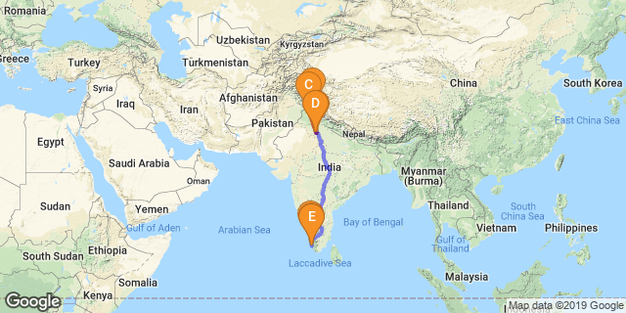
Overview : The best of Himalayas and the backwaters of Kerala
Highlights : mountains, backwaters, yoga, meditation, beach, spa, wellness and Ayurveda

Day 1: Arrives Delhi
Fly into Delhi – Arrive Delhi where you will be met by your Travel Counsellors Representative who will assist and take you to your hotel of stay. Option to do a tour of Old Delhi / New Delhi.

Day 2: Delhi - Dharamshala - Palampur
Resting at the foot of the Dhauladhar Range in the beautiful Kangra Valley, the hill station of Palampur is known as the ‘Tea Capital of Northwest India’. This vibrant little market town is surrounded by majestic mountains lush pine forests, tea plantations and rice fields. Visitors can look forward to a variety of activities including: hiking in the surrounding hills, visiting the local tea factories and lush tea gardens, and discovering an array of ancient temples dotting the lush valley. Don’t miss the opportunity to visit the nearby Dhauladhar National Park, a popular destination for tourists and nature lovers.
Fly Delhi to Dharamsala and from there proceed to Palanpur (approx. 1 ½ hrs drive)

Day 3 & 4: In Palampur
Full Day at leisure to enjoy the activities offered by the resort like including Nature walk, guided village tour.

Day 5: Drive Palampur - Hoshiarpur
The city of Hoshiarpur lies in the upland region near the Outer Himalayas. Hoshiarpur is surrounded by the Shivalik Hills and sandwiched between the Vyas and Sutlej rivers. It boasts a colourful culture, a fascinating history and a host of archaeological remnants. This city is a major hub for transport and industry in the region including oilseed pressing and silk weaving. Visit an array of attractions including: the Sheesh Mahal of Hoshiarpur, a palace of glass; the Archeological Museum, the Bajwara Fort, the Tomb of Shah Nur Jamal, numerous Sikh sites, and the Sheesh Mahal Bazaar filled with traditional wooden handicrafts, Pulkari scarves, and ethnic jewellery.
Drive to Hoshiarpur (approx. 3 ½ hours drive), on arrival check-in at Citrus County Farm.

Day 6: In Hoshiarpur
Breakfast at hotel.
Full day at leisure to explore the activities offered by the lodge. Get a real taste for the traditional life by exploring the village close by, and participating in some local cultural events, take a trip to dairy farm.

Day 7: Hoshiarpur – Chandigarh - Delhi
Drive back to Chandigarh and fly to Delhi.

Day 8: Delhi - Kochi - Alleppey (Alappuzha)
The bustling city of Alappuzha, also known as Alleppey, is set along the coast of the Laccadive Sea. Dubbed the ‘Venice of the East’, it is renowned for its houseboat cruises which float along the tranquil backwater canals of Kerala. It is said to be one of the most popular tourist centres in the state. While cruising the palm-shaded canals is the main attraction, visitors can also enjoy visiting Alappuzha’s beautiful beaches, exploring the little riverside villages dotting the lush countryside and discovering an array of resplendent temples.
Early morning flight to Kochi and from there drive to Alleppey (approx. 2 hours) to board Houseboat for a cruise over the backwaters of Kerala.

Day 9: Alleppey - Mararikulam
Mararikulam is a charming little coastal village known for its pristine sand beaches, swinging coconut palms and quiet, laidback atmosphere. The village has managed to avoid the mass development associated with many of the other beach towns in the area resulting in an untouched natural environment dotted with only a handful of small resorts. The main attraction in the area is the exquisite Marari beach where you will find fishermen heading out daily to fish the waters of this stretch of the Malabar coast, much as their ancestors have done for generations.
Dis-embark Houseboat at Alleppey and drive to Marari (approx. 45 min) and check-in at a beach resort.

Day 10 - 13: In Mararikulam
Days at leisure to do yoga/meditation, cycle ride through the fisherman’s village or rejuvenate oneself with some Ayurveda massages.

Day 14: Marari - Kochi
Also known as Cochin, Kochi is a an attractive city, served as a popular port for over 600 years and is known for its eclectic architecture and its array of religious monuments, museums, galleries, cafes and antique shops. The city stretches across a number of peninsulas and islands, which can be reached by a network of water taxis and bridges. The majority of Kochi’s visitor highlights can be found on the peninsula of Fort Kochi. These highlights include the St Francis Church, the oldest European-built church in India; and Mattancherry Palace, which dates back to 1557 and contains some exceptional Kerala murals and temple art. Other must-see attractions include the Kerala Folklore Museum, displaying more than 4,000 cultural and ethnic artifacts; the 16th-century Jewish Synagogue; and the local market, where the air is filled with the aroma of exotic spices.
Kathakali
Kathakali emerged as an individual style of dance-drama into a "people's theatre" from the traditional dances of the past. The plays were performed by the Rajah's own company of actors, not only in temples and courts, but from village to village and house to house. The new art form (called Ramanattan) soon became very popular all over the Malayalam-speaking area. The feudal chieftains of Malabar (as the area was then called) began to vie with one another in their efforts to produce the best Kathakali troupes and this competition contributed to the rapid development of the art in a very short period.

Day 15: In Kochi
Tour of Kochi exploring Fort Kochi areas. The best way to experience Fort Kochi is on foot and tour operators offer a variety of walking tours where visitors are taken to sites such as the historical Santa Cruz Basilica, Cochin Bishop House, the Dutch Cemetery, the Parade Ground, the famous St Francis Church, and the Indo-Portuguese Museum. Try your luck with the locals on the Chinese fishing nets to get the fresh catch of the day.

Day 16: Kochi – International departure.

