IN-28

Rajasthan Tour with Golden Temple and Himalayas
Delhi - Shimla - Amritsar – Delhi - Agra - Jaipur - Jodhpur - Udaipur
15 Days / 14 Nights

Day 1: Arrive Delhi
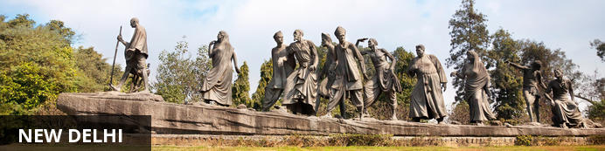
India’s largest city, Delhi, has been one of the country’s commercial and economic hubs for centuries and, as a result, is incredibly rich in culture and history. Made up of the ancient walled city of Old Delhi and the more modern sector, New Delhi, the city encompasses a staggering array of beautiful architecture, notable monuments and age-old temples, including three UNESCO World Heritage Sites – the Red Fort, Qutab Minar and Humayun's Tomb. Other key attractions include the 17th century Chandni Chowk marketplace – still one of the city’s most popular retail centres today, particularly for jewellery and traditional Indian saris; the iconic Bahà’i Lotus Temple – an award-winning architectural gem; and the Jama Masjid, India’s largest mosque.
Flight TBA
Arrives Delhi TBA Hrs

On arrival at Delhi you will be received by a Travel Counsellors' representative and he will transfer you to your hotel for check in. Standard check in time - 1400 Hrs.

Day 2: Delhi
After breakfast you will proceed to visit Old Delhi covering Jama Masjid (the Friday Mosque) drive past Red Fort, visit Chandni Chowk with a rickshaw ride and Raj Ghat.
In the afternoon, visit the UNESCO world heritage sites in New Delhi. Drive Past India Gate – the war memorial, the parlimant buiding and Rashtrapati Bhawan “the President Palace”

Jama Masjid
The majestic Jama Masjid – meaning ‘world-reflecting’ mosque – is Old Delhi’s principal place of worship, and the largest and most renowned of its kind in India. Built in the 17th century by the Mughal Emperor Shahjahan – who also built the Taj Mahal and the Red Fort – it’s an elaborate structure featuring an expansive geometric base topped with globe-shaped minarets crafted from strips of red sandstone and white marble, and a massive courtyard that can hold up to 25 000 people. Jama Masjid is particularly impressive just before dusk, when its rosy hues intensify in the glow of the setting sun.
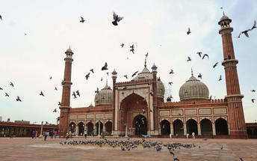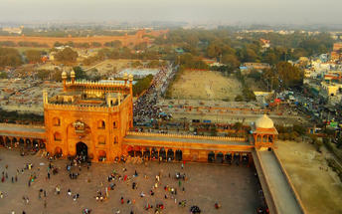

Rickshaw ride Chandni Chowk
Situated in Delhi’s historical old town, frenetic Chandni Chowk – meaning ‘moonlit square’ – is one of the city’s oldest, busiest and most famed shopping areas, built in the 17th century and originally intersected by (now defunct) canals that were designed to capture and reflect the moonlight. It’s a shopper’s paradise – with an eclectic diversity of wares ranging from traditional Indian sweets and other delicacies, to leather goods, electronics, intricately embellished saris and tailor-made suits. But even if you’re not up for any retail therapy, the sights, sounds and atmosphere of this pulsing, labyrinthine marketplace are captivating enough in their own right.

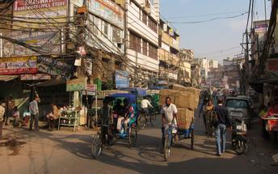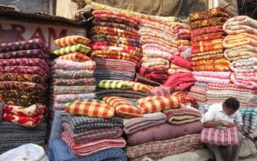

Raj Ghat
Named after a historical ghat of Old Delhi, Raj Ghat is a memorial to Mahatma Gandhi, marking the spot where he was cremated after his assassination in 1948. Housed in an open-air garden area inside a walled complex, the memorial consists of a simple, flat black platform (reflecting the simplicity of Gandhi’s life) that is kept constantly decorated with an abundance of fresh flowers. An eternal flame burns at one end, symbolising the ever-lasting legacy of this great man. Two museums devoted to Mahatma Gandhi, his life and teachings are located nearby.
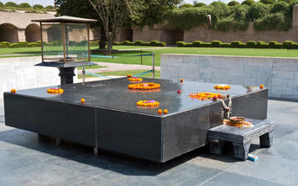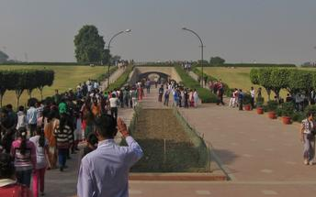

Qutub Minar
Standing tall at 73-metres, the tower consists of 5 storeys with a flight of spiral stairs leading to its top. The walls are adorned with decorative motifs and Quranic inscriptions. At the foot of the tower lie other monuments of historical significance, such as the Quwwat-ul-Islam Mosque and the Iron Pillar of Delhi. The Amazing race Australia used this site as a pitstop in the second series. Visitors can take advantage of stunning photo opportunities.
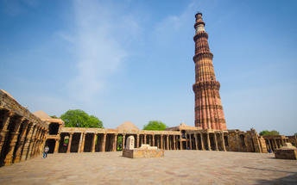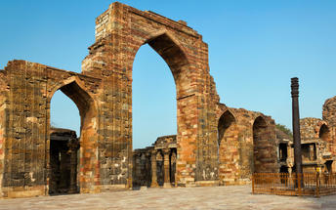

Humayun's Tomb
The mausoleum complex of Humayun, India’s second Mughal Emperor, was commissioned by his widow in 1565 and was the first garden tomb to be built in India, taking seven years to complete. Humayun had travelled widely in Persia and Central Asia during his lifetime, and many of the architectural principles he brought back from these journeys were incorporated into the building at his wife’s instructions. With its double domes, decorative inlaid marble and vast garden with pools connected by channels, this 16th Century building set the stage for the style that culminated in the Taj Mahal almost 100 years later.
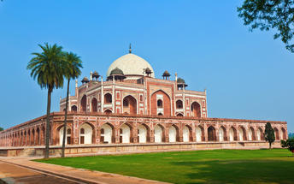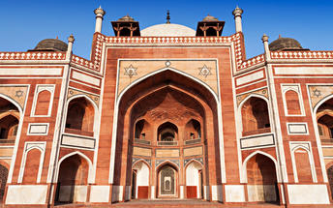

Drive past to India Gate
Also known as the Delhi Memorial or the All India War Memorial, the India Gate was built in commemoration of the roughly 80 000 Indian soldiers who died representing their country in World War One and on various other battlefields, and whose names are inscribed on the structure. Unveiled in 1931, its distinctive arch is reminiscent of the Arc de Triumph in Paris and the Gateway of India in Bombay, and is one of the trademark sights of New Delhi.
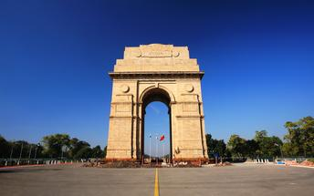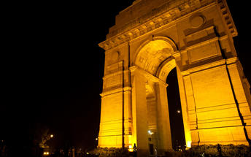

Drive past to Rashtrapati Bhawan
Located in New Delhi, India, Rashtrapati Bhavan is home to the president of the world’s largest democracy and epitomises India’s strength, its democratic traditions and secular character. It was Sir Lutyens who conceptualised the H-shaped building, covering an area of about 5 acres on a 330-acre estate. The mansion features a total of 340 rooms spread over four floors, and the grounds are rich in biodiversity with open spaces, forest cover, parks, gardens, patches of wilderness, numerous fruit-bearing trees and water bodies.

Day 3: Delhi - Shimla
Shimla, lying deep in the foothills of the Himalayas, is the capital city of Himachal Pradesh and the gateway into the more remote northern regions of Kashmir. It is also the stop-off for travellers venturing into the Kullu and Spiti Valleys. Sitting at an altitude of 2159 metres, the city is blessed with a cool climate and beautiful views of river valleys, pine forests, apple orchards and steep mountains covered with maize terraces. The Mall, a long, winding pedestrian-only walkway, is the commercial and social hub of Shimla, while those looking for natural beauty should head uphill through the forest to Jakhu Temple or follow one of the many forest trails in the eastern part of Shimla. To the south of the city, the bazaars bustle with local flavour.
Early morning you will be assisted & transferred to railway station to board the train for Kalka.
Train Kalka Shatabdi
Departs Delhi 0740 Hrs
Arrives Kalka 1105 Hrs

Upon arrival at Kalka, you will be assisted & transferred to Solan [approx. 40 kms/ 02 hours drive]
Arrive Solan and board the Toy Train to Shimla.
Train Himalayan Queen
Departs Solan 1440 Hrs
Arrives Shimla 1730 Hrs

Arrive Shimla and check in at the hotel.

Day 4: Shimla
After breakfast enjoy half day sightseeing tour of Shimla covering Indian Institute of Advanced Studies, Sankat Mochan temple and the Mall road.

Indian Institute of Advanced Study
Also called the Vice regal Lodge, the Indian Institute of Advanced Study is a research institute set in a historical building in Shimla. As a residential centre for research, it encourages creative thinking in areas of deep human significance. The environment of the institute is eminently suitable for academic pursuits, especially in select areas of the humanities, Indian culture, religion and the social and natural sciences. It also has a comprehensive library and documentation facilities.
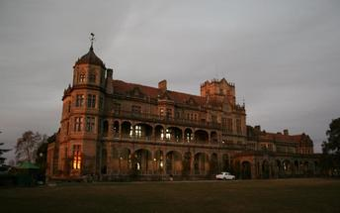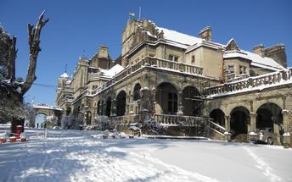

Sankat Mochan Temple
A famous temple of Lord Hanuman in the region is located amidst the mist-clad mountains, providing a serene and scenic environs, making visitors get lost in the mesmerizing atmosphere of the place. The temple was built in the decade of 1960s. Originally dedicated to Lord Hanuman, the temple now also bears the idols of Lord Rama, Lord Shiva, and Lord Ganesha in various complexes.

Shimla Mall Road
The Mall Road is one of the most popular tourist attractions in Shimla that enfolds many hotels, restaurants, clubs, bars, banks, shops, offices, post offices, and tourist offices. People can walk up and down the Mall road slowly and enjoy the scenic views of the nature while sipping their favourite coffee. The Mall road is connected to the Ridge at the Scandal point, where a statue of the nationalist leader Lala Lajpat Rai has been erected.
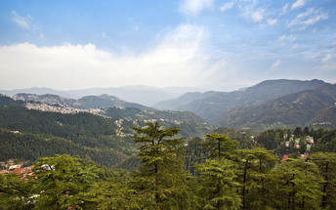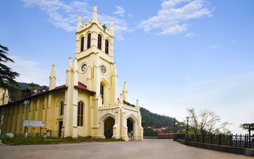

Day 5: Shimla - Amritsar
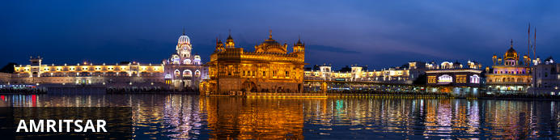
Armritsar is the spiritual capital of the Sikhs and gained its name, meaning ‘Holy Pool of Nectar’, from the body of water around Harmandir Sahib, the Golden Temple. The temple itself is a must see, receiving well over 100 000 people every day, who come to worship at the holy shrine. It is located just 28 kilometres from the Pakistani border post, and a highlight of the area is the Wagah border ceremony that occurs every evening at sunset. Full of pomp and flair, soldiers from both sides parade and lower the two nation’s flags in a ceremony punctuated with theatrics.
After breakfast you will be driven to Amritsar [approx. 300 kms/ 07 hours drive]
Arrive Amritsar and check in at the hotel.
Spend rest of the day at leisure.

Day 6: Amritsar
A full day tour of Amritsar visiting Golden Temple, Jallianwala Bagh and Wagah border.

The Golden Temple
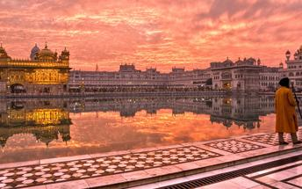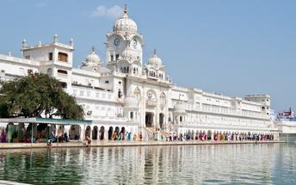

Guru Ka Langar (Langar Hall): Community Kitchen
The tradition of serving langar Initiated by Guru Nanak Dev Ji and then established by the 3rd Guru Sri Guru Amar Dass Ji at Goindwal. Even the Mughal King Akbar came and sat among the ordinary people to share langar. The institution of Guru ka Langar has served the community in many ways. It has ensured the participation of women and children in a task of service for humanity. Women play an important role in the preparation of meals, and the children help in serving food to the pangat. Langar also teaches the etiquette of sitting and eating in a community situation, which has played a great part in upholding the virtue of sameness of all human beings; providing a welcome, secure and protected sanctuary.

Everyone is welcomed to share the Langar; no one is turned away. Each week a family or several families volunteer to provide and prepare the Langar. This is very generous, as there may be several hundred people to feed, and caterers are not allowed. All the preparation, the cooking and the washing-up is done by volunteers and or by voluntary helpers (Sewadars).

In the Golden Temple Community Kitchen at an average 75,000 devotees or tourists, take langar in the Community Kitchen daily; but the number becomes almost double on special occasions. On average 100 Quintal Wheat Flour, 25 Quintal Cereals, 10 Quintal Rice, 5000 Ltr Milk, 10 Quintal Sugar, 5 Quintal Pure Ghee is used a day. Nearly 100 LPG Gas Cylinders are used to prepare the meals. 100’s of employees and devotees render their services to the kitchen.

The Jallianwala Bagh Garden
The Jallianwala Bagh Garden is a fenced garden with several entrances, located in Amritsar, India. This public garden is home to a national memorial, which serves as a lasting tribute to an innocent crowd of peaceful celebrators who lost their lives during a massacre by the British army. Today, the garden is mostly visited by tourists to learn about the killings and to admire the vast greenery or simply for relaxation and meditation.

Wagah Border
The Wagah Border links the towns of Amritsar in India and Punjab in Pakistan. The border serves as a transit point for goods and commuters between India and Pakistan and plays host to the daily lowering of the flag ceremony performed by the Border Security Force of India and the Pakistan Rangers in Pakistan. This ceremony commemorates the unity and cooperation between the two nations who were once rivals.

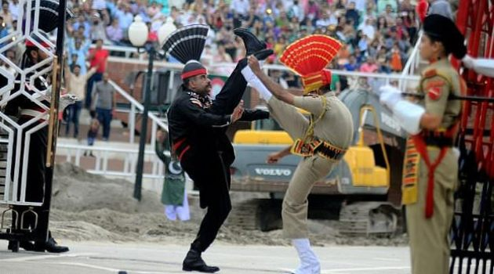
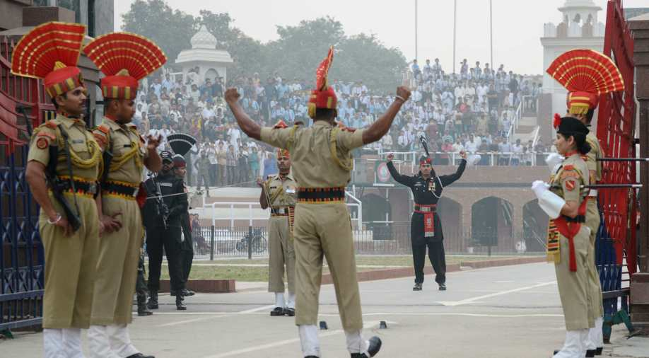

Day 7: Amritsar - Delhi
Breakfast at the hotel. Morning at leisure.
NOTE: Standard check out time at the hotel is 1200 noon.
Later at an appropriate time you will be assisted & transferred to railway station to board the train for Delhi.
Train Shatabdi Express
Departs Amritsar 1650 Hrs
Arrives Delhi 2305 Hrs

Upon arrival at Delhi, you will be assisted & transferred to the hotel for check in.

Day 8: Delhi - Agra
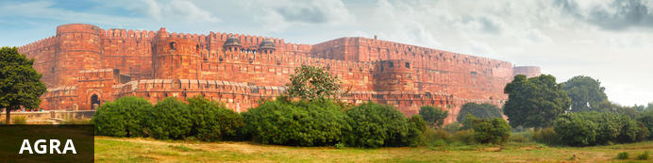
Home of the world-famous Taj Mahal, Agra is one of India’s prime tourist destinations for specifically this reason, though its attractions also extend to an array of other impressive historical sights. These include the red-hued Agra Fort, the sacred Jama Masjid mosque and Itmad-ud-Daulah’s tomb, with its white marble facade embellished with intricate inlaid designs and semi-precious gems. The Taj, however, is in a league of its own and needless to say is a must-see for any visitor to the city. Commissioned by the Mughal emperor Shah Jahan in the 15th century as a memorial to his beloved wife Mumtaz Mahal, it is an architectural masterpiece of exquisite craftsmanship and perfect proportions.
After breakfast you will be driven to Agra [approx. 220 kms/ 04 hours drive]
Arrive Agra and check in at the hotel.
Later visit Agra Fort & sunset visit to Taj Mahal. The monument is closed to public on all Fridays.

Agra Fort
Known as the Red Fort of Agra, this walled imperial city was founded in 1565 by the Emperor Akbar (1556-1605) and is a well-deserving UNESCO World Heritage site, located just 2.5 kilometres from the famous Taj Mahal. Its palaces, grand mosques and elaborate public hall are crafted from pink-red sandstone and are testament to an era when Indo-Muslim art, strongly marked by influences from Persia, was at its height. Emperor Shah Jahan, who built the Taj Mahal for his deceased wife, was imprisoned by his son Aurangzeb in Agra Fort. He is said to have died in the Musamman Burj, a marble tower he himself built, with one of the most alluring views of the Taj Mahal.
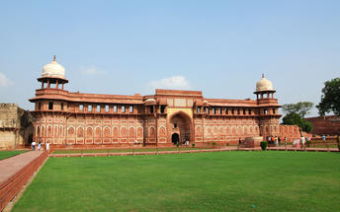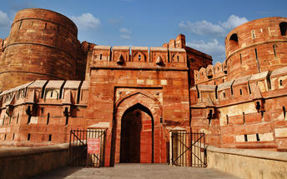

Sunset visit Taj Mahal
The iconic Taj Mahal is not only an architectural masterpiece, a UNESCO World Heritage Site and one of the new Seven Wonders of the World – it’s also the enduring legacy of a royal love story. It was commissioned in the 15th century by the Mughal Emperor Shah Jahan after the death of his third and favourite wife, Mumtaz Mahal, to serve as her final resting place and a symbol of his eternal affection for her. Combining Islamic, Persian, Ottoman Turkish and Indian design elements, it’s an awe-inspiring structure of elegant domes and white marble, which changes colour along with the light – pink at sunrise, pearly white in the afternoon and silver-gold in the full moon.

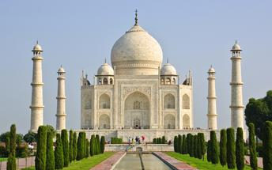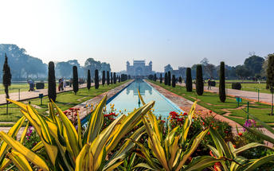

Day 9: Agra - Jaipur
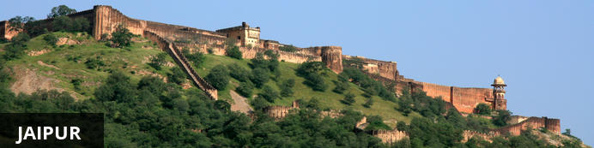
Fringed by the rugged Aravali Hills, Jaipur is the capital and largest city in India’s northern state of Rajasthan. This city is famed for being India’s first planned city featuring a multitude of pink terracotta buildings within the walled historic centre, earning it the nickname, ‘The Pink City’. Jaipur falls within the Golden Triangle, a popular tourist circuit, which includes Delhi, Jaipur and Agra, and serves as a gateway to the neighbouring desert cities of Jaisalmer and Jodhpur. This colourful city is a combination of tradition and modernity and offers visitors vibrant bazaars, lavish palaces and ancient temples. The salmon-hued old city is home to the opulent City Palace, encompassing an impressive assortment of palatial structures, sprawling gardens, courtyards and buildings. Do not miss the fairy-tale splendour of the Amber Fort, set against the backdrop of the arid landscape.

Option to do an early morning sunrise visit Taj Mahal.
Return to the hotel for breakfast.

Later you will be driven to Jaipur [approx. 05-06 hours drive] with a stop enroute at Fatehpur Sikri.

Fatehpur Sikri
This world heritage site is rated as one of the best-preserved collections of Mughal architecture in India. Surrounded by a six kilometre wall, with the fourth being a lake at the time, a day can be spent exploring the elaborate structures within. Marvel at the impressive Jama Masjid mosque, the detailed palaces built for Emperor Akbar’s wives, the public and private discussion halls and vast ornamental pool; all of which took over 15 years to conceptualise and build.

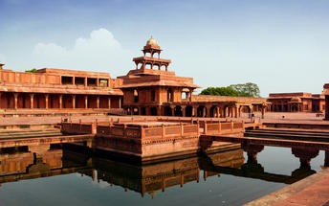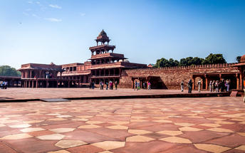

Day 10: Jaipur
After breakfast, proceed for half day sightseeing tour of Jaipur, visiting Amer Fort, City Palace and Astronomical Observatory. En-route photo stop at Hawa Mahal – Palace of Winds.

Amer Fort
Amer Fort, officially known as the ‘Amer Palace’, is one of the most famous forts of Rajasthan attracting around 4000 to 5000 visitors a day during peak tourist season. The palace was named after the small town of Amer, where it is situated - only eleven kilometres from Jaipur. Perfectly picturesque, this 16th century hillside residence is well preserved, boasting grand pavilions and mirrored halls that open onto flourishing gardens and courtyards. Although the palace’s main construction started in 1592 by Maharaja Man Singh, it was added to over the years by successive rulers and continued to be occupied by them until Jaipur was built.

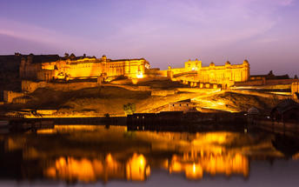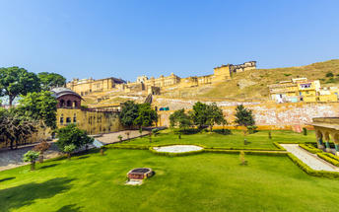

Jaipur City Palace
City Palace forms one of the most famous tourist attractions and a major landmark in Jaipur. The beautiful palace was built by Maharaja Sawai Jai Singh during his reign. Among the various forts and palaces of Jaipur, City Palace stands apart, with its outstanding art and architecture.

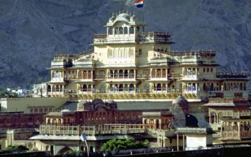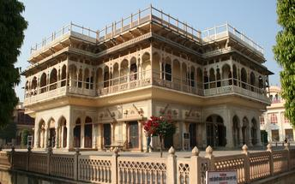

Jantar Mantar Jaipur
In 1734, the year of its completion, the Jai Singh Observatory was the last outpost of medieval science. From the outside, the eighteen fixed observational instruments look more like playground apparatus than sighting devices, but they were used to measure the position of the sun, stars and planets. Built by Jai Singh, the first Maharaja of Jaipur who founded the city in 1727, the observatory is one of a handful. Jai Singh, fulfilling a lifelong interest in mathematics and astronomy, built observatories in Delhi, Jaipur, Ujjain, Mathura and Benares. The Jaipur observatory is the largest and best preserved of these.
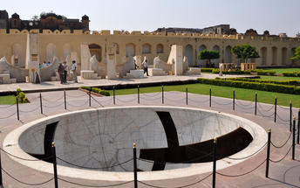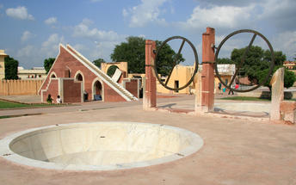

Hawa Mahal (Palace of Winds)
One of Jaipur’s most recognised buildings, the Hawa Mahal (Palace of Winds) is known for its iconic façade. Small windows, decorated with intricate latticework create a honeycomb-like appearance. The original intention of the lattice was to allow the royal ladies to observe everyday life in the street below without being seen. The cooling effect, provided by the breeze passing through the small windows, gave the palace its name. Built in 1799 by Maharaja Sawai Pratap Singh, the unique construction was originally designed to look like the crown of Krishna. A panoramic view of Jaipur can be had from the top of the building.

Day 11: Jaipur - Jodhpur
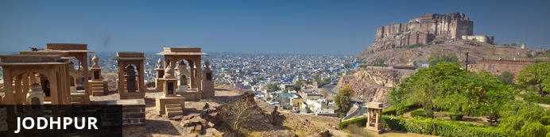
Known as the gateway to the Thar Desert, Jodhpur is the second largest city in the state of Rajasthan, India. It is a popular tourist destination featuring a variety of ornate palaces, age-old forts and sacred temples. Dubbed “The Blue City", most houses in the old city are painted a beautiful shade of indigo. While Jodhpur is largely a sprawling modern metropolis, enclosed within its old city walls is a labyrinth of winding, narrow medieval streets and bazaars. Jodhpur is home to one of the largest forts in India, the massive 15th-century Mehrangarh Fort, which towers over the city from its sandstone plinth. Other must-see attractions include: the Umaid Bhawan Palace, one of the world's largest private residences; and the Jaswant Thada, an intricately carved white marble mausoleum.

Day Itinerary
After breakfast you will be driven to Jodhpur [approx. 320 kms/ 07 hours drive]
Arrive Jodhpur and check in at the hotel.

Day 12: Jodhpur
After breakfast enjoy half day sightseeing tour of Jodhpur covering the majestic Mehrangarh Fort and Jaswant Thada – the royal cenotaphs.

Mehrangarh Fort
Mehrangarh Fort rises four hundred feet above the skyline of Jodhpur from its rock precipice on Bhaurcheeria hill. The foundation of Mehrangarh Fort was laid on May 12, 1459 by Rao Jodha, the fifteenth Rathore ruler who wanted to shift the capital from nearby Mandore to Jodhpur. In all its history, Mehrangarh Fort has never been taken in a siege. Mammoth and imposing from the outside, the interiors of the fort are light and detailed in contrast. Several palaces can be found inside the complex, boasting intricate carvings and sprawling courtyards.
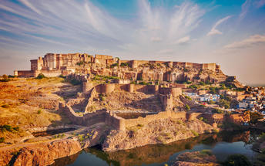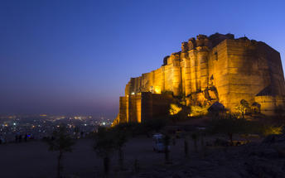

Jaswant Thada
If you’re looking for a quiet place in Jodphur head to Jaswant Thada, popularly known as the ‘Taj Mahal of Marwar’. This architectural landmark was built in 1899 by Maharaja Sardar Singh of Jodhpur State, in memory of his father, Maharaja Jaswant Singh I. Built from intricately carved marble sheets and boasting some beautiful carved marble lattice work, the impeccable design and architecture is symbolic of the fine craftsmanship of a bygone era. Beautiful sculptures, carved gazebos and frescos characterise the cenotaph, with the tiered garden offering superb views across to the fort and over the city.

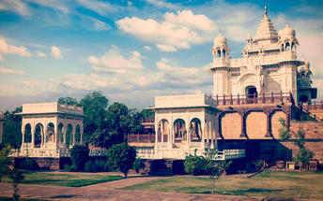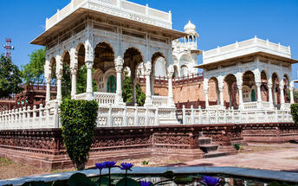

Day 13: Jodhpur - Udaipur
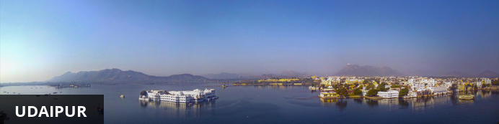
Dubbed the ‘Venice of the East’, the city of Udaipur is built around three interconnected lakes – Lake Pichhola, Fateh Sagar Lake and the smaller Swaroop Sagar Lake – and encircled by the hills of the Aravalli mountain range. It is home to an array of ancient temples and fairy-tale palaces (several of the latter have been converted into luxury heritage hotels) and is known as one of Rajasthan’s most beautiful and romantic cities. Must-see attractions include the City Palace, the Lake Palace (set on a small island in the middle of Lake Pichola) and the Udaipur Solar Observatory – Asia’s premier solar-gazing site.
After breakfast you will be driven to Udaipur [approx. 270 kms/ 05-06 hours drive] with a stop at the magnicient Jain temples at Ranakpur.
Arrive Udaipur and check in at the hotel.

Ranakpur
The complex rests on a lush mountain slope and encompasses a series of temples dating to the 15th century, all constructed from white marble and featuring exquisite decorative detail. The main temple, Chamukha, is a multi-tiered structure with no less than 80 domes and over 1400 pillars, all of which are intricately carved with unique designs – no two are alike.
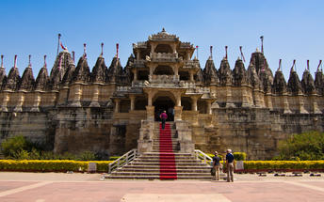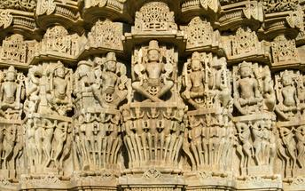

Day 14: Udaipur
After breakfast enjoy half day sightseeing tour of Udaipur visiting the City Palace, Saheliyon ki bari, Jagdish temple and

Udaipur City Palace
Situated above Lake Pichola, Udaipur City Palace has housed many royals over four centuries who have each added their own unique preferences to the establishment. The palace is a one of a kind in Rajasthan. Udaipur City Palace was constructed entirely out of marble and granite which makes it highly luxurious. The inside is even more so with its inlays of coloured glass, engravings, towers, and balconies.
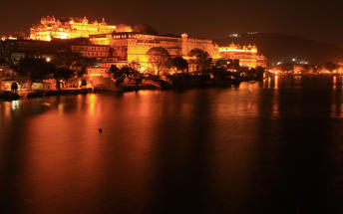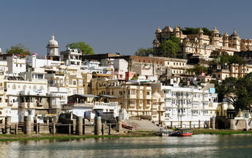

Saheliyon ki Bari
Built by Maharana Sangram Singh II as a garden for women, Saheliyon-ki-Bari or the Garden of the Maidens is a popular tourist destination. Along with a small museum, it has several attractions such as marble elephants, fountains, kiosks and a lotus pool.

Jagdish Temple
Completed in 1651, Jagdish Temple is situated just outside the royal palace. The temple can be seen as soon as visitors enter the city. Puja’s and prayer time are the best time to visit when melodious chants from devotees float through the small interior. Visitors should make a point of climbing the temple's many steps which invite them on a journey of discovery of the rich and vibrant history of Udaipur.
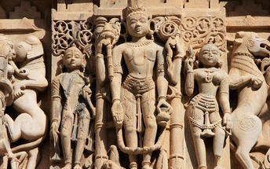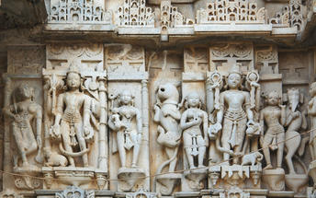

Boat ride at Lake Pichola [subject to water level]
Pichola Lake is one of the most beautiful lakes in Rajasthan. Located in the heart of Udaipur, Pichola is the oldest and one of the largest lakes in all of Udaipur. In 1362 AD Pichola Lake was built by Banjara. Later, Maharana Udai Singh, affected by the charm of this lake and extended the lake when he founded the city of Udaipur and also built a dam made of stone that is in the Badipol region on the shore of the lake. Pichola Lake is enveloped by lofty Palaces, temples, bathing ghats and elevated hills on all its sides.
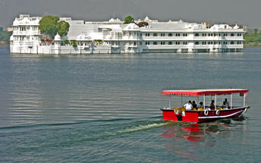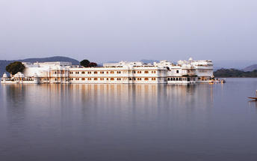

Day 15: Udaipur departure
At an appropriate time, you will be assisted & transferred to airport to board the flight for onward journey.
Flight TBA
Departs Udaipur TBA Hrs

