IN-29

Golden Triangle with Rajasthan and Kerala
New Delhi – Agra – Jaipur – Jodhpur – Udaipur – Kochi – Alleppey – Marari
19 Days / 18 Nights

Day 1: Arrive Delhi - Agra

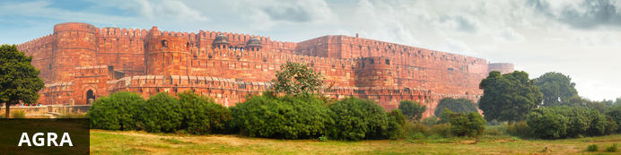
Home of the world-famous Taj Mahal, Agra is one of India’s prime tourist destinations for specifically this reason, though its attractions also extend to an array of other impressive historical sights. These include the red-hued Agra Fort, the sacred Jama Masjid mosque and Itmad-ud-Daulah’s tomb, with its white marble facade embellished with intricate inlaid designs and semi-precious gems. The Taj, however, is in a league of its own and needless to say is a must-see for any visitor to the city. Commissioned by the Mughal emperor Shah Jahan in the 15th century as a memorial to his beloved wife Mumtaz Mahal, it is an architectural masterpiece of exquisite craftsmanship and perfect proportions.
Flight TBA
Arrives Delhi TBA Hrs.

On arrival in Delhi: Having cleared immigration, collected your luggage and passed through customs, please make your way towards the exit of the terminal building where you will see a bank of people waiting for you. Amongst them will be Travel Counsellors Representative who will be waiting to greet you with a paging board with your name on.
You will be transferred to the airport hotel where room is held on immediate occupancy.
Breakfast is at the hotel.
In the afternoon, you will be driven to Agra [Approx. 225 Kms / 4-5 Hrs drive].
On arrival, you will check-in to your hotel.

Day 2: In Agra
Breakfast is at the hotel.
Today, you will proceed for the sightseeing tour of Agra visiting Itmad-ud-daulah, Agra Fort and Taj Mahal (closed on Fridays)

Tomb Of Itmad-Ud-Daulah (Baby Taj)
Tomb of I'timad-ud-Daulah is a Mughal mausoleum built for the grandfather of the Mumtaz Mahal, who the Taj Mahal was in turn built for. The tomb colloquially known as the "jewel box", or the "Baby Taj".
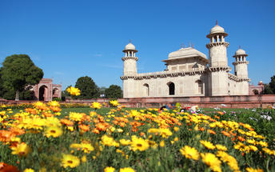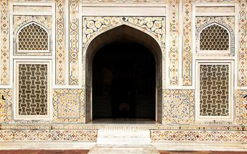

Agra Fort
Known as the Red Fort of Agra, this walled imperial city was founded in 1565 by the Emperor Akbar (1556-1605) and is a well-deserving UNESCO World Heritage site, located just 2.5 kilometres from the famous Taj Mahal. Its palaces, grand mosques and elaborate public hall are crafted from pink-red sandstone and are testament to an era when Indo-Muslim art, strongly marked by influences from Persia, was at its height. Emperor Shah Jahan, who built the Taj Mahal for his deceased wife, was imprisoned by his son Aurangzeb in Agra Fort. He is said to have died in the Musamman Burj, a marble tower he himself built, with one of the most alluring views of the Taj Mahal.
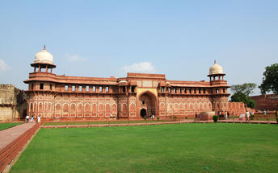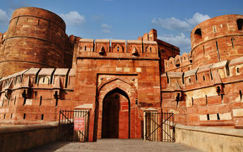

Taj Mahal [Closed on every Friday]
The iconic Taj Mahal is not only an architectural masterpiece, a UNESCO World Heritage Site and one of the new Seven Wonders of the World – it’s also the enduring legacy of a royal love story. It was commissioned in the 15th century by the Mughal Emperor Shah Jahan after the death of his third and favourite wife, Mumtaz Mahal, to serve as her final resting place and a symbol of his eternal affection for her. Combining Islamic, Persian, Ottoman Turkish and Indian design elements, it’s an awe-inspiring structure of elegant domes and white marble, which changes colour along with the light – pink at sunrise, pearly white in the afternoon and silver-gold in the full moon.
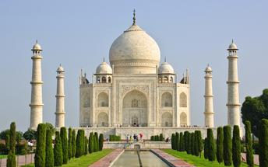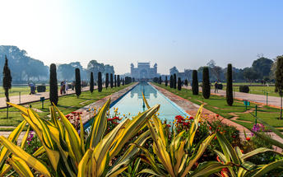

Day 3: Agra - Jaipur
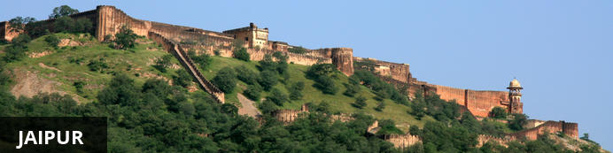
Fringed by the rugged Aravali Hills, Jaipur is the capital and largest city in India’s northern state of Rajasthan. This city is famed for being India’s first planned city featuring a multitude of pink terracotta buildings within the walled historic centre, earning it the nickname,’The Pink City’. Jaipur falls within the Golden Triangle, a popular tourist circuit, which includes Delhi, Jaipur and Agra, and serves as a gateway to the neighbouring desert cities of Jaisalmer and Jodhpur. This colourful city is a combination of tradition and modernity and offers visitors vibrant bazaars, lavish palaces and ancient temples. The salmon-hued old city is home to the opulent City Palace, encompassing an impressive assortment of palatial structures, sprawling gardens, courtyards and buildings. Don’t miss the fairy-tale splendour of the Amber Fort, set against the backdrop of the arid landscape.
Breakfast is at the hotel.
After breakfast, you will be driven to Jaipur [Approx. 255 Kms / 5-6 Hrs drive] with a stop at Fatehpur Sikri.

Fatehpur Sikri
A highlight in the province of Uttar Pradesh, Fatehpur Sikri served briefly as the capital of the Mughal Empire from 1571 to 1585. This world heritage site is rated as one of the best preserved collections of Mughal architecture in India. Surrounded by a six kilometre wall, with the fourth being a lake at the time, a day can be spent exploring the elaborate structures within. Marvel at the impressive Jama Masjid mosque, the detailed palaces built for Emperor Akbar’s wives, the public and private discussion halls and vast ornamental pool; all of which took over 15 years to conceptualise and build.
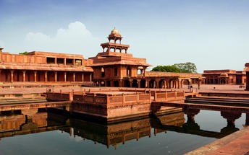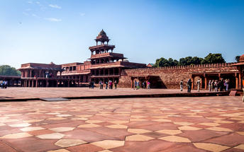

Day 4: In Jaipur
After breakfast, proceed for a full day tour of Jaipur, visiting Amer Fort (en-route photo stop at Hawa Mahal – Palace of Winds), City Palace and Astronomical Observatory.

Amer Fort by jeep ride
Amer Fort, officially known as the ‘Amer Palace’, is one of the most famous forts of Rajasthan attracting around 4000 to 5000 visitors a day during peak tourist season. The palace was named after the small town of Amer, where it is situated - only eleven kilometres from Jaipur. Perfectly picturesque, this 16th century hillside residence is well preserved, boasting grand pavilions and mirrored halls that open onto flourishing gardens and courtyards. Although the palace’s main construction started in 1592 by Maharaja Man Singh, it was added to over the years by successive rulers and continued to be occupied by them until Jaipur was built.
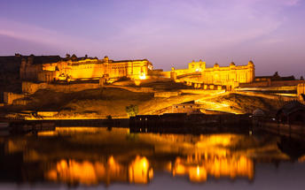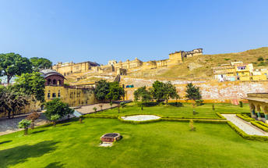

Photo stop at Hawa Mahal (Palace of Winds)
One of Jaipur’s most recognised buildings, the Hawa Mahal (Palace of Winds) is known for its iconic façade. Small windows, decorated with intricate latticework create a honeycomb-like appearance. The original intention of the lattice was to allow the royal ladies to observe everyday life in the street below without being seen. The cooling effect, provided by the breeze passing through the small windows, gave the palace its name. Built in 1799 by Maharaja Sawai Pratap Singh, the unique construction was originally designed to look like the crown of Krishna. A panoramic view of Jaipur can be had from the top of the building.
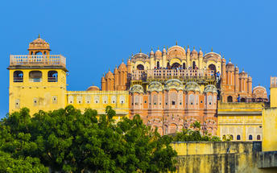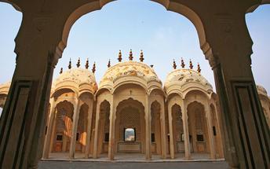

Jaipur City Palace
City Palace forms one of the most famous tourist attractions and a major landmark in Jaipur. The beautiful palace was built by Maharaja Sawai Jai Singh during his reign. Among the various forts and palaces of Jaipur, City Palace stands apart, with its outstanding art and architecture.
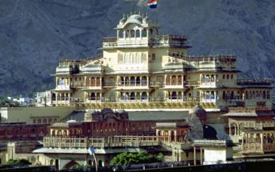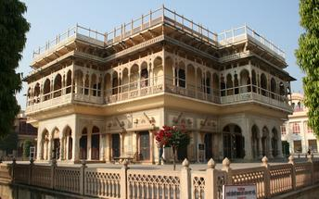

Jantar Mantar Jaipur
In 1734, the year of its completion, the Jai Singh Observatory was the last outpost of medieval science. From the outside, the eighteen fixed observational instruments look more like playground apparatus than sighting devices, but they were used to measure the position of the sun, stars and planets. Built by Jai Singh, the first Maharaja of Jaipur who founded the city in 1727, the observatory is one of a handful. Jai Singh, fulfilling a lifelong interest in mathematics and astronomy, built observatories in Delhi, Jaipur, Ujjain, Mathura and Benares. The Jaipur observatory is the largest and best preserved of these.
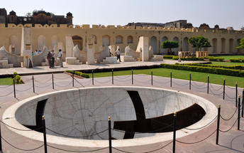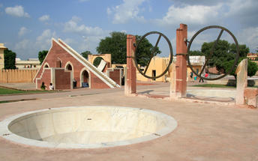

Day 5: In Jaipur
Breakfast is at the hotel.
A day at leisure in Jaipur

Day 6: Drive Jaipur - Jodhpur
After breakfast, you will be driven to Jodhpur. [Approx. 295 kms / 06 Hrs]
On arrival in Jodhpur, check in at the hotel.
Rest of the day is at leisure.

Day 7: Jodhpur

Day Itinerary
After breakfast, proceed for half day sightseeing tour of Jodhpur visiting Mehrangarh fort & Jaswant Thada – the royal cenotaphs.

Mehrangarh Fort
Mehrangarh Fort rises four hundred feet above the skyline of Jodhpur from its rock precipice on Bhaurcheeria hill. The foundation of Mehrangarh Fort was laid on May 12, 1459 by Rao Jodha, the fifteenth Rathore ruler who wanted to shift the capital from nearby Mandore to Jodhpur. In all its history, Mehrangarh Fort has never been taken in a siege. Mammoth and imposing from the outside, the interiors of the fort are light and detailed in contrast. Several palaces can be found inside the complex, boasting intricate carvings and sprawling courtyards.
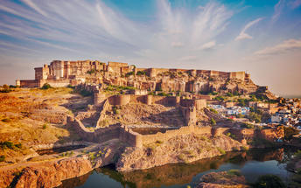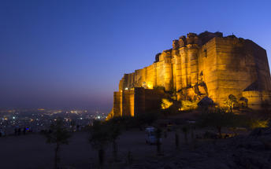

Jaswant Thada
If you’re looking for a quiet place in Jodphur head to Jaswant Thada, popularly known as the ‘Taj Mahal of Marwar’. This architectural landmark was built in 1899 by Maharaja Sardar Singh of Jodhpur State, in memory of his father, Maharaja Jaswant Singh I. Built from intricately carved marble sheets and boasting some beautiful carved marble lattice work, the impeccable design and architecture is symbolic of the fine craftsmanship of a bygone era. Beautiful sculptures, carved gazebos and frescos characterise the cenotaph, with the tiered garden offering superb views across to the fort and over the city.
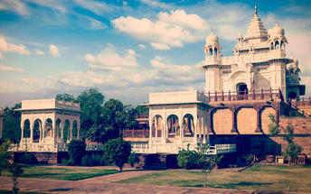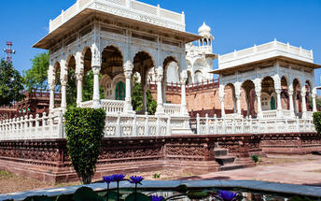

Day 8: Drive Jodhpur – Ranakpur – Udaipur
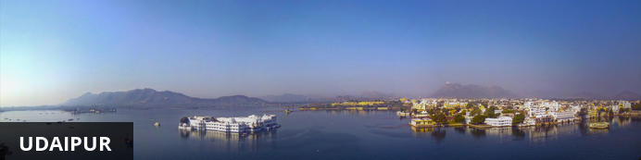
Dubbed the ‘Venice of the East’, the city of Udaipur is built around three interconnected lakes – Lake Pichhola, Fateh Sagar Lake and the smaller Swaroop Sagar Lake – and encircled by the hills of the Aravalli mountain range. It is home to an array of ancient temples and fairy-tale palaces (several of the latter have been converted into luxury heritage hotels) and is known as one of Rajasthan’s most beautiful and romantic cities. Must-see attractions include the City Palace, the Lake Palace (set on a small island in the middle of Lake Pichola) and the Udaipur Solar Observatory – Asia’s premier solar-gazing site.

Day Itinerary
After breakfast, you will be driven to Udaipur [265 Kms/ 05-06 Hrs Approx.] with a stop en- route at Ranakpur Jain temples [with Audio Guide] – (Important – There are dress restrictions to visit the temples – they do not permit leather items like belts, wallets or purse. The dress should cover the body. The temple opens for public from 12 Noon only)

Ranakpur
The small town of Ranakpur is home to what is arguably the most spectacular of all India’s Jain temples. The complex rests on a lush mountain slope and encompasses a series of temples dating to the 15th century, all constructed from white marble and featuring exquisite decorative detail. The main temple, Chamukha, is a multi-tiered structure with no less than 80 domes and over 1400 pillars, all of which are intricately carved with unique designs – no two are alike. As the light changes during the day, so does the colour of the temple interior, shifting from golden to cream and then pale blue at dusk.
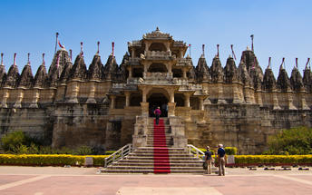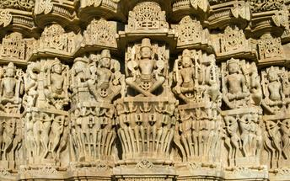

Day 9: In Udaipur
After breakfast, enjoy half day sightseeing of Udaipur visit the City Palace, Jagdish temple, Saheliyon ki bardi and enjoy a shared Boat ride on Lake Pichola. [Subject to water level]

Udaipur City Palace
Situated above Lake Pichola, Udaipur City Palace has housed many royals over four centuries who have each added their own unique preferences to the establishment. The palace is a one of a kind in Rajasthan. Udaipur City Palace was constructed entirely out of marble and granite which makes it highly luxurious. The inside is even more so with its inlays of coloured glass, engravings, towers, and balconies.
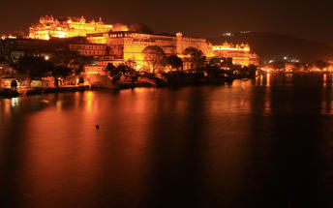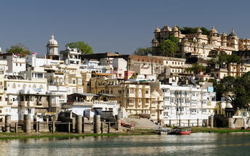

Jagdish Temple
Completed in 1651, Jagdish Temple is situated just outside the royal palace. The temple can be seen as soon as visitors enter the city. Puja’s and prayer time are the best time to visit when melodious chants from devotees float through the small interior. Visitors should make a point of climbing the temple's many steps which invite them on a journey of discovery of the rich and vibrant history of Udaipur.
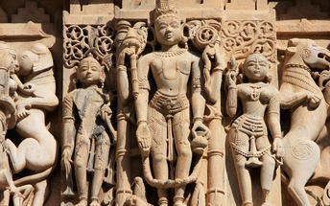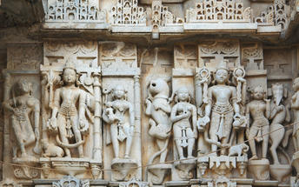

Saheliyon ki Bari
Built by Maharana Sangram Singh II as a garden for women, Saheliyon-ki-Bari or the Garden of the Maidens is a popular tourist destination. Along with a small museum, it has several attractions such as marble elephants, fountains, kiosks and a lotus pool.

Evening Shared Boat ride at Lake Pichola
Pichola Lake is one of the most beautiful lakes in Rajasthan. Located in the heart of Udaipur, Pichola is the oldest and one of the largest lakes in all of Udaipur. In 1362 AD Pichola Lake was built by Banjara. Later, Maharana Udai Singh, affected by the charm of this lake and extended the lake when he founded the city of Udaipur and also built a dam made of stone that is in the Badipol region on the shore of the lake. Pichola Lake is enveloped by lofty Palaces, temples, bathing ghats and elevated hills on all its sides.
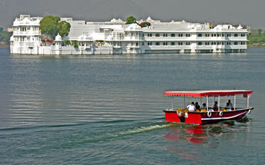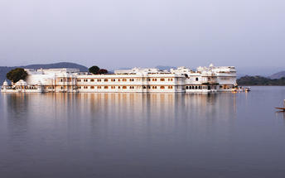

Day 10: In Udaipur
Breakfast is at the hotel. Day at leisure in Udaipur

Day 11: Fly Udaipur – Kochi
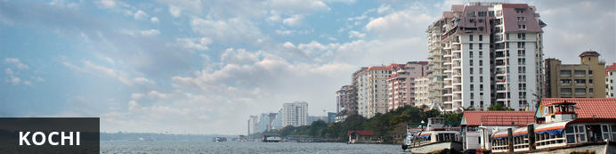
Also known as Cochin, Kochi is a city in southwest India's coastal Kerala state. This attractive city has served as a popular port for over 600 years and is known for its eclectic architecture and its array of religious monuments, museums, galleries, cafes and antique shops. The city stretches across a number of peninsulas and islands, which can be reached by a network of water taxis and bridges. The majority of Kochi’s visitor highlights can be found on the peninsula of Fort Kochi. These highlights include the St Francis Church, the oldest European-built church in India; and Mattancherry Palace, which dates back to 1557 and contains some exceptional Kerala murals and temple art. Other must-see attractions include the Kerala Folklore Museum, displaying more than 4,000 cultural and ethnic artefacts; the 16th-century Jewish Synagogue; and the local market, where the air is filled with the aroma of exotic spices.
At an appropriate time, you will be transferred to Mumbai airport to board flight to Kochi.
Flight TBA
Departs Udaipur TBA
Arrives Kochi TBA

Upon arrival in Cochin, you will be met and transferred to the hotel

Day 12: Kochi – Alleppey
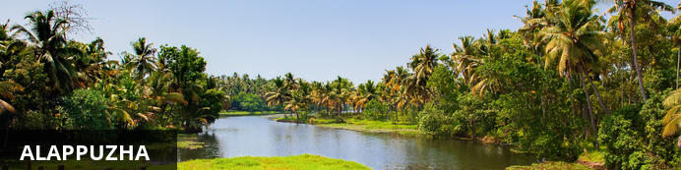
Located in the Indian state of Kerala, the bustling city of Alappuzha, also known as Alleppey, is set along the coast of the Laccadive Sea. Dubbed the ‘Venice of the East’, it is renowned for its houseboat cruises which float along the tranquil backwater canals of Kerala. It is said to be one of the most popular tourist centres in the state. While cruising the palm-shaded canals is the main attraction, visitors can also enjoy visiting Alappuzha’s beautiful beaches, exploring the little riverside villages dotting the lush countryside and discovering an array of resplendent temples. Don’t miss the annual Nehru Trophy Boat Race held at Punnamada Lake.
Breakfast at the hotel.
After breakfast, you will be driven to Alleppey [Approx. 80 Kms / 2 ½ Hrs]. Cruise over the backwaters for rest of the day enjoying the narrow canals and visit to local villages and temples. Standard check-in time for houseboat is 1300 Hrs.
Note:
Houseboat will be anchored in the evening till morning as per regulations.
Air conditioning will be from 1900 hrs till 0700 hrs

Lunch and Dinner is on board.

Day 13: Alleppey - on board House Boat
All meals are on board.
Today, float in sheer bliss as Kerala’s traditional kettuvalloms or houseboats, styled as per the norms of tradition yet equipped with every luxury and every modern amenity, offer the opportunity to relax on the serene waters of the Lake Vembanad. Stay, dine and truly experience the timeless beauty of life along the banks of Kerala.

Day 14: Alleppey – Marari
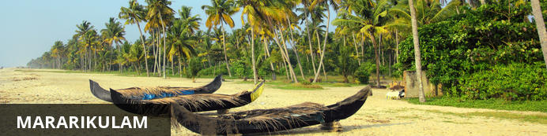
Mararikulam is a charming little coastal village known for its pristine sand beaches, swinging coconut palms and quiet, laidback atmosphere. The village has managed to avoid the mass development associated with many of the other beach towns in the area resulting in an untouched natural environment dotted with only a handful of small resorts. The main attraction in the area is the exquisite Marari beach where you will find fishermen heading out daily to fish the waters of this stretch of the Malabar Coast, much as their ancestors have done for generations.
Breakfast at the hotel
After breakfast, you will de-board the houseboat and driven to Marari [Approx. 30 minutes’ drive]
Rest of the day at leisure for independent activities like yoga/meditation, visit to the fisherman’s village, fish landing, Ayurveda treatments !

Day 15-17: Mararikulam
Breakfast is at the hotel.
Day at leisure to enjoy the beach and the hotel facilities.

Day 18: Mararikulam – Kochi – Delhi Departure
Breakfast at the hotel.
At an appropriate time, you will be transferred to Cochin airport [Approx. 75 kms / 2-3 hrs] to board your onward flight. Standard check-out time is 1200 Hrs.
Flight TBA
Departs Delhi TBA
**** END OF SERVICES ****

