IN-31

Delhi and Mumbai with Maharaja Express - Indian Splendour
Delhi – Maharaja Express (The Indian Splendour) – Mumbai
11 Days / 10 Nights

Day 1: Arrive Delhi

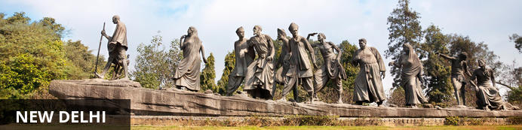
India’s largest city, Delhi, has been one of the country’s commercial and economic hubs for centuries and, as a result, is incredibly rich in culture and history. Made up of the ancient walled city of Old Delhi and the more modern sector, New Delhi, the city encompasses a staggering array of beautiful architecture, notable monuments and age-old temples, including three UNESCO World Heritage Sites – the Red Fort, Qutab Minar and Humayun's Tomb. Other key attractions include the 17th century Chandni Chowk marketplace – still one of the city’s most popular retail centres today, particularly for jewellery and traditional Indian saris; the iconic Bahà’i Lotus Temple – an award-winning architectural gem; and the Jama Masjid, India’s largest mosque.

Flight TBA
Arrive Delhi TBA Hrs
On arrival in Delhi: Company representatives cannot come into the baggage collection area. Having cleared immigration, collected your luggage and passed through customs, please make your way towards the exit of the terminal building where you will see a bank of people waiting for you. Amongst them will be Travel Counsellor Representative who will be waiting to greet you with a paging board of name.
Arrive and check-in at the hotel. (Standard check in time is 1400 hrs)
Rest of the day at leisure

Day 2: Delhi
After breakfast, begin the day with a heritage walk through Old Delhi including a tuk-tuk ride followed by the tour of the UNESCO World heritage sites in New Delhi, ending with drive past India Gate and other government buildings.

Old Delhi Heritage Walk
Delhi is an ancient city with history going back to 3000 BC. It has been mentioned extensively in numerous Indian epics like Mahabharat. But the Delhi we see and know about from written records starts from 736 AD. The city has been built, destroyed and rebuilt numerous times. According to popular folklore, Delhi was site of seven different cities between 3000 BC and 17th century AD. But when we count the smaller settlements around the area, there are atleast fifteen.
This ancient history and influx of people from all over the world has given Delhi a culture and heritage matched by only a handful of places. Delhi is one of very few places where the ancient and modern co-exist side by side complementing each other perfectly. Our heritage walks of Delhi are a perfect way of exploring this amalgam of old traditions, modern development and the unique heritage which makes it so interesting. These heritage walks are a perfect way to explore some of the lesser visited places and gain a new insight about the history, people and sights of Delhi city.

Humayun's Tomb
The mausoleum complex of Humayun, India’s second Mughal Emperor, was commissioned by his widow in 1565 and was the first garden tomb to be built in India, taking seven years to complete. Humayun had travelled widely in Persia and Central Asia during his lifetime, and many of the architectural principles he brought back from these journeys were incorporated into the building at his wife’s instructions. With its double domes, decorative inlaid marble and vast garden with pools connected by channels, this 16th Century building set the stage for the style that culminated in the Taj Mahal almost 100 years later.
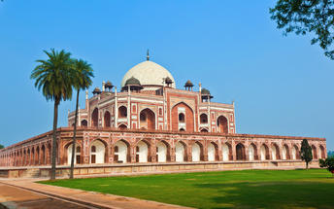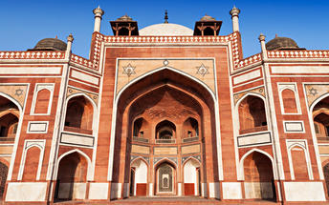

Qutub Minar
The majestic Qutub Minar is a heritage building located in downtown Mehrauli in India. Standing tall at 73-metres, the tower consists of 5 storeys with a flight of spiral stairs leading to its top. The walls are adorned with decorative motifs and Quranic inscriptions. At the foot of the tower lie other monuments of historical significance, such as the Quwwat-ul-Islam Mosque and the Iron Pillar of Delhi. The Amazing race Australia used this site as a pitstop in the second series. Visitors can take advantage of stunning photo opportunities.
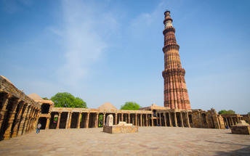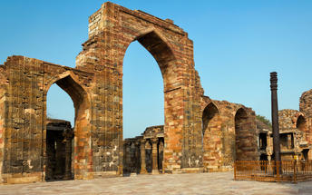

Drive past New Delhi
Later drive past the imposing India Gate, the Parliament building and the Rashtrapati Bhawan, the President’s residence.

Day 3: Delhi- Board Maharaja Express
Morning at appropriate time, you will met and transferred to Safdarjung railway station to board Maharajas Express - Indian Splendor journey.
Guests boarding the Maharaja Express have to report at least an hour before the train's departure at a pre-assigned venue in Delhi for the pre-boarding facilities. All final details related to the meeting point will be emailed or handed over along with the journey's travel vouchers and documents, around 14 days before the departure date.
All Foreign Nationals are required to obtain Tourist VISA to visit India.
NOTE: The itineraries are subject to approval from Ministry of Railways, Govt. of India and may change without prior notice. Destinations, venues, timings etc. may change from time to time.
- 08:15 Welcome and Check in at Delhi Safdarjung Railway Station
- 09:15 Maharajas’ Express proceeds to Agra
- 09:30 Brunch on-board
- 10:45 Tour Briefing on-board
- 14:15 Arrive into Agra
- 14:30 Proceed to visit the Taj Mahal
- 18:30 Return to the comforts of Maharajas’ Express. You can choose optional activities – Spa at a Hotel or Mohabbat the Taj Show
- 19:00 Dinner on-board

Taj Mahal
The iconic Taj Mahal is not only an architectural masterpiece, a UNESCO World Heritage Site and one of the new Seven Wonders of the World – it’s also the enduring legacy of a royal love story. It was commissioned in the 15th century by the Mughal Emperor Shah Jahan after the death of his third and favourite wife, Mumtaz Mahal, to serve as her final resting place and a symbol of his eternal affection for her. Combining Islamic, Persian, Ottoman Turkish and Indian design elements, it’s an awe-inspiring structure of elegant domes and white marble, which changes colour along with the light – pink at sunrise, pearly white in the afternoon and silver-gold in the full moon.
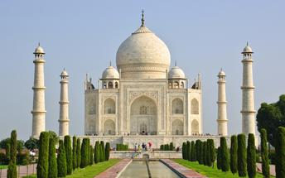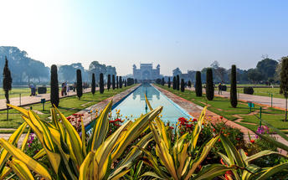

Overnight: Maharajas' Express
Travellers can explore India by rail on one of five fascinating journeys offered by the luxurious Maharajas Express. The train’s décor recreates the elegance and pageantry of erstwhile Maharajas and guests can enjoy state-of-the-art facilities in the spacious, well-appointed cabins and suites. There are two dining cars where guests can feast on gourmet dishes served on gold-edged plates and drink wine from hand-cut Swarovski crystal glasses. Cocktails and snacks can be enjoyed in the Safari Bar while the lounge car also offers a well-stocked bar, library, souvenir shop, and board and card games. Other onboard facilities include live television and CCTV cameras in all public areas, free Wi-Fi, a 24-hour paramedic on board, and an air ambulance in case of emergencies. Activities offered include guided tours to historical and World Heritage sites and cultural experiences such as folk dances.
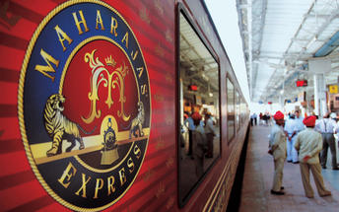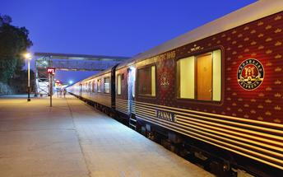

Day 4: Maharaja Express
- 07:00 Proceed to visit the Agra Fort or you may choose optional activity to visit Itmad ud Daula
- 09:00 Return to the comfort of Maharajas’ Express
- 09:15 Breakfast on-board
- 10:45 Maharajas’ Express proceeds to Ranthambore
- 13:00 Lunch on-board
- 15:15 Proceed for an exciting Game Drive at Ranthambore National Park
- 18:15 Return to the comforts of Maharajas’ Express
- 18:45 Maharajas’ Express proceeds to Jaipur
- 19:30 Dinner on-board
- 22:30 Maharajas’ Express arrives at Jaipur

Note: Please contact the on-board guest relationship Executive for the optional services. (Additional charges applicable

Agra Fort
Known as the Red Fort of Agra, this walled imperial city was founded in 1565 by the Emperor Akbar (1556-1605) and is a well-deserving UNESCO World Heritage site, located just 2.5 kilometres from the famous Taj Mahal. Its palaces, grand mosques and elaborate public hall are crafted from pink-red sandstone and are testament to an era when Indo-Muslim art, strongly marked by influences from Persia, was at its height. Emperor Shah Jahan, who built the Taj Mahal for his deceased wife, was imprisoned by his son Aurangzeb in Agra Fort. He is said to have died in the Musamman Burj, a marble tower he himself built, with one of the most alluring views of the Taj Mahal.

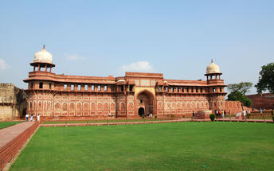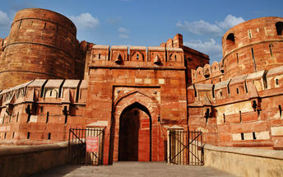

Ranthambore National Park
Located in the Sawai Madhopur district, the Ranthambore National Park, in the western state of Rajasthan, is one of the most visited wildlife parks in India. Spanning over an impressive 1300-square-kilometer stretch of wilderness, the park’s outstanding natural beauty is characterized by its dense jungle, golden savanna, dramatic cliffs and lotus-filled lakes. Considered the best spot to catch a glimpse of tigers in the wild, the park offers visitors a spellbounding combination of mystical temples, wild beauty and crumbling ruins. While the main attraction is undoubtedly the elusive Bengal tiger, the park provides a sanctuary for other wildlife including, among others: sambar, gazelle, caracal, black buck, crocodile, chital, wild boars and a wide array of birds. Don’t miss the ancient Ranthambore Fort, perched high on the cliffs overlooking the vast expanse of this spectacular park.
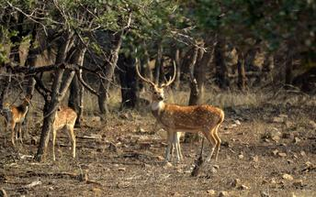

Day 5: Maharaja Express
- 07:00 Breakfast on-board
- 08:00 Proceed to visit the Amber Fort. You may also choose Optional Activities - Spa at a hotel or a visit to City Palace and Observatory (Jantar Mantar) or a Local City Tour
- 12:00 Return to the comforts of Maharajas’ Express
- 13:30 Lunch on-board
- 17:00 Proceed for Dinner at Rambagh Palace
- 21:00 Return to the comforts of Maharajas’ Express
- 23:00 Maharajas' Express proceeds to Bikaner

Note: Please contact the on-board guest relationship Executive for the optional services. (additional charges applicable

Amer Fort
Amer Fort, officially known as the ‘Amer Palace’, is one of the most famous forts of Rajasthan attracting around 4000 to 5000 visitors a day during peak tourist season. The palace was named after the small town of Amer, where it is situated - only eleven kilometres from Jaipur. Perfectly picturesque, this 16th century hillside residence is well preserved, boasting grand pavilions and mirrored halls that open onto flourishing gardens and courtyards. Although the palace’s main construction started in 1592 by Maharaja Man Singh, it was added to over the years by successive rulers and continued to be occupied by them until Jaipur was built.
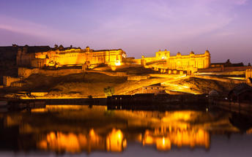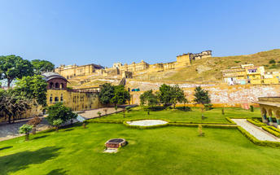

Day 6: Maharaja Express
- 08:00 Enjoy countryside while having breakfast on board
- 10:00 Arrive into Bikaner. Relax on board or you may choose Optional Activities – Visit to Lalgarh Museum or a Local City Tour.
- 13:00 Lunch on board
- 14:00 Proceed to visit the Junagarh Fort followed by sundowners at Sand Dunes
- 17:30 Arrive at the Sand Dunes followed by cocktails, bar-be-que and folk dances.
- 20:15 Return to the comforts of the Maharajas' Express
- 21:00 Train leaves for Jodhpur

Note: Please contact the on-board guest relationship Executive for the optional services. (Additional charges applicable

Junagarh Fort, Bikaner
Junagarh is an impregnable bastion that holds the distinction of having never been captured. It was constructed in 1588 AD by Raja Rai Singh, one of Emperor Akbar’s most distinguished generals. The fort complex houses some magnificent palaces constructed in red sandstone and marble and visitors can feast their eyes on an attractive assortment of courtyards, balconies, kiosks and windows.

Day 7: Maharaja Express
- 07:00 Breakfast on board
- 08:00 Arrive into Jodhpur
- 09:00 Optional Tour to Bishnoi Village or you can enjoy Spa a hotel or an excursion to Umaid Bhawan Palace and Jaswant Thada or a Local City Tour
- 13:00 Lunch on board
- 15:00 Proceed to visit the Mehrangarh Fort followed by a Walking Tour of the Old Clock Tower market. Enjoy a joy ride on Tuk Tuks.
- 17:30 Proceed for an exclusive cocktail dinner at Hanwant Mahal or Khaas Bagh
- 20:15 Return to the comforts of the Maharajas' Express
- 22:00 Maharajas’ Express proceeds to Udaipur

Note: Please contact the on-board guest relationship Executive for the optional services. (Additional charges applicable

Mehrangarh Fort
Mehrangarh Fort rises four hundred feet above the skyline of Jodhpur from its rock precipice on Bhaurcheeria hill. The foundation of Mehrangarh Fort was laid on May 12, 1459 by Rao Jodha, the fifteenth Rathore ruler who wanted to shift the capital from nearby Mandore to Jodhpur. In all its history, Mehrangarh Fort has never been taken in a siege. Mammoth and imposing from the outside, the interiors of the fort are light and detailed in contrast. Several palaces can be found inside the complex, boasting intricate carvings and sprawling courtyards.
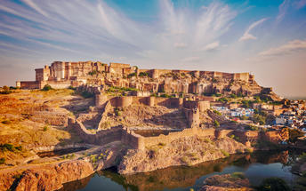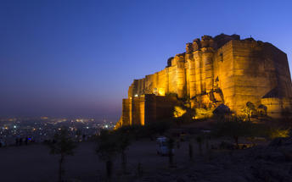

Day 8: Maharaja Express
- 08:00 Breakfast on board
- 10:00 Arrive into Udaipur. Proceed for boat ride on Lake Pichola followed by visit to City Palace, Crystal Gallery.
- 13:30 Lunch at Satkar Hall of Fateh Prakash Palace
- 15:00 Return to the comforts of Maharajas’ Express
- 16:00 Train proceeds to Mumbai
- 19:00 Enjoy an Indian Evening on board
- 20:00 Dinner on board

Note: Please contact the on-board guest relationship Executive for the optional services. (Additional charges applicable

Udaipur City Palace
Situated above Lake Pichola, Udaipur City Palace has housed many royals over four centuries who have each added their own unique preferences to the establishment. The palace is a one of a kind in Rajasthan. Udaipur City Palace was constructed entirely out of marble and granite which makes it highly luxurious. The inside is even more so with its inlays of coloured glass, engravings, towers, and balconies.
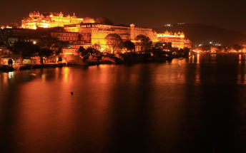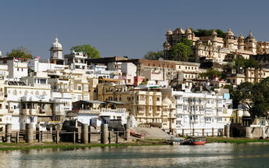

Boat ride at Lake Pichola
Pichola Lake is one of the most beautiful lakes in Rajasthan. Located in the heart of Udaipur, Pichola is the oldest and one of the largest lakes in all of Udaipur. In 1362 AD Pichola Lake was built by Banjara. Later, Maharana Udai Singh, affected by the charm of this lake and extended the lake when he founded the city of Udaipur and also built a dam made of stone that is in the Badipol region on the shore of the lake. Pichola Lake is enveloped by lofty Palaces, temples, bathing ghats and elevated hills on all its sides.
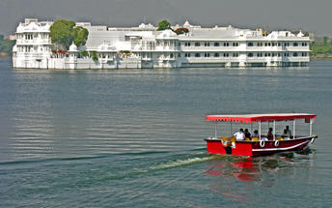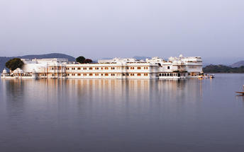

Day 9: De-board at Mumbai
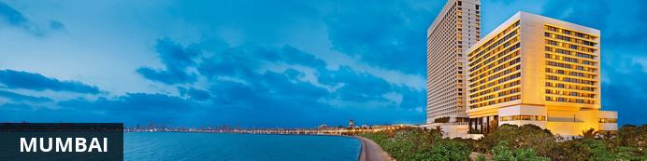
The thriving metropolis of Mumbai is a go-to destination for travellers curious to experience a modern Indian city. Lapped by the Arabian Sea, this urban seaside peninsula is a melting pot of old and new India. Towering office blocks and shiny apartment buildings shoulder crumbling grand dames of architecture. Men play cricket in the leafy central parks, taxis navigate the jam packed streets and families stroll along the seaside promenades of Mumbai, while kilometres away children beg on the peripheries of Asia’s biggest slum. In the wide avenue of Colaba’s high street, western culture overshadows the brightly lit storefronts, where Levi’s, Adidas and McDonalds vie for retail space.
- 07:00 Breakfast on board
- 13:00 Lunch on board
- 15:40 Train arrives at Chatrapati Shivaji Maharaja Terminus, Mumbai.
- 16:00 Disembark and bid farewell to the Maharajas' Express as your journey comes to an end

Upon arrival at Lokmanya Tilak Terminus, you will met and transferred to your hotel.
Rest of the day at leisure.

Day 10: Mumbai
After breakfast, you will proceed for an excursion to Elephanta Caves by return motorboat launch followed by a tour of Mumbai

Elephanta Caves (closed on Mondays)
Elephanta Caves is UNESCO World Heritage site is a fine specimen of rock cut architecture and art of medieval India. To state the trivial, there are no elephants in Elephanta! The name was given by the Portuguese as there was a large elephant sculpture in the island, when it was held by them. Otherwise this island was known as Gharapuri. The island is known for the 7th century caves with boldly executed mythical themes.
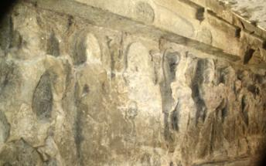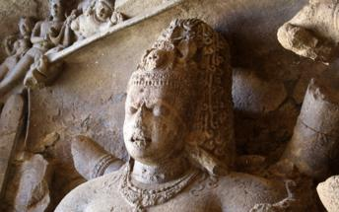

Half Day Mumbai City Tour
Visit to the well-known landmarks, the Gateway of India. Located on the waterfront in Apollo Bunder area in South Mumbai, the Gateway is a basalt arch 26 metres (85 ft) high. It was a crude jetty used by fisher folks and was later renovated and used as a landing place for British governors and other distinguished personages. Next, visit Prince of Whales Museum. It is the main museum in Mumbai, formerly Bombay. It was founded in the early years of the 20th century by prominent citizens of Bombay, with the help of the government, to commemorate the visit of the then Prince of Wales. The museum was renamed in the 1990s or early 2000s after Shivaji, the founder of Maratha Empire. The museum building is built in the Indo-Saracenic style of architecture, incorporating elements of other styles of architecture like the Mughal, Maratha and Jain. The museum building is surrounded by a garden of palm trees and formal flower beds. The museum houses approximately 50,000 exhibits of ancient Indian history as well as objects from foreign lands, categorized primarily into three sections: Art, Archaeology and Natural History. Then, visit Malabar Hills. The colonial bungalows that peppered the hillside in the 18th century have now been replaced by the apartment blocks of Mumbai. You will end your tour by driving past Flora Fountain, Dhobi Ghat, Marine Drive.
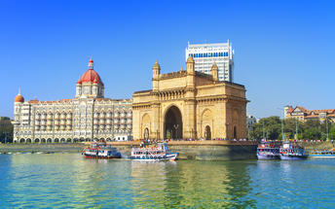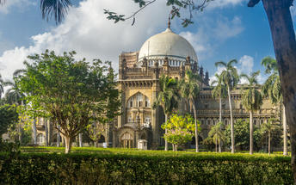

Day 11: Depart Mumbai
Breakfast at hotel.
In time, you will be picked up and transferred to Mumbai airport to board your flight back home.
Flight TBA
Departs Mumbai TBA hrs

