IN-32

Maharaja Express - Heritage of India Tour
Mumbai – Maharaja Express–New Delhi
11 Days / 10 Nights

Day 1: Arrive Mumbai
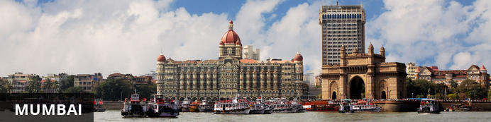
The thriving metropolis of Mumbai is a go-to destination for travellers curious to experience a modern Indian city. Lapped by the Arabian Sea, this urban seaside peninsula is a melting pot of old and new India. Towering office blocks and shiny apartment buildings shoulder crumbling grand dames of architecture. Men play cricket in the leafy central parks, taxis navigate the jam packed streets and families stroll along the seaside promenades of Mumbai, while kilometres away children beg on the peripheries of Asia’s biggest slum. In the wide avenue of Colaba’s high street, western culture overshadows the brightly lit storefronts, where Levi’s, Adidas and McDonalds vie for retail space.

Flight TBA
Arrives Mumbai TBA Hrs

On arrival in Mumbai: Company representatives cannot come into the baggage collection area. Having cleared immigration, collected your luggage and passed through customs, please make your way towards the exit of the terminal building where you will see a bank of people waiting for you. Amongst them will be Travel Counsellor Representative who will be waiting to greet you with a paging board of name.
You will then be transferred to your hotel and assisted with check in.
Standard check in timing is 1400 Hrs.
Rest of the day is at leisure.

Day 2: In Mumbai
After breakfast, proceed for half day sightseeing of Mumbai.
Colonial Heritage Walk:
If you are a first time traveller to the city and want to explore the Tourist precinct of Mumbai by foot, then this tour is specially designed for you. Covering the various tourist landmarks of Mumbai, this tour quite appropriately starts with the Gateway of India, the emblem of Mumbai tourism. This victory arch was built to welcome the British Queen to the city, and it's only befitting to have it as our first stop. Right opposite, you will see the famous domed Taj Mahal Palace Hotel, which has hosted the likes of Barack Obama, the Beatles and a host of other celebrities in its century old lifetime. Post this, we will walk past the Royal Mumbai Yacht Club, the Police Headquarters, the NGMA and the city museum. En-route, we will stumble upon the Kala Ghoda area, which is the art area of Mumbai. Here amidst stories of Sassoon and Jewish history, you will hear stories about the

Watson Hotel - the first iron cast building in the city that hosted Mark Twain. As you walk past the Session court and the high court, you will see the Rajabai towers, the Big Ben of Mumbai. This structure built by generous donation Premchand Roychand, a Mumbai based businessman, still chimes old British tunes once every 15 minutes. As you walk past the Session court and the high court, you will see the Rajabai towers, the Big Ben of Mumbai.

Prince of Wales Museum:
The Chhatrapati Shivaji Maharaj Vastu Sangrahalaya (translation: 'King Shivaji museum'), abbreviated CSMVS and formerly named the Prince of Wales Museum of Western India, is the main museum in Mumbai, Maharashtra.[3] It was founded in the early years of the 20th century by prominent citizens of Mumbai, with the help of the government, to commemorate the visit of George V, who was Prince of Wales at the time. It is located in the heart of South Mumbai near the Gateway of India. The museum was renamed in 1998 after Chhatrapati Shivaji Maharaj, the founder of Maratha Empire.
The building is built in the Indo-Saracenic style of architecture, incorporating elements of other styles of architecture like the Mughal, Maratha and Jain. The museum building is surrounded by a garden of palm trees and formal flower beds.

Dhobi Ghat:
Dhobi Ghat (Mahalaxmi Dhobi Ghat) was an open air laundromat (lavoir) in Mumbai, India. The washers, known as dhobis, work in the open to clean clothes and linens from Mumbai's hotels and hospitals. It was constructed in 1890. There were rows of open-air concrete wash pens, each fitted with its own flogging stone. Called the world's largest outdoor laundry, Dhobi Ghat is a very popular attraction among foreign tourists. The word Dhobi Ghat is used all over India to refer to any place where many washers are present.

Victoria Terminus: Chhatrapati Shivaji Terminus (officially Chhatrapati Shivaji Maharaj Terminus); also known by its former name Victoria Terminus (station code: BBVT/VT, is a historic terminal train station and UNESCO World Heritage Site in Mumbai, Maharashtra, India.
The terminus was designed by British architectural engineer Frederick William Stevens in the style of Victorian Italianate Gothic Revival architecture. Its construction began in 1878, in a location south of the old Bori Bunder railway station, and was completed in 1887, the year marking 50 years of Queen Victoria's rule, the building being named, Victoria Terminus.
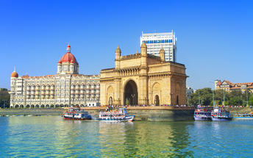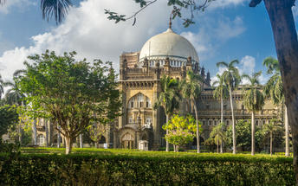
Afternoon is at leisure:
Optional – Dharavi Slum tour : In Mumbai, the largest slum in Asia, have grown in popularity in recent years but for a very good reason. These tours aim to dispel any notions that people may have of Dharavi being a place of misery, and are actually very inspiring. They show what people are capable of achieving despite adverse conditions. What's more, most of the tours are conducted by Dharavi residents themselves.

Day 3: Board Maharajas' Express (Mumbai)

After breakfast, do the check-in formalities of Maharajas Express.
- 09:00 Welcome and Registration at the Taj Mahal Palace Hotel.
- 10:30 Proceed for Chatrapati Shivaji Maharaja Terminus Railway Station, Mumbai.
- 11:30 Maharajas’ Express proceeds to Udaipur.
- 12:30 Lunch on board.
- 19:30 Dinner on board.

Overnight: Maharajas' Express
Travellers can explore India by rail on one of five fascinating journeys offered by the luxurious Maharajas Express. The train’s décor recreates the elegance and pageantry of erstwhile Maharajas and guests can enjoy state-of-the-art facilities in the spacious, well-appointed cabins and suites. There are two dining cars where guests can feast on gourmet dishes served on gold-edged plates and drink wine from hand-cut Swarovski crystal glasses. Cocktails and snacks can be enjoyed in the Safari Bar while the lounge car also offers a well-stocked bar, library, souvenir shop, and board and card games. Other onboard facilities include live television and CCTV cameras in all public areas, free Wi-Fi, a 24-hour paramedic on board, and an air ambulance in case of emergencies. Activities offered include guided tours to historical and World Heritage sites and cultural experiences such as folk dances.
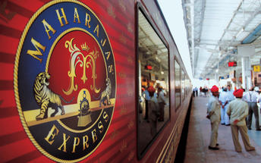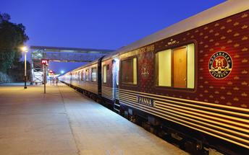

Day 4: Maharajas' Express (Udaipur)
Dubbed the ‘Venice of the East’, the city of Udaipur is built around three interconnected lakes – Lake Pichhola, Fateh Sagar Lake and the smaller Swaroop Sagar Lake – and encircled by the hills of the Aravalli mountain range. It is home to an array of ancient temples and fairy-tale palaces (several of the latter have been converted into luxury heritage hotels) and is known as one of Rajasthan’s most beautiful and romantic cities. Must-see attractions include the City Palace, the Lake Palace (set on a small island in the middle of Lake Pichola) and the Udaipur Solar Observatory – Asia’s premier solar-gazing site.
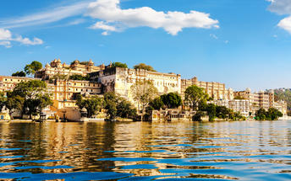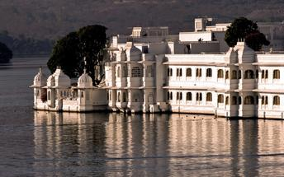
- 08:00 Breakfast on board.
- 10:00 Arrive into Udaipur. Proceed for Boat ride on Lake Pichola followed by visit to City Palace and Crystal Gallery.
- 13:00 Return to the comforts of Maharajas’ Express.
- 13:15 Lunch on board. You may choose Optional Activities - Spa at a hotel or Local City Tour. [On direct payment basis]
- 18:15 Proceed for an Exclusive Dinner at Satkar Hall of Fatehprakash Palace or Jagmandir Island Palace.
- 20:30 Returns to comforts of Maharajas’ Express.
- 22:00 Maharajas’ Express proceeds to Jodhpur.

Day 5: Maharajas' Express (Jodhpur)
- 07:30 Breakfast on board.
- 09:15 Optional Tour to Bishnoi Village (De-board at Rohat Railway Station). [On direct payment basis]
- 13:00 Lunch on board.
- 14:30 Proceed to visit the Mehrangarh Fort followed by a Walking Tour of the Old Clock Tower market and enjoy a joy ride on Tuk Tuks.
- 17:30 Proceed for an exclusive cocktail dinner at Hanwant Mahal or Khaas Bagh.
- 20:15 Return to the comforts of Maharajas' Express.
- 03:00 Maharajas’ Express proceeds to Bikaner.

Jodhpur
Known as the gateway to the Thar Desert, Jodhpur is the second largest city in the state of Rajasthan, India. It is a popular tourist destination featuring a variety of ornate palaces, age-old forts and sacred temples. Dubbed “The Blue City", most houses in the old city are painted a beautiful shade of indigo. While Jodhpur is largely a sprawling modern metropolis, enclosed within its old city walls is a labyrinth of winding, narrow medieval streets and bazaars. Jodhpur is home to one of the largest forts in India, the massive 15th-century Mehrangarh Fort, which towers over the city from its sandstone plinth. Other must-see attractions include: the Umaid Bhawan Palace, one of the world's largest private residences; and the Jaswant Thada, an intricately carved white marble mausoleum.
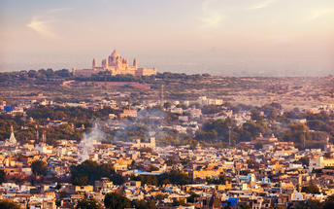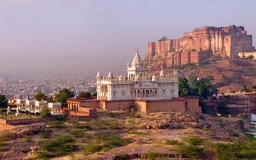

Day 6: Maharajas' Express (Bikaner)
- 08:00 Enjoy countryside while having breakfast on board.
- 10:00 Arrive into Bikaner. Relax on board or you may choose Optional Activities – Visit to Lalgarh Museum or Local City Tour. [On direct payment basis].
- 13:00 Lunch on board.
- 14:00 Visit to Junagarh Fort followed by sundowners at Sand Dunes.
- 17:30 Arrive at the Sand Dunes followed by cocktails, bar-be-que and folk dances.
- 20:15 Return to the comfort of the Maharajas' Express.
- 21:30 Maharajas’ Express proceeds to Jaipur

Bikaner
One of the most loved snack exports out of India has its origins in this Rajhastani city. Bikaneri Bhujia, an Indian version of potato chips, has become popular across the globe and today the crispy snack, using gram flour and spices, provides employment to over 2.5 million people. Bikaner boasts many unique architectural features such as the Bikaner Havelis – manifold mansions lining the narrow lanes of old town, signalling a glorious and opulent heyday in Bikaner history – and the beautiful Junagarh Fort, with its tall ochre walls extending for almost a kilometre around the impressive structure.
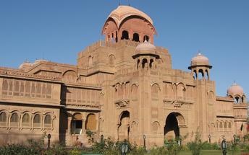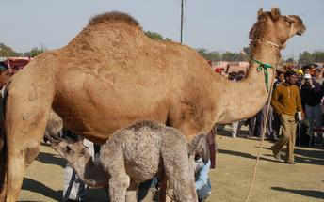

Day 7: Maharajas' Express (Jaipur)
- 08:00 Breakfast on board.
- 09:30 Arrive into Jaipur. Proceed for a visit to Amber Fort.
- 12:30 After sightseeing proceed to Rambagh Palace hotel for lunch.
- 16:00 Return to the comforts of Maharajas’ Express.
You may choose Optional Activities – Spa at a hotel, Visit to City Palace Museum and Observatory or Local City Tour [On direct payment basis].
- 20:00 Dinner on board.
- 21:30 The Maharajas' Express proceeds to Sawai Madhopur (Ranthambore)

Jaipur
Fringed by the rugged Aravali Hills, Jaipur is the capital and largest city in India’s northern state of Rajasthan. This city is famed for being India’s first planned city featuring a multitude of pink terracotta buildings within the walled historic centre, earning it the nickname,’The Pink City’. Jaipur falls within the Golden Triangle, a popular tourist circuit, which includes Delhi, Jaipur and Agra, and serves as a gateway to the neighbouring desert cities of Jaisalmer and Jodhpur. This colourful city is a combination of tradition and modernity and offers visitors vibrant bazaars, lavish palaces and ancient temples. The salmon-hued old city is home to the opulent City Palace, encompassing an impressive assortment of palatial structures, sprawling gardens, courtyards and buildings. Don’t miss the fairy-tale splendour of the Amber Fort, set against the backdrop of the arid landscape.
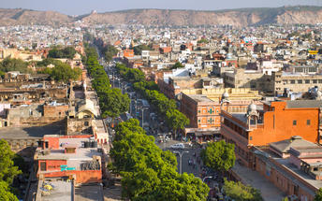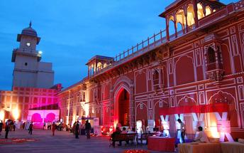

Day 8: Maharajas' Express (Ranthambore-Fatehpur Sikri)
- 06:30 Proceed for an exciting Game Drive at Ranthambore National Park.
- 09:30 Return to the comforts of Maharajas' Express.
- 09:45 Breakfast on board.
- 10:15 Maharajas' Express proceeds for Fatehpur Sikri.
- 13:30 Lunch on board.
- 14:30 Arrive into Fatehpur Sikri.
- 15:30 Visit the deserted Mughal City of Fatehpur Sikri.
- 18:00 Return to the comforts of Maharajas' Express.
- 19:30 Enjoy an “Indian Evening” followed by dinner on board.

Ranthambore National Park
Located in the Sawai Madhopur district, the Ranthambore National Park, in the western state of Rajasthan, is one of the most visited wildlife parks in India. Spanning over an impressive 1300-square-kilometer stretch of wilderness, the park’s outstanding natural beauty is characterized by its dense jungle, golden savanna, dramatic cliffs and lotus-filled lakes. Considered the best spot to catch a glimpse of tigers in the wild, the park offers visitors a spellbounding combination of mystical temples, wild beauty and crumbling ruins. While the main attraction is undoubtedly the elusive Bengal tiger, the park provides a sanctuary for other wildlife including, among others: sambar, gazelle, caracal, black buck, crocodile, chital, wild boars and a wide array of birds. Don’t miss the ancient Ranthambore Fort, perched high on the cliffs overlooking the vast expanse of this spectacular park.
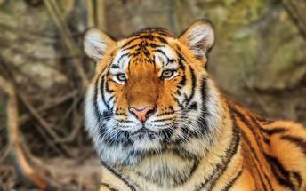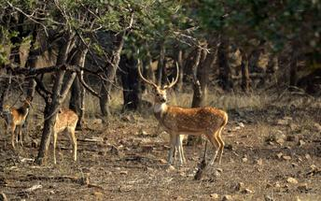

Fatehpur Sikri
A highlight in the province of Uttar Pradesh, Fatehpur Sikri served briefly as the capital of the Mughal Empire from 1571 to 1585. This world heritage site is rated as one of the best preserved collections of Mughal architecture in India. Surrounded by a six kilometre wall, with the fourth being a lake at the time, a day can be spent exploring the elaborate structures within. Marvel at the impressive Jama Masjid mosque, the detailed palaces built for Emperor Akbar’s wives, the public and private discussion halls and vast ornamental pool; all of which took over 15 years to conceptualise and build.
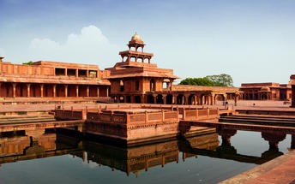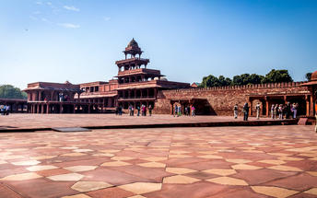

Day 9: Maharajas' Express (Agra – Delhi)
- 06:45 Arrive into Agra and proceed to visit Taj Mahal.
- 09:30 Champagne Breakfast at Taj Khema.

Taj Mahal
The iconic Taj Mahal is not only an architectural masterpiece, a UNESCO World Heritage Site and one of the new Seven Wonders of the World – it’s also the enduring legacy of a royal love story. It was commissioned in the 15th century by the Mughal Emperor Shah Jahan after the death of his third and favourite wife, Mumtaz Mahal, to serve as her final resting place and a symbol of his eternal affection for her. Combining Islamic, Persian, Ottoman Turkish and Indian design elements, it’s an awe-inspiring structure of elegant domes and white marble, which changes colour along with the light – pink at sunrise, pearly white in the afternoon and silver-gold in the full moon.
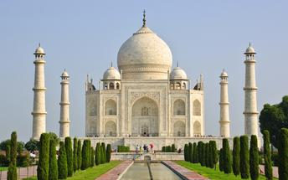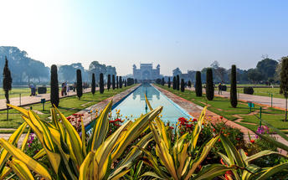
After the breakfast, proceed to Delhi. Arrive Delhi at 1530 hrs and check-in at your hotel for the overnight stay.

Day 10: Delhi
After breakfast, begin the day with a heritage walk through Old Delhi including a tuk-tuk ride followed by the tour of the UNESCO World heritage sites in New Delhi, ending with drive past India Gate and other government buildings.

Old Delhi Heritage Walk
Delhi is an ancient city with history going back to 3000 BC. It has been mentioned extensively in numerous Indian epics like Mahabharat. But the Delhi we see and know about from written records starts from 736 AD. The city has been built, destroyed and rebuilt numerous times. According to popular folklore, Delhi was site of seven different cities between 3000 BC and 17th century AD. But when we count the smaller settlements around the area, there are atleast fifteen.
This ancient history and influx of people from all over the world has given Delhi a culture and heritage matched by only a handful of places. Delhi is one of very few places where the ancient and modern co-exist side by side complementing each other perfectly. Our heritage walks of Delhi are a perfect way of exploring this amalgam of old traditions, modern development and the unique heritage which makes it so interesting. These heritage walks are a perfect way to explore some of the lesser visited places and gain a new insight about the history, people and sights of Delhi city.

Humayun's Tomb
The mausoleum complex of Humayun, India’s second Mughal Emperor, was commissioned by his widow in 1565 and was the first garden tomb to be built in India, taking seven years to complete. Humayun had travelled widely in Persia and Central Asia during his lifetime, and many of the architectural principles he brought back from these journeys were incorporated into the building at his wife’s instructions. With its double domes, decorative inlaid marble and vast garden with pools connected by channels, this 16th Century building set the stage for the style that culminated in the Taj Mahal almost 100 years later.
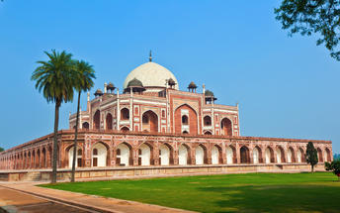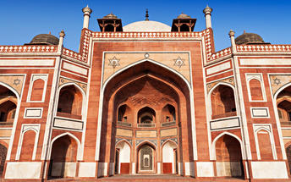

Qutub Minar
The majestic Qutub Minar is a heritage building located in downtown Mehrauli in India. Standing tall at 73-metres, the tower consists of 5 storeys with a flight of spiral stairs leading to its top. The walls are adorned with decorative motifs and Quranic inscriptions. At the foot of the tower lie other monuments of historical significance, such as the Quwwat-ul-Islam Mosque and the Iron Pillar of Delhi. The Amazing race Australia used this site as a pitstop in the second series. Visitors can take advantage of stunning photo opportunities.
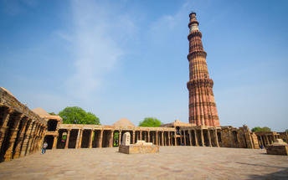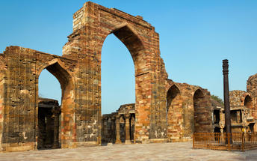

Drive past New Delhi
Later drive past the imposing India Gate, the Parliament building and the Rashtrapati Bhawan, the President’s residence.

Day 11: Delhi Departure
Breakfast is at the hotel.
At an appropriate time, you will be transferred to the airport to board your flight to back home.
Flight TBA
Departs Delhi TBA

**** END OF SERVICES ****

