IN-33

Golden Triangle with Varanasi and Gange Cruise
New Delhi – Agra – Jaipur – Varanasi – Cruise – Delhi
16 Days / 15 Nights

Day 1: Arrive Delhi
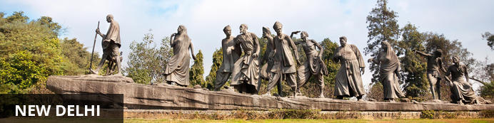
India’s largest city, Delhi, has been one of the country’s commercial and economic hubs for centuries and, as a result, is incredibly rich in culture and history. Made up of the ancient walled city of Old Delhi and the more modern sector, New Delhi, the city encompasses a staggering array of beautiful architecture, notable monuments and age-old temples, including three UNESCO World Heritage Sites – the Red Fort, Qutab Minar and Humayun's Tomb. Other key attractions include the 17th century Chandni Chowk marketplace – still one of the city’s most popular retail centres today, particularly for jewellery and traditional Indian saris.

Day Itinerary
Flight TBA
Arrives Delhi TBA Hrs

On arrival at Delhi you will be received by a Travel Counsellors' representative and he will transfer you to your hotel for check in. Standard check in time - 1400 Hrs.

Day 2: In Delhi
After lite breakfast proceed to Old Delhi Heritage Walk followed by lunch. In the afternoon enjoy half day sightseeing of New Delhi

Old Delhi Heritage Walk
Delhi is an ancient city with history going back to 3000 BC. It has been mentioned extensively in numerous Indian epics like Mahabharat. But the Delhi we see and know about from written records starts from 736 AD. The city has been built, destroyed and rebuilt numerous times. According to popular folklore, Delhi was site of seven different cities between 3000 BC and 17th century AD. But when we count the smaller settlements around the area, there are atleast fifteen. delhi heritage walk
This ancient history and influx of people from all over the world has given Delhi a culture and heritage matched by only a handful of places. Delhi is one of very few places where the ancient and modern co-exist side by side complementing each other perfectly. Our heritage walks of Delhi are a perfect way of exploring this amalgam of old traditions, modern development and the unique heritage which makes it so interesting. These heritage walks are a perfect way to explore some of the lesser visited places and gain a new insight about the history, people and sights of Delhi city.

Humayun's Tomb
The mausoleum complex of Humayun, India’s second Mughal Emperor, was commissioned by his widow in 1565 and was the first garden tomb to be built in India, taking seven years to complete. Humayun had travelled widely in Persia and Central Asia during his lifetime, and many of the architectural principles he brought back from these journeys were incorporated into the building at his wife’s instructions. With its double domes, decorative inlaid marble and vast garden with pools connected by channels, this 16th Century building set the stage for the style that culminated in the Taj Mahal almost 100 years later.
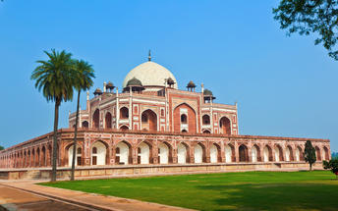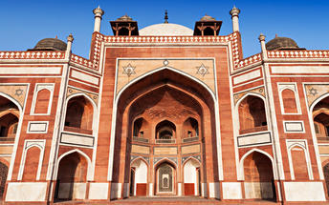

Qutub Minar
The majestic Qutub Minar is a heritage building located in downtown Mehrauli in India. Standing tall at 73-metres, the tower consists of 5 storeys with a flight of spiral stairs leading to its top. The walls are adorned with decorative motifs and Quranic inscriptions. At the foot of the tower lie other monuments of historical significance, such as the Quwwat-ul-Islam Mosque and the Iron Pillar of Delhi. The Amazing race Australia used this site as a pitstop in the second series. Visitors can take advantage of stunning photo opportunities.
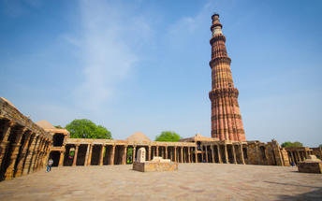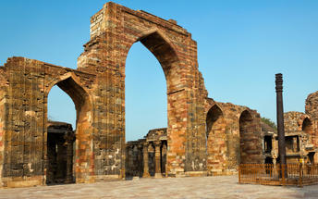

Drive past New Delhi
Later drive past the imposing India Gate, the Parliament building and the Rashtrapati Bhawan, the President’s residence.

Day 3: Delhi – Agra
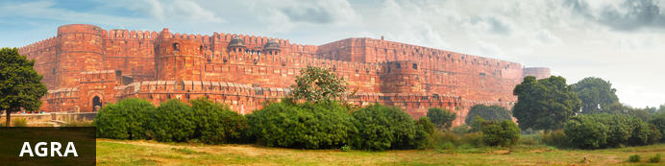
Home of the world-famous Taj Mahal, Agra is one of India’s prime tourist destinations for specifically this reason, though its attractions also extend to an array of other impressive historical sights. These include the red-hued Agra Fort, the sacred Jama Masjid mosque and Itmad-ud-Daulah’s tomb, with its white marble facade embellished with intricate inlaid designs and semi-precious gems. The Taj, however, is in a league of its own and needless to say is a must-see for any visitor to the city. Commissioned by the Mughal emperor Shah Jahan in the 15th century as a memorial to his beloved wife Mumtaz Mahal, it is an architectural masterpiece of exquisite craftsmanship and perfect proportions.

After breakfast you will be driven to Agra (approx 220 kms/ 04 hours drive).

Taj Mahalm(closed on Fridays)
The iconic Taj Mahal is not only an architectural masterpiece, a UNESCO World Heritage Site and one of the new Seven Wonders of the World – it’s also the enduring legacy of a royal love story. It was commissioned in the 15th century by the Mughal Emperor Shah Jahan after the death of his third and favourite wife, Mumtaz Mahal, to serve as her final resting place and a symbol of his eternal affection for her. Combining Islamic, Persian, Ottoman Turkish and Indian design elements, it’s an awe-inspiring structure of elegant domes and white marble, which changes colour along with the light – pink at sunrise, pearly white in the afternoon and silver-gold in the full moon.

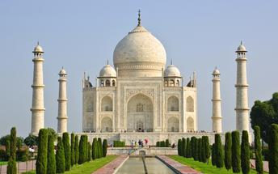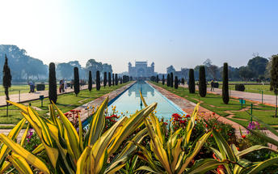

Agra Fort
Known as the Red Fort of Agra, this walled imperial city was founded in 1565 by the Emperor Akbar (1556-1605) and is a well-deserving UNESCO World Heritage site, located just 2.5 kilometres from the famous Taj Mahal. Its palaces, grand mosques and elaborate public hall are crafted from pink-red sandstone and are testament to an era when Indo-Muslim art, strongly marked by influences from Persia, was at its height. Emperor Shah Jahan, who built the Taj Mahal for his deceased wife, was imprisoned by his son Aurangzeb in Agra Fort. He is said to have died in the Musamman Burj, a marble tower he himself built, with one of the most alluring views of the Taj Mahal.

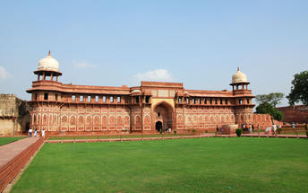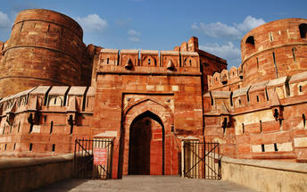

Tomb Of Itmad-Ud-Daulah (Baby Taj)
Tomb of I'timad-ud-Daulah is a Mughal mausoleum built for the grandfather of the Mumtaz Mahal, who the Taj Mahal was in turn built for. the tomb colloquially known as the "jewel box", or the "Baby Taj".

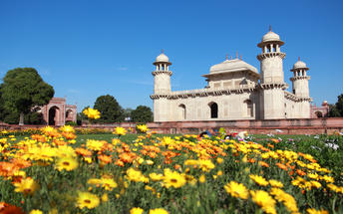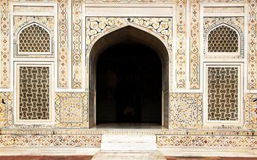

Day 4: Agra – Jaipur
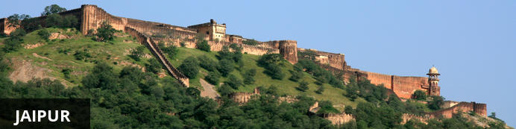
Fringed by the rugged Aravali Hills, Jaipur is the capital and largest city in India’s northern state of Rajasthan. This city is famed for being India’s first planned city featuring a multitude of pink terracotta buildings within the walled historic centre, earning it the nickname,’The Pink City’. Jaipur falls within the Golden Triangle, a popular tourist circuit, which includes Delhi, Jaipur and Agra, and serves as a gateway to the neighbouring desert cities of Jaisalmer and Jodhpur. This colourful city is a combination of tradition and modernity and offers visitors vibrant bazaars, lavish palaces and ancient temples. The salmon-hued old city is home to the opulent City Palace, encompassing an impressive assortment of palatial structures, sprawling gardens, courtyards and buildings. Don’t miss the fairy-tale splendour of the Amber Fort, set against the backdrop of the arid landscape.

After breakfast you will be driven to Jaipur. [approx 260 kms/ 06 hours drive]. Option to do a sunrise visit of Taj

Fatehpur Sikri
A highlight in the province of Uttar Pradesh, Fatehpur Sikri served briefly as the capital of the Mughal Empire from 1571 to 1585. This world heritage site is rated as one of the best preserved collections of Mughal architecture in India. Surrounded by a six kilometre wall, with the fourth being a lake at the time, a day can be spent exploring the elaborate structures within. Marvel at the impressive Jama Masjid mosque, the detailed palaces built for Emperor Akbar’s wives, the public and private discussion halls and vast ornamental pool; all of which took over 15 years to conceptualise and build.

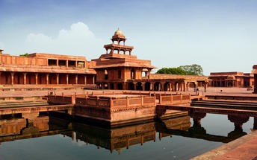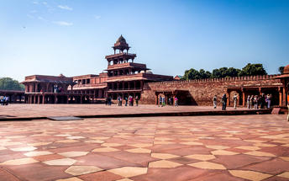

Day 5: In Jaipur
After breakfast, proceed for a full day tour of Jaipur, visiting Amer Fort (A jeep will spare you the uphill climb to the Fortress). En-route photo stop at Hawa Mahal – Palace of Winds), and visit City Palace and Astronomical Observatory.

Amer Fort
Amer Fort, officially known as the ‘Amer Palace’, is one of the most famous forts of Rajasthan attracting around 4000 to 5000 visitors a day during peak tourist season. The palace was named after the small town of Amer, where it is situated - only eleven kilometres from Jaipur. Perfectly picturesque, this 16th century hillside residence is well preserved, boasting grand pavilions and mirrored halls that open onto flourishing gardens and courtyards. Although the palace’s main construction started in 1592 by Maharaja Man Singh, it was added to over the years by successive rulers and continued to be occupied by them until Jaipur was built.
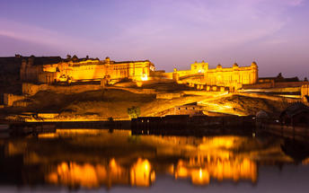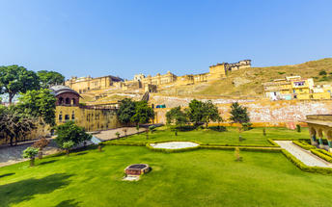

Photo stop at Hawa Mahal (Palace of Winds)
One of Jaipur’s most recognised buildings, the Hawa Mahal (Palace of Winds) is known for its iconic façade. Small windows, decorated with intricate latticework create a honeycomb-like appearance. The original intention of the lattice was to allow the royal ladies to observe everyday life in the street below without being seen. The cooling effect, provided by the breeze passing through the small windows, gave the palace its name. Built in 1799 by Maharaja Sawai Pratap Singh, the unique construction was originally designed to look like the crown of Krishna. A panoramic view of Jaipur can be had from the top of the building.

Jaipur City Palace
City Palace forms one of the most famous tourist attractions and a major landmark in Jaipur. The beautiful palace was built by Maharaja Sawai Jai Singh during his reign. Among the various forts and palaces of Jaipur, City Palace stands apart, with its outstanding art and architecture.
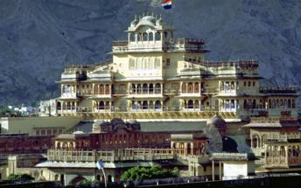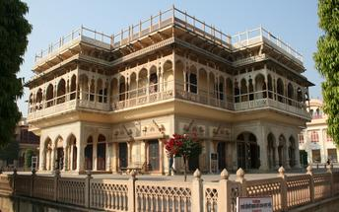

Jantar Mantar Jaipur
In 1734, the year of its completion, the Jai Singh Observatory was the last outpost of medieval science. From the outside, the eighteen fixed observational instruments look more like playground apparatus than sighting devices, but they were used to measure the position of the sun, stars and planets. Built by Jai Singh, the first Maharaja of Jaipur who founded the city in 1727, the observatory is one of a handful. Jai Singh, fulfilling a lifelong interest in mathematics and astronomy, built observatories in Delhi, Jaipur, Ujjain, Mathura and Benares. The Jaipur observatory is the largest and best preserved of these.

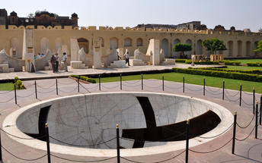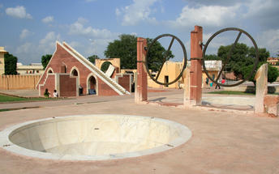

Day 6: Jaipur – Varanasi

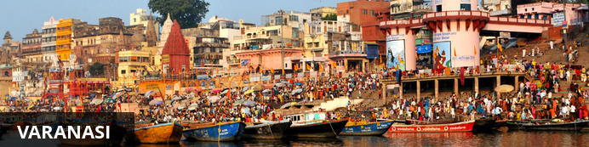
An ancient and deeply sacred city, Varanasi rests along the banks of the holy River Ganges and encompasses a wealth of beautiful riverside temples, stately old forts and vibrant markets. It’s considered the spiritual capital of Hinduism, and it’s widely believed that dying here will bring salvation. As a result, the city is home to a multitude of ghats – stone steps leading to the river –some of which are used for bathing rituals and others as cremation sites. An early morning boat ride along the Ganges offers an excellent way to take in the ghats and the bustling activity centred on them.

At an appropriate time, you will be assisted & transferred to Jaipur airport to board the flight for Varanasi (via flight).

Flight TBA
Depart Jaipur TBA Hrs.
Arrives Varanasi TBA Hrs.

Upon arrival at Varanasi airport, you will be assisted & transferred to the hotel for check in.
Depending on the arrival time, you may witness the Ganga aarti on the ghats of the River Ganges in the evening.

Evening Aarti at Ghat
Varanasi is a sacred and oldest city located at the banks of the holy River Ganga. Where, Ganges Aarti is performed daily in the evening by a group of priests at the Dashashwamedh Ghat near famous Kashi Vishwanath Temple as a dedication to Shiva, Gange, Surya (Sun), Agni (Fire), and the entire universe.
The whole ritual of the Ganges Aarti is performed by the seven students of the Vedas and Upanishads lead by the head priest of the Gangotri Seva Samiti in a well choreographed manner with a great synchronization. The whole event takes around 45 minutes. An announcement at 7.00 pm indicates the beginning of the Aarti.
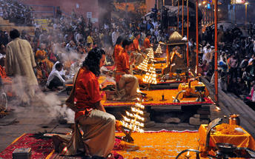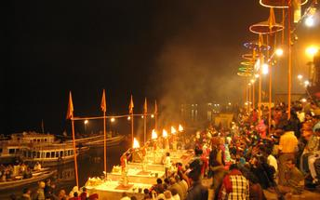

Day 7: In Varanasi
Early morning enjoy private boat ride on the ganges. Return to the hotel for breakfast.
After breakfast you will proceed to visit Sarnath.

Private Boat ride on the River Ganges
Sunrise boat ride on Ganga in Varanasi is a spiritual experience in itself. Sunrise boat ride on Ganga in Varanasi is a memorable experience and not be missed. It gives a glimpse of morning life along the ghats in Varanasi. If you are lucky you can see stunning views of sun rising in the eastern horizon.
Ganga is Varanasi and Varanasi is Ganga. For locals it is the lifeline. For devout pilgrims she is “Ganga Mayya – the mother who will wash away all the sins”. We are fascinated by the energy of the people, their beliefs and devotion to god. We could see people from all walks of life gathering on the ghat to worship the sun as he came up in the eastern horizon.

Sarnath
Sarnath is one of the most important Buddhist pilgrimage centres in India. It is here that Buddha came after reaching enlightenment at Bodh Gaya (present-day Bihar), and where he first began his teachings of Dharma and the four noble truths to his five disciples. It is also an important place for the followers of Jainism. While many of the ancient buildings and structures at Sarnath were damaged or destroyed by the Turks, relics remain in the form of ruins that can be visited, or artefacts held in the Sarnath Archeological Museum, which also houses some of the greatest treasures of Indian Buddhist art, including almost 300 images. The Deer Park, which is the site of Buddha’s first teachings, is maintained as an animal park and still home to resident deer.
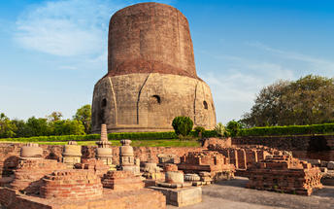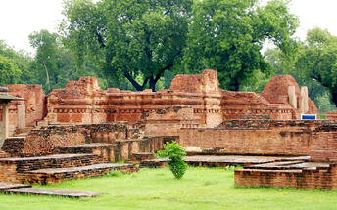

Day 8: Varanasi – ABN Rajmahal Cruise Ship
At an appropriate time, you will be transferred to the Jetty for boarding the ABN Cruise Ship.

Embark on your cruise ship and sail downstream a short distance before putting down anchor for the night. Enjoy dinner on board.

Overnight: ABN Rajmahal
The ABN Rajmahal is a passenger boat that takes guests on a luxurious cruise along the beautiful Ganges River for an authentic Indian experience. Accommodation is available in single, double, and triple guest rooms which feature modern Indian decor and luxurious comfort. The ship features an acclaimed restaurant which serves a combination of authentic local and international cuisine. The fully equipped bar offers a large variety of premium wines, spirits, and beer. Guests may enjoy a massage at the fully equipped onboard spa which offers a large selection of treatments. Entertainment is also available on the ship and includes live song and dance performances.
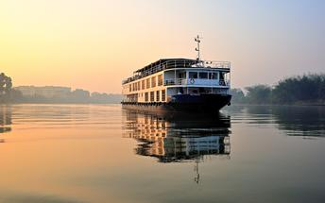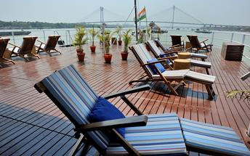

Day 9: ABN Rajmahal
This morning, sail up to anchor near Rajghat. Disembark and drive to Chunar to see the great Mughal fort, the old British cemetery and the Mughal tombs nearby. Carpet-weaving and Chunar pottery are other attractions here. On the way back, visit the Ramnagar Maharaja’s Palace and museum before re-boarding at Rajghat.

Day 10: ABN Rajmahal
Take rowing boats at dawn past the busy and colourful bathing ghats of Varanasi. After breakfast, drive to visit the Buddhist site at Sarnath, the Deer Park where the Buddha preached his first sermon and the archaeological museum. This evening, disembark and take a walk through the busy alleys of Varanasi to experience the beating heart of the city. Join the Ganga Aarti ceremony, where young priests perform their daily rituals with brass lamps and spiritual mantras in front of large crowds from all over India and the world. A truly mesmerising event, this aarti is the essence of Varanasi. Return to the ship moored at Rajghat.

Day 11: ABN Rajmahal
After breakfast on board, disembark and drive to the city of Jaunpur to see the Mughal Bridge, visit its ancient fort and walk to see the splendid Atala mosque. Return to the ship for lunch and sail downstream towards Ghazipur. Alternatively, some may prefer to stay back and explore Varanasi’s tempting shopping possibilities.

Day 12: ABN Rajmahal
This morning, sail downstream and disembark at Ghazipur after breakfast. Visit the imposing tomb of Lord Cornwallis, the General defeated by George Washington in 1781 at Yorktown, so arguably responsible for the loss of the American colonies. We might also be able to spend a little time walking in the busy Ghazipur bazaar, a quintessential Indian experience. Later, sail down towards Buxar.

Day 13: ABN Rajmahal
After breakfast, disembark to the country town of Buxar, famous for the battle fought here in 1764 which, together with Plassey, laid the foundations of the British Raj. Visit the memorial on the battlefield and the old East India Company cemetery in town. Later, take a short cycle rickshaw ride up to the ghats of Buxar. Sail down to anchor near confluence of Ghagra.

Day 14: ABN Rajmahal
Cruise past the busy river port of Doriganj and the confluence with the Sone River to a ghat from which we visit the small yet spectacular Mughal tomb at Maner. Sail down to anchor at Patna.

Day 15: Patna – New Delhi
After breakfast, disembark the ship and you will be transferred to Patna airport for your flight to Delhi.

Flight TBA
Departs Patna TBA Hrs.
Arrives Delhi TBA Hrs.

Arrive Delhi and you will be transferred to an airport hotel.

Day 16: Depart Delhi
At an appropriate time, you will be assisted & transferred to airport to board the flight for onward journey.

Flight TBA
Departs Delhi TBA Hrs.

