IN-34

Maharaja Express – Indian panorama
Delhi – Maharaja Express - Delhi
09 Days / 08 Nights

Day 1: Arrive Delhi
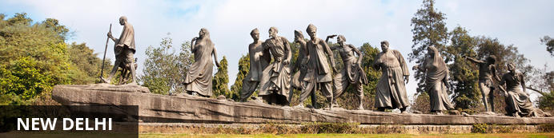
India’s largest city, Delhi, has been one of the country’s commercial and economic hubs for centuries and, as a result, is incredibly rich in culture and history. Made up of the ancient walled city of Old Delhi and the more modern sector, New Delhi, the city encompasses a staggering array of beautiful architecture, notable monuments and age-old temples, including three UNESCO World Heritage Sites – the Red Fort, Qutab Minar and Humayun's Tomb. Other key attractions include the 17th century Chandni Chowk marketplace – still one of the city’s most popular retail centres today, particularly for jewellery and traditional Indian saris; the iconic Bahà’i Lotus Temple – an award-winning architectural gem; and the Jama Masjid, India’s largest mosque.

Flight TBA
Arrives Delhi TBA Hrs

On arrival in Delhi: Company representatives cannot come into the baggage collection area. Having cleared immigration, collected your luggage and passed through customs, please make your way towards the exit of the terminal building where you will see a bank of people waiting for you. Amongst them will be Travel Counsellor Representative who will be waiting to greet you with a paging board of name.
You will then be transferred to your hotel and assisted with check in.

Day 2: Delhi- Board Maharaja Express- Jaipur
Early morning, you will be assisted & transferred to Safdarjung railway station to embark the Luxury train Maharaja Express.
- 07:30 Welcome and Check in at Delhi Safdurjung Railway Station
- 08:00 Breakfast onboard
- 08:30 Maharajas’ Express proceeds to Jaipur
- 13:00 Lunch onboard
- 14:30 Arrive into Jaipur
- 15:00 Proceed to visit City Palace Galleries followed by dinner at Rambagh Palace Hotel
- 20:30 Return to the comforts of Maharajas’ Express. Overnight on train at Jaipur

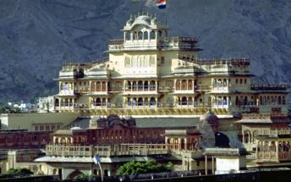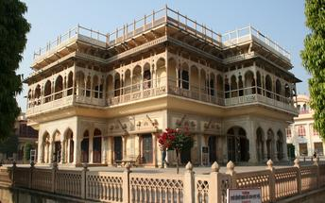

Overnight: On Board Maharaja Express
Travellers can explore India by rail on one of five fascinating journeys offered by the luxurious Maharajas Express. The train’s décor recreates the elegance and pageantry of erstwhile Maharajas and guests can enjoy state-of-the-art facilities in the spacious, well-appointed cabins and suites. There are two dining cars where guests can feast on gourmet dishes served on gold-edged plates and drink wine from hand-cut Swarovski crystal glasses. Cocktails and snacks can be enjoyed in the Safari Bar while the lounge car also offers a well-stocked bar, library, souvenir shop, and board and card games. Other onboard facilities include live television and CCTV cameras in all public areas, free Wi-Fi, a 24-hour paramedic on board, and an air ambulance in case of emergencies. Activities offered include guided tours to historical and World Heritage sites and cultural experiences such as folk dances.

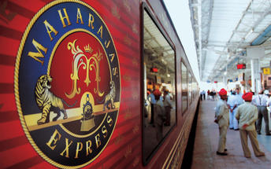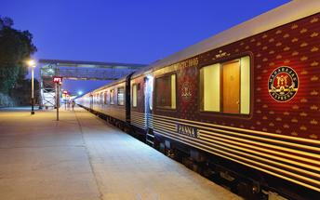

Day 3: Onboard Train (Jaipur- Ranthambhore)
- 07:00 Breakfast onboard
- 08:00 Visit the Amber Fort
- 12:30 Return to the Maharajas' Express for lunch onboard. After lunch you may choose the Optional Activities - Spa at a hotel or a visit to City Palace and Observatory (Jantar Mantar) or a Local City Tour
- 19:30 Dinner onboard
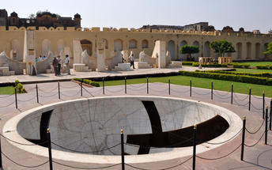
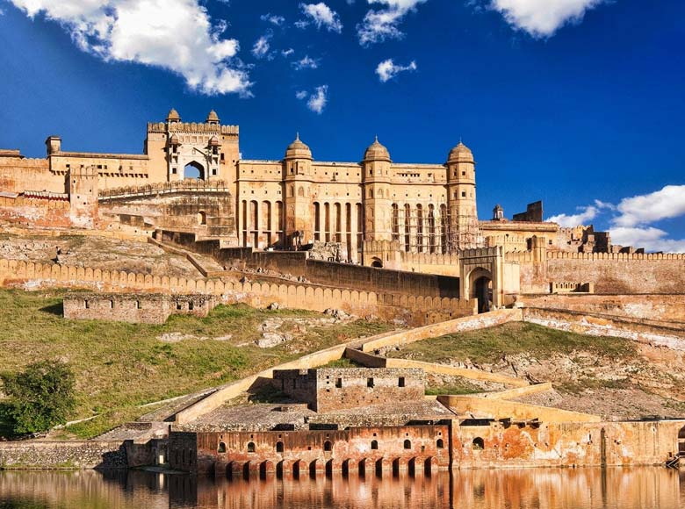
- 23:00 Maharajas' Express leaves for Sawai Madhopur (Ranthambore)

Overnight: On Board Maharaja Express

Day 4: Onboard Train (Ranthambhore- Fatehpur Sikri)
- 06:00 Proceed for an exciting Game Drive at Ranthambore National Park
- 09:30 Return to the comforts of Maharajas' Express
- 09:45 Breakfast onboard
- 10:15 Maharajas' Express proceeds for Fatehpur Sikri
- 13:30 Lunch onboard
- 14:30 Arrive into Fatehpur Sikri
- 15:30 Visit the deserted Mughal City of Fatehpur Sikri
- 18:00 Return to the comforts of Maharajas' Express
- 20:00 Dinner onboard. Overnight on train at Fatehpur Sikri
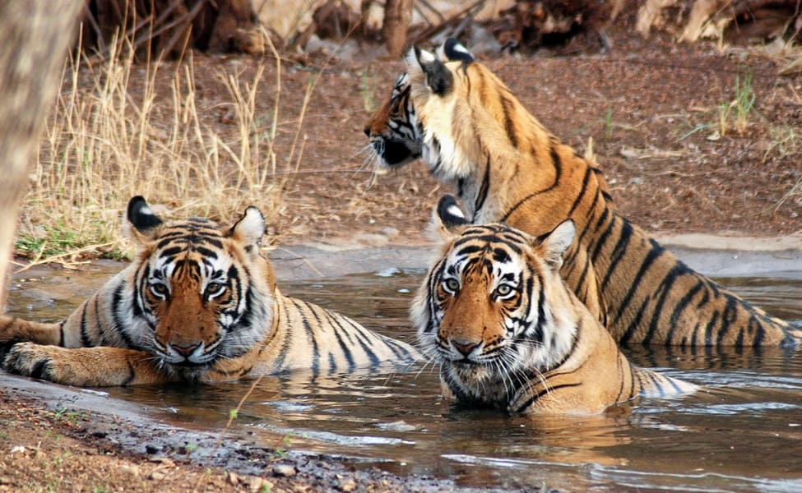
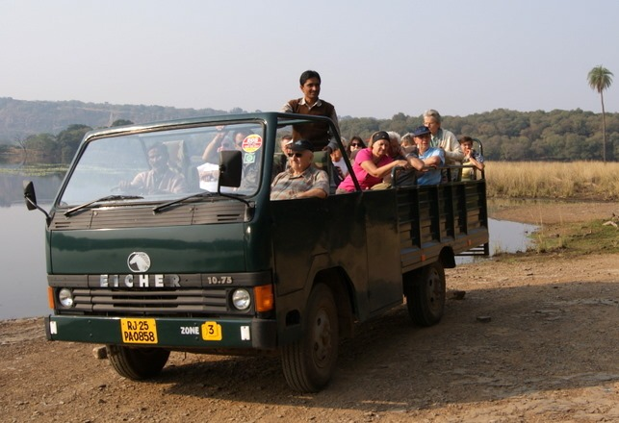

Overnight: On Board Maharaja Express

Day 5: Onboard Train (Fatehpur Sikri- Agra)
- 06:30 Arrive into Agra and proceed to visit the Taj Mahal
- 09:30 Champagne Breakfast at Taj Khema
- 11:00 Return to the comforts of Maharajas’ Express
- 13:00 Lunch onboard. After lunch you may choose Optional Activities such as Spa at a Hotel or Visit to Itmad-ud-daula or Agra Fort or a Local City Tour or Mohabbat the Taj Show
- 17:30 Dinner onboard
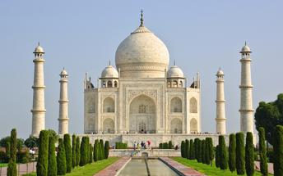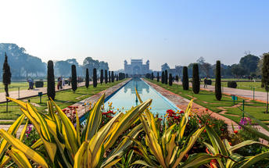

Overnight: On Board Maharaja Express

Day 6: On Board train (Agra- Orchha- Khajuraho- Varanasi)
- 06:30 Breakfast onboard
- 07:30 Deboard at Jhansi to reach Orchha by Road. Visit Orchha Fort and Village Tour by Tuk Tuks
- 10:00 Return to the comforts of Maharajas’ Express and Maharajas Express proceeds to Khajuraho
- 12:00 Lunch onboard
- 15:30 Arrive into Khajuraho and proceed to visit the Western Group of Temples
- 18:00 Return to the comforts of Maharajas’ Express
You may choose Optional Activities – Spa facility at a hotel or Light and Sound Show or Dances of India Show
- 20:00 Dinner Onboard
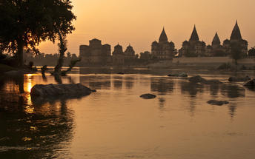
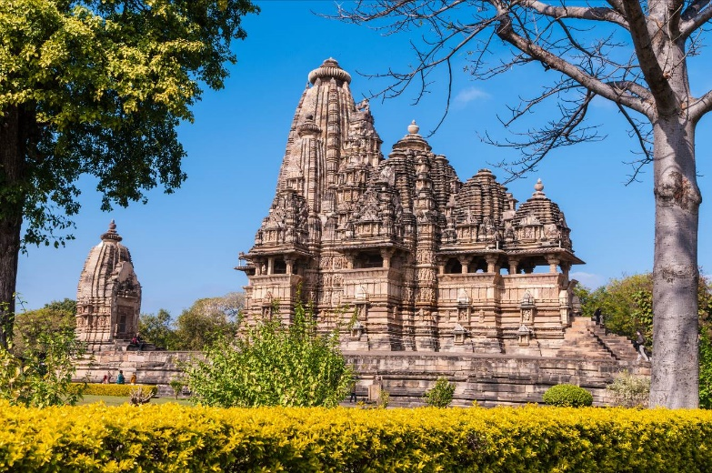
- 23:10 Maharajas’ Express proceeds to Varanasi

Overnight: On Board Maharaja Express

Day 7: Varanasi- Delhi
- Today the train will station at Varanasi, a holy Indian city known for its Hindu and Buddhist pilgrimage sites. Enjoy 08:00 Breakfast onboard
- 12:00 Arrive into Varanasi. Proceed for Lunch at Taj Ganges Hotel
- 14:30 Visit Sarnath ruins followed by visit to silk weaving centre
- 16:30 Proceed for Boat ride on the Ganges to witness Evening Aarti
- 17:30 Enjoy an exclusive vegetarian Dinner with Kathak Dance at Brij Rama Palace at Ghats
- 21:00 Returns to the comforts of the Maharajas’ Express
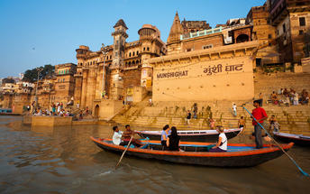
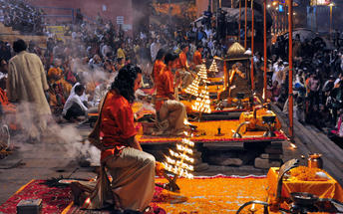
- 21:15 Maharajas’ Express proceeds to Delhi

Overnight: On Board Maharaja Express

Day 8: Disembark Train- Delhi
- 07:15 Breakfast onboard
- 13:00 Lunch onboard
- 15:00 Disembark and bid farewell to the Maharajas’ Express as your journey comes to an end!
You will be picked up at railway station and transferred to the hotel for check In.

Day 09: Delhi departure
Breakfast at the hotel.
At appropriate time, you will be met and transferred to Delhi airport to board your flight back home.
Flight TBA
Departs Delhi TBA Hrs.

