

Treasures of Deccan Plateau
Hyderabad - Hampi - Chikmagalur - Coorg - Kabini Forest Reserve - Mysore - Bangalore
16 Days / 15 Nights
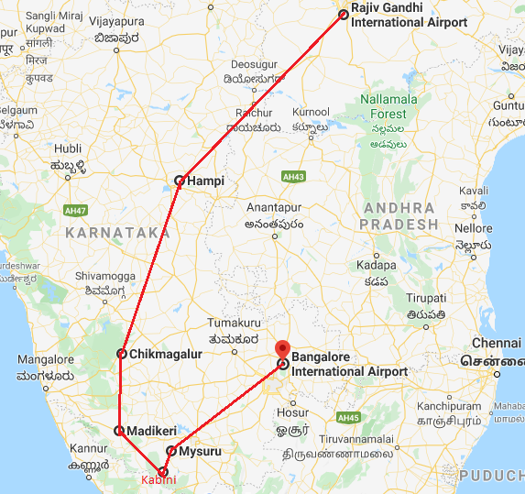

Day 1: Arrive Hyderabad
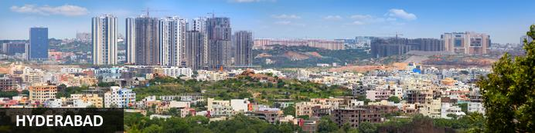
The capital of Telangana, Hyderabad is otherwise known as the ‘City of Pearls’ – a nickname earned from its days as a pearl and diamond trading centre. Today, it is still one of India’s retail hubs, famous for its traditional bazaars – some of which have been operating for centuries. Other points of interest include the imposing Golkonda Fort; the ancient Qutb Shahi Tomb complex – the stately final resting place of the seven kings from the Qutb Shahi dynasty; and the Charminar – a 16th century mosque and monument that is a trademark feature of the city skyline.
Flight TBA
Arrives Hyderabad TBA

On arrival at Hyderabad airport you will be received by a Travel Counsellors' representative and he will transfer you to your hotel for check in. Standard check in time - 1400 Hrs.
Rest of the day at leisure.

Day 2: In Hyderabad
Breakfast at hotel.
Post Breakfast, proceed for city tour of Hyderabad covering Charminar, Meccan Masjid, Salarjung Museum, Purani Haveli, Chowmahalla Palace.

Charminar
The epic signature of the city, Char Minar makes for a wonderful sight. Located in the heart of Hyderabad’s old city, surrounded by Mecca Masjid, built using bricks from Mecca and Laad Bazaar - a boisterous shopping street, this landmark is laced in history.
Built in 1591 by Muhammad Quli Qutub Shah, it was constructed to commemorate the founding of Hyderabad and also to ward of a deadly epidemic that was rampant then in the Golconda region. Graced by 4 minarets soaring almost 50ft in height, it has a mosque and 45 prayer spaces is amongst the famous places in Hyderabad.
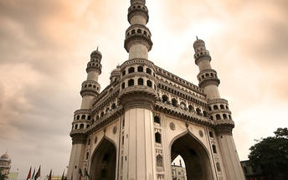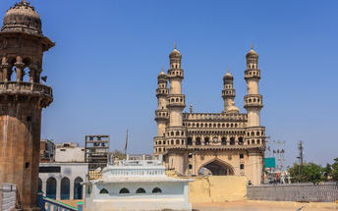

Mecca Masjid
Listed among heritage monuments in Hyderabad, Mecca Masjid or Makka Masjid as referred by locals holds a distinct position of not just being the oldest mosques in the city, but is also one of India’s biggest. This 400year old monument was constructed using the soil from Mecca. Hence the name.
Adding more to the erstwhile era around the Charminar and old Hyderabad city, the mosque’s imposing structure and splendid architecture are visible in its three-arched façade carved from single granite, minarets, and balconies. It is one of the most famous Hyderabad Tourist Places.
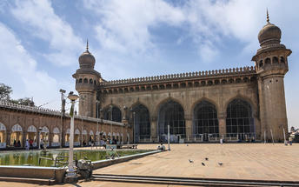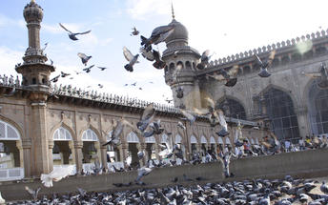

Salarjung Museum (Closed on Friday)
Located in the prime venue of old Hyderabad city, the Salar Jung Museum has illustrious neighbours like the Charminar, Mecca Masjid and State Central Library and you can see all of them in a small walk tour. One of the must see places to visit in Hyderabad with family, this is among India’s premier museums with 38 galleries spread over three buildings.
Nawab Mir Yousuf Ali Khan, who also lent his name to the museum, acquired a rich repository of artistic achievements of diverse European, Asian and Far Eastern countries of the world; a major chunk of the collection is on display. Check out artifacts mirroring the human evolution from 2nd century BC to early 20th century AD.

Chowmahalla Palace (Closed on Friday)
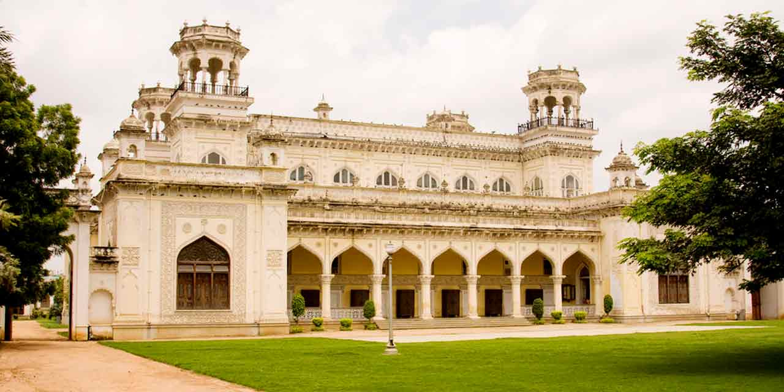
Once regarded as the center of Hyderabad, the magnificent Chowmahalla Palace was the seat of the Asaf Jahi dynasty where the Nizams entertained their official guests and royal visitors. Built over 200 years ago, Chowmahalla Palace is renowned for its unique style and elegance. A synthesis of many architectural styles and influences, the Palace Complex has been meticulously restored.

Purani Haveli (Closed on Friday)
Purani Haveli Hyderabad: is located at the South east of Afzal Gunj Bridge near Dewan Devdi. It is a U shaped complex with a single storied central building in European style which was originally established as the residential quarters of Mir Momen, the Peshwa of Mohammed Quli Qutub Shah around 16th century. Purani Haveli one of the popular tourist spots in Hyderabad was later acquired by Asaf Jah II, the second Nizam of Hyderabad in 18th century who renovated the palace and designated the same to his son Sikandar Jah, the third Nizam of Hyderabad. Later Shikandar Jah moved to the Khilaurat complex. From then on, the place has been popularly known as Purani Haveli, which literally means ‘Old Palace’. In 19th century, the sixth Nizam of Hyderabad Nawab Mir Mahboob Ali Khan Siddiqi again made this place as his official residence. It was then the glory and grandeur of past was returned to Purani Haveli.
Purani Haveli is known for its captivating combination of 18th century European facades and traditional Indian courtyards. It presents a picture of how the city of Hyderabad was in 18th century.

Day 3: In Hyderabad
Breakfast at hotel.
Post Breakfast, Excursion to Golgonda Fort and Qutub Sahi Tomb.

Golkonda Fort
A medieval fort now overlooking the city, Golconda is one of the historical places to visit in Hyderabad. Originally built in mud on a 400ft hill, the fort ruins of today have seen the reign of several dynasties. Situated 11km away from the bustling urbanism of Hyderabad, it derives its name from a Telugu word meaning Shepherd’s Hill. Reminiscence of a well-planned Golconda city within the fortress limits is evident even now. The remains of multiple fortification layers, armories, magazines, mosques, granaries, reservoirs, audience chambers and royal dwellings complement the striking appearance of the fort. Famous for its acoustics, a unique signalling device that was incorporated in its construction, the structure is known for its palaces, ingenious water supply system and the famous Fateh Rahben, one of the cannons used in the last siege of Golconda by Aurangzeb. The Sound & Light show brings alive the grandeur of one of India’s famous forts.
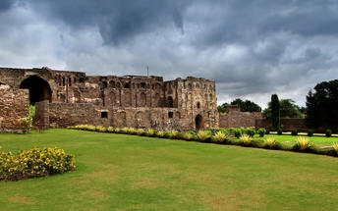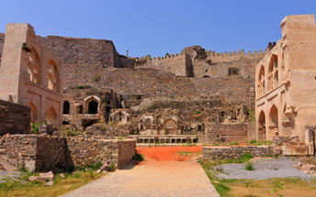

Qutub Sahi Tomb (Closed on Friday)
One of the historical places to visit in Hyderabad is the set of absolutely beautiful Qutub Shahi Tombs ensconced against the lovely backdrop of the picturesque Ibrahim Bagh. These represent the final resting ground of rulers of the founding dynasty of Hyderabad. The most authentic and majestic display of Persian, Hindu, and Pathan architectural designs dedicated to the seven kings who ruled Golconda for nearly 170years, the rulers themselves built these tombs. Take a Cultural Walk through Hyderabad to witness more such amazing architectures here in this beautiful city.
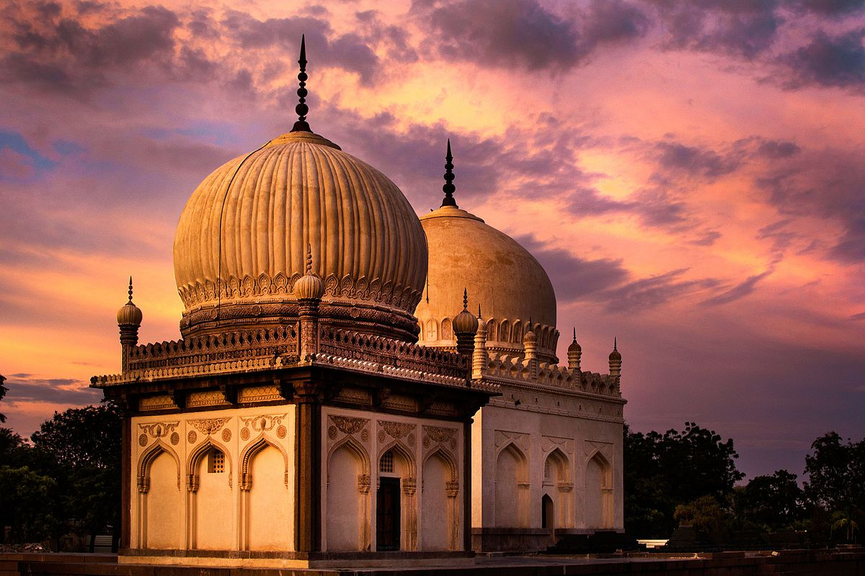

Day 4: Hyderabad – Vidyanagar - Hampi
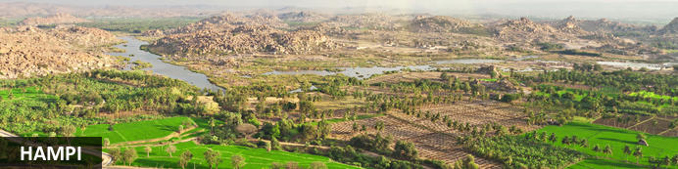
An enchanting ancient city and hippy backpacker destination, Hampi offers the perfect heady mix of Indian charms that make it hard for visitors to leave. Here history and modernity meet: impressive ancient remnants of Vijayanagara, the former capital of the Vijayanagara Empire, are dotted around the congested buildings of Hampi town. Cross the river and you’ll find laid back restaurants and rooms bordered by banana plantations and paddy fields, with a view over the river and ruins. Sightseeing can take up most of your time but don’t neglect to visit the Monkey Temple, a 572-stair climb, to catch the sunset.
In time, a Travel Counsellors Representative will meet at hotel & transfer to Hyderabad airport to board flight to Vidyanagar.

Flight 2T-623
Depart Hyderabad 0830 Hrs
Arrives Vidyanagar 0940 Hrs

On arrival at Vidyanagar, you will be driven to Hampi [Approx 1 hour.] Upon arrival in Hampi, check in at the hotel.
Rest of the day at leisure.

Day 5: In Hampi
After breakfast, proceed for a full day exploration of the Hampi Ruins.

Hampi
Hampi, The World Heritage Center, is the most beautiful and evocative of all the ruins of Karnataka. Capital of Vijayanagar kingdom is full of delightful surprises, viz., Kings Balance where kings were weighed against grain, gold or money which was then distributed to the poor, other attractions are Queen's Bath with its arched corridors, projecting balconies, Lotus Mahal Vittala Temple, Virupaksha Temple, Ugra Narasimha are not to be missed.

The best way to experience this World Heritage Site is to take a leisurely stroll through the eloquent ruins. Most of the important structure and ruins are located in tow areas, which are generally referred to as the Royal Centre and the Sacred Centre. The Royal Centre contains structures that seem to have been palaces, baths, pavilions, royal stables, and temples for ceremonial use. The sacred center is situated on the banks of the holy Tungabhadra River. Visit Vittthala temple and Virupaksha temple.

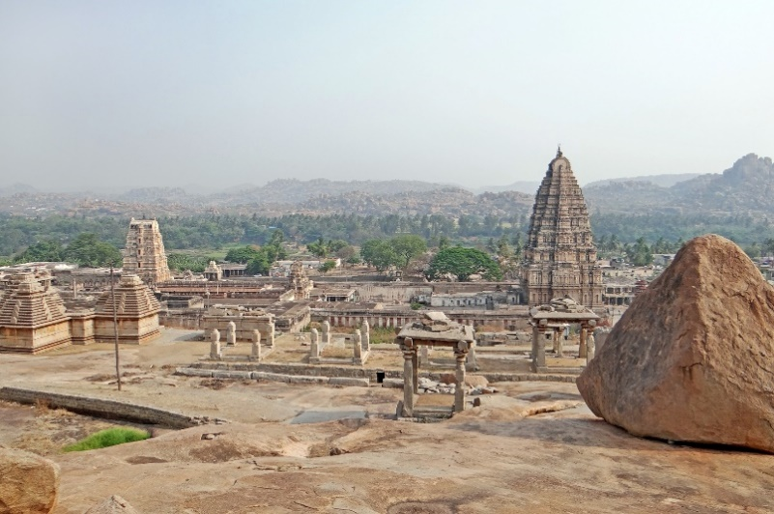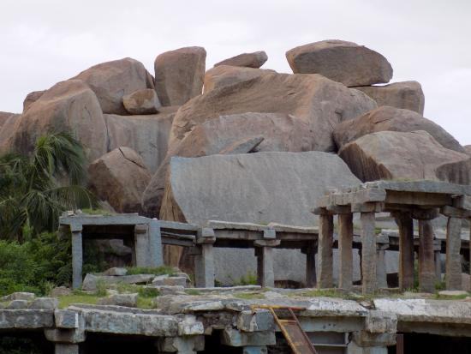

Day 6: In Hampi
Full Day at leisure to enjoy the activities offered by the Resort.

Day 7: Hampi - Chikmagalur
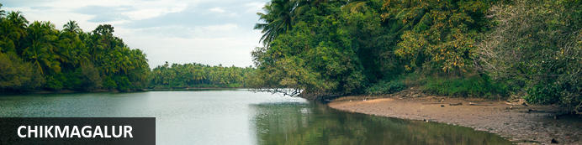
Situated in the state of Karnataka in southwest India, the hill station of Chikmagalur is remarkable for its stunning natural scenery, extraordinary temples, and delicious coffee. Boasting bright green hills and mountains jutting into the sky at extreme angles, Chikmagalur’s terrain is one which inspires near disbelief. A wealth of waterfalls, accessed by picturesque trails through dense forests on the slopes and coffee plantations in the valleys, provide wonderful spots for refreshing dips. Several ancient and exquisitely decorated temples adorn the landscape. The area is known for its abundance of coffee plantations and delicious varietals. Don’t miss the opportunity to visit the Bhadra Wildlife Sanctuary, home to elephants, tigers and leopards; the three holy caves in the Baba Budangiri Mountain Range; and the pretty Mahatama Gandhi Park.
After breakfast you will be transferred to Chikmagalur. [Approx. 6-7 hrs], on arrival check-in at hotel.

Day 8: Chikmgalur - Coorg
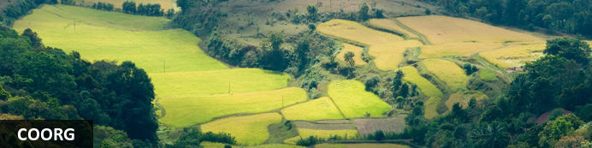
Resting in the spectacularly scenic Western Ghats of south-western Karnataka, Coorg is a historically significant hillstation and a well-loved tourist destination. Coorg is one of mother nature’s darlings with its remarkably scenic landscape comprised of undulating hills, waterfalls, valleys, streams, forests, and endless spice farms. This enchanting natural environment provides plenty of opportunities for outdoor activities including: some interesting treks up to Pushpagiri, Tadiandamol and Brahmagiri Peaks; angling in the Kaveri River; and golfing at one of the area's world-class golf courses.
Morning at leisure and in the afternoon you will be transferred to Coorg [Approx. 5 hrs]. En-route visit ruin of Belur and Halebeedu. On arrival check in your hotel.

Belur
Set on the banks of Yagachi River in the Hassan District in the state of Karnataka, Belooru, or more commonly known as Belur is set amidst lush surrounds. It boasts a rich cultural heritage, historical significance and a variety of sacred temples. Belur is a popular tourist destination in the state of Karnataka. It features the Chennakeshava Temple Complex, is a 12th-century Hindu temple displaying some of the best of Hoysala architecture in the country. Other highlights include: Panduranga Temple, Shankaralingeshwara Temple, and Hoysaleshwara Temple and the spectacular Jain temples in Halebidu.
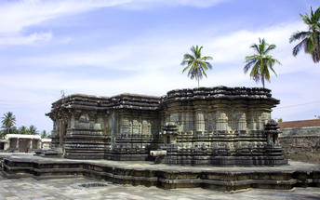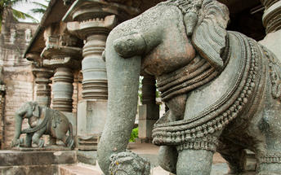

Halebidu
Halebid is known for the presence of two architectural splendors. Hoysaleshawara and Kedareshwara temples are internationally famous and draws in large number of Hindu pilgrims from all over. Two Jain basadi are also the major attractions for the tourists visiting Halebid in Karnataka. You can find two huge pools in front of the temples. It is from these lakes, that the temples have been named. The Hoysaleshwara temple has two nandi bull figures built of monolithic rock at the side of it.
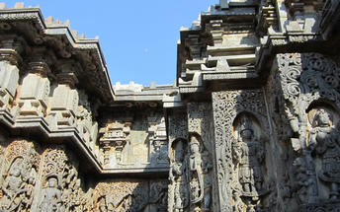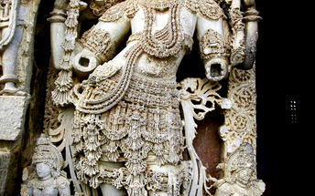

Day 9: In Coorg
Enjoy activities offered by the hotel like bird watching, nature & plantation walk, etc.

Day 10: Coorg - Kabini
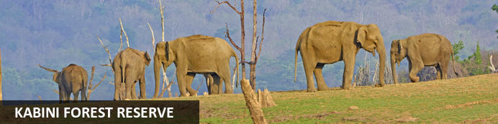
Resting on the banks of the mighty River Kabini, the Kabini Forest Reserve (or the Kabini Wildlife Sanctuary) is a vast expanse of unspoiled wilderness comprised of forestland, water-bodies and steep fertile valleys. This extraordinary reserve forms the south-eastern section of the Nagarhole National Park and is home to the world’s largest population of Asiatic elephants (estimated at around 6,000). In addition to the impressive number of elephant, visitors are likely to spot a number of endangered and rare animal species including, among others: leopard, tiger, panther, sambhar, spotted deer, python, sloth bear, cheetal, crocodile, and over 250 species of bird.
After breakfast you will be driven to Coorg (approx 03 hours drive). En-route stop at Bylekuppe, the second largest Tibetan settlement outside Tibet, complete with a Tibetan monastery with 7,000 monks, a Golden temple, a Tibetan village and a flea market.

Bylekuppe [subject to permission]
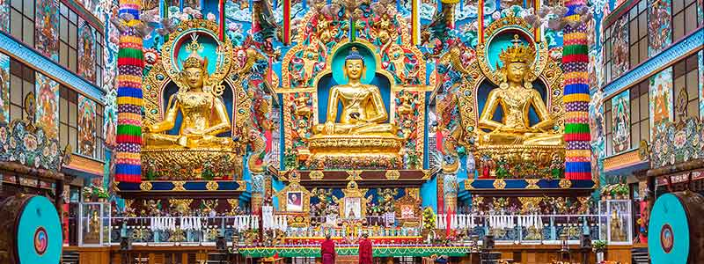
Bylakuppe is a small yet beautiful town, which is a Tibetan Settlement. The monasteries in the town depict an entirely different art form and design. When you enter this place you will feel as if you have travelled to a different country. This place was established for Tibetan refugees who fled from their country to India. It is said that Dalai Lama requested our then prime minister Jawaharlal Nehru to accommodate the refugees and Nehru asked the State Government of Karnataka to dedicate a town called Bylakuppe to The refugees. Since then, Tibetan diasporas have flourished and nurtured here.

Day 11: Kabini
Morning and afternoon enjoy Boat Safari to Nagarhole National Park.
Boat Safari : You will be taken upstream from the resort on the Kabini River to where the river itself separates the Nagarhole National Park from the Bandipur National Park.Today, on the banks of the Kabini, one can witness the largest congregation of Asiatic elephants, peacefully feeding and getting on with their lives. In addition to diverse wildlife sighted on the extensive river banks, the boat safari offers an opportunity to observe the Marsh Crocodile, Smooth-coated Otter and myriad water birds.
Vehicle Safari: The Nagarhole ecosystem supports the highest density of herbivores anywhere in Asia with around 108 animals per sq km. In addition to large herbivores such as the Chital, Sambar, Gaur, Asian Elephant and more, Nagarhole also boasts a large number of predators including the Tiger, Leopard and Wild dog. A highlight of the Park is the largest congregation of Asian Elephants in the world, which occur during the summer months. The visitor can also look forward to bird watching, what with over 300 species of birds recorded in the region.

Day 12: Kabini - Mysore
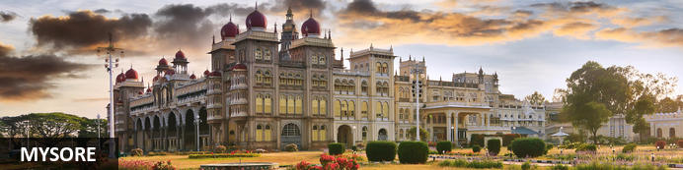
Serving as the capital of the Kingdom of Mysore from 1399 until 1947, the city of Mysore is a rich cultural and historical centre renowned for its beautiful Hindu palaces. Arguably the most captivating of these is the opulent Mysore Palace or Amba Vilas, particularly during the annual Dasara Festival, when every day after sunset it turns incandescent with the light of nearly 100 000 bulbs. In the modern context, Mysore is considered one of India’s cleanest and most efficiently planned cities, and has earned a reputation for its high quality sandalwood and silk.
After breakfast you will be driven to Mysore (approx. 100 kms/ 03 hours drive). Upon arrival you will check in at the hotel.

Day 13: In Mysore
Morning enjoy half day tour of Mysore with your guide.

Mysore Palace
Welcome to the Royal Splendour of Mysuru, the home of the Wodyers who ruled Mysuru for more than 500 years. Known as the City of Palaces, Mysuru retains a quaint charm, that never fails to enchant. The royal lineage can be traced back to 1399, when Yaduraya, a royal prince of the Yadava dynasty, was on a pilgrimage visit to Chamundi Temple with his brother Vijaya,. They took shelter in the Kodi Bhairava temple on the banks of Doddakere, the ‘Big Lake’. There they came to learn that the local royal family was in great danger. Their ruler had just died, and Maranayaka, a neighbouring chief, was threatening the queen. He wanted her daughter’s hand in marriage. The queen and the princess were in very vulnerable position. With the help of Jangama (Wadiyar) killed Maranayaka and married the daughter of Chamaraja and succeeded to the Mysuru principality. And so the Wodyer dynasty was established – a succession of 25 kings who ruled until 1947, when Mysuru became part of the Indian Union. The Wadiyars were great patrons of the arts, and the finest craftsmen in the state were employed to work on the Palaces. Wadiyar period was a new era of prose literature as an independent literary medium and it was in other words a prose writing in the form of the history of the Mysuru rulers. Chamaraja Wadiyar encouraged Kannada scholars like Ramachandra, author of Hayasaara Samuchchaya.
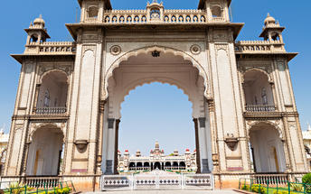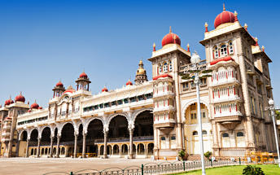

Chamundeshwari Temple
The temple was named after Chamundeshwari or Durga, the fierce form of Shakti, a tutelary deity held in reverence for centuries by Mysore Maharajas.
Chamundi Hill is named after Goddess Chamundi who is believed to be the incarnation of Parvati, the consort of Lord Shiva. A large number of devotees from all over the country and even abroad visit the temple every year. Pilgrims strongly believe that the Goddess helps them to fulfill their needs. Standing as the crown jewel of Mysore, Chamundi Hills is the abode of all powerful Goddess, Chamundi or Chamundeswari. A motorable road, besides a flight of 1,000 steps, take the visitors to its top, where stands the beautiful tall Gopuram of the temple, one of the best examples of the Dravidian school of architecture. The hill rises to a height of 3,489 feet. Half-way to it, near the steps and the road, there is a beautiful 16-foot monolith statue of Nandi, carved in granite, black because of regular anointing with oil and other sacred waters. The beautiful carved statue was a gift by the Maharaja, Dodda Devaraja Wodeyar in 1659.
Brindavan Gardens
The Brindavan Gardens, extends over an area of 60 acres and it is laid out in three terraces, which ends in a horseshoe shape. The slopes are planted with colourful Bougainvillea’s and ornamental plants. The garden is enriched with innumerable fountains decorated with coloured lighting. The illuminated running waters and fountains with changing colours of lights is an event that the tourists can look forward to in the evenings. The garden has many open spaces, lawns, illuminated flower beds and ornamental plants. It also has well laid out roads and pathways.
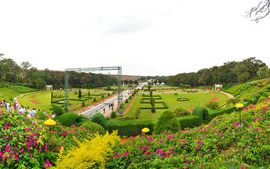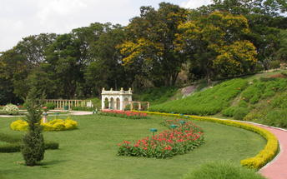

Day 14: Mysore - Bangalore
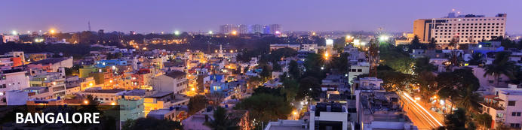
Known as the ‘garden city’, Bangalore offers a leafy backdrop from which to explore the bustling streets of India’s third largest city. Cosmopolitan restaurants line wide avenues where foodies can delight in a smorgasbord of south Indian flavours. Tea lovers can indulge in fragrant cups of Chai and a spell of people watching from any of the tea stalls dotted around the city. A booming IT industry coupled with a city that seeks to preserve its green and colonial heritage has created a modern and sophisticated metropolis. Recently voted the most liveable city in India, Bangalore makes a great base for travelling southern India.
After breakfast, you will be driven to Mysore in your private chauffeur driven vehicle [Approx. 4 hrs drive] with a stop at Srirangapatnam.

Srirangapatna
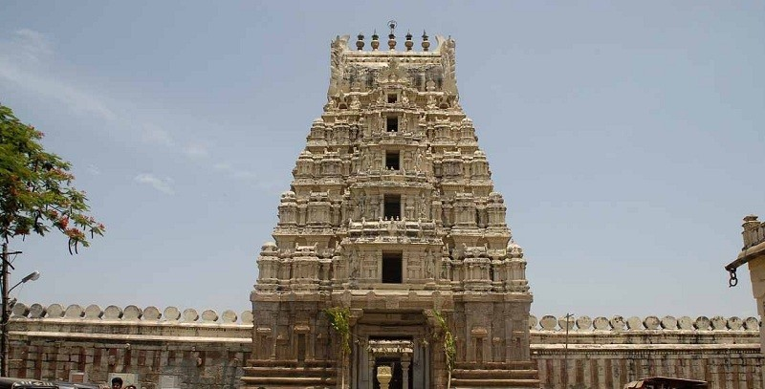
This river island town's name is sourced from the famous Ranganathaswamy Temple which dominates the town, and this temple resembles Hoysala and Vijayanagar architecture as it was re-strengthened and modified after its initial construction in the 9th century.

Day 15: Bangalore
Morning sightseeing tour of Bangalore. Drive past Vidhana Soudha, Lalbagh Botanical Garden, Tippu’s Summer Palace, Bull Temple, Iskcon Temple and Bangalore Palace.

Lalbagh Botanical Garden
Lalbagh, for its unique achievement in nurturing the concept of horticulture and aiding the development of horticulture, has earned a pride of place among the gardens of the world and it is regarded as one of the best gardens in the East for its layout, maintenance, scientific treasure and scenic beauty. It is the place of legends and beauty, a place of rarity and wonder, a place of paradise and landmarks. It is an important genetic resource centre for introduction, acclimatization and maintenance of plants; it envisages documentation of the variations available in plants of ornamental and economic value. It is an important centre of dissemination of scientific, technical and popular information on plants including offering of regular courses
The garden with well-laid out roads, paths, open spaces, shade and a good collection of many types of plant species attracts a large number of visitors. Lalbagh is well protected with stone walls as enclosures and it has four approach gates.

Tipu Sultan's Summer Palace
The intricately carved arches of the Tipu Sultan Fort have been built as per the Islamic style. Another major attraction of the fort is the well-preserved Ganapati temple situated inside it. Within the fort lies Tipu Sultan palace, which dates back to year 1790. Built entirely of teakwood, the palace was constructed as the summer residence of Tipu Sultan. The two-storied palace stands adorned with pillars, arches and balconies.
On either side of the Palace are beautiful gardens, which lead to its main entrance. There are beautiful floral motifs embellishing the walls as well as the ceilings of the Tipu Sultan Palace in Bangalore. Tipu Sultan used to conduct the affairs of the state from the eastern and western balconies of the upper floor. After the death of Tipu sultan, the palace was used by the British as their secretariat, till the year 1867.

Bull Temple
Known as the Nandi Temple, it is a religious shrine famous for its colossal image of a bull. Built in 1537 by Kempe Gowda, Bull Temple is primarily used for the worship of the sacred bull or Basava in Hinduism, Lord Shiva's vahana.

ISKCON Temple
ISKCON Sri Radha Krishna temple was inaugurated in the year 1997. It is not just a temple, but a cultural complex housing the temples dedicated to the Deities of Sri Sri Radha Krishnachandra, Sri Sri Krishna Balarama, Sri Sri Nitai Gauranga, Sri Srinivasa Govinda and Sri Prahlada Narasimha. ISKCON Bangalore has also initiated the construction of Krishna Lila Theme Park at this location with the aim of presenting the cultural heritage of India in an interesting manner with the aid of modern technology. This is an unprecedented and historical project being attempted for the first time in the country.
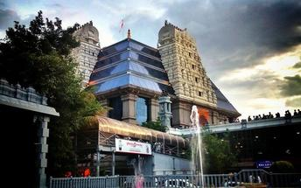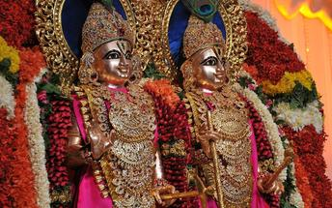

Bangalore Palace
The jewel at the centre of 454 acres of land, Bangalore Palace is a vision straight out of a fairy tale. Built in 1887, this Tudor-style building has an elaborate facade of turrets, towers and arches, and an opulent interior filled with decorative frescoes, woodcarvings and paintings. Since 2005, certain areas of the palace have been open to the public as a museum, the main attraction of which is a photographic gallery containing close to 1000 historical images of viceroys, maharajahs, and countless other captured moments of India’s past.
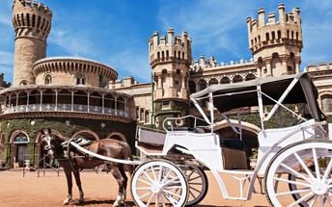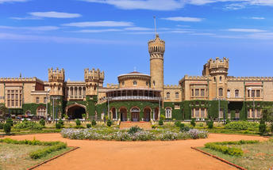

Day 16: Depart Bangalore
At an appropriate time, you will be assisted and transferred to the Bangalore airport to board your flight back home.
Flight TBA
Departs Bangalore TBA

