

Kerala Homestay & Plantation Retreat
Kumbalanghi (Kochi Suburb) - Murinjapuzha (near Thekkady) - Alleppey - Eramalloor (near Alleppey)
8 Days / 7 Nights

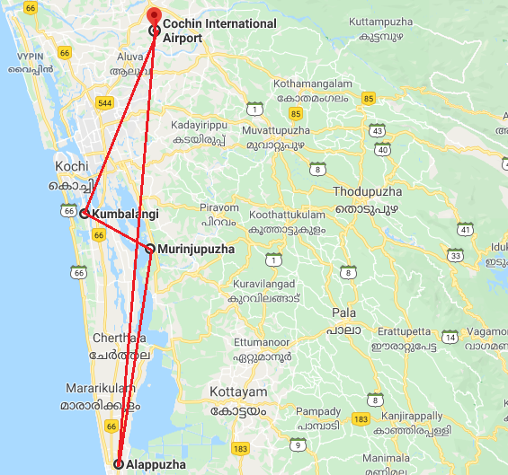

Day 1: Arrive Kochi
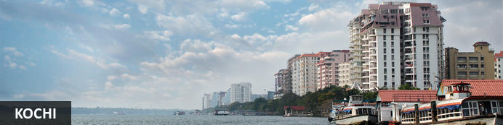
This attractive city has served as a popular port for over 600 years and is known for its eclectic architecture and its array of religious monuments, museums, galleries, cafes and antique shops. The city stretches across a number of peninsulas and islands, which can be reached by a network of water taxis and bridges. The majority of Kochi’s visitor highlights can be found on the peninsula of Fort Kochi. These highlights include the St Francis Church, the oldest European-built church in India; and Mattancherry Palace, which dates back to 1557 and contains some exceptional Kerala murals and temple art. Other must-see attractions include the Kerala Folklore Museum, displaying more than 4,000 cultural and ethnic artefacts; the 16th-century Jewish Synagogue; and the local market, where the air is filled with the aroma of exotic spices.

Flight TBA

Arrives Kochi TBA

On arrival at Kochi airport you will be received by a Travel Counsellors' representative and he will transfer you to Kumbalanghi. – a small village located near to Fort Kochi. Your accommodation here is in a home stay. Standard check in time - 1400 Hrs.

The village is surrounded by a plethora of tranquil backwaters, and the homestay offers you unparalleled services. These includes state-of-art living rooms and other amenities, in addition to the village activities that you can participate which happens in and around the village.

Day 2: In Kochi
Morning enjoy half day sightseeing tour of Cochin. The tour allows you to explore the charming Fort Cochin, Jewish Synagogue, Dutch Palace and St Francis church.

Afternoon enjoy the activities offered by the Homestay like Coir Making, Crab Farming, Clam meat processing, etc.

In the evening Enjoy Kathakali Dance Drama in a local theatre.

Jewish Synagogue (Closed on Friday afternoon and Saturdays)
This synagogue was built in 1568 by the Malabar Yehudans or Cochin Jewish community. It was built close to the Mattancherry Palace Temple on the land gifted by King Rama Varma, a former ruler of Kochi. The Mattancherry Palace Temple and the Mattancherry synagogue share a common wall. This synagogue is the oldest one in the Commonwealth of Nations.
As one approaches the synagogue on Jew Street, its white facade begins to appear very prominently. A clock tower can also be seen, towering over and close to the facade. This was built in 1760 by Ezekiel Rahabi an affluent Jewish businessman. Of the four faces of the clock, the one facing the maharaja's palace showed the time in Malayalam. And among the other three, the face with etchings in Roman numerals was meant for the traders. Of the remaining two faces of the clock, one had writings in Hebrew while the other remains blank.
Stepping inside the Synagogue, one's eyes would easily go to the glass chandeliers and blue willow-patterned Chinese floor tiles. The chandeliers are of Belgian origin. Also of interest are the Scrolls of the Law housed here and the several gold crowns received as gifts and the brass-railed pulpit. And for some exclusive pieces from history, the synagogue also houses the copper plates of privileges given to Joseph Rabban, the earliest known Cochin Jew, dating from the 10th century, written in Tamil, by the ruler of the Malabar Coast.

Dutch Palace (Closed on Friday for full day)
The Dutch Palace is a beautiful palace that was originally built by the Portuguese. It was only during the 17th century that the Dutch took it over, modified it and then presented it to the Raja of Kochi. The main attractions here are the outstanding collection of mural paintings found inside. These murals beautifully depict scenes from the Hindu epics of Mahabharatha and Ramayana.

St Francis Church
It is one of the ancient European churches in the country and is a marvellous specimen of Portuguese architecture in the country. It is a mark of the colonial struggle of the Europeans to make their presence felt in India at that time. This church, built in 1503 by Portuguese traders, was where Vasco da Gama was buried when he died in 1524 AD. However, fourteen years later, his remains were shifted to Lisbon. Earlier, the church was named after Santo Antonio which was changed by Anglican Communion after the name of patron Saint Francis. It is now considered integral to the history and tourism of Kochi. In April 1923, this church became a protected monument under the Protected Monuments Act of 1904. In 1920, the Cenotaph was set up in the memory of the inhabitants of Kochi who died in the World War-I. Apart from all this, one interesting fact to observe is that, despite being very modest in its architecture, the model of this church has been followed by many churches India.

Chinese Fishing Nets
Chinese fishing nets are a type of stationary lift net in India. They are fishing nets that are fixed land installations for fishing. While commonly known as "Chinese fishing nets" in India, the more formal name for such nets is "shore operated lift nets". Try your luck with the locals to get the fresh catch of the day with the nets.

Kathakali
Kathakali is a highly stylized classical kerala dance performance noted for its attractive make-up of characters, their elaborate costumes, detailed gestures and well-defined body movements presented in tune with the anchor playback music and complementary percussion.
Kathakali is said to have evolved from other performing arts like Kootiyattam (a classical Sanskrit drama existing in Kerala), Krishnanattam and Kalarippayattu. Kathakali explicates ideas and stories from the Indian epics and Puranas.
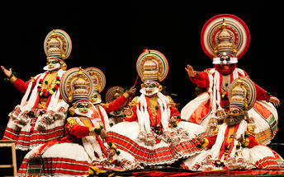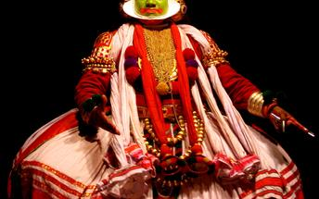

Day 3: Kochi - Thekkady
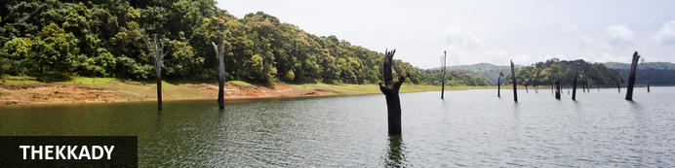
Thekkady comprises evergreen forests and savanna grasslands, and is known for its natural spices such as black pepper, cardamom, cinnamon, nutmeg, ginger and clove. Elephants, tigers, sambar and many other species inhabit the park. Top attractions include the exquisite ancient Mangla Devi Temple, the aromatic Abraham’s spice garden, and the massive waterfall at the sleepy, picturesque village of Chellarkovil. Take in panoramic views of the extraordinary landscape from the Chellarkovil viewpoint, and picnic on the rolling, lush green lawns at Pandikuzhi.
After breakfast, you will be driven to Murinjapuzha near Thekkady [Approx. 150 Kms / 4-5Hrs]

Upon arrival, check in at Paradisa Plantation Retreat.
Paradisa Plantation Retreat is separated from the hustle and bustle of the city. The resort is set on the mountain range of the Western Ghats in Kerala. All around the property are views of hills and valleys while the structures are surrounded by rich greenery. This region is known for its plantations; the resort features coffee and spice plantations. The resort and its surroundings are hosts to a wide range of activities for guests. The scenic countryside invites long walks. The tea plantations and factories are open for tours to learn about the cultivation process. Cooking demonstrations and lessons are available on request. And for entertainment, cultural performances takes place at the restaurant in the evenings.

Day 4: In Paradisa Plantation Retreat
Early morning proceed for a Nature walk at Periyar National park.

Nature Walk
Different nature trails traversing diverse habitats form the trekking routes, generally 4 to 5 km. in length. This is an interpretive program offering excellent opportunity to watch birds, butterflies and other wildlife. The trails often pass through evergreen and moist deciduous forests interspersed with marshy grasslands. The program is offered between 7.00 am and 10.30 am and between 2.00 pm. and 3.00 pm. and lasts for about 3 hours. A maximum of 5 persons can go for trekking at a time along each nature trail, accompanied by a trained tribal guide. The Nature walk is the right program to feel nature, hear her whispers and smell her flowers.
Afternoon enjoy either of the following activities offered by the resort.
- A trek through the plantation is an education.
- See the cultivation and harvesting of coffee, cardamom, cloves and pepper.
- The tea plantations and factory are well worth a visit. The scenic countryside invites you to take long walks. The heady combination of raw nature and the clean air is a potent restorative.

Day 5: Thekkady - Alleppey
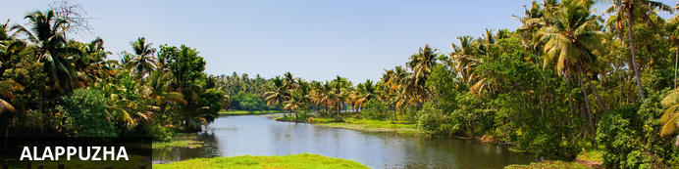
Dubbed as the ‘Venice of the East’, it is renowned for its houseboat cruises which float along the tranquil backwater canals of Kerala. It is said to be one of the most popular tourist centres in the state. While cruising the palm-shaded canals is the main attraction, visitors can also enjoy visiting Alappuzha’s beautiful beaches, exploring the little riverside villages dotting the lush countryside and discovering an array of resplendent temples. Don’t miss the annual Nehru Trophy Boat Race held at Punnamada Lake.
After early breakfast, you will be driven to Alleppey [Approx. 100 Km – 3 Hrs.]. On arrival board the Houseboat at 12:30 for a cruise over the backwaters of Kerala.
Note:
Houseboat will be anchored in the evening till morning as per regulations.
Also note that air-conditioner in the room will operate only from 9 pm till 7 am.

The houseboats or Kettuvallam as they are traditionally called were at one time the mode of transportation for man and goods. Today, these are made to cater to the discerning guests who can lay back and enjoy the gentle cruise. Cruise the backwaters from the main Vembanad Lake through the small estuaries that link small villages to the mainland. Today, these are refurbished and all modern conveniences have been added for tourists who visit this beautiful water locked region of the country. The houseboat cruise takes you through the intricate maze of backwaters, mesmerizing and surprising you at every turn with its serene beauty & simple charm. Enjoy the countryside of Kerala at its best. Soak your eyes & soul with array of coconut trees & endless paddy fields. You will also get chance to take a small stroll through the villages & interact with the locals.

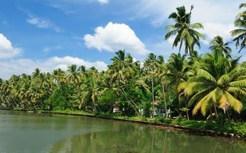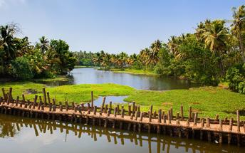

Day 6: Alleppey - Kayal Island Retreat
After breakfast, de-board from the houseboat and transfer to Kayal Island Retreat.
A blue boat will await you at the ferry (Kodumpuram Ferry near Eramalloor Junction). A soothing ride through the backwaters will set the mood for your stay and get you to the shores of our hidden retreat.
Upon arrival, check-in at the homestay.
Remainder of the day at leisure
Tucked away on the secluded shores of Kakkathuruthu, the Island of Crows, Kayal mirrors the undiscovered, unspoiled natural beauty of Kerala. The only way to get there is by traditional rowboats. And when you're there, all you've got to do is give in to the moment. Each cottage is inspired by the local architecture and curated with reclaimed and recycled material. The air-conditioned waterfront cottages have been furnished with old teak cupboards, a reading area and desk for quiet contemplation and an ensuite bath garden for some serious rejuvenation. The walls are adorned with narratives of local history in art. All in all, the cottages are aesthetically designed with plush comforts for the city slicker in you.

Day 7: In Kayal Island Retreat
Full day at leisure to enjoy in-house activities. Once, during your stay, you will be given the following experiences
Village Walk – Complimentary
A guided stroll through our island is always full of surprises. You meet the most interesting people – from toddy tappers, to fishermen, temple priests, farmers and local women. If you’d like to, you can join them in their everyday activities. Cast a net, partake in a temple festival, or have an evening snack at the local tea shop.

Canoe Ride – Complimentary
A favourite with all our travellers, the canoe rides take our guests into the blue. With the skies above and the rippling waters all around, these rides aren’t just the most serene experience. They also give you a peek into the lives of villagers along the shores. If you’d like some fresh catch for your next meal, you can watch the fishermen on the lake, learn a few tricks and cast the net yourself.

Tea Time Ritual – on chargeable basis
When the clock strikes 4, the communist spirit of Kerala comes alive. Local tea shops are abuzz with heated discussions on topics of national interest. Piping hot snacks and endless cups of tea are passed around. We’ve captured this communal moment, and recreated the tea time ritual at Kayal. We serve local snacks along with tea and lots of camaraderie.

Cooking Lesson – on chargeable basis
Loved a dish you had at Kayal? We’ll teach you how to make it. Get a private, hands-on cooking lesson with our in-house, homemaker-turned-chef Naina. From whipping up a sadhya, the traditional Kerala meal served on a banana leaf, to recreating Kayal signatures like coconut pumpkin soup, tender coconut ice cream, and tapioca fish curry – we can share a few recipes with you.

Day 8: Kayal Island Retreat - Cochin Depart
Early morning at an appropriate time, a Travel Counsellors representative will pick you from Kayal Island retreat and transfer to Cochin airport to board your flight back home.

Flight TBA

Departs Kochi TBA

