

Kerala Offbeat plus Nilgiris
Kochi - Athirapally - Pollachi - Coonoor - Coimbatore
8 Days / 7 Nights

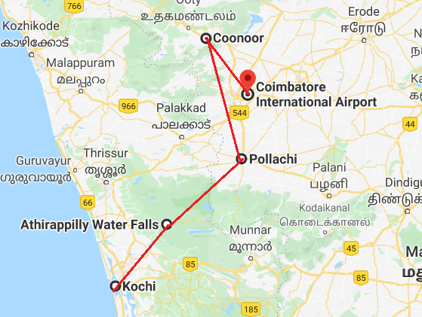

Day 1: Arrive Kochi
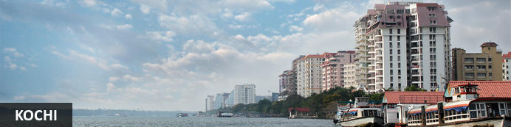
This attractive city has served as a popular port for over 600 years and is known for its eclectic architecture and its array of religious monuments, museums, galleries, cafes and antique shops. The city stretches across a number of peninsulas and islands, which can be reached by a network of water taxis and bridges. The majority of Kochi’s visitor highlights can be found on the peninsula of Fort Kochi. These highlights include the St Francis Church, the oldest European-built church in India; and Mattancherry Palace, which dates back to 1557 and contains some exceptional Kerala murals and temple art. Other must-see attractions include the Kerala Folklore Museum, displaying more than 4,000 cultural and ethnic artifacts; the 16th-century Jewish Synagogue; and the local market, where the air is filled with the aroma of exotic spices.

Flight TBA

Arrives Kochi TBA

On arrival at Kochi airport you will be received by a Travel Counsellors' representative and will transfer you to your hotel. Standard check in time - 1400 Hrs.

Day 2: In Kochi
Morning enjoy a sightseeing tour of Cochin. The tour allows you to explore the charming Fort Cochin, Jewish Synagogue, Dutch Palace and St Francis church.

In the evening Enjoy Kathakali Dance Drama in a local theatre.

Jewish Synagogue (Closed on Friday afternoon and Saturdays)
This synagogue was built in 1568 by the Malabar Yehudans or Cochin Jewish community. It was built close to the Mattancherry Palace Temple on the land gifted by King Rama Varma, a former ruler of Kochi. The Mattancherry Palace Temple and the Mattancherry synagogue share a common wall. This synagogue is the oldest one in the Commonwealth of Nations.
As one approaches the synagogue on Jew Street, its white facade begins to appear very prominently. A clock tower can also be seen, towering over and close to the facade. This was built in 1760 by Ezekiel Rahabi an affluent Jewish businessman. Of the four faces of the clock, the one facing the maharaja's palace showed the time in Malayalam. And among the other three, the face with etchings in Roman numerals was meant for the traders. Of the remaining two faces of the clock, one had writings in Hebrew while the other remains blank.
Stepping inside the Synagogue, one's eyes would easily go to the glass chandeliers and blue willow-patterned Chinese floor tiles. The chandeliers are of Belgian origin. Also of interest are the Scrolls of the Law housed here and the several gold crowns received as gifts and the brass-railed pulpit. And for some exclusive pieces from history, the synagogue also houses the copper plates of privileges given to Joseph Rabban, the earliest known Cochin Jew, dating from the 10th century, written in Tamil, by the ruler of the Malabar Coast.

Dutch Palace (Closed on Friday for full day)
The Dutch Palace is a beautiful palace that was originally built by the Portuguese. It was only during the 17th century that the Dutch took it over, modified it and then presented it to the Raja of Kochi. The main attractions here are the outstanding collection of mural paintings found inside. These murals beautifully depict scenes from the Hindu epics of Mahabharatha and Ramayana.

St Francis Church
It is one of the ancient European churches in the country and is a marvelous specimen of Portuguese architecture in the country. It is a mark of the colonial struggle of the Europeans to make their presence felt in India at that time. This church, built in 1503 by Portuguese traders, was where Vasco da Gama was buried when he died in 1524 AD. However, fourteen years later, his remains were shifted to Lisbon. Earlier, the church was named after Santo Antonio which was changed by Anglican Communion after the name of patron Saint Francis. It is now considered integral to the history and tourism of Kochi. In April 1923, this church became a protected monument under the Protected Monuments Act of 1904. In 1920, the Cenotaph was set up in the memory of the inhabitants of Kochi who died in the World War-I. Apart from all this, one interesting fact to observe is that, despite being very modest in its architecture, the model of this church has been followed by many churches India.

Chinese Fishing Nets
They are fishing nets that are fixed land installations for fishing. While commonly known as "Chinese fishing nets" in India, the more formal name for such nets is "shore operated lift nets". Try your luck to get the fresh catch with the locals.

Kathakali
Kathakali is a highly stylized classical kerala dance performance noted for its attractive make-up of characters, their elaborate costumes, detailed gestures and well-defined body movements presented in tune with the anchor playback music and complementary percussion.
Kathakali is said to have evolved from other performing arts like Kootiyattam (a classical Sanskrit drama existing in Kerala), Krishnanattam and Kalarippayattu. Kathakali explicates ideas and stories from the Indian epics and Puranas.
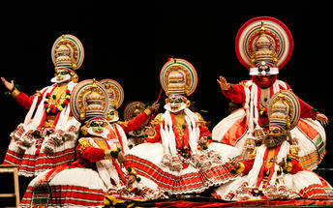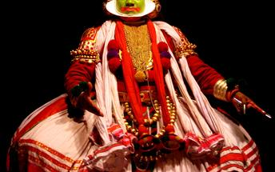

Day 3: Kochi - Athirapally
After breakfast, you will be driven to Ahirapally [Approx. 3 Hrs drive], on arrival check-in at hotel.

Afternoon visit Athirapally Falls.
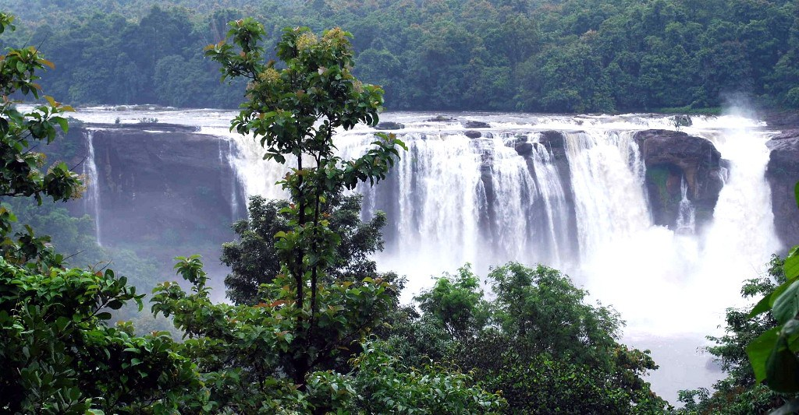
The 25-metre-high, 100-metre-wide waterfall which has been aptly dubbed “The Niagara of India”. The area is also renowned for its exceptional wildlife watching opportunities as it is inhabited by a range of exotic animals including tigers, leopard, sambar, elephant, bison, lion-tailed macaque and an extraordinary variety of bird species.

Day 4: Athirapally - Pollachi
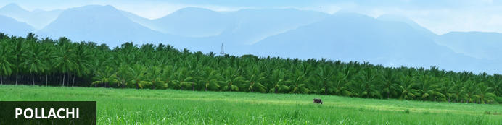
The town boasts the Western Ghats as its scenic backdrop, making it a popular choice among filmmakers with over 1500 films shot in the area. Aside from its spectacular surrounding landscapes, the main attractions are the nearby Anamalai Wildlife Sanctuary and Parambikulam Wildlife Sanctuary, both of which form a refuge for an impressive array of wildlife such as elephant, gaur, tiger, panther, sloth-bear, wild bear, porcupine, pangolin, civet cat, crocodiles and a number of different bird species. Other popular attractions in the area include a large colourful market and a variety of exquisite temples.

After breakfast, drive to Pollachi (approx. 4 hours drive), upon arrival check-in at the resort.
Rest of the day at leisure.

Day 5: In Pollachi
Full day at leisure to enjoy the activities offered by resort like Handloom Tour, Bird Watching, Palm Jaggery Tour, etc.
Optional Excursion to Temple of Consciousness:
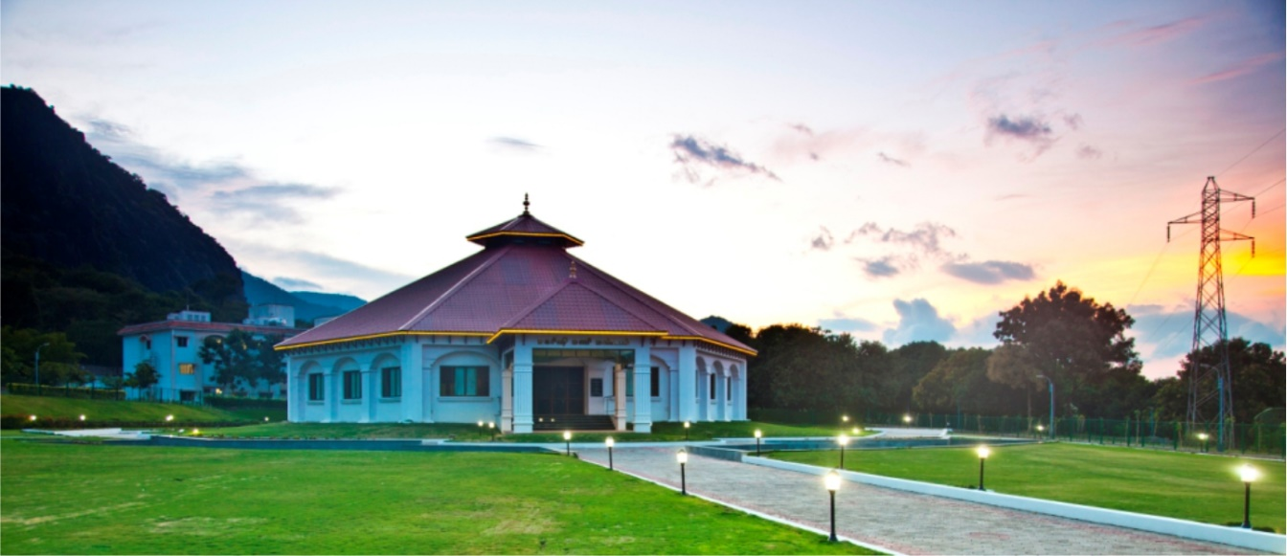
Arivu Thirukoil is also known as the ‘Temple of Consciousness’. The yoga practice at the Temple of Consciousness inspired from the great Yogic Vethathiri Maharishi, who founded over 300 yoga centres on the world. It lies on the fringes of the Annalami Tiger Reserve in complete harmony with nature. Simplified Kundalini Yoga (SKY) practice is the highlight of the centre, along with a museum, meditation hall, living quarters of the Yogic, tomb of the teacher, library and an in-house bookstore. You can spend ample time in the campus and take in the peace and tranquillity that envelops the establishment.

Day 6: Pollachi - Coonoor
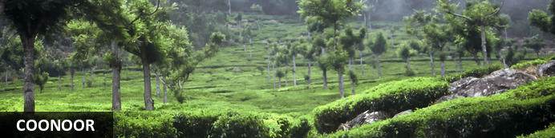
Described as a ‘tea-garden’ town, Coonoor is surrounded by tea plantations and enjoys a pleasantly cool climate all year round. The main attraction is Sim’s Park, a quaint, well maintained 12-hectare botanical garden that also attracts bird lovers to the area, and hosts the annual Fruit Show in summer. For hikers, there are plenty of trails leading from the town, including a 9km walk to Lamb’s Rock that gives spectacular views of the Coimbatore plains and tea plantations, or a 5km walk to the sublime Law’s Falls, a popular tourist attraction.
After breakfast, drive to Coonoor (approx. 5 hours drive), upon arrival check-in at the hotel.
Afternoon proceed for sightseeing of Coonoor visit Sim’s Park, St. George Church, Tea Factory.

Sim’s Park
This is an unusual park-cum-botanical garden that was developed around the natural contours of the land more than a hundred years ago by Mr. J.D. Sims and Major Murray in the year of 1874. Naturally occurring trees, shrubs and creepers are in the park as are many unusual species of plants that have been brought in from a variety of places around the world.

St. George Church
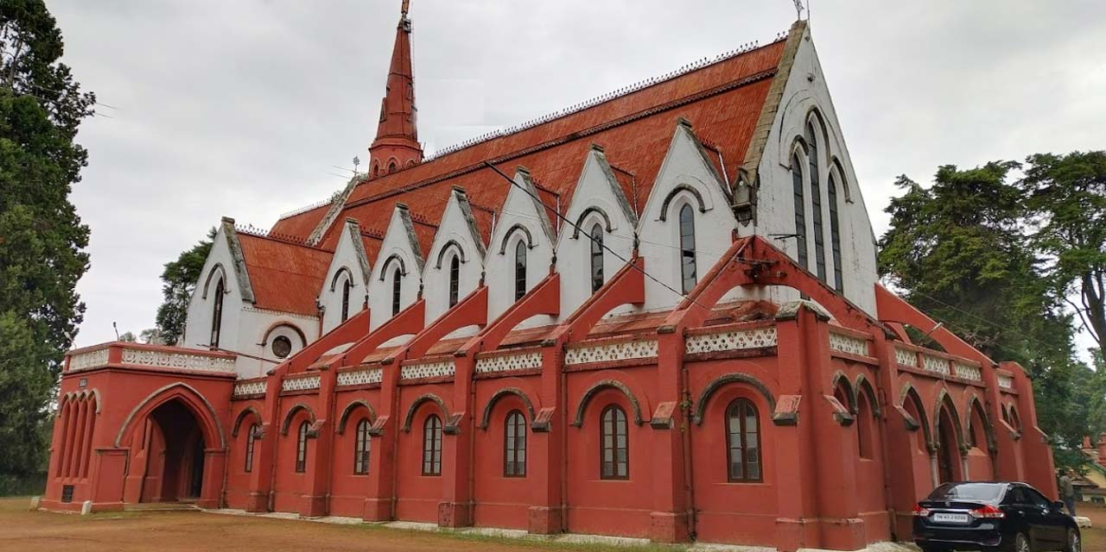
A beautiful remnant of the British era, St. Georg e’s Church was constructed way back in the year 1826 and was designed by Colonel J. T. Boileau. The prime attraction of this sacred site is the deep ochre colored stucco that has white coverings. The entry inside the church is from its atrium. The architecture of the church is not only marvelous but its surroundings are also extremely serene, offering complete peace of mind and are appealing to the eyes too. A brilliant example of a classic Cantonment Church, this church has amazing interiors. While the church has vaulted roof and has 6 Ionic columns, which are segregate the main hall into side aisles and central nave. The main altar is decked-up with attractive marble inlay work and gothic sculptures. The church is close to the main town and us easily accessible.

Tea Factory
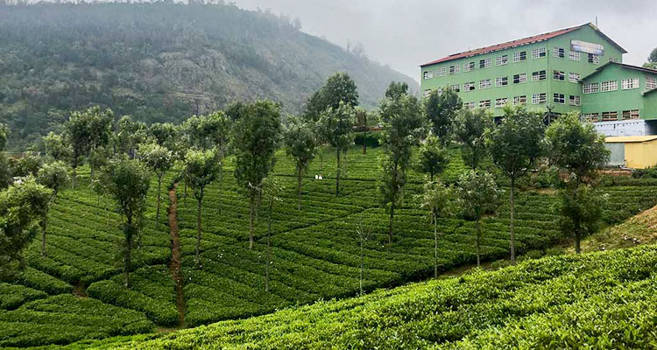
It is a place that's drenched with the smell of fresh tea that's being brewed. 2km northeast of upper Coonoor is this Nilgiris of the western ghat. Coonoor is situated 19 km away from its sister hilltop Ooty. This hilly Indian countryside was set up to utilise the tea plantations around Nilgiri Hills that produces an exquisite tea. With time, the estate evolved to stand as a site promoting education and tourism. The 50-year-old tea factory is a study tour for tea lovers as well as those who wish to know how tea is being processed.

Day 7: In Coonoor
After early breakfast, enjoy joy ride on Nilgiri Mountain Train from Coonoor to Ooty.

The Nilgirim Mountain Railway
The Nilgiri Mountain Railway toy train is the highlight of a visit to the popular hill station of Ooty. Established in the early 19th century by the British as the summer headquarters of the Chennai government, Ooty now draws tourists wanting to escape the stifling summer heat. The railway opened 1899 and was completed in 1908. It was declared a UNESCO World Heritage site in 2005. The quaint toy train pulls blue and cream wooden carriages with large windows.
Head off for a mesmerizing railway journey as you board on the Coonoor to Ooty by Toy Train.

The almost nostalgic toy train gives visitors a revitalizing travel experience moving through lush green tea estates, thick forests, tall eucalyptus trees and lofty mountains. Covering a distance of 19 kms the Ooty to Coonoor route offers the most spectacular scenery along its way. The journey is slow and gives you ample opportunity to discover nature’s bounties.

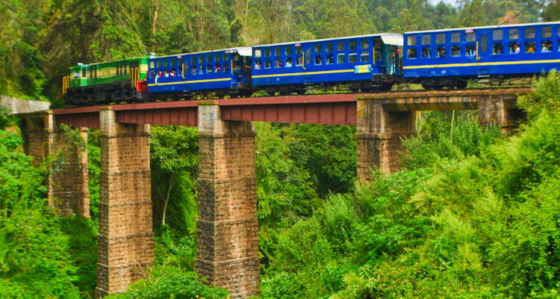
On arrival in Ooty, proceed for sightseeing of Ooty visit Botanical Garden, Rose Garden, St. Stephens Church.
Later return back to Coonoor.

Botanical Garden
Lying on the lower slopes of the Doddabetta peak, the Government Botanical Garden is a splendid garden sprawled over an area of 22 hectares. The garden is divided into several sections that are trimmed beautifully to present an endearing sight. Visitors are greeted with astounding colourful natural beauty from the moment they pass through the gates. For more than 160 years, foreign and local travellers have strolled the lush green lawns of the garden, admiring the stunning variety of flowers, ferns and orchids present here.

The Ooty Botanical Garden was laid down in the year 1848 and was designed so as to have a terraced terrain. The slopes of the hill lie at an ascent of 2500 metres above mean sea level, as a result of which the garden enjoys a temperate climate ideal for a number of plants and shrubs to grow. The Botanical garden in Ooty. It is home to many rare species of trees, chief among them being the cork tree, the only one of its kind in India. The paperbark tree, the monkey puzzle tree and an old fossilized tree estimated to be 20 million years old round out the other rare species. The monkey puzzle tree has been named so because even monkeys fail to climb it. In addition to these, a number of exotic and indigenous vegetation of plants, shrubs, ferns, trees, herbal and bonsai plants are found here as well.

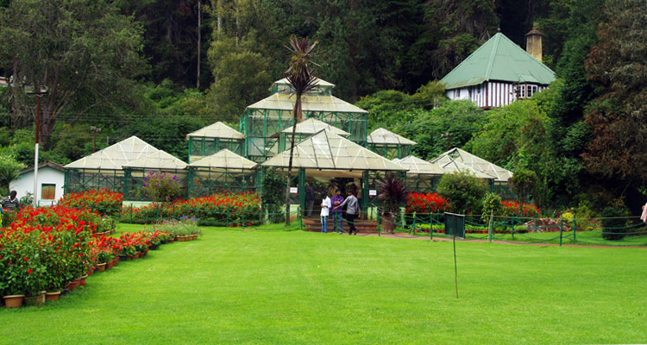

Rose Garden
The pride of Ooty lies in the Rose Garden, which belongs to an elite club of 35 rose gardens around the world which has won the Garden of Excellence Award for South Asia from the World Federation of Rose Societies. Containing more than twenty thousand variety of roses the Rose Garden is one of the most beautiful and well maintained gardens you find the country, or perhaps, the world. The climate of Ooty is ideal for the plants to have a long blooming season.

St Stephens Church
The St Stephens Church, Ooty is one of the architectural marvels that the British left for us. A very old church, which dates back to the 19th century, it was build to coincide with the birthday of King George IV. The main beam and all the required timber were taken from Tipu Sultan's palace after the British defeated him in the Mysore War. The timber was bought all the way down from Seringapatanam and carried through the Sigur Ghat. The marvel of British architecture is clearly visible in the church and it also has a painting of the Last Supper.

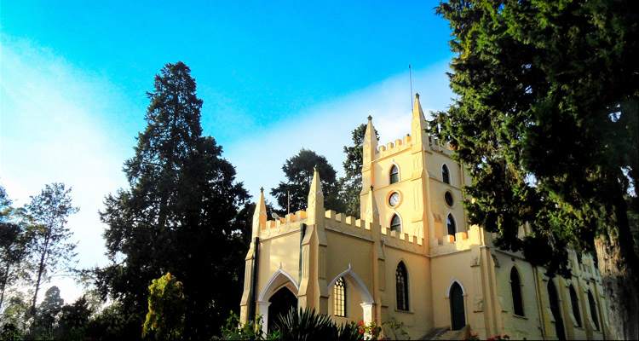

Day 8: Coonoor - Coimbatore Departure
After breakfast, drive to Coimbatore airport (approx. 3 hours drive) to board flight back to home via Mumbai/Delhi.

Flight TBA

Departs Coimbatore TBA

