Hidden Trails of Rajasthan
New Delhi - Mandawa - Jaipur - Agra - Ramathra - Shahpura - Narlai – Udaipur - Delhi
16 Days / 15 Nights
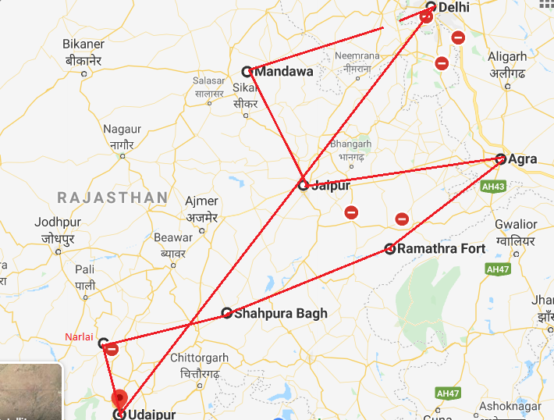

Day 1: Arrive Delhi
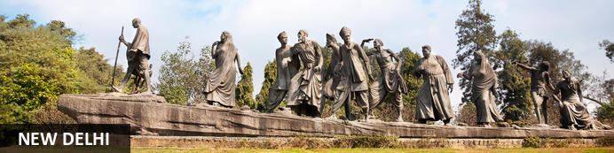
India’s largest city, Delhi, has been one of the country’s commercial and economic hubs for centuries and, as a result, is incredibly rich in culture and history. Made up of the ancient walled city of Old Delhi and the more modern sector, New Delhi, the city encompasses a staggering array of beautiful architecture, notable monuments and age-old temples, including three UNESCO World Heritage Sites – the Red Fort, Qutab Minar and Humayun's Tomb. Other key attractions include the 17th century Chandni Chowk marketplace – still one of the city’s most popular retail centres today, particularly for jewellery and traditional Indian saris; the iconic Bahà’i Lotus Temple – an award-winning architectural gem; and the Jama Masjid, India’s largest mosque.
Flight TBA
Arrives Delhi TBA

On arrival in Delhi: A Travel Counsellors representative will meet you at airport & transfer you to hotel for check in.
Standard check in time - 1400 Hrs.
Rest of the day is at leisure

Day 2: In Delhi
After breakfast, proceed for a full day sightseeing tour of Delhi, beginning with a heritage walk through Old Delhi followed by a visit through the UNESCO world heritage sites in New Delhi

Heritage Walk
Delhi is an ancient city with history going back to 3000 BC. It has been mentioned extensively in numerous Indian epics like Mahabharat. But the Delhi we see and know about from written records starts from 736 AD. The city has been built, destroyed and rebuilt numerous times. According to popular folklore, Delhi was site of seven different cities between 3000 BC and 17th century AD. But when we count the smaller settlements around the area, there are atleast fifteen. delhi heritage walk
This ancient history and influx of people from all over the world has given Delhi a culture and heritage matched by only a handful of places. Delhi is one of very few places where the ancient and modern co-exist side by side complementing each other perfectly. Our heritage walks of Delhi are a perfect way of exploring this amalgam of old traditions, modern development and the unique heritage which makes it so interesting. These heritage walks are a perfect way to explore some of the lesser visited places and gain a new insight about the history, people and sights of Delhi city.

Drive past the imposing India Gate, the Parliament building and the Rashtrapati Bhawan, the President’s residence.

Qutub Minar
Standing tall at 73-metres, the tower consists of 5 storeys with a flight of spiral stairs leading to its top. The walls are adorned with decorative motifs and Quranic inscriptions. At the foot of the tower lie other monuments of historical significance, such as the Quwwat-ul-Islam Mosque and the Iron Pillar of Delhi. The Amazing race Australia used this site as a pitstop in the second series. Visitors can take advantage of stunning photo opportunities.
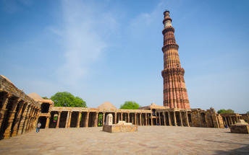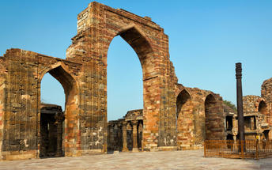

Humayun's Tomb
The mausoleum complex of Humayun, India’s second Mughal Emperor, was commissioned by his widow in 1565 and was the first garden tomb to be built in India, taking seven years to complete. Humayun had travelled widely in Persia and Central Asia during his lifetime, and many of the architectural principles he brought back from these journeys were incorporated into the building at his wife’s instructions. With its double domes, decorative inlaid marble and vast garden with pools connected by channels, this 16th Century building set the stage for the style that culminated in the Taj Mahal almost 100 years later.
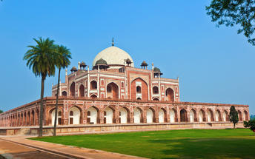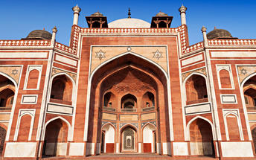

Day 3: Delhi - Mandawa
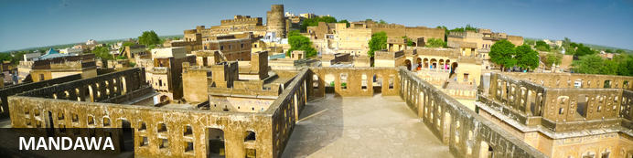
Located in the Shekhawati region of the Jhunjhunu district, the town of Mandawa is known as the "Open-air Art Gallery" of Rajasthan. Originally, a trading post for rich merchants, Mandawa has flourished into a popular tourist destination offering visitors a collection of historic mansions, palaces and forts, which feature elaborate frescoes and intricate architecture. This relatively small yet bustling town is a treasure trove for art collectors who can hunt through the quaint medieval bazaars for traditional handmade relics. The most visited attraction is undoubtedly the 18th-century Mandawa fort, recently converted into a heritage hotel, which displays exquisite murals, paintings and mosaic work.
After breakfast, you will be driven to Mandawa [approx.. 265 kms /06 hrs drive].
On arrival in Mandawa, check in to hotel.
Rest of the day will be at leisure.

Day 4: In Mandawa
After breakfast do a tour of the town covering the local market: a school and the beautiful Havelies. The fresco trail in Mandawa town will take you to Gulab Rai Ladia Haveli, Lakshminarayan Ladia Haveli, Mohanlal Saraf Haveli & the Chowkhani Haveli among others.

Day 5: Mandawa - Jaipur
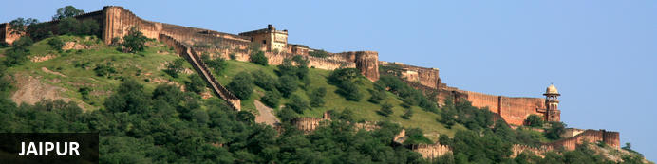
Fringed by the rugged Aravali Hills, Jaipur is the capital and largest city in India’s northern state of Rajasthan. This city is famed for being India’s first planned city featuring a multitude of pink terracotta buildings within the walled historic centre, earning it the nickname,’The Pink City’. Jaipur falls within the Golden Triangle, a popular tourist circuit, which includes Delhi, Jaipur and Agra, and serves as a gateway to the neighbouring desert cities of Jaisalmer and Jodhpur. This colourful city is a combination of tradition and modernity and offers visitors vibrant bazaars, lavish palaces and ancient temples. The salmon-hued old city is home to the opulent City Palace, encompassing an impressive assortment of palatial structures, sprawling gardens, courtyards and buildings. Don’t miss the fairy-tale splendour of the Amber Fort, set against the backdrop of the arid landscape.
After breakfast, you will be driven to Jaipur [approx.. 175 kms/ 04 hrs drive].
On arrival in Jaipur, check in to hotel.

Day 6: In Jaipur
After breakfast, proceed for a full day tour of Jaipur, visiting Amer Fort, City Palace and Astronomical Observatory Take a photo stop at Hawa Mahal – Palace of Winds.

Amer Fort
Amer Fort, officially known as the ‘Amer Palace’, is one of the most famous forts of Rajasthan attracting around 4000 to 5000 visitors a day during peak tourist season. The palace was named after the small town of Amer, where it is situated - only eleven kilometres from Jaipur. Perfectly picturesque, this 16th century hillside residence is well preserved, boasting grand pavilions and mirrored halls that open onto flourishing gardens and courtyards. Although the palace’s main construction started in 1592 by Maharaja Man Singh, it was added to over the years by successive rulers and continued to be occupied by them until Jaipur was built.
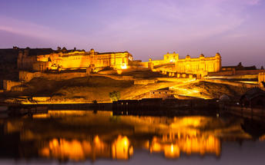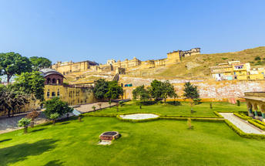

Photo stop at Hawa Mahal (Palace of Winds)
One of Jaipur’s most recognised buildings, the Hawa Mahal (Palace of Winds) is known for its iconic façade. Small windows, decorated with intricate latticework create a honeycomb-like appearance. The original intention of the lattice was to allow the royal ladies to observe everyday life in the street below without being seen. The cooling effect, provided by the breeze passing through the small windows, gave the palace its name. Built in 1799 by Maharaja Sawai Pratap Singh, the unique construction was originally designed to look like the crown of Krishna. A panoramic view of Jaipur can be had from the top of the building.

Jaipur City Palace
City Palace forms one of the most famous tourist attractions and a major landmark in Jaipur. The beautiful palace was built by Maharaja Sawai Jai Singh during his reign. Among the various forts and palaces of Jaipur, City Palace stands apart, with its outstanding art and architecture.
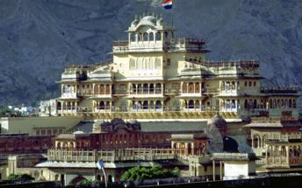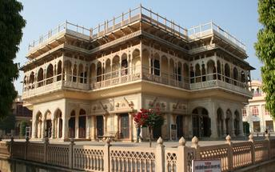

Jantar Mantar
In 1734, the year of its completion, the Jai Singh Observatory was the last outpost of medieval science. From the outside, the eighteen fixed observational instruments look more like playground apparatus than sighting devices, but they were used to measure the position of the sun, stars and planets. Built by Jai Singh, the first Maharaja of Jaipur who founded the city in 1727, the observatory is one of a handful. Jai Singh, fulfilling a lifelong interest in mathematics and astronomy, built observatories in Delhi, Jaipur, Ujjain, Mathura and Benares. The Jaipur observatory is the largest and best preserved of these.
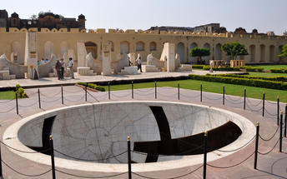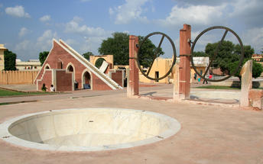

Day 7: Jaipur – Fatehpur Sikri - Agra
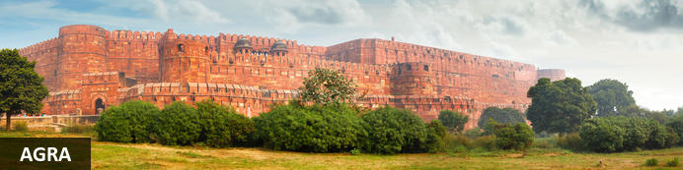
Home of the world-famous Taj Mahal, Agra is one of India’s prime tourist destinations for specifically this reason, though its attractions also extend to an array of other impressive historical sights. These include the red-hued Agra Fort, the sacred Jama Masjid mosque and Itmad-ud-Daulah’s tomb, with its white marble facade embellished with intricate inlaid designs and semi-precious gems. The Taj, however, is in a league of its own and needless to say is a must-see for any visitor to the city. Commissioned by the Mughal emperor Shah Jahan in the 15th century as a memorial to his beloved wife Mumtaz Mahal, it is an architectural masterpiece of exquisite craftsmanship and perfect proportions.
After breakfast, you will be driven to Agra with a stop at Fatehpur Sikri enroute [approx.235 kms /05 hrs drive].
On arrival in Agra , check in to hotel. Later visit Agra Fort and a optional to do a Sunset visit of Taj Mahal [Taj Mahal remains closed on Fridays].

Fatehpur Sikri
This world heritage site is rated as one of the best preserved collections of Mughal architecture in India. Surrounded by a six kilometre wall, with the fourth being a lake at the time, a day can be spent exploring the elaborate structures within. Marvel at the impressive Jama Masjid mosque, the detailed palaces built for Emperor Akbar’s wives, the public and private discussion halls and vast ornamental pool; all of which took over 15 years to conceptualise and build.

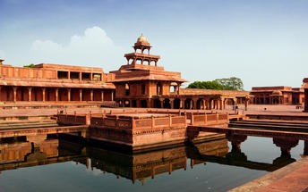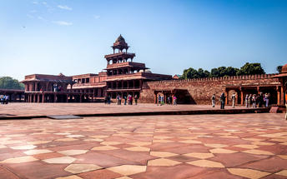

Agra Fort
Known as the Red Fort of Agra, this walled imperial city was founded in 1565 by the Emperor Akbar (1556-1605) and is a well-deserving UNESCO World Heritage site, located just 2.5 kilometres from the famous Taj Mahal. Its palaces, grand mosques and elaborate public hall are crafted from pink-red sandstone and are testament to an era when Indo-Muslim art, strongly marked by influences from Persia, was at its height. Emperor Shah Jahan, who built the Taj Mahal for his deceased wife, was imprisoned by his son Aurangzeb in Agra Fort. He is said to have died in the Musamman Burj, a marble tower he himself built, with one of the most alluring views of the Taj Mahal.
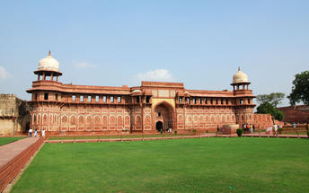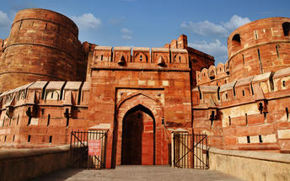

Day 8: Drive Agra - Ramathra
Sunrise visit to Taj Mahal.
Sunrise visit Taj Mahal
The iconic Taj Mahal is not only an architectural masterpiece, a UNESCO World Heritage Site and one of the new Seven Wonders of the World – it’s also the enduring legacy of a royal love story. It was commissioned in the 15th century by the Mughal Emperor Shah Jahan after the death of his third and favourite wife, Mumtaz Mahal, to serve as her final resting place and a symbol of his eternal affection for her. Combining Islamic, Persian, Ottoman Turkish and Indian design elements, it’s an awe-inspiring structure of elegant domes and white marble, which changes colour along with the light – pink at sunrise, pearly white in the afternoon and silver-gold in the full moon.

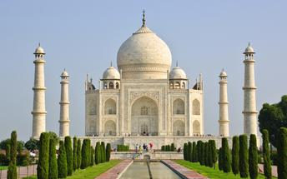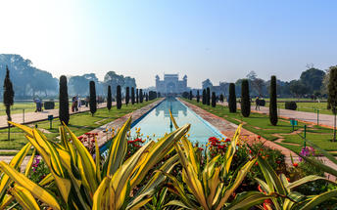
Later you will be driven to Ramathra [approx..210 kms/ 04 hrs drive] and check-in at the unique Ramathra Fort. This hotel is fairly isolated and surrounded by natural sites. The Kailadevi National Park is about 15 km away. Accommodation options for visitors involves a choice between a suite or a luxury tented camp. Each option comes with modern amenities within a comfortable setting. Jeep safaris can be arranged at the hotel to explore the country side. Guests can also take a walking tour through the Ramathra village which comprises of small settlements of farmers and herders. At sunset, the locals put up various shows of Bhajan singing and community activities for entertainment.

Day 9: In Ramathra
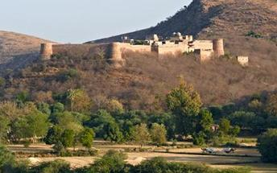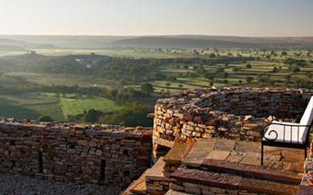
The options for the activities are :
- Boating and Bird watching
- Walking tour of Ramathra village
- Nature walk along the lake and adjoining hillside
- Trekking to old fort ruins
- Temple trail visiting various old temples
- Visit to Organic Farm

Day 10: Ramathra - Shahpura
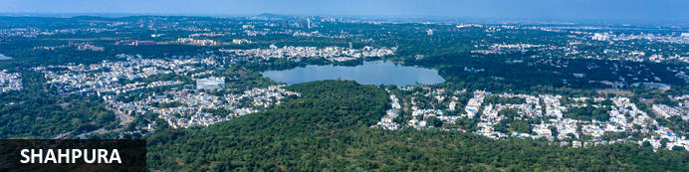
Resting on the sun-drenched plains of Rajasthan, , the city of Shahpura serves as a midway stopover between Jaipur and Udaipur. This city is a little oasis amidst the dry hills of Rajasthan and is a place of pilgrimage for the Ram Snehi, a spiritual and religious group with traditions originating in the early 19th century. Shahpura is primarily untouched by modernity and seems eternally preserved in time. Surrounded by over 250 small lakes, the area is a bird watching paradise and an idyllic setting for visitors to enjoy boating on Shahpura’s picturesque lake. Other attractions include: the Ramdwara Temple, an ancient place of worship; the annual Phooldol Mela, a five-day religious festival; and the ancient, crumbling Dhikhola Fort, a great location for visitors to enjoy evening sundowners with views of the expansive landscape.
After breakfast, you will be driven to Shahpura Bagh [approx.. 270 kms/ 05hrs drive].
On arrival in Shahpura, check in to hotel.

Day 11: In Shahpura
Breakfast at hotel.
Enjoy activities/ tour offered by hotel.
A trip into Shahpura reveals the town’s rich multi-cultural vibrancy and its fascinating arts and crafts tradition. Sit with the Joshis and watch a traditional Phad, a painting depicting mythology and history, come to life.
Explore the many goods on sale in the marketplace. Get a leather mojari, or local footwear, made to your size. Understand the local people's way of life, mingle with artisans and farmers and innocent children...
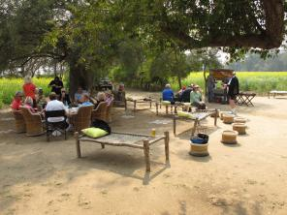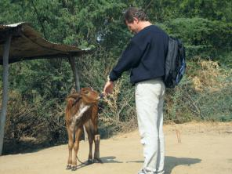

Day 12: Shahpura - Narlai
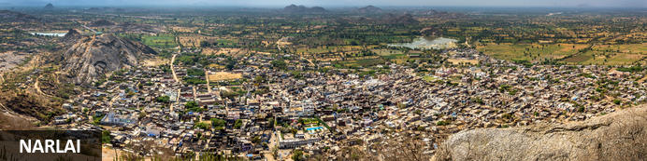
Resting in the heart of the Aravalli Hills, Narlai is a busy little village dating back to the 15th century. This charming village is full of character and rustic charm and is surrounded by idyllic countryside dotted with countless sacred temples including the prominent Shri Adinath Jain Temple which dates back to the year 907 and features two enormous elephant statues standing guard at its entrance. Other popular attractions include the imposing Kumbhalgarh Fort; the impressive 17th-century Rawla Narlai heritage hotel, once the vacation home the the Maharaja Jodhpur; and the colossal Shri Aai Mata Shrine, set high up on a hilltop and containing a lamp which is believed to have an eternal flame.
After breakfast, you will be driven to Narlai [approx.. 210 kms / 04 hrs drive].
On arrival in Narlai, check in to hotel.
In the afternoon, you will proceed for a village walk in Narlai and the same will be accompanied by the hotel staff.
The village has several tourist attractions and the hotel arranges excursions and activities to discover these sites. The hotel organises horse safaris by experienced horse riders that covers the country side route.

Day 13: Narlai – Ranakpur - Udaipur 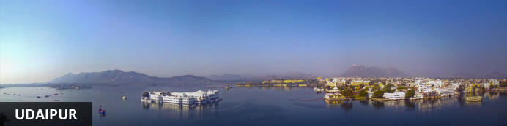
Dubbed the ‘Venice of the East’, the city of Udaipur is built around three interconnected lakes – Lake Pichhola, Fateh Sagar Lake and the smaller Swaroop Sagar Lake – and encircled by the hills of the Aravalli mountain range. It is home to an array of ancient temples and fairy-tale palaces (several of the latter have been converted into luxury heritage hotels) and is known as one of Rajasthan’s most beautiful and romantic cities. Must-see attractions include the City Palace, the Lake Palace (set on a small island in the middle of Lake Pichola) and the Udaipur Solar Observatory – Asia’s premier solar-gazing site.
After breakfast, enjoy a unique mountain train ride through the Aravalli hills and later proceed to Udaipur with a stop at the unique 15th centry Jain temples at Ranakpur.

A nice pleasure trip in to the Aravali Hills by Meter guage train on 1930’s British Track. The track consists of 17 U shape bridges and 2 tunnels with lots of monkeys. Distance covered is only 17 KM but time taken is 2 Hours.

Ranakpur
The complex rests on a lush mountain slope and encompasses a series of temples dating to the 15th century, all constructed from white marble and featuring exquisite decorative detail. The main temple, Chamukha, is a multi-tiered structure with no less than 80 domes and over 1400 pillars, all of which are intricately carved with unique designs – no two are alike.
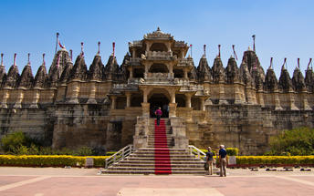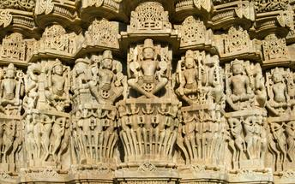
Arrive Udaipur and check in at the hotel.

Day 14: In Udaipur
After breakfast enjoy half day sightseeing tour of Udaipur visiting the City Palace, Saheliyon ki bari, Jagdish temple and in the evening enjoy a boat ride on lake pichola (subject to water level)

Udaipur City Palace
Situated above Lake Pichola, Udaipur City Palace has housed many royals over four centuries who have each added their own unique preferences to the establishment. The palace is a one of a kind in Rajasthan. The Palace was constructed entirely out of marble and granite which makes it highly luxurious. The inside is even more so with its inlays of coloured glass, engravings, towers, and balconies.
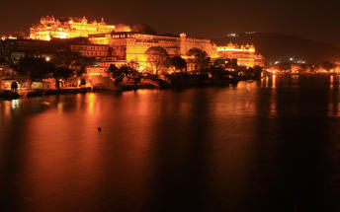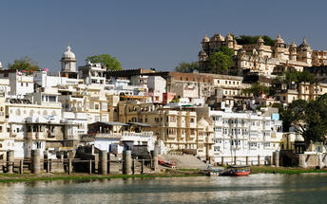

Saheliyon ki Bari
Built by Maharana Sangram Singh II as a garden for women, Saheliyon-ki-Bari or the Garden of the Maidens is a popular tourist destination. Along with a small museum, it has several attractions such as marble elephants, fountains, kiosks and a lotus pool.

Jagdish Temple
Completed in 1651, Jagdish Temple is situated just outside the royal palace. The temple can be seen as soon as visitors enter the city. Puja’s and prayer time are the best time to visit when melodious chants from devotees float through the small interior. Visitors should make a point of climbing the temple's many steps which invite them on a journey of discovery of the rich and vibrant history of Udaipur.
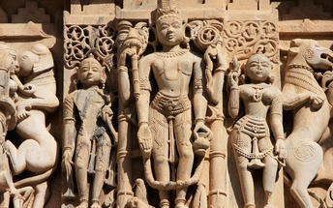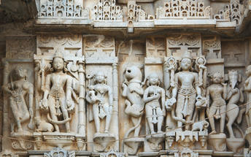
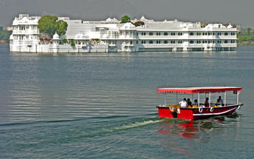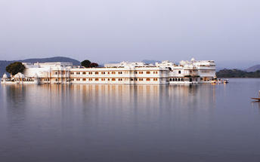

Day 15: Udaipur - Delhi
After breakfast, you will be assisted & transferred to Udaipur airport to board flight for Delhi.
On arrival in Delhi, you will be assisted & transferred to hotel for check in.

Day 16: Depart Delhi
At an appropriate timing, you will be assisted and transferred to airport to board flight to back home.
Flight TBA
Departs Delhi TBA

