In Search of the wild
New Delhi – Ranthambore – Barli – Bera/Jawai – Mumbai – Gir - Mumbai
16 Days / 15 Nights
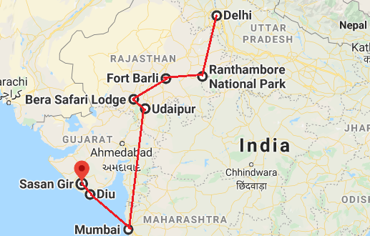

Day 1: Arrive Delhi
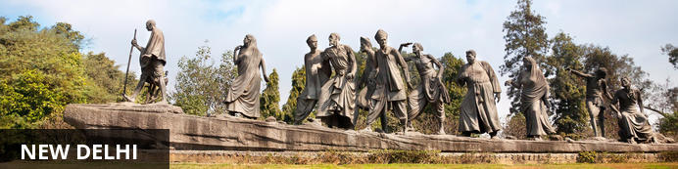
India’s largest city, Delhi, has been one of the country’s commercial and economic hubs for centuries and, as a result, is incredibly rich in culture and history. Made up of the ancient walled city of Old Delhi and the more modern sector, New Delhi, the city encompasses a staggering array of beautiful architecture, notable monuments and age-old temples, including three UNESCO World Heritage Sites – the Red Fort, Qutab Minar and Humayun's Tomb. Other key attractions include the 17th century Chandni Chowk marketplace – still one of the cities most popular retail centres today, particularly for jewellery and traditional Indian saris; and the Jama Masjid, India’s largest mosque.
On arrival in Delhi: Having cleared immigration, collected your luggage and passed through customs, please make your way towards the exit of the terminal building where you will see a bank of people waiting for you. Amongst them will be Travel Counsellors Representative who will be waiting to greet you with a paging board with your name on.
You will be transferred to your hotel and assisted with check in. Standard check in time is 1400 hrs.

Day 2: In Delhi
After breakfast, proceed for a full day sightseeing tour of Delhi, beginning with a heritage walk through Old Delhi followed by a visit through the UNESCO world heritage sites in New Delhi

Heritage Walk
Delhi is an ancient city with history going back to 3000 BC. It has been mentioned extensively in numerous Indian epics like Mahabharat. But the Delhi we see and know about from written records starts from 736 AD. The city has been built, destroyed and rebuilt numerous times. According to popular folklore, Delhi was site of seven different cities between 3000 BC and 17th century AD. But when we count the smaller settlements around the area, there are atleast fifteen. delhi heritage walk
This ancient history and influx of people from all over the world has given Delhi a culture and heritage matched by only a handful of places. Delhi is one of very few places where the ancient and modern co-exist side by side complementing each other perfectly. Our heritage walks of Delhi are a perfect way of exploring this amalgam of old traditions, modern development and the unique heritage which makes it so interesting. These heritage walks are a perfect way to explore some of the lesser visited places and gain a new insight about the history, people and sights of Delhi city.

Drive past the imposing India Gate, the Parliament building and the Rashtrapati Bhawan, the President’s residence.

Qutub Minar
Standing tall at 73-metres, the tower consists of 5 storeys with a flight of spiral stairs leading to its top. The walls are adorned with decorative motifs and Quranic inscriptions. At the foot of the tower lie other monuments of historical significance, such as the Quwwat-ul-Islam Mosque and the Iron Pillar of Delhi. The Amazing race Australia used this site as a pitstop in the second series. Visitors can take advantage of stunning photo opportunities.
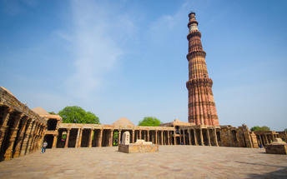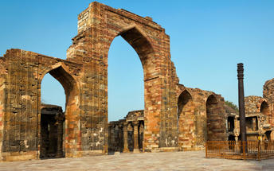

Humayun's Tomb
The mausoleum complex of Humayun, India’s second Mughal Emperor, was commissioned by his widow in 1565 and was the first garden tomb to be built in India, taking seven years to complete. Humayun had travelled widely in Persia and Central Asia during his lifetime, and many of the architectural principles he brought back from these journeys were incorporated into the building at his wife’s instructions. With its double domes, decorative inlaid marble and vast garden with pools connected by channels, this 16th Century building set the stage for the style that culminated in the Taj Mahal almost 100 years later.
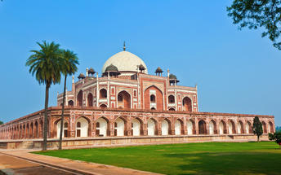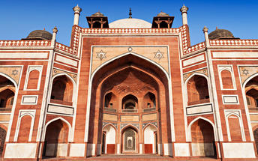

Day 3: Delhi - Ranthambore

Ranthambore National Park, in the western state of Rajasthan, is one of the most visited wildlife parks in India. Spanning over an impressive 1300-square-kilometer stretch of wilderness, the park’s outstanding natural beauty is characterized by its dense jungle, golden savanna, dramatic cliffs and lotus-filled lakes. Considered the best spot to catch a glimpse of tigers in the wild, the park offers visitors a spellbounding combination of mystical temples, wild beauty and crumbling ruins. While the main attraction is undoubtedly the elusive Bengal tiger, the park provides a sanctuary for other wildlife including, among others: sambar, gazelle, caracal, black buck, crocodile, chital, wild boars and a wide array of birds. Don’t miss the ancient Ranthambore Fort, perched high on the cliffs overlooking the vast expanse of this spectacular park.
After breakfast check out from the hotel and transferred to railway station for train ride to Sawai Madhopur.
Upon arrival at Sawai Madhopur, you will be met and taken to the hotel for check in.

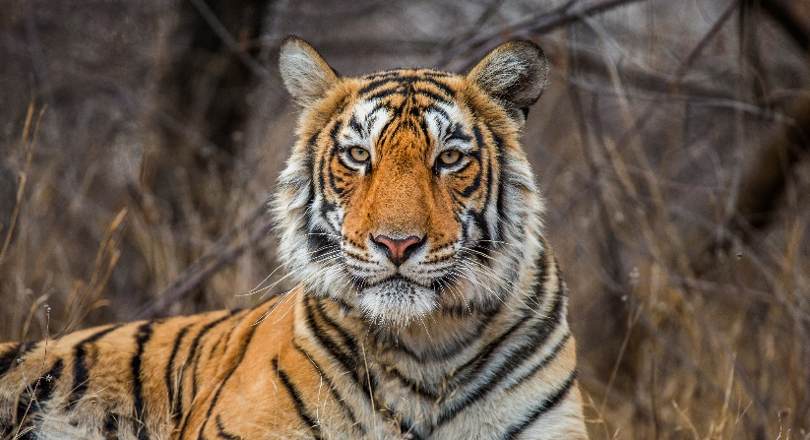
Day 4: In Ranthambore
Enjoy morning and afternoon game drive in to the park.
The game drive is either by shared jeep (max. 6 persons in a jeep) or by open bus (canter – max 20 person). The schedule of the game drive is :
Morning : 0600 – 0930 hrs
Afternoon : 1500 – 1800 hrs

Day 5: In Ranthambore
Enjoy morning and afternoon game drive in to the park

Day 6: Ranthambore - Barli

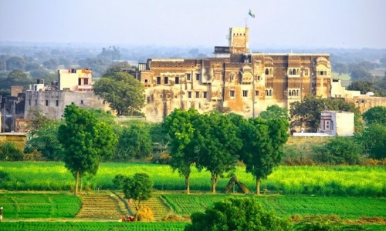
Barli is a wonderful rural village in Ajmer, in Rajasthan. It’s brilliantly located approximately three hours from Jaipur, approximately four hours from Jodhpur and just over four hours from Udaipur, making it a perfect two night stop en route. The village itself is very authentic, with tiny winding streets full of life. Here it’s possible to meet the local people, visit the school, see pottery artists at work as well as seeing their local temples.

After breakfast, you will driven to Barli. Approx. 240 Kms / 5 Hrs drive.

On arrival, check in at your hotel.

Day 7: Barli

After breakfast, explore the beautiful fort, meet with the local people, a school and the village or indulge in a ayurveda massage or attend a cooking dem..

Day 8: Barli – Bera/Jawai
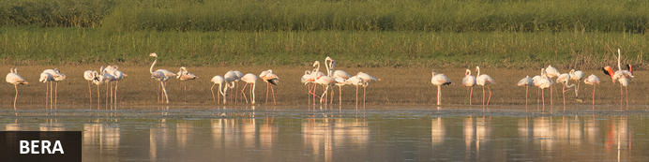
Tucked away in the Aravali mountain range, Bera is a tiny hamlet surrounded by some spectacularly scenic countryside. This surrounding wilderness area is characterised by a desert landscape of forest plains and rocky outcrops inhabited by an impressive array of wildlife species including Indian wolf, sloth bear, Indian leopard, striped hyena, golden jackal, and jungle cat. The hamlet itself features a small but charming heritage hotel, Castle Bera, which serves as an ideal base for exploring the area’s many tourist attractions. These include the Jawai hills and lake, one of the region’s most renowned wild leopard spotting locations; the Ranakpur Temple, a famous Jain structure; and Kumbalgarh Sanctuary, a vast wildlife refuge centred around the impressive historic fort of Kumbhalgarh.

After breakfast, you will be driven to Bera/Jawai. Approx. 240 Kms / 5-6 Hrs drive. Afternoon enjoy a game drive at Bera

Day 9-10: In Bera/Jawai

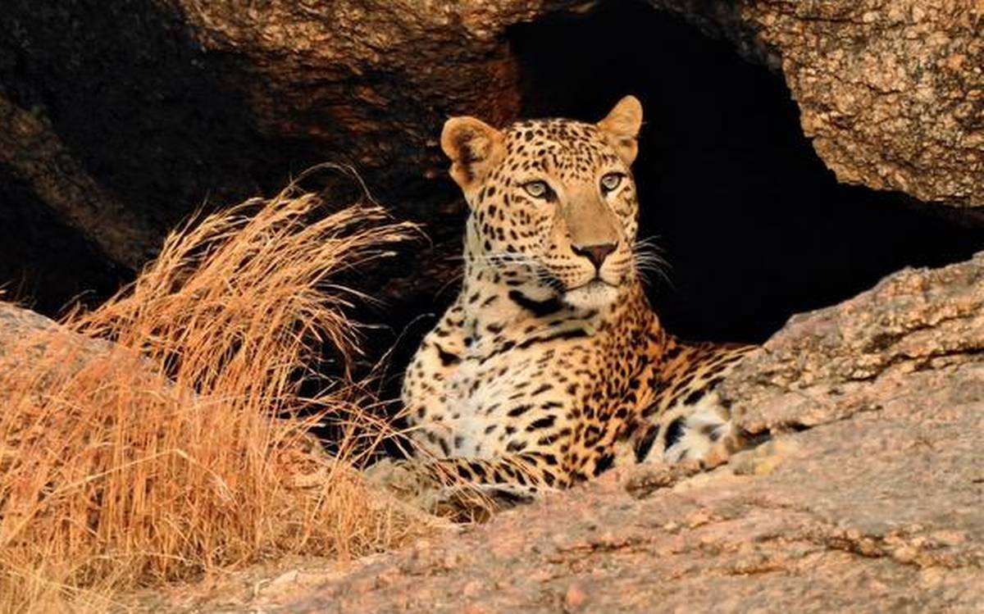
Enjoy morning and afternoon game drive in to the park (max. 6 persons in a jeep). The game drive is provided by the shared jeep. The schedule of the game drive is :

SUMMER SEASON –
Morning: 5.00 AM – 8.00 AM
Evening: 5.00 PM – 8.00 PM

WINTER SEASON –
Morning: 6.30 AM – 9.00 AM
Evening: 4.00 PM – 7.00 PM

Day 11: Bera/Jawai – Udaipur - Mumbai
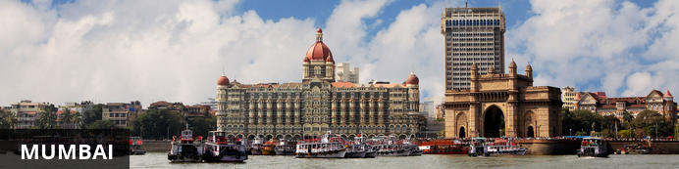
The thriving metropolis of Mumbai is a go-to destination for travellers curious to experience a modern Indian city. Lapped by the Arabian Sea, this urban seaside peninsula is a melting pot of old and new India. Towering office blocks and shiny apartment buildings shoulder crumbling grand dames of architecture. Men play cricket in the leafy central parks, taxis navigate the jam-packed streets and families stroll along the seaside promenades of Mumbai, while kilometres away children beg on the peripheries of Asia’s biggest slum. In the wide avenue of Colaba’s high street, western culture overshadows the brightly lit storefronts, where Levi’s, Adidas and McDonalds vie for retail space.
Breakfast at the hotel. Later at an appropriate time, you will be driven to Udaipur airport [Approx. 145 Kms / 3 Hrs drive] to board the flight to Mumbai.
Upon arrival at Mumbai airport, you will be assisted & transferred to the hotel for check in. Rest of the day is at leisure.

Day 12: Mumbai – Diu – Sasan Gir

Gir National Park in Gujarat is the only place in the world where you can spot lions roaming free in the wild. The real discovery channel of India is situated approximately 65 Kms South East of Junagarh District. The Government notified the large geographical extent of Sasan Gir as wildlife sanctuary on 18th September, 1965 in order to conserve the Asiatic Lion. It covers total area of 1412 square kilometers of which 258 Km forms the core area of the National Park. Indiscriminate hunting by the people of Junagarh led to their decrease in population drastically, while they were completely wiped out from the other parts of Asia. It was the kind effort of Nawabs of Junagarh who protected the queen royalty in his own private hunting grounds. Later in due course of time Department of Forest Officials came forward to protect the world’s most threatened species. From a population of approximately 20 lions in 1913, they have risen to a comfortable 523 according to 2015 census.
Today, you will be transferred to the airport to board your flight to Diu (Note – The flight from Mumbai -Diu sector operates on the selected days in a week).
On arrival in Diu, you will be driven to Gir [Approx. 95 Kms / 2 ½ - 3 Hrs drive] followed by check-in at your hotel.

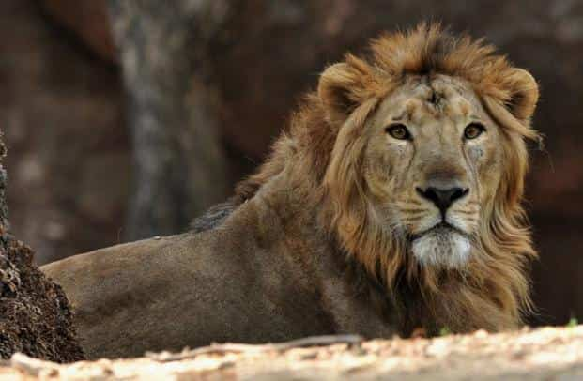
Day 13-15: Sasan Gir

Enjoy morning and afternoon game drive in to the park (max. 6 persons in a jeep). The game drive is provided the by shared jeep.

The schedule of the game drive is :

Morning: 6:45 AM - 9:45 AM & 8:30 AM - 11:30 AM
Afternoon: 3:00 PM - 6:00 PM

Day 16: Sasan Gir – Diu – Mumbai Departure
Today, you will be drive to Diu airport [Approx. 95 Kms / 2 ½ - 3 Hrs drive] to board your flight to Mumbai. (Note – The flight from Diu - Mumbai sector operates on the selected days in a week).
On arrival in Mumbai, you will board your onward flight.
Flight TBA
Departs Delhi TBA

