

Ceylon Cultural Highlights with Wildlife
Negombo - Wilpattu National Park - Anuradhapura - Sigiriya - Kandy - Nuwara Eliya - Kalutara
17 Days / 16 Nights

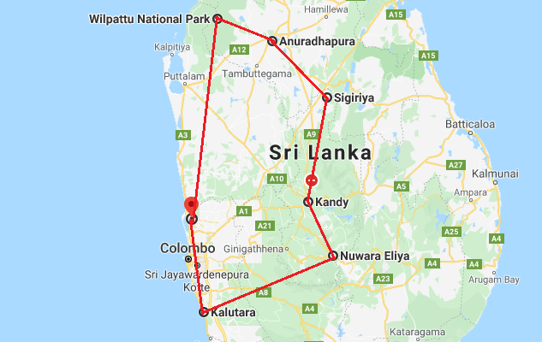

Day 1: Arrive Colombo - Negombo

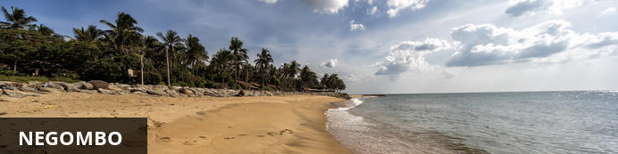
This bustling, fishing town on the west coast of Sri Lanka (and close to the Bandaranaika International Airport), had a rather turbulent colonial history involving the Dutch, Portuguese and British due to the cinnamon trade. In fact, the wild cinnamon that grew in the region was described as ‘the very best in the universe as well as the most abundant’. The remnants of this colonial period remain with the strong Catholic Church influence in the town. The Negombo Lagoon and the many canals offer superb birdwatching, the town’s Old Quarter is worth a visit, and the community is friendly and welcoming.

Day Itinerary
Flight TBA
Arrive Colombo TBA hrs

Arrive at Colombo Airport where you will be received by your chauffeur guide who will take you to the hotel in Negombo (approx. half hour drive) Upon arrival check in at the hotel.

Rest of the day at leisure.

Day 2: Negombo

Morning at leisure. Afternoon tour of the city including a boat trip on Dutch Canal.

Dutch Canal
A 200-year old waterway that flows into Negombo Lagoon is lined with fishing boats and attracts birds and wildlife. Take a boat trip through the canal to enjoy a glimpse into the lives of locals as they drift past rows of residences on either side of the canal.

Day 3: Negombo - Wilpattu National Park

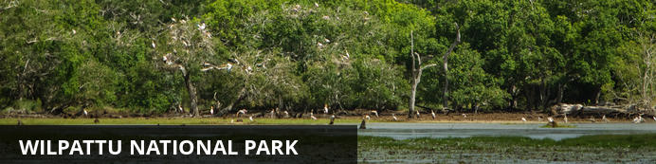
Along the stunning west coast, the off-the-beaten-track Wilpattu National Park is set close to the historical city of Anuradhapura. Dubbed the ‘Land of Lakes’, the park’s main feature is the many natural lakes, of which the park is named, that dot the northwest coast. Nature lovers will delight in the unspoilt wilderness, where eagle-eyed visitors can look forward to catching a glimpse of the local wildlife. Discover the area’s history and find the ancient ruins in the park, venture through the thick untouched jungle for a true wilderness safari experience and soak up the scenic landscapes blanketed in scrublands, wetlands and thick jungle. Commonly spotted species include: leopard, elephant, mongoose, sloth bear and a variety of wetland bird species such as egret, whistling teal, spoonbill, white Ibis, and many more.

Day Itinerary
After breakfast, Leave for Wilpattu National Park (approx. 140 kms/3 hrs).

Afternoon game drive in the park.

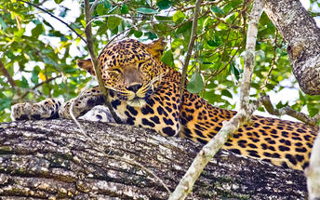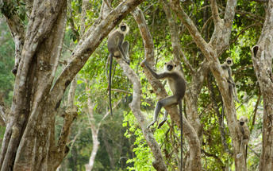

Day 4: Wilpattu - Anuradhapura

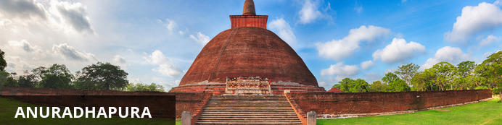
After Sanghamitta, the founder of an order of Buddhist nuns, brought a sacred branch from Buddha’s ‘tree of enlightenment’ to Anuradhapura in the 3rd century BC, the city flourished as the island’s political and religious capital. It thrived for 1 300 years, becoming renowned for its colossal city walls, shrines, public buildings and complicated irrigation systems (which still function today). After an invasion by the Pandyans, Anuradhapura was abandoned, all but disappearing into the jungle until its rediscovery by the British in the 19th century. Subsequent restoration led to its being re-established as a sacred Buddhist pilgrimage site, and more recently a UNESCO World Heritage Site, housing the Sri Maha Bodhiya (Bodhi Tree) and the Ruwanwelisaya, one of the world’s tallest monuments, surrounded by walls that are spectacularly decorated with 1 900 elephant figures.

Day Itinerary
Morning leave for Anuradhapura (approx. an hour). Afternoon visit the beautiful Isrumuniya temple

Anuradhapura
Anuradhapura - one of the greatest and oldest civilizations in the world starring 113 kings & spanning over 1300 years in its peak - avows of being the greatest city of ancient Sri Lanka following its reign as the first capital. The sapphire of its crown is certainly the Sri Maha Bodhi - the sacred Bo sapling extracted from the tree under which Lord Buddha attained enlightenment - standing more than 2200 years in its pride. Stroll through the sacred trails of the venerated city to adore the legacy that interweaves Ruwanweliseya - the gigantic dagoba resting alongside the Basawakkulama Tank - shading the Samadhi Buddha Statue & Isurumuniya Rock Temple that empower the culture, heritage and
supremacy of arguably the strongest kingdom in history.

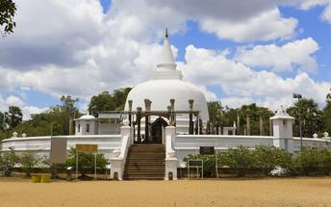
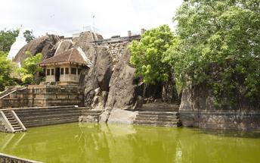

Day 5: Anuradhapura - Sigiriya

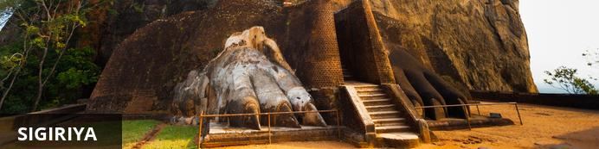
The small village of Sigiriya is best known for its proximity to the magnificent Sigiriya ‘Lion Rock’. This ancient rock fortress rises abruptly from the lush landscape and reaches over 200 metres in height. Crowning this massive outcrop are the ruins of an ancient civilisation, which is considered to be one of the best -preserved examples of ancient urban planning and have been listed as a UNESCO World Heritage Site. Visitors can walk through the lily-dotted moats, lush gardens and cave shrines, through the grand lion-paw entrance, and climb the series of steep staircases passing beautiful murals painted on the sheer rock walls, and enjoy exploring the ruins and soaking up spectacular views of the surrounds.

Day Itinerary
Morning leave for Habarana visiting Mihintale enroute (approx. 76 kms / 2 hrs). Rest of the day at leisure.

Day 6: Sigiriya

Day Itinerary
Morning visit the ruins at Polonnaruwa and later in the day take a jeep ride at Minneriya National Park.

Polonnaruwa
The city is comprised of two distinct parts: the New Town area, known as Kaduruwela; and the royal ancient city of the Kingdom of Polonnaruwa, the second oldest of Sri Lanka’s ancient kingdoms. This rich archaeological treasure trove contains countless fascinating ruins all conveniently grouped into one compact and easily accessible tourist site.
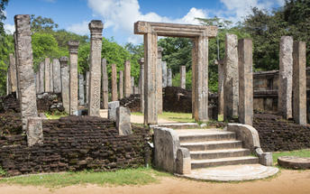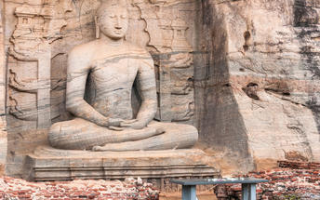

Safari at Minneriya National Park
Spreading over 8800 hectares, this is a sanctuary for elephants. Minneriya is home to herds of deer and ample birdlife, but its spotlight remains between swaying trunks & flapping ears. Park your jeep on the bank of the reservoir and switch off its engine. Watch carefully as herds of elephants - one by one - roll on to the grass-covered banks, to feed on tender shoots. In fact, this is the largest elephant gathering in the world - over 300 at a time - which has garnished the park to become a magnet for wildlife enthusiasts across the globe.

Day 7: Sigiriya

Day Itinerary
Sunrise visit to Sigiriya.

Sigiriya Lion Rock
Sigiriya Lion Rock is a massive column of rock, just over 200 m high, jutting out between the foliage in the northern Natale District of Sri Lanka. The well-preserved site is one of the earliest examples of ancient urban planning and has been declared as a UNESCO World Heritage Site. Sigiriya was established as a stronghold by a rogue king over 1,500 years ago, due to its elevated position which offers 360-degree views of the surrounds. The king built his palace on top of the rock, and the colourful frescoes that it was decorated with, are still visible. A gateway in the form of a lion stands on a small plateau halfway up the side of the rock, giving it its name. After the king’s death, the site was abandoned until it was taken over by a monastery, which functioned there until the 14th century.
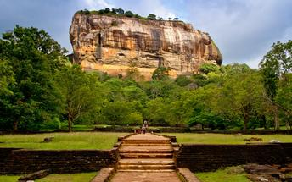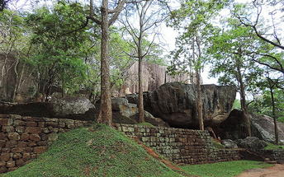
Rest of the day at leisure.

Day 8: Sigiriya - Kandy

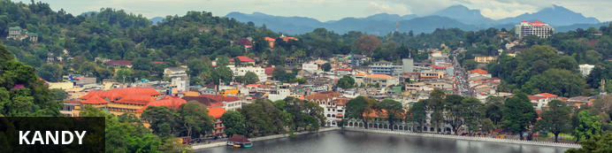
The second major city in Sri Lanka (the other being Colombo) lies in the midst of the Kandy Plateau, an area of tropical tea plantations. A prominent feature is Kandy Lake, to the north of which lies the golden-roofed Temple of The Tooth, a UNESCO World Heritage Site and important place for Buddhist worship, as it is said to house a tooth relic of Buddha. Other fascinating places include the Ceylon Tea Museum, the Buddhist Publication Society, the Ayurveda centre in the Amaya Hills nearby, the Kandyan Art Association and Cultural Centre, where crafts people can be seen at work.

Day Itinerary
Leave for Kandy with stop at Dambulla caves and the spice plantations at Matale (approx. 96 kms / 3 hrs).

Dambulla Cave Temple
Dambulla cave temple also known as the Golden Temple of Dambulla is a World Heritage Site (1991). It is the largest and best-preserved cave temple complex in Sri Lanka. The rock towers 160 m over the surrounding plains. There are more than 80 documented caves in the surrounding area. Major attractions are spread over 5 caves, which contain statues and paintings. These paintings and statues are related to Lord Buddha and his life. There total of 153 Buddha statues, 3 statues of Sri Lankan kings and 4 statues of gods and goddesses. The latter include two statues of Hindu gods, the god Vishnu and the god Ganesh. The murals cover an area of 2,100 square metres. Depictions on the walls of the caves include the temptation by the demon Mara, and Buddha's first sermon.
Prehistoric Sri Lankans would have lived in these cave complexes before the arrival of Buddhism in Sri Lanka as there are burial sites with human skeletons about 2700 years old in this area, at Ibbankatuwa near the Dambulla cave complexes.

Matale
Resting in the folds of a verdant valley in the centre of Sri Lanka, Matale is an urban and agricultural town 105 kilometres from Colombo and 26 kilometres from Kandy. Known for its prolific production of tasty spices, the town also boasts captivating nature trails and enthralling temples. Travellers can visit idyllic plantations to see how vanilla, cocoa and cardamom thrive, and those with adventurous palates can try the region’s famous chillis.
Arrive in Kandy and visit the Kandy temple

Sri Dalada Maligawa Temple of the Sacred Tooth Relic
Sri Dalada Maligawa or the Temple of the Sacred Tooth Relic is located in the royal palace complex of the former Kingdom of Kandy, which houses the relic of the tooth of Buddha. Since ancient times, the relic has played an important role in local politics because it is believed that whoever holds the relic holds the governance of the country. Kandy was the last capital of the Sri Lankan kings and is a UNESCO world heritage site partly due to the temple.
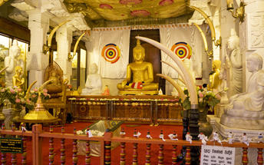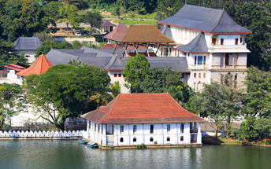

Day 9: Kandy - Nuwara Eliya

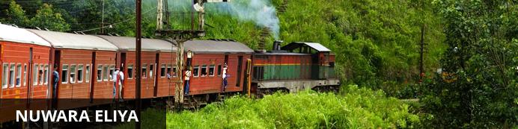
Sometimes referred to as “Little England’, the city is well-kept and neat and features British-style red-brick walls, mock-Tudor half-timbering and a very English country club. The surrounding areas offer breath-taking views of valleys, meadows, mountains and greenery, and most importantly a wonderful break from the heat and humidity of the coast. Tea Estates, waterfalls, and mountains complete the picture. Visitors can take guided tours of the tea plantations, meander through the roses, take a picturesque walk to the ‘Lovers’ Leap’ waterfall, and meander through orchids and giant cypresses at the Hakgala Gardens. Other highlights include the Seetha Amman and Nuwara Eliya Buddhist Temples and the Galway's Land National Park.

Day Itinerary
Leave for the train station to board the scenic train ride to Nanu Oya (Distance approx. 78 km / 3 ½ hours)
NB: Please note that train journeys are subject to availability 10 days prior to the date of train ride. Please do not confirm this facility to clients until you receive confirmations from us.
Your chauffeur guide will leave with your luggage after dropping you at Kandy train station and will wait at Nanu Oya train station to receive you and then transfer to the hotel. Rest of the day at leisure.

Day 10: Nuwara Eliya

Day Itinerary
Visit Nuwara Eliya city and a Tea Plantation and learn the process “leaf to cup”
Sri Lanka, Tea and Tourism are words which cannot be separated. Take a tour to the cold & misty hills that take pride of an ultimate tea tour, covering lush green blankets of tea plantations. Or just step into a tea factory processing the prestigious brand of Ceylon Tea, to observe a rich tradition kept alive up to date. As you observe the hissing and swishing of machines, inhaling the heavenly scent arising from these facilities, make sure to end your day in style over a perfectly blended cup of pure Ceylon Tea.

Day 11: Nuwara Eliya - Kalutara

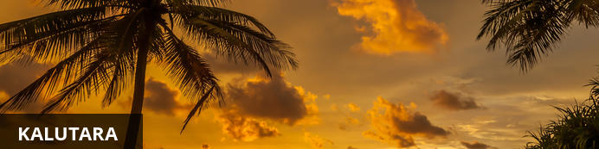
Kalutara is located about 42 kilometres south of Colombo and is one of the third largest urban areas in the western district. This is where the Kalu Ganga River meets the Indian Ocean. Watch fishermen haul in their catch along any of the picturesque beaches at Kalutara. Some significant monuments are found here, including the Gangatilaka Vihara, a holy Buddhist shrine built in 1960, boasting a hollow white Dagoba (stupa). Inside are interesting murals depicting the life story of Buddha. Richmond Castle, an exquisite plantation mansion, offers picnic and boating facilities for travellers looking for a relaxed day out.

Day Itinerary
Morning, Leave Nuwara Eliya for Kalutara for the beach stay (approx. 5 ½ hrs). Arrive and check in at the hotel.

Day 12-16: Kalutara

Day Itinerary
Day at leisure on the beach.

Day 17: Kalutara – Colombo Depart

Day Itinerary
Check-out hotel by Noon and later proceed to Colombo doing a tour of the city before check-in at the airport for the international flight. (Approx. 1 ½ hrs drive from Kalutara to Airport)
Flight TBA
Depart Colombo TBA

