

Classic Ceylon
Colombo – Anuradhapura – Jaffna – Trincomalee – Sigiriya – Kandy – Koggala - Colombo
Number of days : 17 days / 16 nights

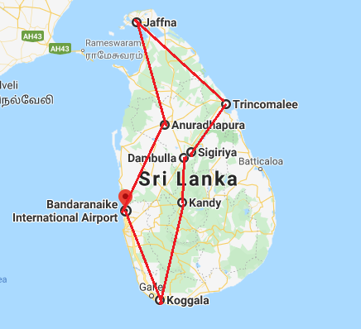

Day 1: Arrive Colombo

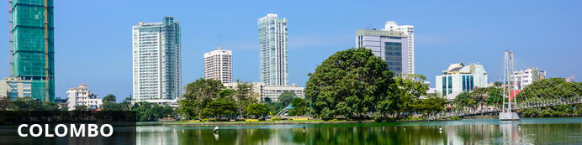
Sri Lanka’s seaside metropolis of Colombo offers a laid-back atmosphere coupled with a mixture of crumbling colonial buildings and glinting skyscrapers. Stroll to Pettah, Colombo’s main market and be dazzled by the variety of gems, the brightly coloured fruit and vegetable stalls and the plethora of ayurvedic medicines on offer. Sample some of the city’s fine fare, from curries to crabs, in any one of the beachfront bistros or inner city dining rooms. Nature lovers should head to Galle Face Green, a grassy promenade along the Indian Ocean for a stroll or take a scenic train ride to Mount Lavinia Beach.

Day Itinerary
Flight TBA
Arrive Colombo TBA Hrs
Arrive at Katunayake International Airport (BIA) where the guests will be received by their chauffeur-guide, who will take them to the hotel in Colombo (Approx. 1 hour drive)
Upon arrival check in at the hotel.

Rest of the day at leisure.

Day 2: Colombo - Anuradhapura

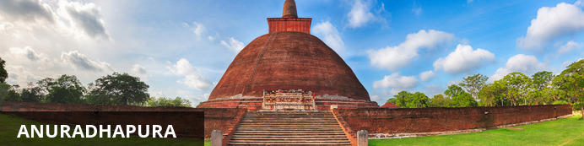
After Sanghamitta, the founder of an order of Buddhist nuns, brought a sacred branch from Buddha’s ‘tree of enlightenment’ to Anuradhapura in the 3rd century BC, the city flourished as the island’s political and religious capital. It thrived for 1 300 years, becoming renowned for its colossal city walls, shrines, public buildings and complicated irrigation systems (which still function today). After an invasion by the Pandyans, Anuradhapura was abandoned, all but disappearing into the jungle until its rediscovery by the British in the 19th century. Subsequent restoration led to its being re-established as a sacred Buddhist pilgrimage site, and more recently a UNESCO World Heritage Site, housing the Sri Maha Bodhiya (Bodhi Tree) and the Ruwanwelisaya, one of the world’s tallest monuments, surrounded by walls that are spectacularly decorated with 1 900 elephant figures.

Day Itinerary
After breakfast, leave for Anuradhapura (approx. 5 hours).
Rest of the day at leisure.

Day 3: Anuradhapura

Day Itinerary
After breakfast, explore Anuradhapura with chauffeur guide. Evening at leisure.
Commanding a rich Sri Lankan heritage, Anuradhapura - one of the greatest and oldest civilizations in the world starring 113 kings & spanning over 1300 years in its peak - avows of being the greatest city of ancient Sri Lanka following its reign as the first capital. The sapphire of its crown is certainly the Sri Maha Bodhi - the sacred Bo sapling extracted from the tree under which Lord Buddha attained enlightenment - standing more than 2200 years in its pride. Stroll through the sacred trails of the venerated city to adore the legacy that interweaves Ruwanweliseya - the gigantic dagoba resting alongside the Basawakkulama Tank - shading the Samadhi Buddha Statue & Isurumuniya Rock Temple that empower the culture, heritage and supremacy of arguably the strongest kingdom in Sri Lankan history.

Day 4: Anuradhapura - Jaffna

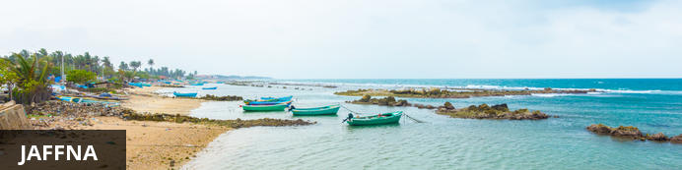
Set on the northern tip of Sri Lanka, the ancient city of Jaffna serves as the capital city of the Northern Province, Sri Lanka’s least-visited region. Emerging from over two decades of isolation and civil war, visitors can now explore this fascinating region with its many beaches, temples, forts, and rich archaeological history. This port town has retained its unique character boasting a captivating mixture of vibrant Tamil culture and colonial charm. Jaffna provides a great base from which to explore the scenic Jaffna Peninsula and the surrounding islands. Visitors can stroll the city's leafy tree-lined streets; view the golden arches of the Nallur Kandaswamy temple; discover the impressive star-shaped Jaffna Fort, a 17-century Portuguese fort; and visit the Jaffna Archaeological Museum, displaying pre-colonial artifacts Dutch cannons.

Day Itinerary
After breakfast, leave for Jaffna (approx. 4 hours). Arrive and check-in at the hotel
Rest of the day at leisure.

Day 5: Jaffna

Day Itinerary
After breakfast, visit to Nagadeepa.
Nagadeepa Purana Vihara is an ancient Buddhist temple which is among the country's sixteen or seventeen holiest Buddhist shrines.
According to contemporary history, the Gautama Buddha visited the site after five years of attaining Enlightenment to settle the dispute between two warring Naga kings, Chulodara and Mahodara.
Ancient history according to the Mahavamsa chronicles and the Tamil Buddhist epic Manimekalai mentions a gem-studded throne and a stone with the Buddha’s footprint at the island Nainativu, (also known as Nagadeepa) which pilgrims from India visited.

Day 6: Jaffna

Day Itinerary
After breakfast, morning explore the Jaffna Fort, the town and Nallur Kovil – a beautiful Hindu temple
Jaffna Fort: Built by the Portuguese in 1618 under Phillippe de Oliveira following the Portuguese invasion of Jaffna. The fort is located near Karaiyr. Due to numerous miracles attributed to the statue of Virgin Mary in the church inside the fort, Jaffna Fort was named as Fortress of Our Lady of Miracles of Jafanapatão (Fortaleza de Nossa Senhora dos Milagres de Jafanapatão). It was captured by the Dutch under Rijcklof van Goens in 1658 who expanded it. In 1795, it was taken over by the British, and remained under the control of a British garrison till 1948. As the only large military fort in the country, due to the presence of only government and military buildings within its ramparts, it was garrisoned by a detachment of the Ceylon Army.

Day 7: Jaffna - Trincomalee

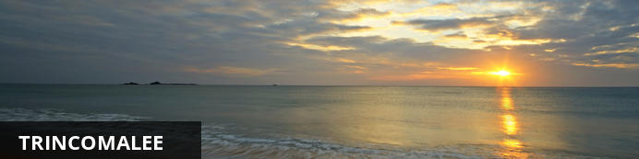
Trincomalee has one of the finest natural deep-water harbours in the world. The beaches of Nilaveli, Uppaveli and the off-shore Pigeon Island are major attractions, and in recent years, whale watching has become a popular pastime for visitors and locals alike. Dive centres allow for diving and snorkelling, and plenty of swimming. Visit the Trincomalee District, also known as Gokanna, to see a multitude of ancient Buddhist temple ruins, now major archaeological sites. About eight kilometres out of the city are the hot springs at Kanniyai that draw regular crowds for their therapeutic value.

Day Itinerary
Leave Jaffna for Trincomalee (approx.5 hours).
Rest of the day at leisure.

Day 8: Trincomalee

Day Itinerary
Day at leisure. (Optional Excursion to Pigeon Island including boat ride and picnic lunch on the island).

Day 9: Trincomalee

Day Itinerary
After breakfast, visit Trincomalee town, Lovers Leap and Konneswaran Temple.
Trincomalee, the city which houses one of the best natural deep-water ports in the world, has a legacy that has painted history since royalty throughout colonization, heading towards modern Sri Lanka revamping a fancy development effort. Enter the granite-built Portuguese fort resting in the heart of Trincomalee or head towards the crystal blue sea for an enthralling experience in scuba diving, snorkeling or fishing. If adventure is your pick, then head few more kilometers to be 'whaled' by the giant fins that crash down the blue waves! Meanwhile, head towards the classical-medieval Hindu temple 'Koneswaram' which blazes a subtle sense of Dravidian architecture or take a stroll towards the Bhadrakali Amman Temple dedicated to the goddess Kali. Pigeon Island is another famous pick in Trincomalee. Being a popular marine sanctuary, Pigeon Island - colonized by rock pigeons - houses some of the best preserved coral reefs. After a couple of excursions, trace your bear feet along the clear sands of Marble Beach which has a strong sense of beauty and subtlety, to feast your experience in the east!

Day 10: Trincomalee - Sigiriya

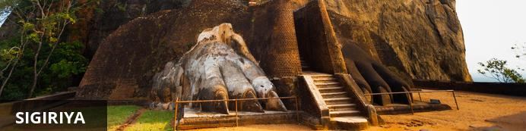
Situated in the northern Matale District of Sri Lanka, the small village of Sigiriya is best known for its proximity to the magnificent Sigiriya ‘Lion Rock’. This ancient rock fortress rises abruptly from the lush landscape and reaches over 200 metres in height. Crowning this massive outcrop are the ruins of an ancient civilisation, which are considered to be one of the best -preserved examples of ancient urban planning and have been listed as a UNESCO World Heritage Site. Visitors can walk through the lily-dotted moats, lush gardens and cave shrines, through the grand lion-paw entrance, and climb the series of steep staircases passing beautiful murals painted on the sheer rock walls, and enjoy exploring the ruins and soaking up spectacular views of the surrounds.

Day Itinerary
After breakfast, leave for Sigiriya (approx. 2 hrs). Late evening climb Sigiriya Rock.
Sigiriya Rock- The 5th century rock citadel of King Kasyapa and World Heritage Site - Sigiriya - doesn't only boasts of ancient Sri Lankan engineering & urban planning supremacy but also acclaims to be one of the finest monuments of art & culture. Step through the gigantic 'Lion Paws' - overlooking the symmetrical royal gardens below - to comprehend the absolute splendor that once dominated this rock fortress. Surrounded by ramparts & moats the Lion Rock - resembling the mythological 'City of Gods' - is coated by frescoes that relate to Gupta style paintings found in Ajanta caves of India. Walk in the shade of an eminent 'mirror wall' embracing the Western face of Sigiriya representing an artistic hundred meters laminated with graffiti.
Wander into the well-fabricated museum downstairs for an epic journey of yesteryears to realize how the citadel floated above citizens with the castle, ponds and irrigation systems that pumped water right onto its summit with an ingenious hydraulic system describing a colossal masterpiece of the great king which remained a wonder in Asia for centuries

Day 11: Sigiriya

Day Itinerary
Morning explore Polonaruwa ruins followed by jeep ride at Minneriya National park.
Polonaruwa ruins
Rising with the decline of Anuradhapura, the city of Polonnaruwa - medieval capital & crown jewel of King Parakramabahu I - remains superior proof of ancient culture & heritage blended with religious beliefs. Walk across its scattered walls of the World Heritage Site - blessed by stupas, resting Buddha statues, irrigation canals and fantastically carved Hindu sculptures - while observing the relic house - Watadage - which boasts of beautiful stone carvings. Take a close glance and you will realize a subtle Hindu influence on architecture and statues found in Polonnaruwa. Or sit by the side of Galviharaya and observe the absolute beauty gushing out of every bend of its huge Buddhist statues. Nissankamalla Council Chamber is however, a head-spinning beauty to just sit back and observe with its swaying pillars reminding the aesthetics of a powerful kingdom which rests beside Parakrama Samudraya - sea of Parakramabahu & masterpiece of irrigation.

Safari at Minneriya National Park
Spreading over 8800 hectares, this is a sanctuary for elephants. Minneriya is home to herds of deer and ample birdlife, but its spotlight remains between swaying trunks & flapping ears. Park your jeep on the bank of the reservoir and switch off its engine. Watch carefully as herds of elephants - one by one - roll on to the grass-covered banks, to feed on tender shoots. In fact, this is the largest elephant gathering in the world - over 300 at a time - which has garnished the park to become a magnet for wildlife enthusiasts across the globe.

Day 12: Sigiriya – Dambulla - Kandy

Day Itinerary
After breakfast, leave for Kandy with a stop at Dambulla and the spice plantations at Matale.
Dambulla Cave Temples
Dambulla Rock Temple houses some of the most unique drawings in magnificently constructed 5 cave temples flanking the golden temple of Dambulla. Observe how exquisitely cave paintings are done along walls that shelter 150 statues of Lord Buddha. As you enter the retreat, look straight up to the gigantic Buddha statue glittering in gold over a land, which today houses an important junction in the country's economic and cultural uplifting.

Kandy Temple
Experience an ancient Kandyan legacy engraved around its crown jewel, the temple of the sacred tooth relic of Lord Buddha. A stroll across this small lakeside town - cradled among the misty hills - will feature the Kandy City Centre - bundled with latest and world class brands, bazaar, an arts & crafts centre, as well as a gem museum & lapidary.

Day 13: Kandy/ Koggala

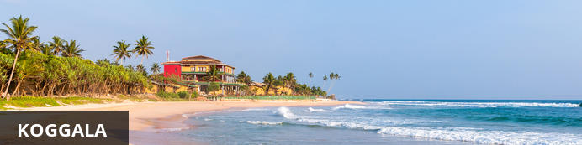
The village of Koggala on Sri Lanka’s south coast offers stretches of exquisite beaches – and good surf – for those seeking a quiet holiday surrounded by nature. Enjoy fresh seafood at one of the little beach restaurants with the picturesque bay as a backdrop. Buddhist hermitages, situated on the islets of Koggala Lake may be visited with prior arrangement, or pop into the Martin Wickramasinghe Folk Art Museum for a sample of the local traditions. Alternatively, you can arrange a catamaran ride or fishing expedition on the lake with one of the villagers, or take a tuk tuk along the dirt tracks to the lake and enjoy the indigenous flora, and fauna, including the elusive monitor lizard.

Day Itinerary
After breakfast, leave Kandy to Koggala (approx. 6 hours)
Evening at leisure.

Day 14: In Koggala

Day Itinerary
Day at leisure. Optional : You can do a cycling through the inland paddy fields (optional) or Kanneliya Walking Trek and lunch by waterfall (optional) or Galle Fort with resident host (optional) .

Day 15: In Koggala

Day Itinerary
Day at leisure. Optional : Early morning Whale Watching with picnic breakfast on board boat

Day 16: Koggala - Colombo

Day Itinerary
Transfer to Colombo after breakfast (approx. 3 hours). Rest of the day at leisure.
Optional: you can do a tour of the city by tuk-tuk

Day 17: Leave Colombo

Day Itinerary
Transfer to airport and connect flight to back home.
Flight TBA
Depart Colombo TBA Hrs

**** END OF SERVICES ****

