

Explore Sri Lanka
Galle - Udawalawe National Park - Ella - Kandy - Sigiriya - Trincomalee - Negombo
15 Days / 14 Nights

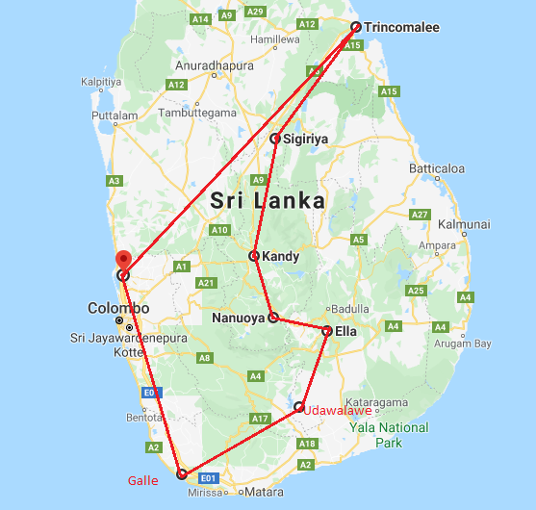

Day 1: Arrive Colombo - Galle

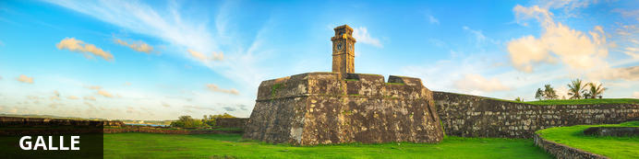
Pronounced ‘gawl’ in English, Galle is the best example of a walled city built by the Portuguese in South Asia in the 16th Century. It was extensively fortified by the Dutch in the 17th century. When you enter the old city gates of this World Heritage Site you can’t help but notice the grand colonial houses and boutique shops and of course the beautiful beaches on the fringes of town. Attracting many luxury travellers from around the world, the town is also a favourite with cricket fans who rate the Galle International Stadium to be one of the most picturesque cricket grounds in the world.

Day Itinerary
Flight TBA
Arrive Colombo TBA Hrs

Arrive at Katunayake International Airport (BIA) where you will be received by your chauffeur-guide, who will take you to the hotel in Galle (Approx. 3 hrs drive)
Upon arrival check in at the hotel.

Rest of the day at leisure.

Day 2: Galle

Day Itinerary
In the morning do a tour of the city and spend the rest of the day at leisure.
Galle, the epic Southern capital, is the intersection where classic Dutch architecture meets a tropical setting creating a vivid atmosphere in beauty. Walk the Dutch-haunted streets listening to the creaks of wooden saloon doors and observe how European architecture mingles with South Asian traditions today flooding cultural enthusiasts on a global scale. Its original ramparts and bastions preserved up to date showcase evidences of a heritage preserved for more than 3 ½ centuries. Walk clockwise within the fort to observe the ‘old gate’ carrying the British coat of arms.

Flanking the old gate is the Zwart bastion – the oldest of all – and the lighthouse standing 18 feet in its glory next to the Point Utretcht Bastion. This Dutch bliss is painted with streets that spread in a rectangular grid pattern pierced with houses carrying Dutch colonial style verandas. Hop into the Dutch Hospital Shopping Complex to be mesmerized by an array of souvenir selections. However, its hallmark stands a reality where the Dutch fort remains a working community with its usual buzz of administrative offices, court complex, commercial buildings, churches and Southern folks frequenting its streets bracing the air of the Elysium of architecture, Galle!

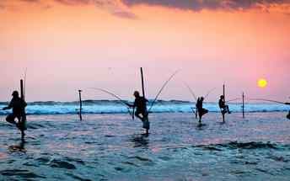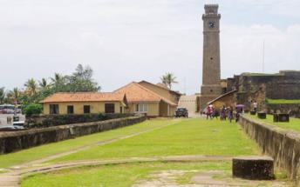

Day 3: Galle - Udawalawe National Park

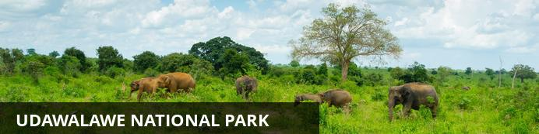
Situated about 165 kilometres from Colombo, the Udawalawe National Park has become a popular tourist destination and the third most visited game park in Sri Lanka. It was originally built to provide a sanctuary for the wild animals displaced by the construction of the Udawalawe Reservoir in 1972 on the Walawe River. It covers nearly 30 000 hectares, and is home to herds of Sri Lankan elephants, water buffalo, monitor lizards, sambar deer, leopards and indigenous water birds. Open-top safaris led by experienced guides through the savannah-type landscape are the ideal way to view the wildlife, with most visitors being assured of enjoying a special treat of viewing young and adult elephant at the water holes.

Day Itinerary
Breakfast at the hotel and drive to Udawalawa ( Approx. 2 ½ hours drive).
Evening Jeep safari at Udawalawa National Park.
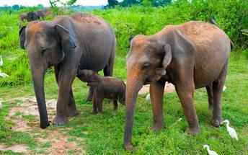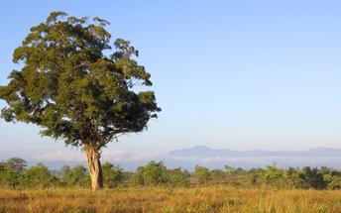

Day 4: Udawalawe National Park - Ella

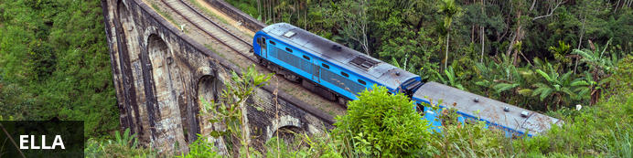
Resting on the southern edge of Sri Lanka’s picturesque Hill Country, the small, sleepy village of Ella is known for its exceptional natural scenery, its wonderfully tranquil atmosphere, and its pleasantly moderate climate. This popular backpacker-hub has become a well-established, must-see tourist destination and an ideal base for travellers exploring the idyllic surrounding countryside cloaked in tea plantations and lush forest. With only a handful of essential stores and tourist facilities, Ella has managed to retain its rural charm and visitors will find a single street winding its way down the hillside past a few quaint cafés, guesthouses and cottages enclosed in neat, flower-filled gardens. At the edge of the escarpment you will find a classic view past the renowned Ella Rock on the right and through a cleft in the hills – the so-called Ella Gap – to the plains far below.

Day Itinerary
After breakfast visit Elephant Transit Home.

Udawalawe Elephant Transit Home
Established in 1995 by the Sri Lankan Department of Wildlife Conservation, its main purpose is to rehabilitate orphaned elephant calves and then return them into the wild. Feeding the calves with milk happens every three hours throughout the day and public viewing is permitted.
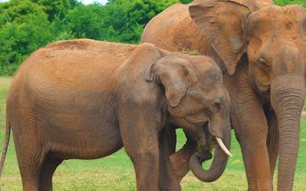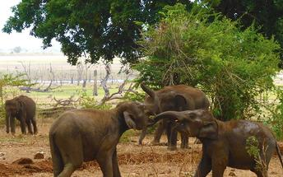
Thereafter proceed to Ella (Approx. 2 hours drive). Arrive and check-in at the hotel. Rest of the day at leisure

Day 5: Ella

Day Itinerary
Explore Ella – visit the city, 9 arch bridge, Ella gap and little Adam’s peak
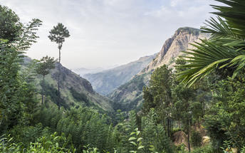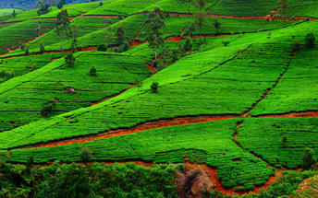

Day 6: Ella - Kandy

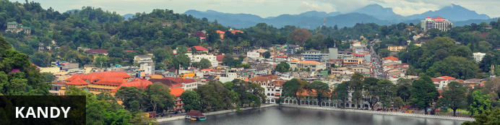
The second major city in Sri Lanka (the other being Colombo) lies in the midst of the Kandy Plateau, an area of tropical tea plantations. A prominent feature is Kandy Lake, to the north of which lies the golden-roofed Temple of The Tooth, a UNESCO World Heritage Site and important place for Buddhist worship, as it is said to house a tooth relic of Buddha. Other fascinating places include the Ceylon Tea Museum, the Buddhist Publication Society, the Ayurvedic centre in the Amaya Hills nearby, the Kandyan Art Association and Cultural Centre, where crafts people can be seen at work

Day Itinerary
After breakfast get on board to the train from Ella railway station and enjoy the scenic train journey to Nanu Oya (Approx. 3 ½ hours train journey)
NB: Please note that train journeys are subject to availability 10 days prior to the date of train ride. Please do not confirm this facility to clients until you receive confirmations from us.
From there onwards you will be driven to Kandy (Approx. 3 hours drive)

Day 7: Kandy

Day Itinerary
Today visit Temple of the tooth relic, Kandy city, the market place and evening witness the Kandy cultural dance show
Kandy, which is the hill capital is another “World Heritage Site”. It was the last stronghold of the Sinhalese Kings during the Portuguese, Dutch and British rule and finally ceded to the British in 1815 after an agreement. To the Buddhists of Sri Lanka and the World, Kandy is one of the most sacred sites as it is the home of the “Dalada Maligawa” – Temple of the Sacred Tooth Relic of Lord Buddha. Today it is the center of Buddhism, Arts, Crafts, Dancing, Music and Culture. Visitors can see these Dance & Music at the daily Cultural Performances held at several places in the city.
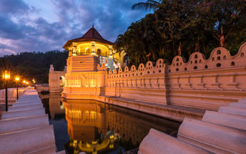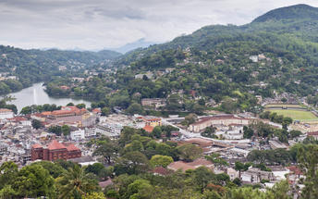
Temple of the sacred Tooth Relic: Last ruled by King Sri Wickrama Rajasinghe – before it was brought under the British rule in 1815, Kandy – the World Heritage Site & last royal capital of Sri Lankan kings – crafts an array of culture, history and heritage in the minds of visitors across the globe. Experience an ancient Kandyan legacy engraved around its crown jewel, the temple of the sacred tooth relic of Lord Buddha. A stroll across this small lakeside town – cradled among the misty hills – will feature the Kandy City Centre – bundled with latest and world class brands, bazaar, an arts & crafts centre, as well as a gem museum & lapidary. Walk in colour as you glide through fresh fruits and
Vegetables in the Kandy market.

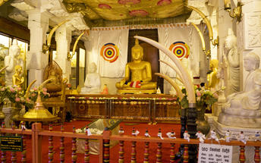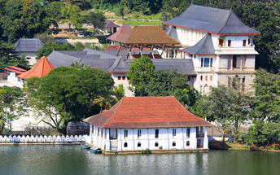

Day 8: Kandy - Sigiriya

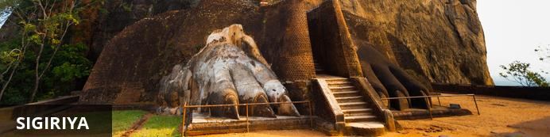
This ancient rock fortress rises abruptly from the lush landscape and reaches over 200 metres in height. Crowning this massive outcrop are the ruins of an ancient civilisation, which are considered to be one of the best -preserved examples of ancient urban planning and have been listed as a UNESCO World Heritage Site. Visitors can walk through the lily-dotted moats, lush gardens and cave shrines, through the grand lion-paw entrance, and climb the series of steep staircases passing beautiful murals painted on the sheer rock walls, and enjoy exploring the ruins and soaking up spectacular views of the surrounds.

Day Itinerary
After breakfast, drive to Sigiriya with stops at the spice plantations at Matale and the magnificent rock cut cave temples at Dambulla (Approx. 3 ½ hours drive)

Dambulla
It is the largest and best-preserved cave temple complex in Sri Lanka. The rock towers 160 m over the surrounding plains. There are more than 80 documented caves in the surrounding area. Major attractions are spread over 5 caves, which contain statues and paintings. These paintings and statues are related to Lord Buddha and his life. There total of 153 Buddha statues, 3 statues of Sri Lankan kings and 4 statues of gods and goddesses. The latter include two statues of Hindu gods, the god Vishnu and the god Ganesh. The murals cover an area of 2,100 square metres. Depictions on the walls of the caves include the temptation by the demon Mara, and Buddha’s first sermon.
Prehistoric Sri Lankans would have lived in these cave complexes before the arrival of Buddhism in Sri Lanka as there are burial sites with human skeletons about 2700 years old in this area, at Ibbankatuwa near the Dambulla cave complexes.

Day 9: Sigiriya

Day Itinerary
Morning excursion to the ruins at Polonnaruwa followed by a jeep ride at Minneriya National Park

Polonnaruwa
The city is comprised of two distinct parts: the New Town area, known as Kaduruwela; and the royal ancient city of the Kingdom of Polonnaruwa, the second oldest of Sri Lanka’s ancient kingdoms. This rich archeological treasure trove contains countless fascinating ruins all conveniently grouped into one compact and easily accessible tourist site.Later in the afternoon drive to Minneriya national park for a Jeep safari.
Later in the afternoon drive to Minneriya national park for a Jeep safari.

Minneriya National Park
Spreading over 8800 hectares, this is a sanctuary for elephants. Minneriya is home to herds of deer and ample birdlife, but its spotlight remains between swaying trunks & flapping ears. Park your jeep on the bank of the reservoir and switch off its engine. Watch carefully as herds of elephants – one by one – roll on to the grass-covered banks, to feed on tender shoots. In fact, this is the largest elephant gathering in the world – over 300 at a time – which has garnished the park to become a magnet for wildlife enthusiasts across the globe.

Day 10: Sigiriya - Trincomalee

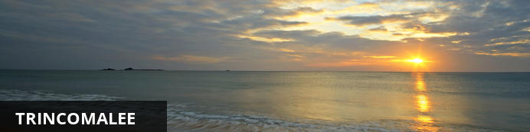
Situated about 250km to the north east of the capital Colombo, the major resort and port city Trincomalee has one of the finest natural deep-water harbours in the world. The beaches of Nilaveli, Uppaveli and the off-shore Pigeon Island are major attractions, and in recent years, whale watching has become a popular pastime for visitors and locals alike. Dive centres allow for diving and snorkelling, and plenty of swimming. Visit the Trincomalee District, also known as Gokanna, to see a multitude of ancient Buddhist temple ruins, now major archeological sites. About eight kilometres out of the city are the hot springs at Kanniyai that draw regular crowds for their therapeutic value.

Day Itinerary
Early morning climb Sigiriya Rock Fortress.

Sigiriya
The well-preserved site is one of the earliest examples of ancient urban planning and has been declared a UNESCO World Heritage Site. Sigiriya was established as a stronghold by a rogue king over 1,500 years ago, due to its elevated position which offers 360-degree views of the surrounds. The king built his palace on top of the rock, and the colourful frescoes that it was decorated with, are still visible. A gateway in the form of a lion stands on a small plateau halfway up the side of the rock, giving it its name. After the king’s death, the site was abandoned until it was taken over by a monastery, which functioned there until the 14th century.
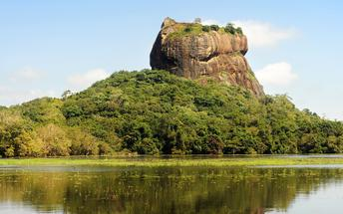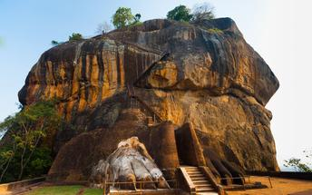
Later drive to Trincomalee (Approx. 2 ½ hours drive)

Day 11-13: Trincomalee

Day Itinerary
Days at leisure on the beach.

Day 14: Trincomalee - Negombo

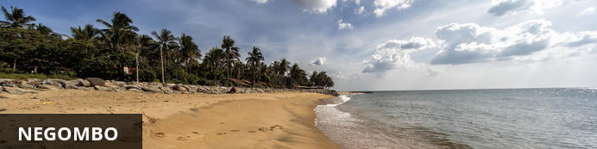
This bustling, fishing town on the west coast of Sri Lanka (and close to the Bandaranaika International Airport), had a rather turbulent colonial history involving the Dutch, Portuguese and British due to the cinnamon trade. In fact, the wild cinnamon that grew in the region was described as ‘the very best in the universe as well as the most abundant’. The remnants of this colonial period remain with the strong Catholic Church influence in the town. The Negombo Lagoon and the many canals offer superb birdwatching, the town’s Old Quarter is worth a visit, and the community is friendly and welcoming.

Day Itinerary
After breakfast, leave for to Negombo (Approx. 6 hours drive)

Day 15: Depart Colombo

Day Itinerary
Breakfast at the hotel.
Check out as per standard time 1200 hrs.
In time, transfer from hotel to Colombo airport (approx. half hour) to board flight for onward destination
Flight TBA
Depart Colombo TBA Hrs

**** END OF SERVICES ****

