

Hiking in Sri Lanka
Negombo - Kandy - Nuwara Eliya - Udawalawe National Park - Galle
08 Days / 07 Nights

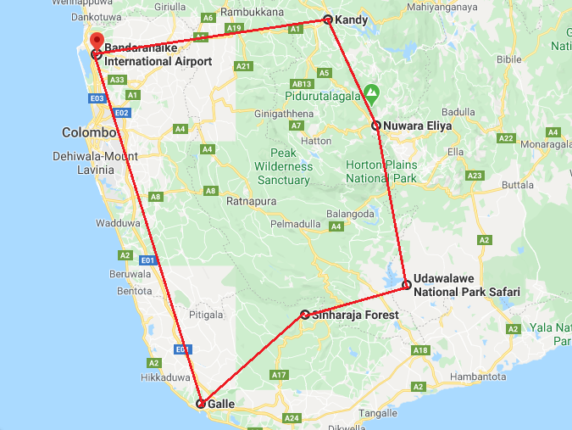

Day 1: Arrive Colombo - Negombo

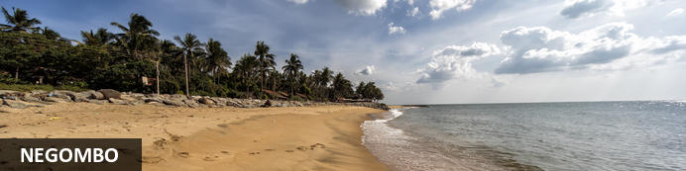
This bustling, fishing town on the west coast of Sri Lanka (and close to the Bandaranaika International Airport), had a rather turbulent colonial history involving the Dutch, Portuguese and British due to the cinnamon trade. In fact, the wild cinnamon that grew in the region was described as ‘the very best in the universe as well as the most abundant’. The remnants of this colonial period remain with the strong Catholic Church influence in the town. The Negombo Lagoon and the many canals offer superb birdwatching, the town’s Old Quarter is worth a visit, and the community is friendly and welcoming.

Day Itinerary
Flight TBA
Arrive Colombo TBA hrs
Arrive at Katunayake International Airport (BIA) where the guests will be received by their chauffeur-guide, who will take them to the hotel in Negombo (Approx. ½ hour)
Upon arrival check in at the hotel.

Rest of the day at leisure.

Day 2: Negombo - Kandy

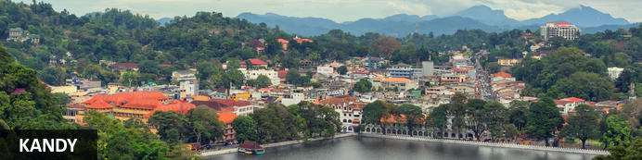
The second major city in Sri Lanka (the other being Colombo) lies in the midst of the Kandy Plateau, an area of tropical tea plantations. A prominent feature is Kandy Lake, to the north of which lies the golden-roofed Temple of The Tooth, a UNESCO World Heritage Site and important place for Buddhist worship, as it is said to house a tooth relic of Buddha. Other fascinating places include the Ceylon Tea Museum, the Buddhist Publication Society, the Ayurvedic centre in the Amaya Hills nearby, the Kandyan Art Association and Cultural Centre, where crafts people can be seen at work, and the Kandy Muslim Hotel, which offers the finest spiced curries served with naan or rotis.

Day Itinerary
Breakfast at the hotel. Leave for Kandy (approx. 4 hrs).
Late afternoon Enjoy a Trekking at Udawattakelle
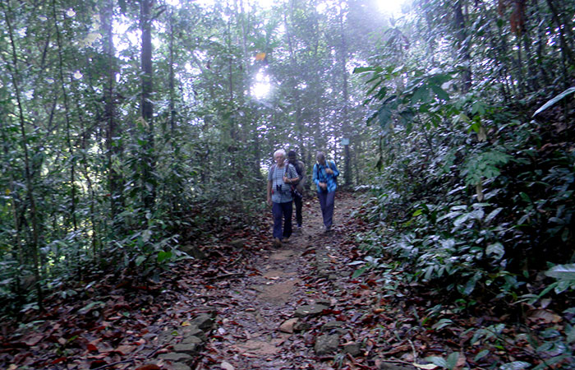
Udawatta Kele Sanctuary or the Royal Forest Park of Kandy is situated on the hillside behind the Dalada Maligawa or the Temple of the Tooth Relic. This forest extents about 257 acres and is considered to be a vital Bio reserve for the much-populated Kandy City. Centuries back, area surrounding Kandy had been a Rain Forest and the human settlements took place during the era of King Panditha Parakramabahu (1302-1326 AD) and in 1371 AD, King Wickramabahu made Kandy his Kingdom. During this era Kandy was called as “Senkadagala”. This name came into being due to a Brahmin named Senkanda, who lived in a cave at Udawattakele during that era. During the Kandyan Kingdom, this forest area behind the palace was called ” Uda wasala watta” or the ‘Upper Palace Garden’ frequented by the royalty and was out of bound to the people. Since the downfall of the Kandyan Kingdom in 1815, this forest area started to lose its pristine condition due to wood cutting etc.

Day 3: Kandy

Day Itinerary
After breakfast proceed to Knuckles (Approx.: 2Hrs)
Enjoy a Full Day Trekking at Knuckles Mountain Range: The Knuckles Mountain Range takes its name from a series of recumbent folds and peaks in the west of the massif which resemble the knuckles of clenched fist when viewed from certain locations in the Kandy District. Whilst this name was assigned by early British surveyors, the Sinhalese residents have traditionally referred to the area as Dumbara Kanduvetiya meaning Mist-laden Mountain Range (Cooray, 1984). The higher montane area is often robed in thick layers of cloud. In addition to its aesthetic value, the range is of great scientific interest. It is a climatic microcosm of the rest of Sri Lanka as the conditions of all the climatic zones in the country are exhibited in the massif. At higher elevations, there is a series of isolated cloud forests, harbouring a variety of flora and fauna. Although the range constitutes approximately 0.03% of the island’s total area, it is home to a significantly higher proportion of the country’s biodiversity. The isolated Knuckles range harbours several relict, endemic flora and fauna that are distinct from central massif. More than 34 percent of Sri Lanka’s endemic trees, shrubs, and herbs are only found in these forests.
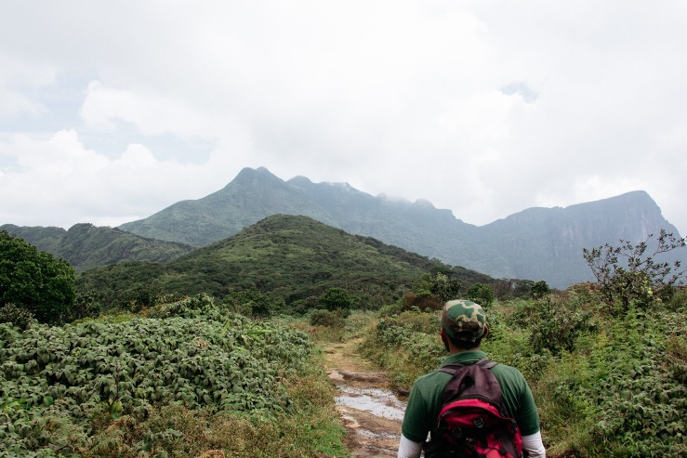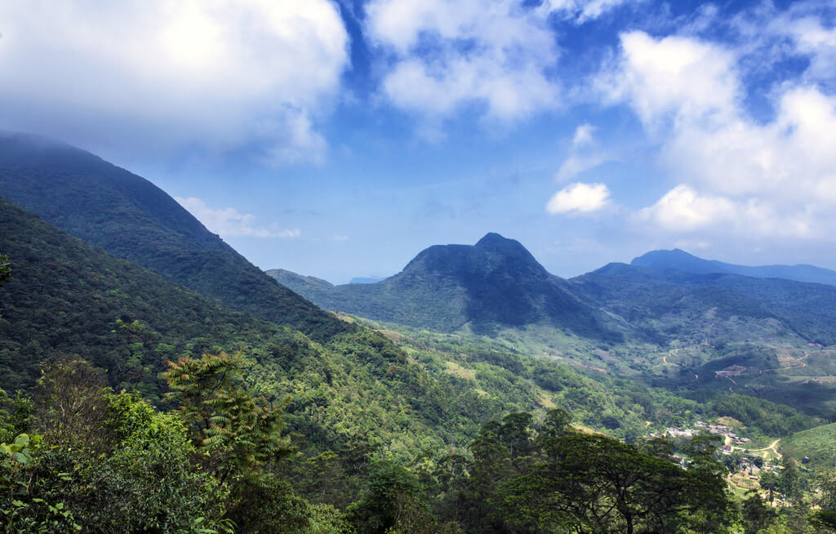

Day 4: Kandy - Nuwara Eliya

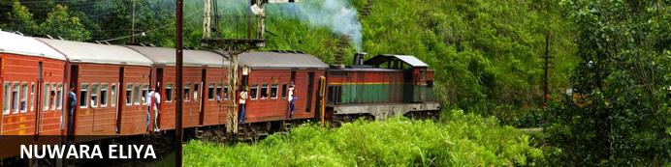
Referred to as “Little England’, the city is well-kept and it features British-style red-brick walls, mock-Tudor half-timbering and a very English country club. The surrounding areas offer breath-taking views of valleys, meadows, mountains and greenery, and most importantly a wonderful break from the heat and humidity of the coast. Tea Estates, waterfalls, and mountains complete the picture. Visitors can take guided tours of the tea plantations, meander through the roses, take a picturesque walk to the ‘Lovers’ Leap’ waterfall, and meander through orchids and giant cypresses at the Hakgala Gardens. Other highlights include the Seetha Amman and Nuwara Eliya Buddhist Temples and the Galway's Land National Park.

Day Itinerary
Breakfast at the hotel.
After breakfast, visit the Kandy Temple.
Temple of the sacred Tooth Relic: Last ruled by King Sri Wickrama Rajasinghe – before it was brought under the British rule in 1815, Kandy – the World Heritage Site & last royal capital of Sri Lankan kings – crafts an array of culture, history and heritage in the minds of visitors across the globe. Experience an ancient Kandyan legacy engraved around its crown jewel, the temple of the sacred tooth relic of Lord Buddha. A stroll across this small lakeside town – cradled among the misty hills – will feature the Kandy City Centre – bundled with latest and world class brands, bazaar, an arts & crafts centre, as well as a gem museum & lapidary. Walk in colour as you glide through fresh fruits and
vegetables in the Kandy market.
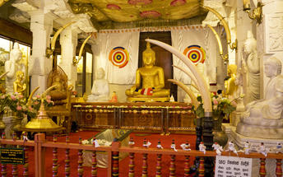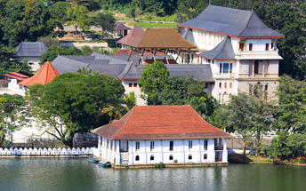
After the visit, leave for Nuwara Eliya (approx. 3 hrs) – a beautiful drive through the tea plantations. Here you have the opportunity to learn the process “leaf to cup”
Sri Lanka, Tea and Tourism are words which cannot be separated. Take a tour to the cold & misty hills that take pride of an ultimate tea tour, covering lush green blankets of tea plantations. Or just step into a tea factory processing the prestigious brand of Ceylon Tea, to observe a rich tradition kept alive up to date. As you observe the hissing and swishing of machines, inhaling the heavenly scent arising from these facilities, make sure to end your day in style over a perfectly blended cup of pure Ceylon Tea.

Day 5: Nuwara Eliya

Day Itinerary
With the packed breakfast from the hotel, proceed to Horton Plains (Approx.: 45Mins) the UNESCO world Heritage site.

Horton Plains
With an altitude above 7000ft, the plateau sweeps to a robust 3169 hectares sheltering flora and fauna varieties that may be found no where else on earth. As the tributary of Belihul Oya - Bakers Falls - thunders down rocks head along the 9km trekking path - across frost-covered grass - to feel the icy-cold wind against your face. You may even gaze down World's End, a head-spinning 3700ft drop towards the Southern end or drive carefully through herds of sambar deer, shy to human touch & birdlife chirping across the plains. If you're cautious enough you may be greeted by the sights of a grunting wild boar, a pouncing fishing cat, otters or even the 'Spotted-Ghost that haunts the plains', the Sri Lankan Leopard!
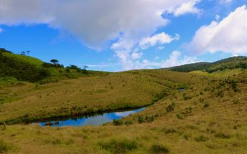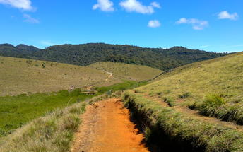
Back to hotel in Nuwara Eliya.
Optional: Climb at Adam’s Peak
There is probably no mountain anywhere more famous than Sri Pada – Adam’s Peak (7362ft/2250m) for non-mountain reasons than this. It is sacred to three religions; to Buddhists the human-foot-shaped hollow on the pinnacle boulder marks one of the personal appearances of the Buddha; the Muslims believe that the depression marks Adam’s expiation of his disobedience by standing there for an age on one foot; to the Hindus, by whom the Peak has been venerated for millennia, its name is Sivan Adi Padham, for it is the Creative Dance of the god Siva that the ‘print’ calls to remembrance.

Whichever legend you may believe, this beautiful place has been a pilgrimage center for over a thousand years. The sunrise produces the famous spectacle of the Shadow of the Peak. The north east winds that blow in the pilgrim season have laid, some thousands of feet below Adam’s Peak, a layer of misty cloud. Over this the sun casts the vast dark triangular shadow of the huge summit pyramid. Its point lies, at first, upon the infinitely distant horizon, then as the sun waxes, races backward, foreshortening the shadow, until it is swallowed altogether in the rock of the peak itself.

The climb could be classified as strenuous climbing. There are approximately 5500 steps to be climbed.
Duration approximately 04 hours one way depending on personal fitness
Best time to climb would be during the season, which commences on the first full moon day of December to the full moon day of May. This is practiced due to religious reasons mainly considering the health and safety aspects. Also you could witness the rich varied traditions and devotions of the locals when climbing during this period, However more adventurous people will find it fascinating to do the climb during the off season.

Day 6: Nuwara Eliya - Udawalawe National Park

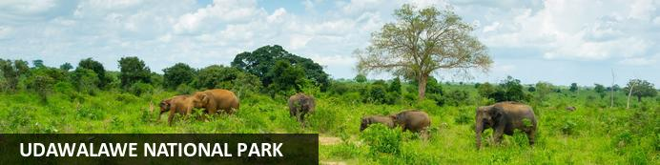
It was originally built to provide a sanctuary for the wild animals displaced by the construction of the Udawalawe Reservoir in 1972 on the Walawe River. It covers nearly 30 000 hectares, and is home to herds of Sri Lankan elephants, water buffalo, monitor lizards, sambar deer, leopards and indigenous water birds. Open-top safaris led by experienced guides through the savannah-type landscape are the ideal way to view the wildlife, with most visitors being assured of enjoying a special treat of viewing young and adult elephant at the water holes.

Day Itinerary
Breakfast at the hotel.
Leave for Udawalawe (approx. 4 hrs) Afternoon visit the Elephant transit home and enjoy a jeep ride at Udawalawe National Park

Udawalawe Elephant Transit Home
Established in 1995 by the Sri Lankan Department of Wildlife Conservation, its main purpose is to rehabilitate orphaned elephant calves and then return them into the wild. Feeding the calves with milk happens every three hours throughout the day and public viewing is permitted.
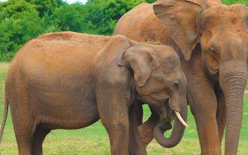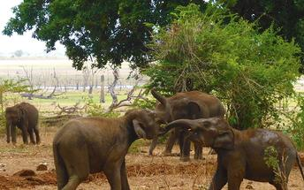

Day 7: Udawalawe National Park – Sinharaja Rain Forest - Galle

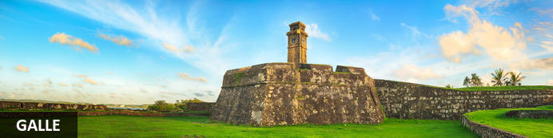
Pronounced ‘gawl’ in English, Galle is the best example of a walled city built by the Portuguese in South Asia in the 16th Century. It was extensively fortified by the Dutch in the 17th century. When you enter the old city gates of this World Heritage Site you can’t help but notice the grand colonial houses and boutique shops and of course the beautiful beaches on the fringes of town. Attracting many luxury travellers from around the world, the town is also a favourite with cricket fans who rate the Galle International Stadium to be one of the most picturesque cricket grounds in the world.

Day Itinerary
After breakfast proceed to Sinharaja (Approx.: 3Hrs)
Enjoy a Trekking at Sinharaja Rain Forest Reserve: Sinharaja Forest Reserve is a national park and a biodiversity hotspot. It is of international significance and has been designated a Biosphere Reserve and World Heritage Site by UNESCO. According to International Union for Conservation of Nature (IUCN), Sinharaja is the country’s last viable area of primary tropical rainforest. More than 60% of the trees are endemic and many of them are considered rare. The hilly virgin rainforest, part of the Sri Lanka lowland rain forests ecoregion, was saved from the worst of commercial logging by its inaccessibility, and was designated a World Biosphere Reserve in 1978 and a World Heritage Site in 1988. The reserve’s name translates as Lion Kingdom. The reserve is only 21 km (13 mi) from east to west, and a maximum of 7 km (4.3 mi) from north to south, but it is a treasure trove of endemic species, including trees, insects, amphibians, reptiles, birds, and mammals.
Thereafter proceed to Galle (Approx.: 3.5Hrs)

Day 8: Galle - Colombo Depart

Day Itinerary
Breakfast at the hotel.
Check out as per standard time 1200 hrs.
In time, transfer from Galle hotel to Colombo airport (Approx. 150km / 3 hrs) to connect flight back home.
Flight TBA
Depart Colombo TBA Hrs

**** END OF SERVICES ****

